

COMPANY RATING WEBSITE

Final Report

|  |  |  |
| --- | --- | --- |
| **COMPANY RATING WEBSITE – *KẾ SINH NHAI TEAM*** | | |
| **Group Members** | Trần Quốc Hưng | SE02970 |
| Nguyễn Sơn Lâm | SE03090 |
| Nguyễn Việt Hùng | SE03293 |
| Nguyễn Nhật Quang | SE03122 |
| Trần Đăng | SE03039 |
| **Supervisor** | Bùi Đình Chiến | |
| **Project code** | CRW | |

- Hanoi, 19/08/2016 -

# DEFINITION AND ACRONYMS

|  |  |  |
| --- | --- | --- |
| Acronym | Definition | Note |
| CC | Infrastructure Configuration Controller |  |
| CI | Configuration Item |  |
| CM | Configuration Management |  |
| CRW | Company Rating Website | Project’s name |
| PP | Project Plan |  |
| CSCI | Computer Software Configuration Items |  |
| PM | Project Manager |  |
| PTL | Project Technical Leader |  |
| QA | Quality Assurance Officer |  |
| Source | Source Code |  |
| PIC | Person in Charge |  |
| SRS | Software Requirement Specification |  |
| WIP | Work in Progress |  |
| WP | Work Product |  |
| U | User | Including Guest, Member, Moderator and Administrator |
| M | Member |  |
| RU | Registered User | Including Member, Moderator and Administrator |
| AD | Administration | Including Moderator and Administrator |
| URL | Uniform Resource Locator | Website’s hyperlink |
| Q&A | Question & Answer |  |
| GUI | Graphical User Interface |  |
| KLOC | 1000 line of code |  |
| AWS | Amazon Web Services | Web Service for hosting |
| SNS | Social Network Service |  |

Table of Contents

DEFINITION AND ACRONYMS 1

I. INTRODUCTION 11

1 Project Information 11

2 Project Members 11

3 Background 11

4 Existing System 12

4.1 Glassdoor.com 12

4.2 CareerBliss.com 13

II. PROJECT PLAN 14

1 Project Overview 14

1.1 Project Description 14

1.2 Scope and Purpose 14

1.2.1 Project Purpose 14

1.2.2 Scope of Project 14

1.2.3 The functions of Project 14

1.3 Assumptions and Constraints 16

1.4 Project Objective 18

1.4.1 Standard Objective 18

1.4.2 Specific Objectives 19

1.5 Critical Dependencies 19

1.6 Project Risk 19

2 Project Development Approach 22

2.1 Project Process 22

2.1.1 FPT Software Process Model 22

2.1.2 Project Life Cycle 22

2.2 Requirement Change Management 23

2.3 Quality Management 24

2.3.1 Defect Prevention Strategy 24

2.3.2 Review Strategy 24

2.3.3 Unit Testing Strategy 25

2.3.4 Integration Testing Strategy 25

2.3.5 System Testing Strategy 25

2.3.6 Estimates of Defects to be detected 26

2.3.7 Measurements Program 26

3 Estimation 27

3.1 Size 27

3.2 Effort 27

3.3 Schedule 27

3.3.1 Project Milestone & Deliverables 27

3.4 Resource 28

3.5 Infrastructure 29

3.6 Training Plan 29

3.7 Finance 30

4 Project Organization 31

4.1 Organization Structure 31

4.2 Project Team 31

4.3 External Interfaces 34

5 Communications And Reporting 35

III. CONFIGURATION MANAGEMENT PLAN 37

1 Configuration Management Process 37

1.1 CI Identification & Naming convention 37

1.2 Project Infrastructure 38

1.3 CI Baseline Procedure 39

1.3.1 For Document 39

1.3.2 For Source code 40

1.4 Project Baseline schedule 41

2 Directory structure & Access right 42

2.1 Promotion Area 42

2.2 Directory structure 42

2.3 Access right control 43

2.4 Version numbering rule 44

2.4.1 For Documents 44

2.4.2 For Software Source Files: 44

2.5 Other CM rules 45

IV. SOFTWARE REQUIREMENTS SPECIFICATIONS 46

1 Overall Description 46

1.1 System Overview 46

1.2 Use Case Diagram 47

1.3 Product Features 48

1.4 User Characteristics 49

1.5 User Documentation 49

1.6 Assumption 49

1.7 Entity-Relationship Model 50

1.7.1 Entity-Relationship Diagram 50

1.7.2 Entity Detail 50

*E01. RegisteredUser* 50

*E02. Email-PasswordInformation* 50

*E03. 3rdPartyInformation* 50

*E04. Company* 51

*E05. OverallReview* 51

*E06. SalaryAndBenefitReview* 52

*E07. Job* 52

*E08. Comment* 52

*E09. Notification* 52

*E10. Report* 53

*E11. BookmarkList* 53

*E12. FollowList* 53

2 Functional Specification 54

2.1 Business rule 54

2.2 Use Case 55

2.2.1 User 55

**UC001 - View Reviews** 56

**UC002 – Search Review** 57

**UC003 - View Companies** 59

**UC004 – Search Company** 60

**UC005 – View Comments** 62

2.2.2 Guest 63

**UC006 – Register** 64

**UC007 – Create Review (Anonymous)** 66

2.2.3 Member/Administrator 67

**UC008 – Login** 68

**UC009 – Logout** 69

**UC010 – View Notifications** 70

**UC011 – Receive Notification** 71

**UC012 – View Account Info** 73

**UC013 – Update Account Info** 74

**UC014 – Change Password** 75

**UC015 – Forgot Password** 76

**UC016 – Add Comment** 78

**UC017 – Remove Comment** 79

**UC018 – Add Company** 81

2.2.4 Member 82

**UC019 – Manage Followed Companies** 83

**UC020 – Follow Company** 84

**UC021 – Unfollow Company** 85

**UC022 – Manage Reviews** 87

**UC023 – Create Review** 88

**UC024 – Update Review** 89

**UC025 – Remove Review** 90

**UC026 – Report Review** 91

**UC027 – Upvote Review** 92

**UC028 – Remove Review Upvote** 93

**UC029 – Manage Bookmarks** 95

**UC030 – Add Bookmark** 96

**UC031 – Remove Bookmark** 97

2.2.5 Administrator 98

**UC032 – Manage Companies** 99

**UC033 – Update Company** 100

**UC034 – Remove Company** 101

**UC035 – Manage Reports** 103

**UC036 – Approve Report** 104

**UC037 – Manage Accounts** 106

**UC038 – Search Account** 107

**UC039 – Change Account State** 108

3 Non-Functional Specification 109

3.1 Reliability 109

3.2 Performance Requirements 109

3.2.1 Availability 109

3.2.2 Response time 109

3.2.3 Maintainability 109

3.3 Hardware/Software Requirements 109

3.4 Information Requirements 109

V. ARCHITECTURE DESIGN 110

1 Architecture Design Choice 110

1.1 MVC Model 110

1.1.1 MVC Model Overview 110

1.1.2 Pros and Cons 110

1.1.3 Reasoning 111

2 MEAN Stack And MEAN.JS Framework 112

2.1 MEAN and MEAN.JS overview 112

2.2 Pros and Cons 112

2.3 Reasoning 112

3 Architectural Representation 114

4 Goals And Constraints 115

5 Logical View 116

5.1 Package diagram 116

5.1.1 Model 116

5.1.2 Controller (Server-side) 116

5.1.3 Controller (Client-side) 117

5.1.4 View 117

5.2 Class diagram 119

5.3 Sequence diagram 120

6 Deployment View 136

VI. DATABASE DESIGN 137

1 Database 137

1.1 Entity-Relationship Diagram 137

1.1.1 Entity description 138

1.1.2 Relationship 138

2 Collection Diagram 139

*E01. User* 139

*E02. Company* 139

*E03. Review* 140

*E04. OverallReview* 140

*E05. SalaryAndBenefitReview* 141

*E06. Job* 141

*E07. Comment* 141

*E08. Notification* 141

*E09. Report* 141

VII. SCREEN DESIGN 142

1 Screen Flow 142

2 Screen Design 143

2.1 Header 143

2.2 Footer 144

2.3 Homepage 145

2.4 Register 146

2.5 Login 147

2.6 Forgot Password 148

2.7 Account Management 149

2.8 Notification 152

2.9 Pending Reviews/Reports 154

2.10 User Management 159

2.11 Company Management 161

2.12 Account Info 164

2.13 Update Profile 166

2.14 Change Avatar 167

2.15 Change Password 169

2.16 Review Management 170

2.17 Follow List 172

2.18 Bookmark List 173

2.19 Company List 175

2.20 Create Company 178

2.21 Company Details 182

2.22 Update Company 189

2.23 Create Review 192

2.24 Create Review Details 195

2.25 Review Details 199

VIII. TEST PLAN 206

1 Introduction 206

1.1 Background information 206

1.2 Scope of testing 206

1.3 Constraints 207

1.4 Risk list 207

1.5 Guarantee the quality model 208

2 Requirements For Test 211

2.1 Test item 211

2.2 Acceptance test criteria 212

2.3 Feature not to be tested 212

3 Test Strategy 213

3.1 Test type 213

3.1.1 Function testing 213

3.1.2 User Interface testing 214

3.1.3 Data and Database Integrity testing 215

3.2 Test stages 215

4 Resources 216

4.1 Human Resource 216

5 Test Environment 216

5.1 Hardware 216

5.2 Software 216

5.3 Infrastructure 216

6 Test Milestones 218

7 Deliverables 218

8 Test Case 219

8.1 Unit Test Case 219

8.2 Integration Test Case 219

8.3 System Test Case 219

9 Test Report 220

9.1 Test Result 220

9.2 Defect Report 221

IX. USER MANUAL 222

1 Installation Guide 222

1.1 Prepare Environment 222

1.2 Deploy website to AWS 222

1.2.1 Setup hosting at AWS 222

1.2.1.1 Setup new account to use EC2 instance at AWS 222

1.2.1.2 Launching EC2 Instance 224

1.2.1.3 Setting Security Access 225

1.2.2 Deploying website code onto AWS 227

1.2.2.1 Connecting to EC2 Instance 227

1.2.2.2 Deploying CRW code onto EC2 Instance 229

1.2.2.3 Configuring MongoDB 230

1.2.3 Running website 234

1.3 Setup RoboMongo at local computer 234

2 User Guide 239

2.1 Register 239

2.2 Login 239

2.3 Logout 240

2.4 Recover password: 240

2.5 Discover company 241

2.5.1 Go to Company list page 241

2.5.2 Filter at Company list page 242

2.6 Search company 243

2.6.1 Search via search bar at header 243

2.6.2 Search via Company list page 243

2.7 Company details 244

2.7.1 Follow a company 244

2.7.2 Unfollow a company 245

2.8 Review Details 245

2.8.1 Comment 246

2.8.2 Delete comment 247

2.8.3 Upvote review 247

2.8.4 Remove upvote 248

2.8.5 Bookmark review 248

2.8.6 Remove bookmark 249

2.8.7 Report 250

2.9 Write review 250

2.9.1 Write review for an existed company 250

2.9.2 Write review for a new company 251

2.10 Account management 253

2.10.1 Account info 253

2.10.2 Notification 253

2.10.3 Posted review managemnt: 254

2.10.4 Bookmarked review managemnt: 255

2.10.5 Followed company list: 255

2.10.6 Edit account info 256

2.10.6.1 Update profile 256

2.10.6.2 Update avatar 257

2.10.6.3 Update password 257

2.10.7 Manage SNS account 258

2.11 Admin management 258

2.11.1 Pending review management 258

2.11.1.1 Approve a review 258

2.11.1.2 Reject a review 259

2.11.2 Report management 260

2.11.2.1 Accept report(s) 260

2.11.2.2 Reject report(s) 261

2.11.3 User management 262

2.11.3.1 Block/Unblock an user 263

2.11.3.2 Promote/demote an user/mod 264

2.11.4 Company management 265

X. REFERENCE 267

1. INTRODUCTION

# Project Information

* **Project Name**: Company Rating Website
* **Project Code**: CRW
* **Project Type**: Web Application
* **Project Category**: Review
* **Project Manager**: Trần Quốc Hưng
* **Timeline**: From 09th May 2016 to 30th August 2016

# Project Members

|  |  |  |  |
| --- | --- | --- | --- |
| Fullname | E-mail | Position | Roll no. |
| Bùi Đình Chiến | chienbd@gmail.com | Supervisor |  |
| Trần Quốc Hưng | hungtqse02970@fpt.edu.vn | Leader | SE02970 |
| Nguyễn Sơn Lâm | lamnsse03090@fpt.edu.vn | Member | SE03090 |
| Nguyễn Việt Hùng | hungnvse03293@fpt.edu.vn | Member | SE03293 |
| Nguyễn Nhật Quang | quangnnse03122@fpt.edu.vn | Member | SE03122 |
| Trần Đăng | dangtse03039@fpt.edu.vn | Member | SE03039 |

# Background

Nowadays people have multiple ways to hand in their CVs, be it directly or virtually. The problem lies on whether they would fit with the company of choice. To that end, we have decided to create a website that may bring a solution to the proposed problem.

# Existing System

## Glassdoor.com

* Advantages:
  + Famous.
  + Controllable level of details on review.
  + Connection to employers.
* Disadvantages:
  + Does not support Vietnamese.
  + UI is unintuitive.
  + Unclear how gathered information are used.

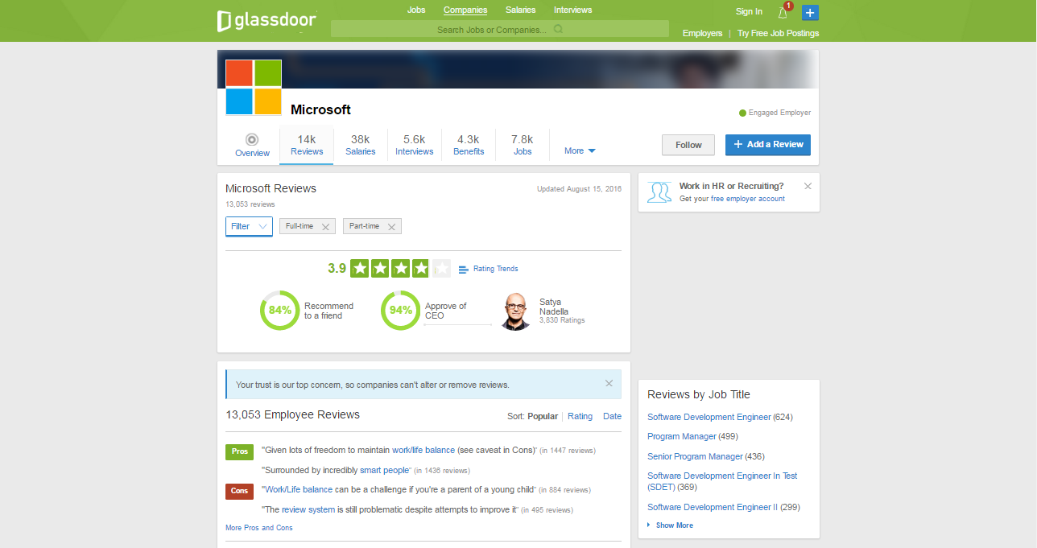

## CareerBliss.com

* Advantages:
  + Intuitive design.
  + Information is scientifically generalized.
  + Does not require an account.
* Disadvantages:
  + Only accept US based company.
  + Lacking in information.
  + Does not support Vietnamese.

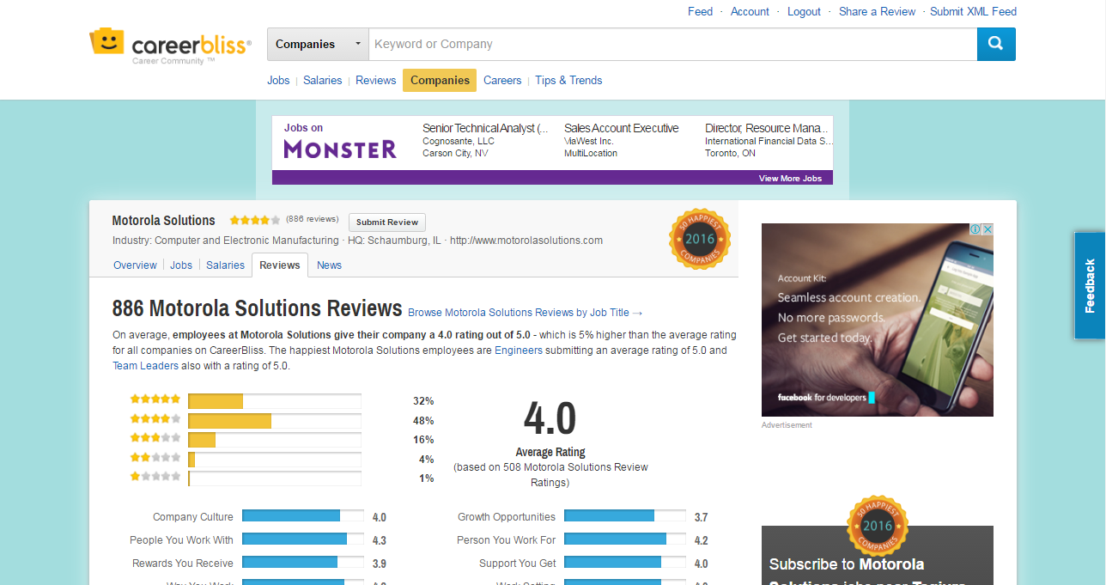

1. PROJECT PLAN

# Project Overview

## Project Description

1. Project Description

|  |  |  |  |
| --- | --- | --- | --- |
| **Project Code** | CRW | **Contract Type** | None |
| **Customer** | FPT University | **2nd Customer** | None |
| **Project Level** | Group | **Project Rank** | None |
| **Application Type** | Website | **Project Manager** | Trần Quốc Hưng |
| **Project Category** | Development | **Business Domain** | Review |

## Scope and Purpose

### Project Purpose

CRW helps it user to have an insider’s view from employees/ex-employees’ review on any available company. Everyone who comes to this website would be able to read and create reviews as they like, be it about the profession’s upbringing, the opinions of those who worked there, or just simply how well the employee would be treated.

### Scope of Project

This project contains: Requirement Analysis, Design, Coding and Testing (Unit Test, Integration Test, and System Test).

### The functions of Project

These are the functions of our project:

**Guest Modules**

* **Register**: Guests can register an account and login to use all features of CRW.
* **Login:** Guests can login with their account to use CRW.
* **Search Review**: Guests can search for reviews with company name; which will display all of reviews relate to the inputted information.
* **Post Review:** Guest can post new reviews with Basic Company Info, Basic Job Info, Personal Input and Ratings. Depending on the type of Review (Company or Salary & Benefits) some information required may vary
* **Filter**: Guests can filter to show reviews by Company or by Salary & Benefit. CRW will display reviews related to the selected option.

**User Modules**

* **Logout**: Users can logout of their account to exit CRW.
* **Search Review**: Users and guest can search for reviews with Job Title and/or Company Name; which will display all of reviews relate to the inputted information.
* **Filter**: Users can filter to show reviews by Company or by Salary & Benefit. CRW will display reviews related to the selected option.
* **Follow**: Users can follow a company to get notification whenever a new review related to said company is posted.
* **Review:**
  + **Post New:** Users can post new reviews with Basic Company Info, Basic Job Info, Personal Input and Ratings. Depending on the type of Review (Company or Salary & Benefits) some information required may vary.
  + **Update Information**: User can update information of his/her posted reviews.
  + **Comment**: Users can comment on a review to discuss with other users.
  + **Bookmark**: Users can bookmark a review for later use.
  + **Upvote**: Users can upvote a review of their preference, which will affect the search review result’s order.
  + **Report:** User can report a review which violate regulation to a moderator.
* **Profile:**
  + **Change Password:** Users can change password for security purposes.
  + **Update Profile:** Users can update Basic Profile Info.
  + **Manage Posted Review:** Users can update or remove his/her review(s). Additionally, users can view their review’s state of approval.
  + **Manage Bookmarked Review:** Users can view or remove his/her bookmarks.
  + **Notification:** Users can receive notification from various event .

**Moderator Modules**

Moderators inherits all User Modules and have the following additional features:

* **Manage User:**
  + **Search User:** Moderators can search by username and the system will display simple information on said user’s account (name, email, phone number)
  + **Deactive/Active User:** Moderator can set user’s account to deactive or active.
* **Manage Review:** 
  + **Edit Review Status:** Moderators can set status of a review between Waiting, Approved and Denied.
  + **Edit Review Highlight Status:** Moderators can set Highlightstatus of a review, which put that review to the top of the company page.
* **Manage Reports:** 
  + **View Reports:** Moderators can view reports of a review and decide whether they should act upon it.
  + **Warn Reported Reviewer:** Moderators can send a warning to the owner of a reported review.

**Admin Modules**

Admin inherits all Moderator Modules and have the following additional features:

* **Manage Moderator:**
  + **Promote / Demote Moderator:** Admin can set user’s account role to mod or user.

## Assumptions and Constraints

1. Assumptions and Constraints

|  |  |  |
| --- | --- | --- |
| No. | Description | Note |
| Assumptions | | |
|  | Customer reviewers will get seven days to approve a milestone document. If no comments are received within this time period, it will be considered as approved. | External Interfaces |
| Constraints | | |
|  | This project must be completed and delivered before 26/08/2016 | Schedule |
|  | In doing project processing, PM must submit report (include 6 reports) on certain date. | Schedule |
|  | Software Requirement Specification Document and Project Plan must be completedwithin10dayssince12/05/2016  **Deadline**: 24/05/2016 | Schedule |
|  | Design Document (include Architecture Design, Screen Design, Database Design) must be completed within 15 days since 24/05/2016  Deadline:13/06/2016 | Schedule |
|  | Integration TestPlan (include test plan and test case…) must be completed within16dayssince21/06/2016  **Deadline**: 26/07/2016 | Schedule |
|  | Completed coding activity and have unit test result within 18.5 days since 27/06/2016  **Deadline**: 21/07/2016 | Schedule |
|  | Deliver report about User manual, software package and installation guide on 2 days since 18/08/2016  **Deadline**: 19/08/2016 | Schedule |
|  | Complete all of document and application before finishingtheprojecton23/08/2016 | Schedule |
|  | Project contains 5 members | Resource |

## Project Objective

### Standard Objective

1. Standard Objective 1

|  |  |  |  |  |
| --- | --- | --- | --- | --- |
| Metrics | Unit | Committed | Re-committed | Note |
| Start Date |  | 09/05/2016 |  |  |
| End Date |  | 26/06/2016 |  |  |
| Duration | Day | 80 |  |  |
| Team Size | Person | 5 |  |  |
| Billable Effort | Person-day | 400 |  | 1 Person-day = 5 hours |
| Calendar Effort | Person-day | 400 |  | 1 Person-day = 5 hours |
| Effort Usage | % | 100 |  | 1 Person-day = 5 hours |

1. Standard Objective 2

|  |  |  |  |
| --- | --- | --- | --- |
| Metrics | Unit | Project Target | Formula |
| Customer Satisfaction | Point | 9.5 | = Total points of customer survey.  Max is 100, min is 0. |
| Leakage | Wdef/mm | 5 | = No of Wdef Defects detected after delivery for acceptance test of a product/Product size |
| Effort Efficiency | % | 95 | = (Billable effort/Calendar effort)*100% |
| Timeliness | % | 100 | = (No of deliverable delivered on time/ Total # of deliverables delivered)*100% |

### Specific Objectives

1. Specific Objectives

|  |  |  |
| --- | --- | --- |
| Metrics | Unit | Project Target |
| Training technology: MEAN, Bootstrap, jQuery, AngularJS | Person-day | 8 |
| Execute group review | Person-day | 5 |
| Training requirements, process before coding | Person-day | 6 |

## Critical Dependencies

1. Critical Dependencies

|  |  |  |  |
| --- | --- | --- | --- |
| No | Dependency | Expected delivery date | Note |
|  | This project must be completed and delivered to FPT University. | 23/08/2016 |  |
|  | Project Plan and SRS must be completed and delivered to Supervisor. | 20/05/2016 |  |
|  | User manual, Software Package and Installation Guide must be completed and delivered to Supervisor and FPT University. | 16/08/2016 |  |

## Project Risk

PM identifies risks in the Risk Management Plan. The document is updated to trigger each milestone, each event also. The document is updated weekly by the PM, Risk Management Plan will be notified to all of the stakeholders affected. Status of risk is reported to supervisor at Project Milestones Report.

1. Risk Management Plan

|  |  |  |  |  |  |  |  |  |  |  |  |
| --- | --- | --- | --- | --- | --- | --- | --- | --- | --- | --- | --- |
| # | Risk | Category | Root Cause | Triggers | Avoidance plan | Contigency plan | Fallback plan | Risk Owner | Probability | Impact | Status |
| 1 | Conflict among team members | People | Team member doesn't understand each others | Has issue inside team | Plan some team buildings to improve teammate | Have a meeting to resolve conflict problem |  | **LamNS** | **Low** | **High** | **Resolved** |
| 2 | Requirement is changed after project is started | Process | SRS not good (not realistic, not feasible, not meet customer needs) | Customer (user) make change request. Or project team cannot develop the system as desciption in SRS. | Requirement should be paid a lot of attention. SRS should be reviewed carefully by PM and the supervisor. | With each requirement changes, the project team should have a meeting to analyze the change requests and take actions. | Re-estimate and update plan. | **HungTQ** | **High** | **High** | **Resolved** |
| 3 | Team member do not meet the deadline | Process | Undisciplined and habit of team member, loose management | Have a deadline | Setting rule and punishment for not meeting the deadline: lost money and named at meeting minute. | Punish the member who didn't meet the deadline. Working over time. | Ask for help from outsider, supervisors. | **HungTQ** | **Medium** | **Medium** | **Resolved** |
| 4 | Inability to verify/validate products against requirements. | Process |  | Inability to verify/validate products against requirements. | Print out the result to check by normal eyes. Debug into code to see how the code is running | Print out the result to check by normal eyes. Debug into code to see how the code is running | Ask for help from supervisors | **DangT** | **Medium** | **Low** | **Resolved** |
| 5 | The server has defective parts. | Technology | Defective power supply… | Server is down | Ensure the supplier provides with the adequate warranties. | Replace or fix the defective parts quickly. | Buy a new one. | **LamNS** | **Low** | **Medium** | **Open** |
| 6 | Delivery project doesn’t meet requirement | Process | Team member not understand requirement | Can't delivery project | Teamlead have to review sourcecode and follow requirement | Fix in next version | Extend dealine | **HungTQ** | **Medium** | **Medium** | **Resolved** |

# Project Development Approach

## Project Process

Process of this project is performed follow to Software Development Process of FPT Software.

### FPT Software Process Model



1. FPT Software Process Model

The software lifecycle is broken into cycles, each cycle working on a new generation of the product. The FPT Software process divides one development cycle in six consecutive phases:

1. Initiation phase
2. Definition phase
3. Solution phase
4. Construction phase
5. Transition
6. Termination

### Project Life Cycle

Basing on FPT Software process and real-world project, we decided to divide the project into 4 phases: Initiation, Solution, Construction, and Termination:

* **Initiation Phase:** This is the explanatory phase of the project. Project objective and description is described at this stage. The purpose of this phase is to collect and understand business requirements, detail the project plan and agree upon a high level statement of work. Our primary objectives are complete project identification and project plan. After these are completed, the project is checked against the following criteria:
  + Identify business functions of the system
  + Determining the scope, conditions and limitations of the project
  + List the main functions of the system
  + List one or more suitable architecture for the system
  + Identify project risks
  + Complete Report #1
* **Solution Phase**: In this phase, the architecture of the system is designed. The goal is to translate requirements and specification into a technical solution to produce Technical Design, create basic test plan.
  + Our *primary objectives* are completeRequirement Specification, Architecture Design and Database Design.
  + Finally, the plan must be provided (including estimates of cost and time) for the construction phase. The plan must ensure proper and accurate based on experience.
  + Complete Report #2 and Report #3
* **Construction Phase**: This is the longest phase of a project life cycle.
  + In this phase, all functions of the system will be installed. The installation will be divided into small stages, each stage of the installation a few functions. The results of each phase will be the release of the module function can be executed.
  + Construction and improvement of products until the final product is ready to deliver to the user. During this phase, all the components and other features of the application is developed and integrated into the product.
  + Excute test to ensure the quality of final product.
  + This phase emphasizes the resource management and control operations to optimize cost, time and quality.
  + Complete Report #4 and #5.
* **Termination Phase**: This is the final phase in the life cycle of a project.
  + Complete Report #6
  + Complete software package.
  + Their products will be deployed to the client. The feedback received during the transfer process will be recorded and put on the new functional requirements or functionality enhancements in the next version of the product.
  + Phase transfer switch also includes the training system and the new system for the user.

## Requirement Change Management

1. Requirement Change Management

|  |  |
| --- | --- |
| **Who logs the change request?** | Any team members |
| **Who reviews the change request?** | PM or who is PM assign |
| **Who approves the change request?** | PM by default. PTL if:   * Changes to project scope * Changes in delivery plan of project deliverables * Changes to assignment for key roles (PM, PTL) |

## Quality Management

### Defect Prevention Strategy

1. Defect Prevention Strategy

|  |  |  |
| --- | --- | --- |
| Item (Process/Product) | Strategy | Expected Benefits |
| Requirement missing | List up all of requirement into SRS document. | 10–20% reduction in defect injection rate and about 2% improvement in productivity |
| Careless mistake in Design Document Format/Template wrong | After designing, QA will review Document Format base on checklist review design | Improvement in quality as overall defect removal efficiency will improve; some benefits in productivity as defects will be detected early |
| Use wrong template | Have a meeting to disseminate all template that is used in this project for all member | All member will use right template when do document |
| Coding application does not match with User Requirement | Develop team must study about Requirement/Design within 1 weeks since project is assigned.  PM and PTL has responsibility to review task results and explain User Requirement for Develop team | Coding Application match with User Requirement. |

### Review Strategy

1. Review Strategy

|  |  |  |  |  |
| --- | --- | --- | --- | --- |
| Review Item | Reviewer | Review Type | Review Method | Completion Criteria |
| Project Plan | PM,QA, Supervisor | Group review | Use checklist and Self-review |  |
| Project Schedule |  | Group review | Use checklist |  |
| CM Plan | PM,QA, Supervisor | One-person review | Use checklist |  |
| Business analysis and requirements specification document, Use Case catalog | Self-review, PM,QA Supervisor | Group review and One-person review | Use checklist |  |
| Design document, object model | PM,QA, Supervisor | One-person Review |  |  |
| Stage plans |  | One-person review | Self-review and use checklist |  |

### Unit Testing Strategy

1. Unit Testing Strategy

|  |  |  |  |  |
| --- | --- | --- | --- | --- |
| Item to be Unit Tested | Unit Test Type | Unit Test Technique | Tool Used | Unit Test Completion Criteria |
| Source Code | White-Box Test | Using unit test case and test script | None | - Number of UTC/KLOC: 20 UTC/KLOC |

### Integration Testing Strategy

1. Integration Testing Strategy

|  |  |  |  |  |
| --- | --- | --- | --- | --- |
| Item to be Integration Tested | Integration Test Type | Integration Test Technique | Tool Used | Completion Criteria |
| Do test by flow of functions and items which have concern each other | Black-Box Test |  | Checklist, Boundary | - Number of UTC/KLOC: 20  - Number of defects/KLOC: 2-3 |

### System Testing Strategy

1. System Testing Strategy

|  |  |  |  |  |
| --- | --- | --- | --- | --- |
| Item to be System Tested | System Test Type | System Test Technique | Tool Used | Completion Criteria |
| Test whole system | Black-Box Test |  | None | -Number of UTC/KLOC: 60  -Number of defects/KLOC: 4-6 |

### Estimates of Defects to be detected

1. Estimates of Defects to be detected

|  |  |  |  |
| --- | --- | --- | --- |
| Review/Testing Stage | Targeted No. of Defects to be detected | % of Defects to be detected | Basic for Estimation |
| Requirements review | 10 | 7% | Referenced to similar project estimations |
| Design review | 15 | 11% | Referenced to similar project estimations |
| Code review | 30 | 22% | Referenced to similar project estimations |
| Unit Test | 50 | 38% | Referenced to similar project estimations |
| Integration Test | 15 | 11% | Referenced to similar project estimations |
| System Test | 10 | 7% | Referenced to similar project estimations |
| User Acceptance Test | 5 | 4% | Referenced to similar project estimations |
| Total | 135 | 100% |  |

### Measurements Program

1. Measurements Program

|  |  |  |  |
| --- | --- | --- | --- |
| Data to be collected | Purpose | PIC | When |
| Size: No. of KLOC | Achieve target | PM | At the end of stages |
| Effort: No. person-day | Monitor and controlling team member to keep plan | Team members | Daily |
| Quality: No. defects detected | Managing product’s quality | Reviewer  Tester | Right after the review/test |
| Schedule | Monitor and controlling software developing processing keep plan | PM | Weekly and at the end of stages |

# Estimation

## Size

This project is performed and must complete all requirements from teacher and FPT University. So size of our project is in Capstone Project limit.

## Effort

1. Effort

|  |  |  |  |  |  |
| --- | --- | --- | --- | --- | --- |
|  | Initiation | Solution | Construction | Termination | Total |
| Effort(person/day) | 60 | 140 | 155 | 45 | **400** |
| Total % budgeted Effort Usage (%) | 100 | 100 | 100 | 100 |  |

## Schedule

### Project Milestone & Deliverables

1. Project Milestone & Deliverables

|  |  |  |  |  |
| --- | --- | --- | --- | --- |
| No | Stage | Committed Delivery date | Description of Deliverable | Delivery media |
| Initiation | | | | |
|  | Develop project idea | 10/05/2016 | Project goals and scope defined, milestone description defined, resource committed | Commit to GitHub |
|  | Q&A Management Sheet | 13/05/2016 | Criteria: Documentation reviewed |
|  | Project Plan | 19/05/2016 | Criteria: Documentation reviewed |
|  | User Requirements Specification | 18/05/2016 | Criteria: Documentation reviewed |
|  | Progress Report 1 | 20/05/2016 | Completed Report 1 |
| Solution | | | | |
|  | Demo & Prototype | 01/06/2016 | Completed Demo and Prototype | Commit to GitHub |
|  | SRS | 24/05/2016 | Criteria: Documentation reviewed |
|  | Architecture Design | 07/06/2016 | Criteria: Documentation reviewed |
|  | Screen Design | 01/06/2016 | Criteria: Documentation reviewed |
|  | Database Design | 27/05/2016 | Criteria: Documentation reviewed |
|  | Class/Component Design | 13/06/2016 | Criteria: Documentation reviewed |
|  | Progress Report 2 | 14/06/2016 | Completed Progress Report 2 |
|  | Test Plan | 20/06/2016 | Criteria: Documentation reviewed |
|  | Test Case | 26/06/2016 | Criteria: Documentation reviewed |
|  | Progress Report 3 | 27/06/2016 | Completed Progress Report 3 |
| Construction | | | | |
|  | Complete Coding and Unit Test | 21/07/2016 | Source code  Acceptance criteria: Product unit tested | Commit to GitHub |
|  | Progress Report 4 | 22/07/2016 | Completed Progress Report 4 |
|  | Testing | 10/08/2016 | Excuted test and completed Test Report |
|  | Quality Control | 15/08/2016 | Criteria: Documentation reviewed |
|  | Progress Report 5 | 16/08/2016 | Completed Progress Report 5 |
| Termination | | | | |
|  | Progress Report 6 | 19/08/2016 | Completed Progress Report 6 | Commit to GitHub |
|  | Submit the last document and CD source code | 19/08/2016 | Final Documents and Source Code |
|  | Presentation for Capstone Project | 26/08/2016 | Criteria: Completed |
|  | Project Complete | 26/08/2016 | Criteria: Completed |

## Resource

Specified as in the section V.2. Project Team

## Infrastructure

1. Infrastructure

|  |  |  |  |
| --- | --- | --- | --- |
| Item | Description | Expected Availability by | Note |
| Development Environment | | | |
| Operating System | Window 10 (64 bit) |  |  |
| Browser | Chrome 52  Firefox 46  Internet Explorer 11 |  |  |
| Technology | | | |
| Development language | Javascript |  |  |
| Database | MongoDB 3.2 |  |  |
| Hardware Requirement | | | |
| Hardware Configuration | 4GB workspaces on server |  |  |
| Equipment & Tools | | | |
| Source Version Control | GitHub Desktop Program | Definition stage |  |
| Task Tracking | MS Project Professional 2015 | Initiation stage |  |
| SRS | Microsoft Office Word 2015  Microsoft Office Excel 2015  Microsoft Office Visio 2015 | Initiation stage |  |

## Training Plan

1. Training Plan

|  |  |  |  |
| --- | --- | --- | --- |
| Training Area | Participants | Duration | Waiver Criteria |
| Technical | | | |
| MEAN stack, Express, MongoDB | DangT  HungNV | 1 week | Mandatory |
| AngularJS, jQuery | DangT  QuangNN | 1 week | Mandatory |
| Bootstrap | LamNS  HungTQ | 1 week |  |
| Process | | | |
| Quality system |  | 3 hours | If already trained |
| Configuration management |  | 2 hours | If already trained for CC. For others, on-the-job training |
| Group review |  | 2 hours | If already trained |
| Defect prevention |  | 2 hours | Mandatory |

## Finance

Because this project is non-business, it is a Capstone Project at FPT University. So we do not estimate about finance.

# Project Organization

## Organization Structure

1. Organize Structure

## Project Team

1. Project Team Description

|  |  |  |  |  |  |
| --- | --- | --- | --- | --- | --- |
| Role | Responsibility | Full name | Effort (%) | Start date | End date |
| PM | Have overall responsibility of the project:  - Project planning and scheduling  - Task assignment and tracking processing  - Review documents  - Reporting to supervisor | Trần Quốc Hưng | 40 | 09/05/2016 | 26/08/2016 |
| PTL | PTL is responsible for the technical project execution | Trần Đăng | 100 | 09/05/2016 | 26/08/2016 |
| Developer #1 | - Study technique (C#, MVC, AngularJS, etc.) | Nguyễn Việt Hùng | 100 | 09/05/2016 | 26/08/2016 |
| Developer #2 | - Support coding functions and modules of system. | Trần Quốc Hưng | 10 | 09/05/2016 | 26/08/2016 |
| Programmer #3 | - Support coding functions and modules of system. | Nguyễn Nhật Quang | 50 | 09/05/2016 | 26/08/2016 |
| Test Leader | - Create test plan, test case, test report, quality report  - Execute test. | Nguyễn Sơn Lâm | 50 | 15/06/2016 | 26/08/2016 |
| Tester | - Support creating test plan, test case, test report, quality report  - Execute test. | Nguyễn Nhật Quang | 50 | 15/06/2016 | 26/08/2016 |
| Design  Leader | - Create screen design, prototype  - Review design of others member | Trần Quốc Hưng | 50 | 09/05/2016 | 26/08/2016 |
| Designer #1 | - Support creating screen design | Nguyễn Sơn Lâm | 50 | 09/05/2016 | 26/08/2016 |

1. Human Resource Budget Allocation

|  |  |  |  |  |  |  |  |  |  |  |  |  |  |  |  |  |
| --- | --- | --- | --- | --- | --- | --- | --- | --- | --- | --- | --- | --- | --- | --- | --- | --- |
| Role | Name | W2-May | W3-May | W4-May | W1-Jun | W2-Jun | W3-Jun | W4-Jun | W5-Jun | W1-Jul | W2-Jul | W3-Jul | W4-Jul | W1-Aug | W2-Aug | Total (pd) |
| PM  Designer  Dev | Trần Quốc Hưng | 100% | 100% | 100% | 100% | 100% | 100% | 100% | 100% | 100% | 100% | 100% | 100% | 100% | 100% | 80 |
| PTL  Developer | Trần Đăng | 100% | 100% | 100% | 100% | 100% | 100% | 100% | 100% | 100% | 100% | 100% | 100% | 100% | 100% | 80 |
| Developer | Nguyễn Việt Hùng | 100% | 100% | 100% | 100% | 100% | 100% | 100% | 100% | 100% | 100% | 100% | 100% | 100% | 100% | 80 |
| Test Leader  Designer | Nguyễn Sơn Lâm | 100% | 100% | 100% | 100% | 100% | 100% | 100% | 100% | 100% | 100% | 100% | 100% | 100% | 100% | 80 |
| Tester  Developer | Nguyễn Nhật Quang | 100% | 100% | 100% | 100% | 100% | 100% | 100% | 100% | 100% | 100% | 100% | 100% | 100% | 100% | 80 |

|  |  |  |  |  |  |  |  |  |  |  |  |  |  |  |  |  |
| --- | --- | --- | --- | --- | --- | --- | --- | --- | --- | --- | --- | --- | --- | --- | --- | --- |
| Total |  |  |  |  |  |  |  |  |  |  |  |  |  |  |  | 400 |

## External Interfaces

1. External Interfaces

|  |  |  |  |
| --- | --- | --- | --- |
| Department | Contact Person  (name-position) | Contact Address  (email, phone no.) | Responsibility |
| Teacher | Bùi Đình Chiến | ChienBD@fpt.edu.vn | - Review and accept documents during project  - Review and accept products of the project.  - Resolve escalated issues and receive project reports. |
| Training Department |  | acad.hn@fpt.edu.vn | Management course of student |

# Communications And Reporting

1. Communication and Reporting Plan

|  |  |  |  |  |
| --- | --- | --- | --- | --- |
| Communication Type | Method /  Tool | Schedule | Information | Participants  Responsible |
| Project Task Tracking | | | | |
| Task scheduling | MS Project Professional 2015 | At the beginning of every stage and weekly  Rescheduling as necessary | Schedule | PM |
| Task assignment | MS Project Professional 2015 | Weekly | Task assignment | PTL |
| Task status reporting | Daily Report | Daily |  | Team members |
| Project Meeting | | | | |
| Kick-off Meeting | Face to face | Initiation stage | Project Introduction  Project plan review  Risk  Stakeholders | PM  Team member |
| Project Progress Review Meetings | Face to face | Weekly and on event | Project status report Open issues, risks and changes  Improvement discussion |  |
| Milestone Meetings | Face to face | 5 days after the completion of stages: Definition, Solution and Construction | Objective review  Performance Evaluation (quality, schedule, effort)  Causal analysis  Project plan for next stage | PM  QA  Team member  Supervisor |
| Supervisor Communication and Reporting | | | | |
| Documentation, Information Sharing | GitHub Desktop Program | When available | All project documentation and information | PM  Team Members  QA |
| Project Report | FSoft and FU standard format | 5pm Monday, Weekly | Project status report  Issue requiring clarifications  Escalation | PM |
| Project Meetings with supervisor | Face to face | 9h10, Thursday, Weekly | As above | PM |
| Requirement gathering and clarification | Face to face meeting | During requirement analysis phase | As in Q&A list | PM |
| Review Project Plan & Project schedule | By attend project meeting | Significant changes to WO, Project Plan and Project schedule (scope, objectives Organization, Human Resources, major milestone, deliverables) |  | PM |
| Project Progress Review | Email, Operation meeting at Group and Division level | Weekly | Project status report  Issue requiring clarifications  Escalation | PM |
| Project Milestone Review | Email  Project milestone review meeting | End of every stage | Project objective review  Evaluate project performance (quality, schedule, effort)  Causal analysis  Project plan for next stage | PM |

1. CONFIGURATION MANAGEMENT PLAN

# Configuration Management Process

## CI Identification & Naming convention

1. CI Identification & Naming convention

|  |  |  |
| --- | --- | --- |
| CSCI | Configuration Items | Naming Conventions |
| Project Management | PP | CRW_ProjectPlan_v<x.x>_[language code] |
| CM Plan | CRW_CMPlan_v<x.x>_[language code] |
| Introduction (Report 1) | CRW_Introduction_v<x.x>_[language code] |
| Risk Management | CRW_Risk Management_[language code] |
| Project Schedule | CRW_Project_Schedule_v<x.x>_[language code] |
| Examination | CRW_Examination_v<x.x>_[language code] |
| Requirement & Design | Software Requirement Specification | CRW_SoftwareRequirementSpecification_v<x.x>_[language code] |
| Screen Design | CRW_ScreenDesign_v<x.x>_[language code] |
| Architecture Design | CRW_ArchitectureDesign_v<x.x>_[language code] |
| Class Design | CRW_ClassDesign_v<x.x>_[language code] |
| Data Design | CRW_DataDesign_v<x.x>_[language code] |
| Prototype | Prototype_v<x.x> |
| Build | Source code | CRW_SourceCode_v<x.x>_Tested/Untested |
| Test Plan | CRW_TestPlan_v<x.x>_[language code] |
| System Test Case | CRW_SystemTest Case_v<x.x>_[language code] |
| Integration Test Case | CRW_IntegrationTest_v<x.x>_[language code] |
| Unit Test Case | CRW_UnitTestCase_v<x.x> _[language code] |
| Defect Log Management | CRW_DefectLogManagement_v<x.x>_[language code] |
| Component Test Case | CRW_ComponentTestCase_v<x.x> _[language code] |
| Test report | CRW_TestReport_v<x.x>_[language code] |
| Process | Guideline_Name of guideline | CRW_Guideline_Title of guideline |
| Coding Convention/Standard | CRW_Coding convention |
| Checklist_Name of checklist | Checklist_Title of checklist_v<x.x> |
| Document type | MS Word | ***.docx |
| MS Project | ***.mpp |
| MS Excel | ***.xls |

## Project Infrastructure

1. Project Infrastructure

|  |  |  |  |
| --- | --- | --- | --- |
| Tool | Version | Purpose | Note |
| GitHub Desktop Program | 1.8 | For source control |  |
| Microsoft Visio | 2015 | For visual diagrams |  |
| Microsoft Project | 2015 | For project management |  |
| Astah | 7.0 | For visual diagrams |  |
| Visual Paradigm | 13.2 | For visual diagrams |  |
| Microsoft Office | 2015 | For documentation and presentation |  |
| Hosted Redmine | [Online] | For bug control |  |
| MongoDB | 2015 | For development |  |
| Adobe Illustrator | CS6 | For design |  |
| Sublime Text | 3.0 | For development |  |

## CI Baseline Procedure

### For Document

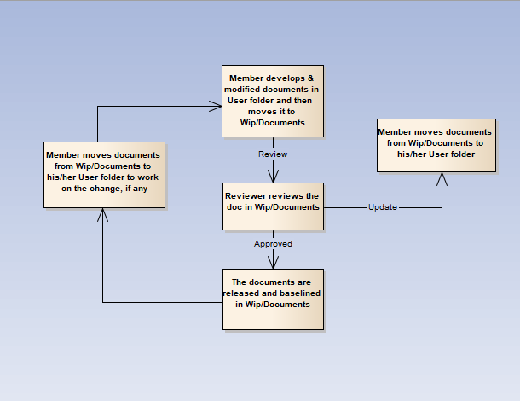

1. CI Baseline Procedure for document

### For Source code

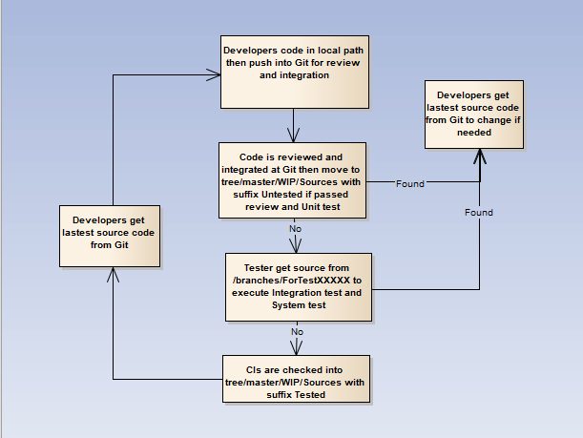

1. CI Baseline Procedure for source code

## Project Baseline schedule

1. Project Baseline schedule

|  |  |  |  |
| --- | --- | --- | --- |
| No. | Baseline Name | When Baseline | PIC |
| 1 | Initiation | Within 7 days from approval. It is mandatory requirement that CI versions in Startup baseline are to be archived in separate folders in Archive area | Project team |
| 2 | Solution | When Architectural design v1.0 is released | Project team |
| 3 | Construction | At the end of development phase | Project team |
| 4 | Termination | After the final release. It is mandatory requirement that CI versions in Wrap-up baseline to be archived in separate folders in Archive area | Project team |

# Directory structure & Access right

## Promotion Area

1. Promotion Area

|  |  |
| --- | --- |
| Area | Purpose |
| Develop Area | Area for different users to store his/her own items |
| Review Area | For storing review-ready items.  Reviewer gets review-pending items from this area |
| Test Area | Applicable for Source items.  For storing items passed Unit Test and Code Review |
| Release Area | For storing items ready for release and all released versions of items  Users get the latest items from this area |
| Archive Area | For archiving all released versions of each CI  Archive area is a protected area for project baselines where all the CIs cannot be changed by any member |

## Directory structure

1. Directory structure

|  |  |  |  |  |
| --- | --- | --- | --- | --- |
| Main Folder | Sub Folder | Purpose | Map to Area | Access right |
| Project Directory : | | | | |
| WIP | Documents | Documents of Requirements, Design, Test, … | Release + Review | Full: PM, CC  Modify: PIC  Read: All |
| Deliverables | Document of Reports (1->6) to deliver | Release + Review | Full: PM, CC  Modify: PIC  Read: All |
| Meeting minutes | Store project meeting minutes, including meeting minutes with customer | Release + Review | Full: PM, CC  Modify: All |
| Plan | Store Proposal, Estimation, Project Plans, Project schedule, Task list | Review + Release | Full: PM, CC  Modify: PTL  Read: All |
| Record | Store project records, divided into  Review: include Review, Test and Inspection records  Change request  Acceptance  Mails  ... | NA | Full: PM, CC  Modify: All |
| Sources | Store VSS file of Source code | Archive | Refer to VSS directory |
| Users | User’s working area, store user’s items | Develop | Full: PM, CC  Modify: User  Read: All |
| Reference | Processes | Store Documents and Other materials/data supplied by customer or those support software development and production operation in the project… | Release | Full: PM, CC  Modify: PIC  Read: All |
| Templates | Store Guidelines/Standards/Forms/Templates/Checklist specified for the project usage | Release | Full: PM, CC  Modify: PIC  Read: All |
| Final |  | Final document | Release | Full right: Project QAs  Read right: All |

## Access right control

Access right of non-project team members (ex: auditor, external reviewer, etc…) must have permission gotten from PM and granted in the pre-defined duration, then revoked at expiry date by CC. As soon as a member is out of the project, his or her access right is revoked also.

The access right is reviewed frequently and updated by CC at August 19th, 2016.

After project asset is approved by QA at project closure time, PM informs to Technique Team to revoke the access right of all project team members. If someone has a request for data reference, audit, etc…, he or she must get the approval of authorized person, normally Team Leader, and then send the request to Technique Team. Technique Team is responsible for implementing such kind of requests.

## Version numbering rule

### For Documents

The version level is maintained as numbered identifier with two components

1.1

Revision

Version

The original version will be numbered 0.1. Subsequent revisions will be numbered 0.2, 0.3. The release version will be 1.0.

**Version number**, which appears to the left of the decimal. It changes only when the core architecture of the item changes. For example: when an item is completely overhauled, with substantial internal changes, the version 1.0 would become version 2.0.

**Revision number,** which appears to the right of the decimal. It changes when existing content is changed, but the overall structure and flow of the item remains the same. The normal sequence of revision is 1.1, 1.2 and so on.

### For Software Source Files:

Software executable and support files are generally identified by name and version number, such as “Main DB v1.1.a”. The scratch edition will be 1.0. The version numbering scheme consists of three components:

1.1a

Revision

Version

Update

view

**Version number**, which appears to the left of the decimal. It changes only when the core architecture of the software item changes, as when moving from one area of the development tool to another, when an application is completely overhauled, or the user interface changes fundamentally. In this case, version 1.1a would become version 2.0.

**Revision number**, which appears to the right of the decimal. It changes when new features, functionality or other content are added or significantly changed. In normal case, the core architecture or user interface have been extended or limited in some manner. The most common reason for changing the revision number is when adding a new module or other functionality to the software. The normal sequence of revision is 1.0, 1.1, and 1.2 and so on.

**Update level** is appended or incremented when the only change to the software item is to correct one or more defects, without the addition of any new functionality. Version 1.1 would become v1.1a, v1.1b and so on. This updating is over ridden when a combination revision, involving bug fixes and new feature additions, is performed. In such a case, the software revision number is incremented and any update indicator is dropped, as in v1.1b to v1.2.

## Other CM rules

**Rule for deliverables releases:** When a member releases any WP, he/ she must review carefully, takes review from other member and has clearly comment.

**Rule for changing document:** When a member wants to develop or modify documents, he must copy the documents from Documents folder to User folder to work on the change (if any), then merge it to Document folder with another version and has clearly comment. Members are absolutely not allowed to edit directly on the Project folder.

1. SOFTWARE REQUIREMENTS SPECIFICATIONS

# Overall Description

## System Overview



1. System Overview Diagram

## Use Case Diagram

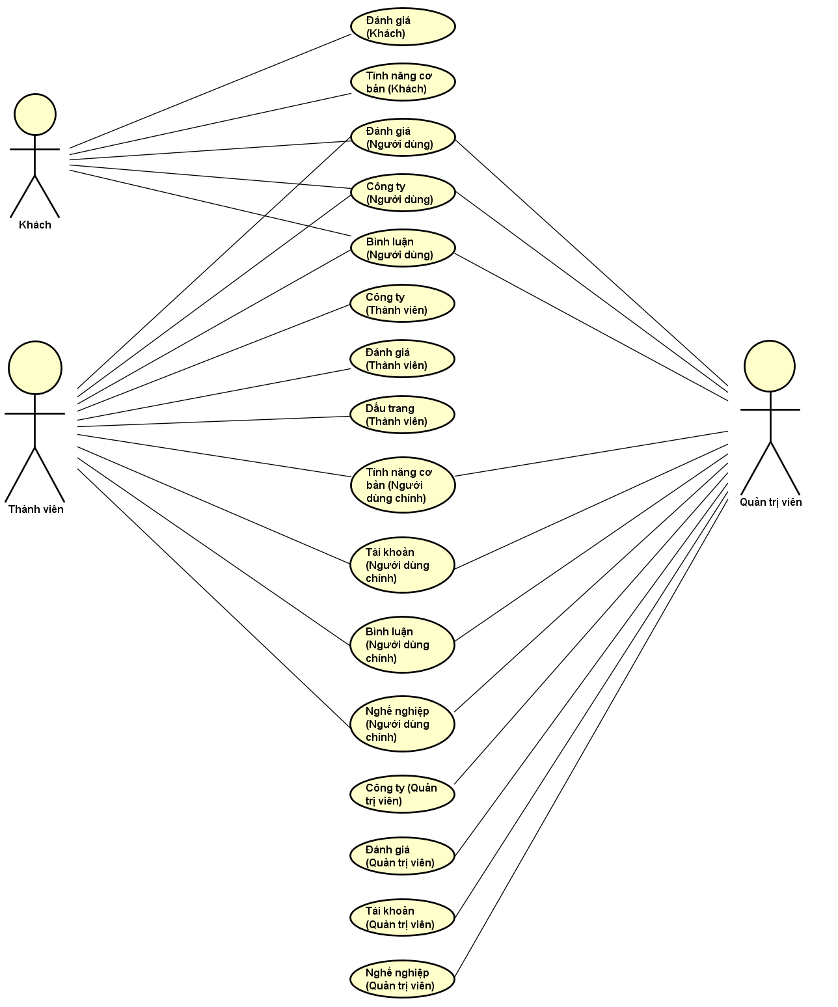

1. Use Case Digram

## Product Features

1. List system’s function via Use Case, grouped by actor(s) of said function. Common functions are grouped seperately.

|  |  |  |  |
| --- | --- | --- | --- |
| Use Case No. | Function Group | Function | Note |
| User | | | |
| UC001 | Review | View Reviews |  |
| UC002 | Search Review |  |
| UC003 | Company | View Companies |  |
| UC004 | Search Company |  |
| UC005 | Comment | View Comments |  |
| Guest | | | |
| UC006 | Common | Register |  |
| UC007 | Review | Create Review (Anonymous) |  |
| Member/Moderator/Administrator | | | |
| UC008 | Common | Login |  |
| UC009 | Logout |  |
| UC010 | View Notifications |  |
| UC011 | Receive Notification |  |
| UC012 | Account | View Account Info |  |
| UC013 | Update Account Info |  |
| UC014 | Change Password |  |
| UC015 | Forgot Password |  |
| UC016 | Comment | Add Comment |  |
| UC017 | Remove Comment |  |
| UC018 | Add Company |  |
| Member | | | |
| UC019 | Company | Manage Followed Companies |  |
| UC020 | Follow Company |  |
| UC021 | Unfollow Company |  |
| UC022 | Review | Manage Reviews |  |
| UC023 | Create Review |  |
| UC024 | Update Review |  |
| UC025 | Remove Review |  |
| UC026 | Report Review |  |
| UC027 | Upvote Review |  |
| UC028 | Remove Review Upvote |  |
| UC029 | Bookmark | Manage Bookmarks |  |
| UC030 | Add Bookmark |  |
| UC031 | Remove Bookmark |  |
| Moderator/Administrator | | | |
| UC032 | Company | Manage Companies |  |
| UC033 | Update Company |  |
| UC034 | Remove Company |  |
| UC035 | Review | Manage Reports |  |
| UC036 | Approve Report |  |
| UC037 | Account | Manage Accounts |  |
| UC038 | Search Account |  |
| UC039 | Change Account State |  |

## User Characteristics

CRW allows users to search, view or create any amount of reviews for a company they have previously worked at. All reviews will be proof-readed by Administrators and Moderators to maintain its integrity before being posted on CRW. Other users may follow and comment on the review, even report if needed. As such, users are given the chance to have a more generalized view on a company.

CRW has 3 objective users:

* Guest: Non-registered user, can use basic function such as Search Review, View Review, etc...
* Member: Has registered an account, can use most functions available, such as Login, Logout, Manage Reviews, Report, Follow Company, etc…
* Admin: Has access to all functions avilable with an Administration control panel for Manage Account, Manage Reports, Manage Company, etc.

## User Documentation

User Guide: Provide detailed explanation about the system, screens and guide users how to use all features of CRW.

## Assumption

* Receive the guidance and great support of the overseeing teacher.
* None of the members got severely ill during the software development process.
* No device failure during the software development process.
* All reports and tasks meet their deadline.
* No internal conflict during the whole project.

## Entity-Relationship Model

### Entity-Relationship Diagram

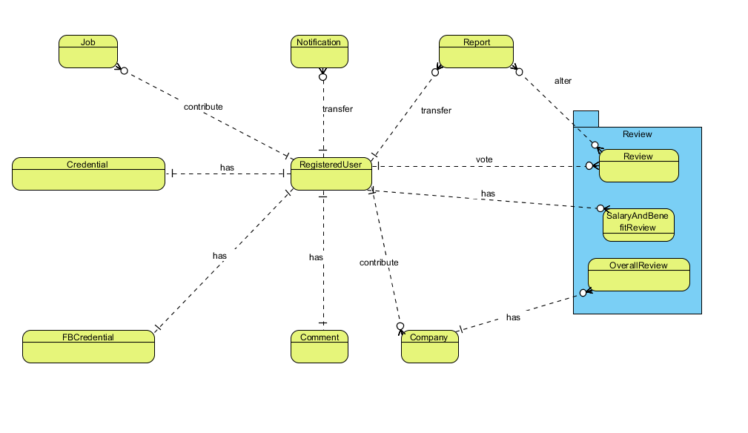

1. Entity-Relationship Diagram

### Entity Detail

1. *RegisteredUser*
2. List of RegisteredUser properties

|  |  |  |  |  |
| --- | --- | --- | --- | --- |
| No | Name | Type | Required | Description |
|  | name | String | Y | Displayed name |
|  | profileImageURL | String | N | Account’s avatar |
|  | signInType | String | Y | User’s sign in method |
|  | description | String | N | Account’s personal info |
|  | roles | String | Y | Account type (Member, Administrator) |
|  | accState | String | Y | Account state (Active, Banned) |

1. *Email-PasswordInformation*
2. List of Email-PasswordInformation properties

|  |  |  |  |  |
| --- | --- | --- | --- | --- |
| No | Name | Type | Required | Description |
|  | email | String | Y | Account’s email |
|  | password | String | N | Password if account is registered with an email |
|  | salt | String | N | Support password encryptions |
|  | resetPasswordToken | String | N | Token used in password reset |
|  | resetPasswordExpires | Date | N | Token’s expire date |

1. *3rdPartyInformation*
2. List of 3rdPartyInformation properties

|  |  |  |  |  |
| --- | --- | --- | --- | --- |
| Số | Thuộc tính | Kiểu dữ liệu | Bắt buộc | Mô tả |
|  | id | String | Y | 3rd party ID |
|  | accessToken | String | Y | 3rd party access token |
|  | email | String | Y | User’s email used by 3rd party |
|  | name | String | Y | Displayed name in 3rd party application |
|  | first_name | String | Y | First name in 3rd party application |
|  | last_name | String | Y | Last name in 3rd party application |
|  | picture | GridFS | Y | 3rd party account’s avatar |

1. *Company*
2. List of Company properties

|  |  |  |  |  |
| --- | --- | --- | --- | --- |
| No | Name | Type | Required | Description |
|  | _id | ObjectID | Y | An identifier for companies |
|  | name | String | Y | Company’s name |
|  | alias | Array | N | Company’s aliases |
|  | avatar | String | Y | Company’s avatar |
|  | description | String | Y | Company’s detailed info |
|  | website | String | Y | Company’s website |
|  | personnelSize | String | N | Company’s personnel size |
|  | companyType | String | N | Company’s type |
|  | hq | String | N | Company’s headquarter |
|  | founded | Date | N | Company’s founded date |
|  | industry | String | N | Company’s industrial focus |
|  | contact | String | N | Company’s contact |
|  | photo | Array | N | Company’s photoes |
|  | video | Array | N | Company’s video |
|  | state | String | Y | Company’s current state (Active, Locked) |
|  | overallRating | Number | N | Company’s overall rating |
|  | averageRating | Number | N | Company’s average rating |

1. *OverallReview*
2. List of Overall Review properties

| No | Name | Type | Required | Description |
| --- | --- | --- | --- | --- |
|  | _id | ObjectID | Y | An identifier for reviews |
|  | userID | ObjectID | Y | An identifier for reviewers |
|  | stayAnonymous | Boolean | N | Anonimity of the reviewer |
|  | highlight | Boolean | N | State of reviews’ highlight |
|  | title | String | Y | Review’s title |
|  | job | Array | Y | Reviewer’s profession |
|  | isJobCurrent | String | N | Reviewer’s current state of profession |
|  | jobLength | String | N | Reviewer’s time soent as stated profession |
|  | contract | String | N | Reviewer’s type of contract |
|  | pros | String | N | Review’s pros regarding the company |
|  | cons | String | N | Review’s cons regarding the company |
|  | supplement | String | N | Additional information regarding the company |
|  | rating | Number | Y | Review’s grading of the company |
|  | upvoteCount | Number | Y | Review’s amount of upvote |
|  | upvoteUser | Array | Y | Review’s upvoter pool |
|  | state | String | Y | Review’s state (Approved, Rejected, Pending) |
|  | lastUpdated | Date | N | Review’s last updated date |

1. *SalaryAndBenefitReview*
2. List of SalaryAndBenefitReview properties

|  |  |  |  |  |
| --- | --- | --- | --- | --- |
| No | Name | Type | Required | Description |
|  | _id | ObjectID | Y | An identifier for reviews |
|  | userID | ObjectID | Y | An identifier for reviewers |
|  | stayAnonymous | Boolean | N | Anonimity of the reviewer |
|  | highlight | Boolean | N | State of reviews’ highlight |
|  | title | String | Y | Review’s title |
|  | job | Array | Y | Reviewer’s profession |
|  | isJobCurrent | String | N | Reviewer’s current state of profession |
|  | jobLength | String | N | Reviewer’s time soent as stated profession |
|  | contract | String | N | Reviewer’s type of contract |
|  | basePay | Number | Y | Reviewer’s base payment |
|  | payRaise | Number | N | Reviewer’s adjusted payment raise |
|  | cashBonus | Number | N | Reviewer’s bonus in cash |
|  | profitSharing | Number | N | Reviewer’s share in profit |
|  | healthRating | Number | N | Reviewer’s grading on healthcare policies |
|  | opportunity Rating | Number | N | Reviewer’s grading on promotion opportunity |
|  | parentalLeaveRating | Number | N | Reviewer’s grading on parental leave policies |
|  | timeOffRating | Number | N | Reviewer’s grading on paid leave policies |
|  | pensionRating | Number | N | Reviewer’s grading on pension policies |
|  | supplement | String | N | Additional information regarding the company |
|  | upvoteCount | Number | Y | Review’s amount of upvote |
|  | upvoteUser | Array | Y | Review’s upvoter pool |
|  | state | String | Y | Review’s state (Approved, Rejected, Pending) |
|  | lastUpdated | Date | N | Review’s last updated date |

1. *Job*
2. List of Job properties

|  |  |  |  |  |
| --- | --- | --- | --- | --- |
| No | Name | Type | Required | Description |
| 1. 1 | _id | ObjectID | Y | An identifier for professions |
|  | name | String | Y | Profession’s name |

1. *Comment*
2. List of Comment properties

|  |  |  |  |  |
| --- | --- | --- | --- | --- |
| No | Name | Type | Required | Description |
|  | _id | ObjectID | Y | An identifier for comments |
|  | userID | ObjectID | Y | Comment’s writer |
|  | content | String | Y | Comment’s content |

1. *Notification*
2. List of Notification properties

|  |  |  |  |  |
| --- | --- | --- | --- | --- |
| No | Name | Type | Required | Description |
|  | _id | ObjectID | Y | An identifier for notifications |
|  | message | String | Y | Notification’s content |
|  | targetLink | String | Y | Notification’s hyperlink |
|  | hasRead | Boolean | Y | Notification’s state (Read, Not Read) |

1. *Report*
2. List of Report properties

|  |  |  |  |  |
| --- | --- | --- | --- | --- |
| No | Name | Type | Required | Description |
|  | _id | ObjectID | Y | An identifier for reports |
|  | user | ObjectID | Y | An identifier for reporters |
|  | content | String | Y | Report’s content |
|  | isConsidered | String | Y | Report’s state |

1. *BookmarkList*
2. List of BookmarkList properties

|  |  |  |  |  |
| --- | --- | --- | --- | --- |
| No | Name | Type | Required | Description |
|  | _id | ObjectID | Y | An identifier for bookmark |
|  | userID | ObjectID | Y | An identifier for user |
|  | reviewID | ObjectID | Y | An identifier for review |

1. *FollowList*
2. List of FollowList properties

|  |  |  |  |  |
| --- | --- | --- | --- | --- |
| No | Name | Type | Required | Description |
|  | _id | ObjectID | Y | An identifier for bookmark |
|  | userID | ObjectID | Y | An identifier for user |
|  | companyID | ObjectID | Y | An identifier for company |

# Functional Specification

## Business rule

1. List of required business rules

|  |  |
| --- | --- |
| No | Definition |
|  | Search textbox must have more than 2 letters input |
|  | Name must not be blank |
|  | Name must not be more than 100 characters |
|  | When User access to a non-existing page, CRW display message “Trang không tồn tại” |
|  | Email format must be followed |
|  | Guest cannot view Registered User info |
|  | Displayed date format must be DD/MM/YYYY |
|  | Date input format is datetime |
|  | Number is rounded up to 2 decimal numbers |
|  | Money unit must be VND |
|  | Guest can create a review without logging in |
|  | Password must have more than 8 characters, 1 uppercase, 1 special, 1 number |
|  | File size limit is 1 mb |

## Use Case

### User

Reviews

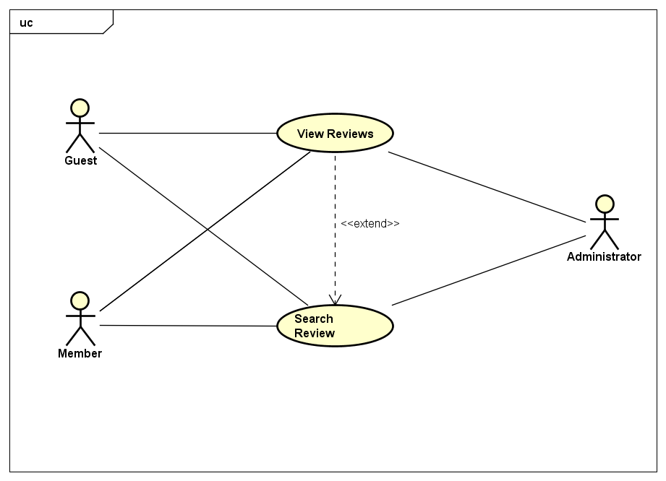

1. Review Group Use Cases for User

**UC001 - View Reviews**

1. Detailed Use Case description and User - System interactions

|  |  |  |  |  |
| --- | --- | --- | --- | --- |
| Use Case ID | | UC001 | Version | 1.0 |
| Use Case Name | | View Reviews | | |
| Author | | Trần Đăng | **Last Updated** | 26/05/2016 |
| Primary Actor | | User | **Secondary Actor** |  |
| Description | | Display review in details | | |
| Preconditions | | Review exists  Currently at Detailed Company screen | | |
| Postconditions | | Detailed Review screen is displayed | | |
| Normal Flow | | | | |
| Step | **Actor** | **Action** | | |
| 1 | User | Click on Review’s title | | |
| 2 | System | Display Detailed Review screen with the chosen review’s info | | |
|  | | | | |
| Alternative Flows | | | | |
| AT1 | User access the Review through an existing URL | | | |
| Step | **Actor** | **Action** | | |
| 1 | User | Open the URL for the Review | | |
| 2 | System | Display Detailed Review screen with the chosen review’s info | | |
|  | | | | |
| Exceptions: None | | | | |
| Priority | | High | | |
| Frequency of Use | | High | | |
| Business Rules | | B4 | | |

**UC002 – Search Review**

1. Detailed Use Case description and User - System interactions

|  |  |  |  |  |
| --- | --- | --- | --- | --- |
| Use Case ID | | UC002 | Version | 1.0 |
| Use Case Name | | Search Review | | |
| Author | | Trần Đăng | **Last Updated** | 26/05/2016 |
| Primary Actor | | User | **Secondary Actor** |  |
| Description | | Search for review of a company, possibily with filter | | |
| Preconditions | | Currently at Detailed Company screen | | |
| Postconditions | | Matching reviews are displayed | | |
| Normal Flow | | | | |
| Step | **Actor** | **Action** | | |
| 1 | User | Input search query | | |
| 2 | System | Display Detailed Company screen with matching result | | |
|  | | | | |
| Alternative Flows | | | | |
| AT1 | After step 2, User wants to sort the search result | | | |
| Step | **Actor** | **Action** | | |
| 3 | User | Click on “Đánh giá”, “Thời gian” or “Ủng hộ” | | |
| 4 | System | Sort the search result accordingly | | |
|  | | | | |
| AT2 | After step 2, User wants to limit the amount of search result on a single page | | | |
| Step | **Actor** | **Action** | | |
| 3 | User | Click on the dropdown list next to “Hiển thị” and choose 5, 10 or 20 | | |
| 4 | System | Limit the search result accordingly | | |
|  | | | | |
| Exceptions: None | | | | |
| EX1 | At step 2, if there’s no possible result | | | |
| Step | **Actor** | **Action** | | |
| 2 | System | Display message “0 kết quả cho từ khóa [search query]” | | |
| Priority | | High | | |
| Frequency of Use | | High | | |
| Business Rules | | B1 | | |

Company

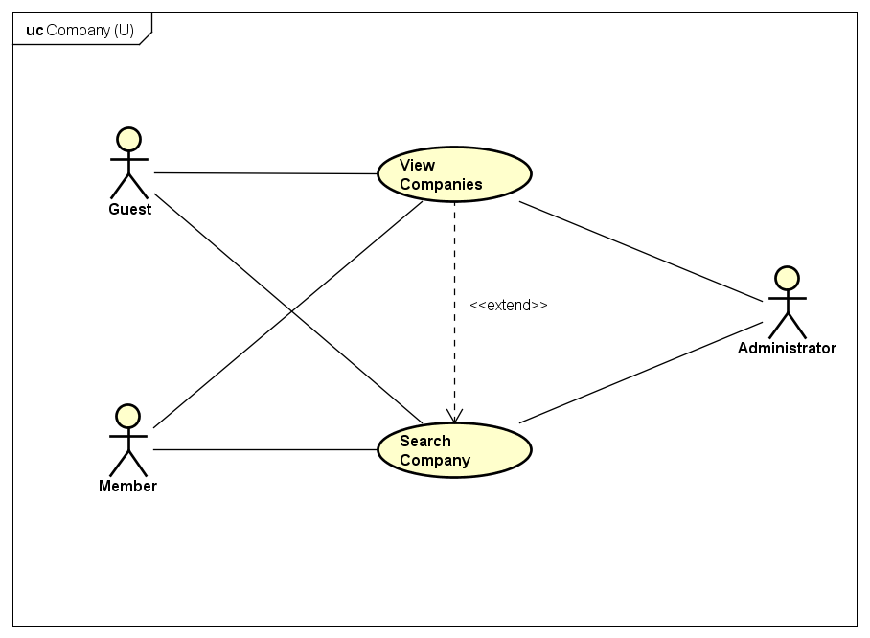

1. Company Group Use Cases for User

**UC003 - View Companies**

1. Detailed Use Case description and User - System interactions

|  |  |  |  |  |
| --- | --- | --- | --- | --- |
| Use Case ID | | UC003 | Version | 1.0 |
| Use Case Name | | View Companies | | |
| Author | | Trần Đăng | **Last Updated** | 26/05/2016 |
| Primary Actor | | User | **Secondary Actor** |  |
| Description | | Displays a company’s information | | |
| Preconditions | | Company exists | | |
| Postconditions | | Detailed Company screen is displayed | | |
| Normal Flow | | | | |
| Step | **Actor** | **Action** | | |
| 1 | User | Click on Company’s name | | |
| 2 | System | Display Detailed Company screen with the chosen company’s info | | |
|  | | | | |
| Alternative Flows | | | | |
| AT1 | User access the Company through an existing URL | | | |
| Step | **Actor** | **Action** | | |
| 1 | User | Open the URL for the Company | | |
| 2 | System | Display Detailed Company screen with the chosen company’s info | | |
|  | | | | |
| Exceptions: None | | | | |
| Priority | | High | | |
| Frequency of Use | | High | | |
| Business Rules | | B4 | | |

**UC004 – Search Company**

1. Detailed Use Case description and User - System interactions

|  |  |  |  |  |
| --- | --- | --- | --- | --- |
| Use Case ID | | UC004 | Version | 1.0 |
| Use Case Name | | Search Company | | |
| Author | | Trần Đăng | **Last Updated** | 26/05/2016 |
| Primary Actor | | User | **Secondary Actor** |  |
| Description | | Search for a company, possibily with filter | | |
| Preconditions | | Searchbar is clicked upon | | |
| Postconditions | | Matching companies are displayed | | |
| Normal Flow | | | | |
| Step | **Actor** | **Action** | | |
| 1 | User | Input search query | | |
| 2 | System | Display Search Result screen with matching result | | |
|  | | | | |
| Alternative Flows | | | | |
| AT1 | After step 2, User wants to sort the search result | | | |
| Step | **Actor** | **Action** | | |
| 3 | User | Click on “Đánh giá” or “Tên công ty” | | |
| 4 | System | Sort the search result accordingly | | |
|  | | | | |
| AT2 | After step 2, User wants to limit the amount of search result on a single page | | | |
| Step | **Actor** | **Action** | | |
| 3 | User | Click on the dropdown list next to “Hiển thị” and choose 8, 16 or 32 | | |
| 4 | System | Limit the search result accordingly | | |
|  | | | | |
| Exceptions | | | | |
| EX1 | At step 2, if there’s no possible result | | | |
| Step | **Actor** | **Action** | | |
| 4 | System | Display message “0 kết quả cho từ khóa [search query]” | | |
| Priority | | High | | |
| Frequency of Use | | High | | |
| Business Rules | | B1 | | |

Comment

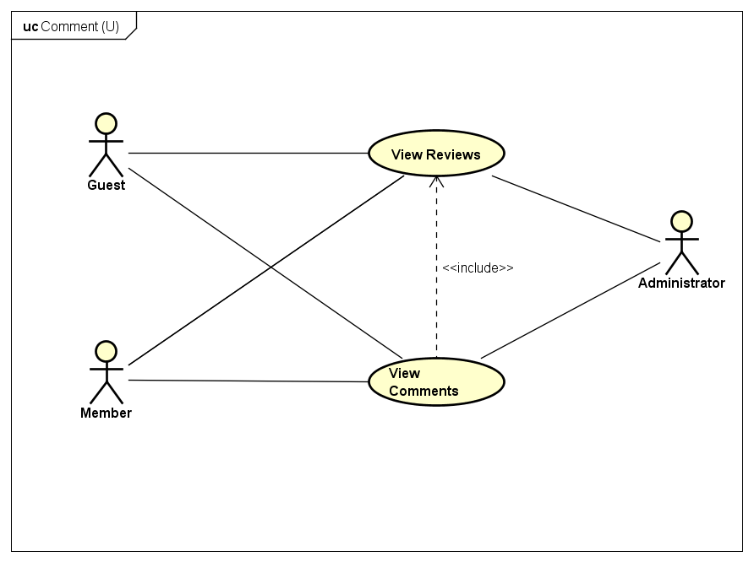

1. Comment Group Use Cases for User

**UC005 – View Comments**

1. Detailed Use Case description and User - System interactions

|  |  |  |  |  |
| --- | --- | --- | --- | --- |
| Use Case ID | | UC005 | Version | 1.0 |
| Use Case Name | | View Comments | | |
| Author | | Trần Đăng | **Last Updated** | 26/05/2016 |
| Primary Actor | | User | **Secondary Actor** |  |
| Description | | Display comments from a review | | |
| Preconditions | | Review exists  Currently at Detailed Company screen | | |
| Postconditions | | Comments are displayed | | |
| Normal Flow | | | | |
| Step | **Actor** | **Action** | | |
| 1 | User | Click on Review’s title | | |
| 2 | System | Display Detailed Review screen with the chosen review’s comments | | |
|  | | | | |
| Alternative Flows | | | | |
| AT1 | User access the Review through an existing URL | | | |
| Step | **Actor** | **Action** | | |
| 1 | User | Open the URL for the Review | | |
| 2 | System | Display Detailed Review screen with the chosen review’s comments | | |
|  | | | | |
| Exceptions: None | | | | |
| Priority | | Low | | |
| Frequency of Use | | High | | |
| Business Rules | | B4 | | |

### Guest

Common

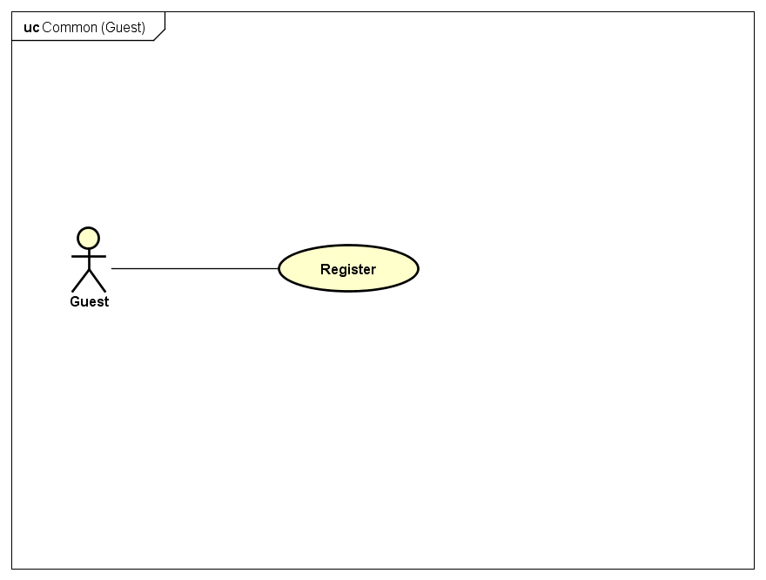

1. Common Group Use Cases for Guest

**UC006 – Register**

1. Detailed Use Case description and Guest - System interactions

|  |  |  |  |  |  |
| --- | --- | --- | --- | --- | --- |
| Use Case ID | | UC006 | Version | 1.0 | |
| Use Case Name | | Register | | | |
| Author | | Trần Đăng | **Last Updated** | 26/05/2016 | |
| Primary Actor | | Guest | **Secondary Actor** |  | |
| Description | | Register to become a Member of CRW | | | |
| Preconditions | | None | | | |
| Postconditions | | Account is successfully created | | | |
| Normal Flow | | | | | |
| Step | **Actor** | **Action** | | | |
| 1 | Guest | Click on “Đăng nhập” on the navbar | | | |
| 2 | System | Show Login screen | | | |
| 3 | Guest | Click on “Đăng ký ngay” on the screen | | | |
| 4 | System | Show Register screen | | | |
| 5 | Guest | Input info as required and click “Đăng ký” | | | |
| 6 | System | Create and save a new account with inputted info in the System | | | |
|  | | | | |
| Alternative Flows | | | | | |
| AT1 | At step 3 Guest choose to register with a Facebook account | | | | |
| Step | **Actor** | **Action** | | | |
| 3 | Guest | Click on “Đăng nhập với tài khoản Facebook” | | | |
| 4 | System | Opens a new popup window redirecting to Facebook authentication | | | |
| 5 | Guest | Accept request for account linking | | | |
| 6 | System | Save account info in the System | | | |
|  | | | | | |
| Exceptions | | | | | |
| EX1 | At step 5 Guest did not input all required info | | | | |
| Step | **Actor** | **Action** | | | |
| 6 | System | Display error messages accordingly and halt guest progress until cleared | | | |
| Priority | | High | | | |
| Frequency of Use | | Normal | | | |
| Business Rules | | B2, B3, B5, B11, B12 | | | |

Reviews

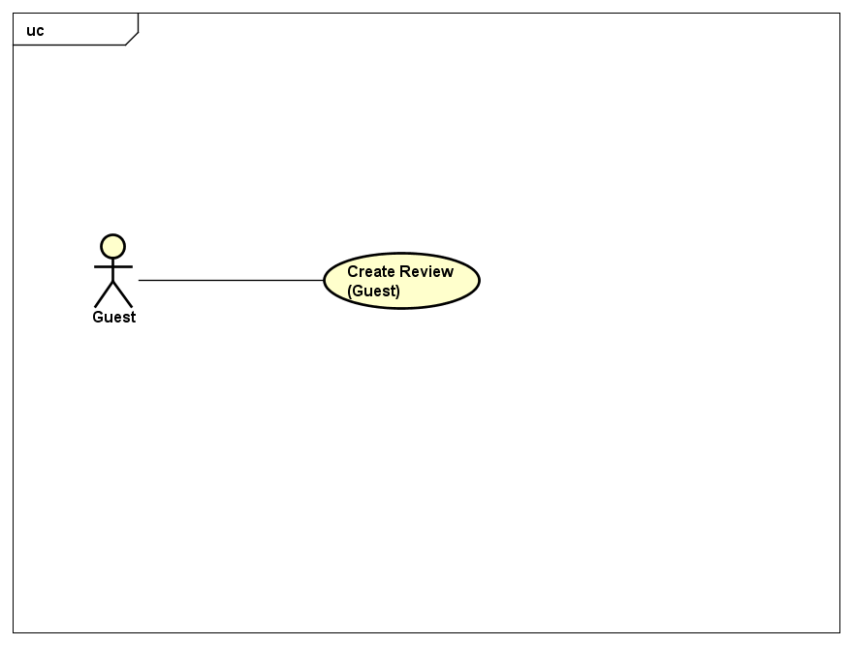

1. Review Group Use Cases for Guest

**UC007 – Create Review (Anonymous)**

1. Detailed Use Case description and Guest - System interactions

|  |  |  |  |  |
| --- | --- | --- | --- | --- |
| Use Case ID | | UC007 | Version | 1.0 |
| Use Case Name | | Create Review (Anonymous) | | |
| Author | | Trần Đăng | **Last Updated** | 26/05/2016 |
| Primary Actor | | Guest | **Secondary Actor** |  |
| Description | | Post a review to CRW without an account | | |
| Preconditions | | Currently at Detailed Company screen | | |
| Postconditions | | Review is saved in the system | | |
| Normal Flow | | | | |
| Step | **Actor** | **Action** | | |
| 1 | Guest | Click on “+ Đánh giá” | | |
| 2 | System | Display Create Review page | | |
| 3 | Guest | Input info as required and click “Gửi đánh giá” | | |
| 4 | System | Save the review into the system with pending state | | |
|  | | | | |
| Alternative Flows: None | | | | |
|  | | | | |
| Exceptions | | | | |
| EX1 | At step 3 Guest did not input all required info | | | |
| Step | **Actor** | **Action** | | |
| 4 | System | Display error messages accordingly and halt guest progress until cleared | | |
|  | | | | |
| Priority | | Normal | | |
| Frequency of Use | | High | | |
| Business Rules | | B11 | | |

### Member/Administrator

Common

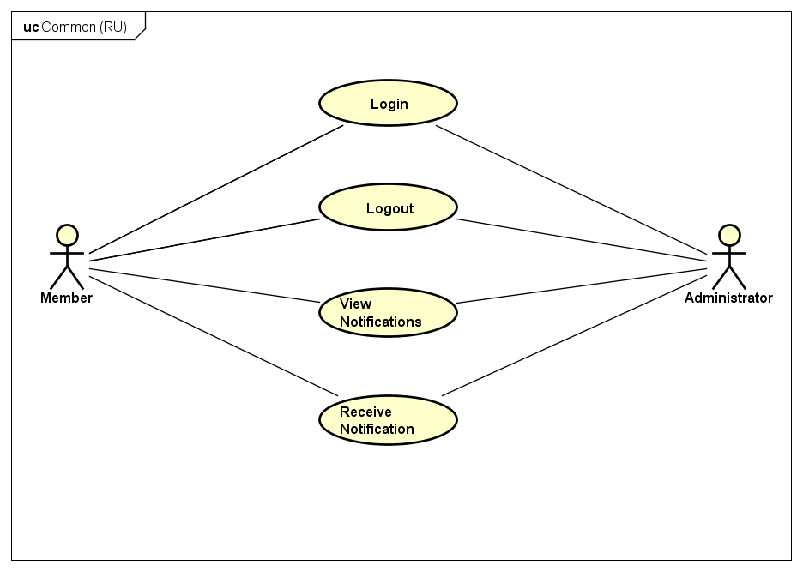

1. Common Group Use Cases for Registered User

**UC008 – Login**

1. Detailed Use Case description and Registered User - System interactions

|  |  |  |  |  |
| --- | --- | --- | --- | --- |
| Use Case ID | | UC008 | Version | 1.0 |
| Use Case Name | | Login | | |
| Author | | Trần Đăng | **Last Updated** | 26/05/2016 |
| Primary Actor | | RU | **Secondary Actor** |  |
| Description | | Login to an account on CRW | | |
| Preconditions | | Currently not logged in | | |
| Postconditions | | Login successfully | | |
| Normal Flow | | | | |
| Step | **Actor** | **Action** | | |
| 1 | RU | Click on “Đăng nhập” on navbar | | |
| 2 | System | Show Login screen | | |
| 3 | RU | Input account credentials as required and click “Đăng nhập” | | |
| 4 | System | Log the RU in with the account of choice | | |
|  | | | | |
| Alternative Flows | | | | |
| AT1 | At step 3 RU Login by Facebook account | | | |
| Step | **Actor** | **Action** | | |
| 3 | RU | Click on “Đăng nhập với tài khoản Facebook” | | |
| 4 | System | Log the RU in with the account of choice | | |
|  | | | | |
| Exceptions | | | | |
| EX1 | At step 3 RU did not input all required info | | | |
| Step | **Actor** | **Action** | | |
| 4 | System | Display error messages accordingly and halt RU progress until cleared | | |
|  | | | | |
| EX2 | At step 3 RU’s account is banned | | | |
| Step | **Actor** | **Action** | | |
| 4 | System | Display error messages accordingly and halt RU progress until cleared | | |
|  | | | | |
| EX3 | At step 3 of AT1 RU’s account is banned | | | |
| Step | **Actor** | **Action** | | |
| 4 | System | Display error messages accordingly and halt RU progress until cleared | | |
| Priority | | High | | |
| Frequency of Use | | High | | |
| Business Rules | | None | | |

**UC009 – Logout**

1. Detailed Use Case description and Registered User - System interactions

|  |  |  |  |  |
| --- | --- | --- | --- | --- |
| Use Case ID | | UC009 | Version | 1.0 |
| Use Case Name | | Logout | | |
| Author | | Trần Đăng | **Last Updated** | 26/05/2016 |
| Primary Actor | | RU | **Secondary Actor** |  |
| Description | | Logout from current account on CRW | | |
| Preconditions | | Logged in | | |
| Postconditions | | Logout successfully | | |
| Normal Flow | | | | |
| Step | **Actor** | **Action** | | |
| 1 | RU | Click on “Đăng xuất” on navbar’s dropdown menu | | |
| 2 | System | Log the RU out of the account | | |
|  | | | | |
| Alternative Flows: None | | | | |
|  | | | | |
| Exceptions: None | | | | |
| Priority | | High | | |
| Frequency of Use | | High | | |
| Business Rules | | None | | |

**UC010 – View Notifications**

1. Detailed Use Case description and Registered User - System interactions

|  |  |  |  |  |
| --- | --- | --- | --- | --- |
| Use Case ID | | UC010 | Version | 1.0 |
| Use Case Name | | View Notifications | | |
| Author | | Trần Đăng | **Last Updated** | 26/05/2016 |
| Primary Actor | | RU | **Secondary Actor** |  |
| Description | | View all notifications sent by system | | |
| Preconditions | | Logged in | | |
| Postconditions | | Notification screen is displayed | | |
| Normal Flow | | | | |
| Step | **Actor** | **Action** | | |
| 1 | RU | Click on “Thông báo” on navbar | | |
| 2 | System | Show Notification screen | | |
|  | | | | |
| Alternative Flows | | | | |
| AT1 | After step 2 RU wants to see the notification’s trigger | | | |
| Step | **Actor** | **Action** | | |
| 3 | RU | Click on “Tới đường dẫn đính kèm” | | |
| 4 | System | Display the screen accordingly | | |
|  | | | | |
| Exceptions | | | | |
| EX1 | After step 1 RU has yet to receive any notification | | | |
| Step | **Actor** | **Action** | | |
| 2 | System | Show message “Bạn chưa có thông báo nào” | | |
| Priority | | Normal | | |
| Frequency of Use | | High | | |
| Business Rules | | None | | |

**UC011 – Receive Notification**

1. Detailed Use Case description and Registered User - System interactions

|  |  |  |  |  |
| --- | --- | --- | --- | --- |
| Use Case ID | | UC011 | Version | 1.0 |
| Use Case Name | | Receive Notification | | |
| Author | | Trần Đăng | **Last Updated** | 26/05/2016 |
| Primary Actor | | RU | **Secondary Actor** |  |
| Description | | Receive a notification from System | | |
| Preconditions | | Logged in | | |
| Trigger | | Followed company has a new review  RU’s review has a new comment  RU’s review is warned by AD | | |
| Postconditions | | Receive Notification successfully | | |
| Normal Flow | | | | |
| Step | **Actor** | **Action** | | |
| 1 | RU | Register to the Receive Notification pool | | |
| 2 | System | Send Notification to RU in the Receive Notification pool when triggered | | |
|  | | | | |
| Alternative Flows: None | | | | |
|  | | | | |
| Exceptions: None | | | | |
| Priority | | Normal | | |
| Frequency of Use | | High | | |
| Business Rules | | None | | |

Account

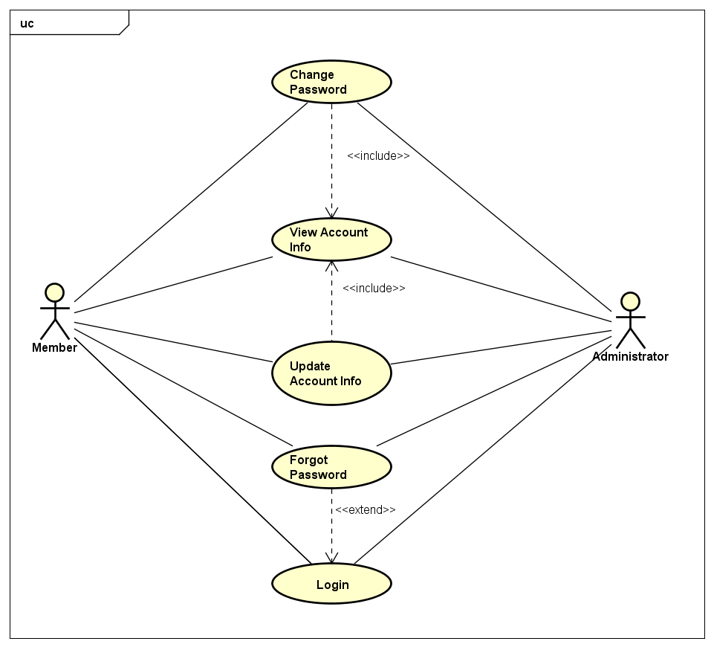

1. Account Group Use Cases for Registered User

**UC012 – View Account Info**

1. Detailed Use Case description and Registered User - System interactions

|  |  |  |  |  |
| --- | --- | --- | --- | --- |
| Use Case ID | | UC012 | Version | 1.0 |
| Use Case Name | | View Account Info | | |
| Author | | Trần Đăng | **Last Updated** | 26/05/2016 |
| Primary Actor | | RU | **Secondary Actor** |  |
| Description | | Display RU’s info | | |
| Preconditions | | Logged in  Currently at Detailed Review|Manage Accounts (AD) screen | | |
| Postconditions | | Detailed Account Info screen is displayed | | |
| Normal Flow | | | | |
| Step | **Actor** | **Action** | | |
| 1 | RU | Click on a RU’s name | | |
| 2 | System | Return RU’s info and available actions depending on RU’s access level | | |
|  | | | | |
| Alternative Flows | | | | |
| AT1 | User access the RU’s Detailed Account Info through an existing URL | | | |
| Step | **Actor** | **Actor** | | |
| 1 | User | Open the URL for the RU’s Detailed Account Info | | |
| 2 | System | Return RU’s info and available actions depending on RU’s access level | | |
|  | | | | |
| Exceptions: None | | | | |
| Priority | | High | | |
| Frequency of Use | | Normal | | |
| Business Rules | | B6 | | |

**UC013 – Update Account Info**

1. Detailed Use Case description and Registered User - System interactions

|  |  |  |  |  |
| --- | --- | --- | --- | --- |
| Use Case ID | | UC013 | Version | 1.0 |
| Use Case Name | | Update Account Info | | |
| Author | | Trần Đăng | **Last Updated** | 26/05/2016 |
| Primary Actor | | RU | **Secondary Actor** |  |
| Description | | Change RU’s account info | | |
| Preconditions | | Logged in  Currently at RU’s own Detailed Account Info screen | | |
| Postconditions | | RU’s account is successfully updated in the system | | |
| Normal Flow | | | | |
| Step | **Actor** | **Action** | | |
| 1 | RU | Make changes as needed and click on “Cập nhật” | | |
| 2 | System | Save changes into the system | | |
|  | | | | |
| Alternative Flows | | | | |
|  | | | | |
| Exceptions: None | | | | |
| EX1 | At step 1 changes did not fulfill system’s requirement | | | |
| Step | **Actor** | **Action** | | |
| 2 | System | Display error messages accordingly and halt RU progress until cleared | | |
| Priority | | High | | |
| Frequency of Use | | Normal | | |
| Business Rules | | None | | |

**UC014 – Change Password**

1. Detailed Use Case description and Registered User - System interactions

|  |  |  |  |  |
| --- | --- | --- | --- | --- |
| Use Case ID | | UC014 | Version | 1.0 |
| Use Case Name | | Change Password | | |
| Author | | Trần Đăng | **Last Updated** | 26/05/2016 |
| Primary Actor | | RU | **Secondary Actor** |  |
| Description | | Change the account password | | |
| Preconditions | | Logged in  Currently at RU’s own Detailed Account Info screen | | |
| Postconditions | | RU’s account password is successfully updated in the system | | |
| Normal Flow | | | | |
| Step | **Actor** | **Action** | | |
| 1 | RU | Make changes as needed and click on “Lưu mật khẩu” | | |
| 2 | System | Save changes into the system | | |
|  | | | | |
| Alternative Flows: None | | | | |
|  | | | | |
| Exceptions | | | | |
| EX1 | At step 1 changes did not fulfill system’s requirement | | | |
| Step | **Actor** | **Action** | | |
| 2 | System | Display error messages accordingly and halt RU progress until cleared | | |
|  | | | | |
| Priority | | High | | |
| Frequency of Use | | Low | | |
| Business Rules | | B12 | | |

**UC015 – Forgot Password**

1. Detailed Use Case description and Registered User - System interactions

|  |  |  |  |  |
| --- | --- | --- | --- | --- |
| Use Case ID | | UC015 | Version | 1.0 |
| Use Case Name | | Lấy lại mật khẩu | | |
| Author | | Trần Đăng | **Last Updated** | 26/05/2016 |
| Primary Actor | | RU | **Secondary Actor** |  |
| Description | | RU forgot password and want to access an owned account | | |
| Preconditions | | Currently at Login screen | | |
| Postconditions | | RU can login to the account and change password as needed | | |
| Normal Flow | | | | |
| Step | **Actor** | **Action** | | |
| 1 | RU | Click on “Quên mật khẩu” | | |
| 2 | System | Display Forgot Password screen | | |
| 3 | RU | Input account’s registered email and click “Submit” | | |
| 4 | System | Show message “Đã gửi mail” and send a reset password email accordingly | | |
| 5 | RU | Click on the mail’s URL | | |
| 6 | System | Display Change Password screen, refer to UC014 | | |
|  | | | | |
| Alternative Flows | | | | |
| AT1 | After step 3, RU does not have a password due to logging in by Facebook | | | |
| Step | **Actor** | **Action** | | |
| 4 | System | Show message “Top of Form  Có vẻ bạn đã đăng ký bằng tài khoản FacebookBottom of Form  ”. End of Use Case | | |
|  | | | | |
| Exceptions | | | | |
| EX1 | After step 3, email does not belong to any account | | | |
| Step | **Actor** | **Action** | | |
| 4 | System | Show message “Không tìm thấy tài khoản tương ứng” | | |
|  | | | | |
| Priority | | High | | |
| Frequency of Use | | Low | | |
| Business Rules | | None | | |

Comment

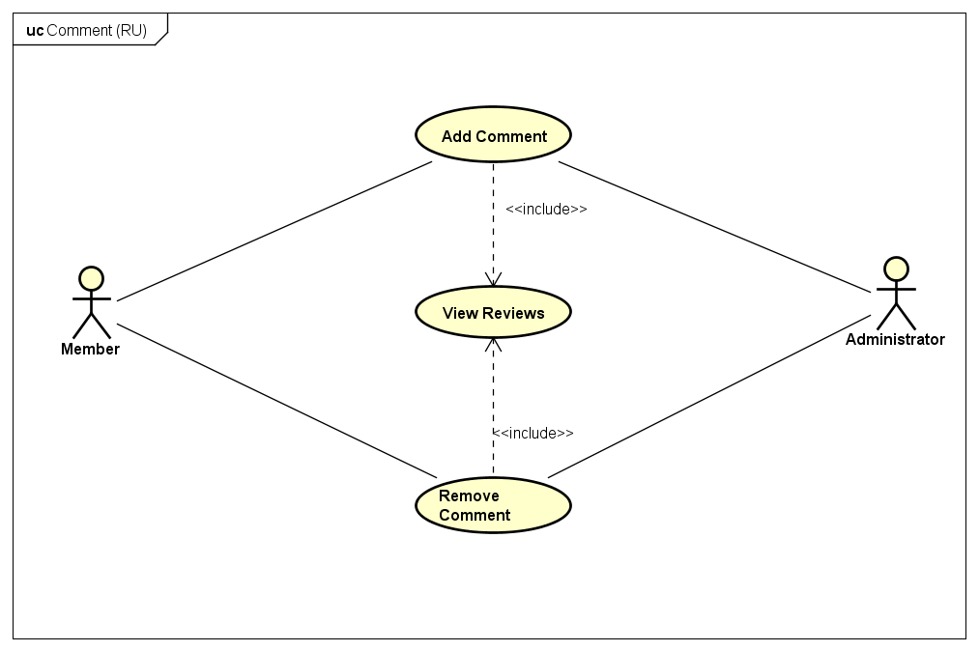

1. Comment Group Use Cases for Registered User

**UC016 – Add Comment**

1. Detailed Use Case description and Registered User - System interactions

|  |  |  |  |  |
| --- | --- | --- | --- | --- |
| Use Case ID | | UC016 | Version | 1.0 |
| Use Case Name | | Add Comment | | |
| Author | | Trần Đăng | **Last Updated** | 26/05/2016 |
| Primary Actor | | RU | **Secondary Actor** |  |
| Description | | Post a comment on a review | | |
| Preconditions | | Logged in  Currently at Detailed Review screen | | |
| Postconditions | | Comment is successfully saved into the system | | |
| Normal Flow | | | | |
| Step | **Actor** | **Action** | | |
| 1 | RU | Input comment and click “Gửi bình luận” | | |
| 2 | System | Save the comment into the system and show it on the comment section | | |
|  | | | | |
| Alternative Flows: None | | | | |
|  | | | | |
| Exceptions: None | | | | |
| Priority | | Low | | |
| Frequency of Use | | High | | |
| Business Rules | | None | | |

**UC017 – Remove Comment**

1. Detailed Use Case description and Registered User - System interactions

|  |  |  |  |  |
| --- | --- | --- | --- | --- |
| Use Case ID | | UC017 | Version | 1.0 |
| Use Case Name | | Remove Comment | | |
| Author | | Trần Đăng | **Last Updated** | 26/05/2016 |
| Primary Actor | | RU | **Secondary Actor** |  |
| Description | | Remove an owned comment on a review | | |
| Preconditions | | Logged in  Currently at Detailed Review screen | | |
| Postconditions | | Comment is successfully removed from the system | | |
| Normal Flow | | | | |
| Step | **Actor** | **Action** | | |
| 1 | RU | Click on “Xóa” from the dropdown menu on the owned comment | | |
| 2 | System | Remove comment from the system | | |
|  | | | | |
| Alternative Flows: None | | | | |
|  | | | | |
| Exceptions: None | | | | |
| Priority | | Low | | |
| Frequency of Use | | High | | |
| Business Rules | | None | | |

Company

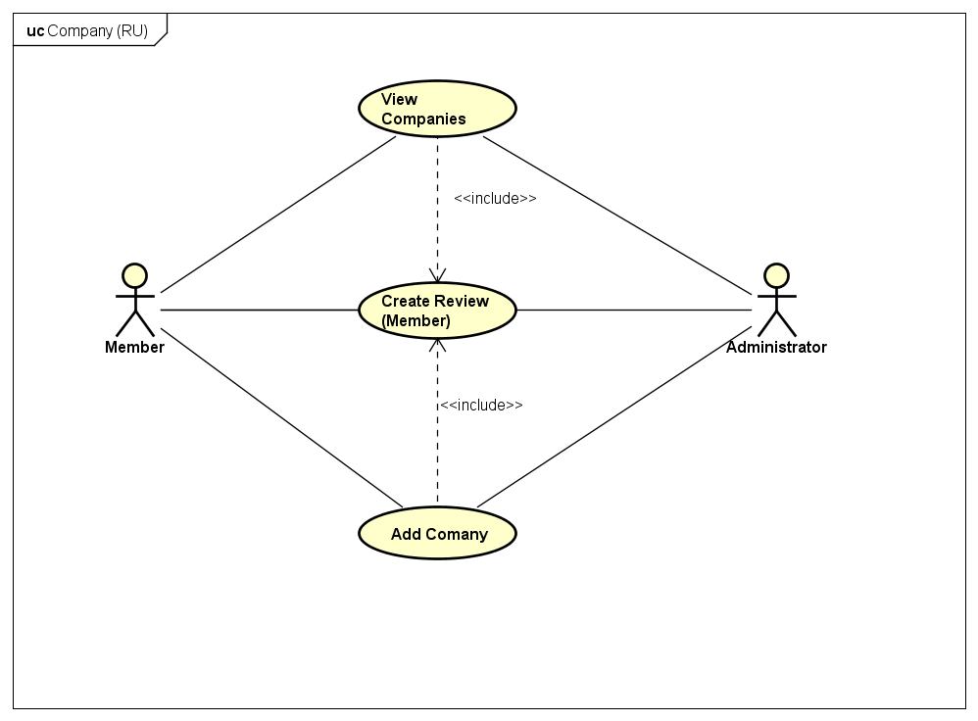

1. Company Group Use Cases for Registered User

**UC018 – Add Company**

1. Detailed Use Case description and Registered User - System interactions

|  |  |  |  |  |
| --- | --- | --- | --- | --- |
| Use Case ID | | UC018 | Version | 1.0 |
| Use Case Name | | Add Company | | |
| Author | | Trần Đăng | **Last Updated** | 27/05/2016 |
| Primary Actor | | RU | **Secondary Actor** |  |
| Description | | Add a new company to the system | | |
| Preconditions | | New company is not currently exist in the system  Currently at Manage Companies screen (AD)  Currently at View Companies List screen(Member) | | |
| Postconditions | | New company is successfully saved into the system | | |
| Normal Flow | | | | |
| Step | **Actor** | **Action** | | |
| 1 | RU | Click on “Tạo công ty mới” | | |
| 2 | System | Display Add Company screen | | |
| 3 | RU | Input info as required and click “Tạo công ty” | | |
| 4 | System | Save new company info into the system | | |
|  | | | | |
| Alternative Flows: None | | | | |
|  | | | | |
| Exceptions | | | | |
| EX1 | At step 3, RU did not input all required info | | | |
| Step | **Actor** | **Action** | | |
| 4 | System | Display error messages accordingly and halt RU progress until cleared | | |
|  | | | | |
| Priority | | High | | |
| Frequency of Use | | Normal | | |
| Business Rules | | None | | |

### Member

Company

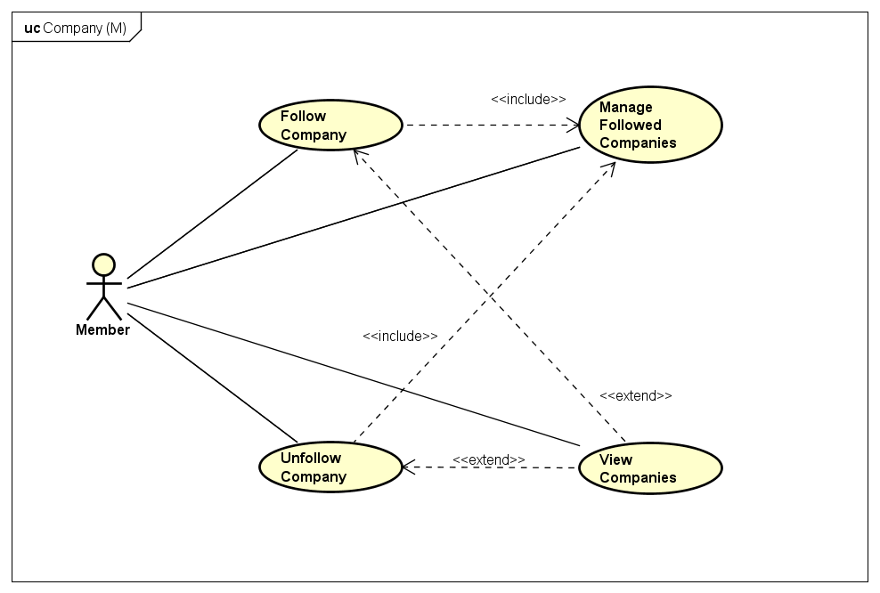

1. Company Group Use Cases for Member

**UC019 – Manage Followed Companies**

1. Detailed Use Case description and Member - System interactions

|  |  |  |  |  |
| --- | --- | --- | --- | --- |
| Use Case ID | | UC019 | Version | 1.0 |
| Use Case Name | | Manage Followed Companies | | |
| Author | | Trần Đăng | **Last Updated** | 27/05/2016 |
| Primary Actor | | Member | **Secondary Actor** |  |
| Description | | List all of member’s followed companies | | |
| Preconditions | | Logged in  Currently at Member’s own Detailed Account Info screen | | |
| Postconditions | | List of followed companies is successfully displayed | | |
| Normal Flow | | | | |
| Step | **Actor** | **Action** | | |
| 1 | Member | Click on “Công ty đang theo dõi” | | |
| 2 | System | Display list of followed companies | | |
|  | | | | |
| Alternative Flows | | | | |
| AT1 | After step 2, Member wants to limit the amount of shown companies on a single page | | | |
| Step | **Actor** | **Action** | | |
| 3 | Member | Click on the dropdown list next to “Hiển thị” and choose 5, 10 or 20 | | |
| 4 | System | Limit the amount of companies accordingly | | |
|  | | | | |
| Exceptions | | | | |
| EX1 | At step 2, Member has yet to follow any company | | | |
| Step | **Actor** | **Action** | | |
| 2 | System | Show message “Chưa có công ty nào được theo dõi” | | |
|  | | | | |
| Priority | | Normal | | |
| Frequency of Use | | Low | | |
| Business Rules | | None | | |

**UC020 – Follow Company**

1. Detailed Use Case description and Member - System interactions

|  |  |  |  |  |  |
| --- | --- | --- | --- | --- | --- |
| Use Case ID | | | UC020 | Version | 1.0 |
| Use Case Name | | | Follow Company | | |
| Author | | | Trần Đăng | **Last Updated** | 27/05/2016 |
| Primary Actor | | | Member | **Secondary Actor** |  |
| Description | | | Allow member to receive notification from the chosen company | | |
| Preconditions | | | Logged in  Currently at Detailed Company screen | | |
| Postconditions | | | Company added to followed company list | | |
| Normal Flow | | | | | |
| Step | **Actor** | | **Action** | | |
| 1 | Member | | Click on “Theo dõi” | | |
| 2 | System | | Display a popup modal box asking for a confirmation | | |
| 3 | Member | | Click on “Xác nhận” | | |
| 4 | System | | Change the button to “Bỏ theo dõi” and save the chosen company to member’s followed company list | | |
|  | | | | | |
| Alternative Flows: None | | | | | |
|  | | | | | |
| Exceptions | | | | | |
| EX1 | At step 3 Member no longer want to remove review | | | | |
| Step | **Actor** | **Action** | | | |
| 3 | Member | Click on “Từ chối” | | | |
| 4 | System | Close the popup modal box | | | |
| Priority | | | Normal | | |
| Frequency of Use | | | Low | | |
| Business Rules | | | None | | |

**UC021 – Unfollow Company**

1. Detailed Use Case description and Member - System interactions

|  |  |  |  |  |  |
| --- | --- | --- | --- | --- | --- |
| Use Case ID | | | UC021 | Version | 1.0 |
| Use Case Name | | | Unfollow Company | | |
| Author | | | Trần Đăng | **Last Updated** | 27/05/2016 |
| Primary Actor | | | Member | **Secondary Actor** |  |
| Description | | | Allow member to no longer receive notification from the chosen company | | |
| Preconditions | | | Logged in  Currently following the chosen company  Currently at Detailed Company|Manage Followed Companies screen | | |
| Postconditions | | | Company removed from followed company list | | |
| Normal Flow | | | | | |
| Step | **Actor** | | **Action** | | |
| 1 | Member | | Click on “Bỏ theo dõi” | | |
| 2 | System | | Display a popup modal box asking for a confirmation | | |
| 3 | Member | | Click on “Xác nhận” | | |
| 4 | System | | Change the button to “Theo dõi” and remove the chosen company from member’s followed company list | | |
|  | | | | | |
| Alternative Flows: None | | | | | |
|  | | | | | |
| Exceptions | | | | | |
| EX1 | At step 3 Member no longer want to remove review | | | | |
| Step | **Actor** | **Action** | | | |
| 3 | Member | Click on “Từ chối” | | | |
| 4 | System | Close the popup modal box | | | |
| Priority | | | Normal | | |
| Frequency of Use | | | Low | | |
| Business Rules | | | None | | |

Review

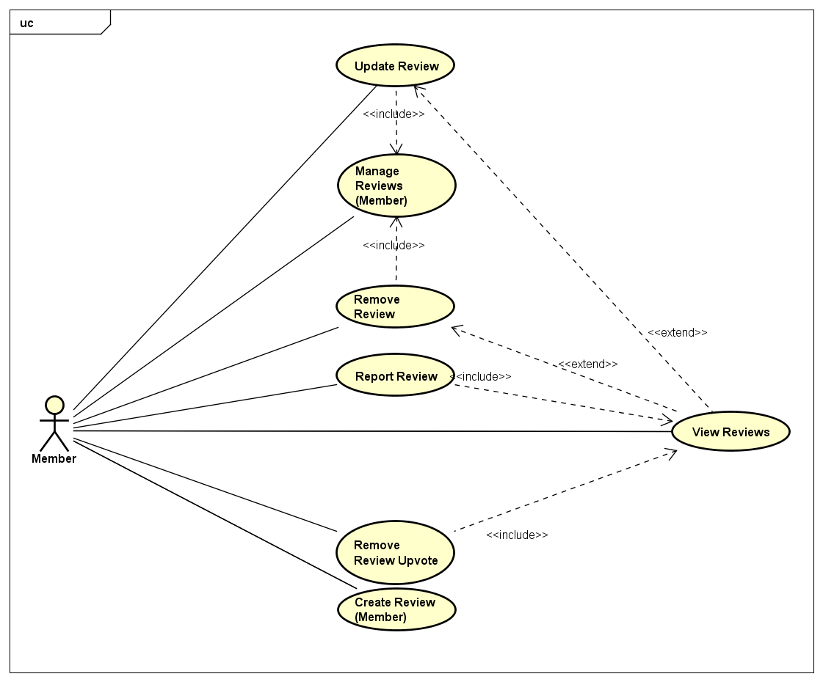

1. Group Use Cases for đánh giá của Member

**UC022 – Manage Reviews**

1. Detailed Use Case description and Member - System interactions

|  |  |  |  |  |
| --- | --- | --- | --- | --- |
| Use Case ID | | UC022 | Version | 1.0 |
| Use Case Name | | Manage Reviews | | |
| Author | | Trần Đăng | **Last Updated** | 27/05/2016 |
| Primary Actor | | Member | **Secondary Actor** |  |
| Description | | List all of member’s reviews | | |
| Preconditions | | Logged in  Currently at Member’s own Detailed Account Info screen | | |
| Postconditions | | List of member’s reviews is successfully displayed | | |
| Normal Flow | | | | |
| Step | **Actor** | **Action** | | |
| 1 | Member | Click on “Bài đánh giá đã đăng” | | |
| 2 | System | Display list of member’s reviews | | |
|  | | | | |
| Alternative Flows | | | | |
| A1 | After step 2, Member wants to limit the amount of shown reviews on a single page | | | |
| Step | **Actor** | **Action** | | |
| 3 | Member | Click on the dropdown list next to “Hiển thị” and choose 5, 10 or 20 | | |
| 4 | System | Limit the amount of companies accordingly | | |
|  | | | | |
| Exceptions | | | | |
| EX1 | At step 2, Member has no review | | | |
| Step | **Actor** | **Action** | | |
| 2 | System | Show message “Bạn chưa có đánh giá nào” | | |
|  | | | | |
| Priority | | High | | |
| Frequency of Use | | Normal | | |
| Business Rules | | None | | |

**UC023 – Create Review**

1. Detailed Use Case description and Member - System interactions

|  |  |  |  |  |
| --- | --- | --- | --- | --- |
| Use Case ID | | UC023 | Version | 1.0 |
| Use Case Name | | Create Review | | |
| Author | | Trần Đăng | **Last Updated** | 27/05/2016 |
| Primary Actor | | Member | **Secondary Actor** |  |
| Description | | Post a review to CRW with an account | | |
| Preconditions | | Logged in | | |
| Postconditions | | Review is saved in the system | | |
| Normal Flow | | | | |
| Step | **Actor** | **Action** | | |
| 1 | Member | Click on “+ Đánh giá” | | |
| 2 | System | Display Create Review screen | | |
| 3 | Member | Input info as required and click “Gửi đánh giá” | | |
| 4 | System | Save the review into the system with pending state | | |
|  | | | | |
| Alternative Flows: None | | | | |
|  | | | | |
| Exceptions | | | | |
| EX1 | At step 3 Member did not input all required info | | | |
| Step | **Actor** | **Action** | | |
| 4 | System | Display error messages accordingly and halt member progress until cleared | | |
| Priority | | High | | |
| Frequency of Use | | High | | |
| Business Rules | | None | | |

**UC024 – Update Review**

1. Detailed Use Case description and Member - System interactions

|  |  |  |  |  |
| --- | --- | --- | --- | --- |
| Use Case ID | | UC024 | Version | 1.0 |
| Use Case Name | | Update Review | | |
| Author | | Trần Đăng | **Last Updated** | 27/05/2016 |
| Primary Actor | | Member | **Secondary Actor** |  |
| Description | | Update a posted review | | |
| Preconditions | | Logged in  Is the owner of the review  Currently at Detailed Review|Manage Reviews screen | | |
| Postconditions | | Member’s changes are successfully saved in the system | | |
| Normal Flow | | | | |
| Step | **Actor** | **Action** | | |
| 1 | Member | Click on “Cập nhật đánh giá” | | |
| 2 | System | Display Update Review screen | | |
| 3 | Member | Make changes as needed and click on “Cập nhật” | | |
| 4 | System | Save changes into the system and change review’s state to pending | | |
|  | | | | |
| Alternative Flows: None | | | | |
|  | | | | |
| Exceptions | | | | |
| EX1 | At step 3 Member did not input all required info | | | |
| Step | **Actor** | **Action** | | |
| 4 | System | Display error messages accordingly and halt member progress until cleared | | |
| Priority | | High | | |
| Frequency of Use | | High | | |
| Business Rules | | None | | |

**UC025 – Remove Review**

1. Detailed Use Case description and Member - System interactions

|  |  |  |  |  |
| --- | --- | --- | --- | --- |
| Use Case ID | | UC025 | Version | 1.0 |
| Use Case Name | | Remove Review | | |
| Author | | Trần Đăng | **Last Updated** | 27/05/2016 |
| Primary Actor | | Member | **Secondary Actor** |  |
| Description | | Remove a posted and approved review | | |
| Preconditions | | Logged in  Is the owner of the review  Currently at Detailed Review|Manage Reviews screen | | |
| Postconditions | | Review is successfully removed from the system | | |
| Normal Flow | | | | |
| Step | **Actor** | **Action** | | |
| 1 | Member | Click on “Xóa bài đánh giá” | | |
| 2 | System | Display a popup modal box asking for a confirmation | | |
| 3 | Member | Click on “Xác nhận” | | |
| 4 | System | Remove the review from the system | | |
|  | | | | |
| Alternative Flows: None | | | | |
|  | | | | |
| Exceptions | | | | |
| EX1 | At step 3 Member no longer want to remove review | | | |
| Step | **Actor** | **Action** | | |
| 3 | Member | Click on “Từ chối” | | |
| 4 | System | Close the popup modal box | | |
| Priority | | High | | |
| Frequency of Use | | Normal | | |
| Business Rules | | None | | |

**UC026 – Report Review**

1. Detailed Use Case description and Member - System interactions

|  |  |  |  |  |
| --- | --- | --- | --- | --- |
| Use Case ID | | UC026 | Version | 1.0 |
| Use Case Name | | Report Review | | |
| Author | | Trần Đăng | **Last Updated** | 27/05/2016 |
| Primary Actor | | Member | **Secondary Actor** |  |
| Description | | Report a rule violating or false-flagging review on CRW | | |
| Preconditions | | Logged in  Currently at Detailed Review screen | | |
| Postconditions | | Report is successfully logged into the system | | |
| Normal Flow | | | | |
| Step | **Actor** | **Action** | | |
| 1 | Member | Click on “Báo cáo vi phạm” | | |
| 2 | System | Display reasoning and confirmation popup modal box | | |
| 3 | Member | Input reasoning and click on “Gửi báo cáo” | | |
| 4 | System | Log the report into the system | | |
|  | | | | |
| Alternative Flows: None | | | | |
|  | | | | |
| Exceptions | | | | |
| EX1 | At step 3 Member no longer want to report | | | |
| Step | **Actor** | **Action** | | |
| 3 | Member | Click on “Hủy báo cáo” | | |
| 4 | System | Close the popup modal box | | |
| Priority | | Normal | | |
| Frequency of Use | | Normal | | |
| Business Rules | | None | | |

**UC027 – Upvote Review**

1. Detailed Use Case description and Member - System interactions

|  |  |  |  |  |
| --- | --- | --- | --- | --- |
| Use Case ID | | UC027 | Version | 1.0 |
| Use Case Name | | Upvote Review | | |
| Author | | Trần Đăng | **Last Updated** | 27/05/2016 |
| Primary Actor | | Member | **Secondary Actor** |  |
| Description | | Upvote a review to the member’s liking | | |
| Preconditions | | Logged in  Currently at Detailed Review screen | | |
| Postconditions | | Increase the amount of upvote on the review by 1 | | |
| Normal Flow | | | | |
| Step | **Actor** | **Action** | | |
| 1 | Member | Click on “Ủng hộ” | | |
| 2 | System | Display a popup modal box asking for a confirmation | | |
| 3 | Member | Click on “Xác nhận” | | |
| 4 | System | Change the button to “Bỏ ủng hộ” and increase the mount of upvote by 1 | | |
|  | | | | |
| Alternative Flows: None | | | | |
|  | | | | |
| Exceptions | | | | |
| EX1 | At step 3 Member no longer want to upvote the review | | | |
| Step | **Actor** | **Action** | | |
| 3 | Member | Click on “Từ chối” | | |
| 4 | System | Close the popup modal box | | |
| Priority | | High | | |
| Frequency of Use | | High | | |
| Business Rules | | None | | |

**UC028 – Remove Review Upvote**

1. Detailed Use Case description and Member - System interactions

|  |  |  |  |  |
| --- | --- | --- | --- | --- |
| Use Case ID | | UC028 | Version | 1.0 |
| Use Case Name | | Remove Review Upvote | | |
| Author | | Trần Đăng | **Last Updated** | 27/05/2016 |
| Primary Actor | | Member | **Secondary Actor** |  |
| Description | | Remove member’s upvote from a review | | |
| Preconditions | | Logged in  Currently upvoted the chosen review  Currently at Detailed Review screen | | |
| Postconditions | | Decrease the amount of upvote on the review by 1 | | |
| Normal Flow | | | | |
| Step | **Actor** | **Action** | | |
| 1 | Member | Click on “Bỏ ủng hộ” | | |
| 2 | System | Display a popup modal box asking for a confirmation | | |
| 3 | Member | Click on “Xác nhận” | | |
| 2 | System | Change the button to “Ủng hộ” and decrease the amount of upvote by 1 | | |
|  | | | | |
| Alternative Flows: None | | | | |
|  | | | | |
| Exceptions | | | | |
| EX1 | At step 3 Member no longer want to remove upvote from the review | | | |
| Step | **Actor** | **Action** | | |
| 3 | Member | Click on “Từ chối” | | |
| 4 | System | Close the popup modal box | | |
| Priority | | High | | |
| Frequency of Use | | High | | |
| Business Rules | | None | | |

Bookmark

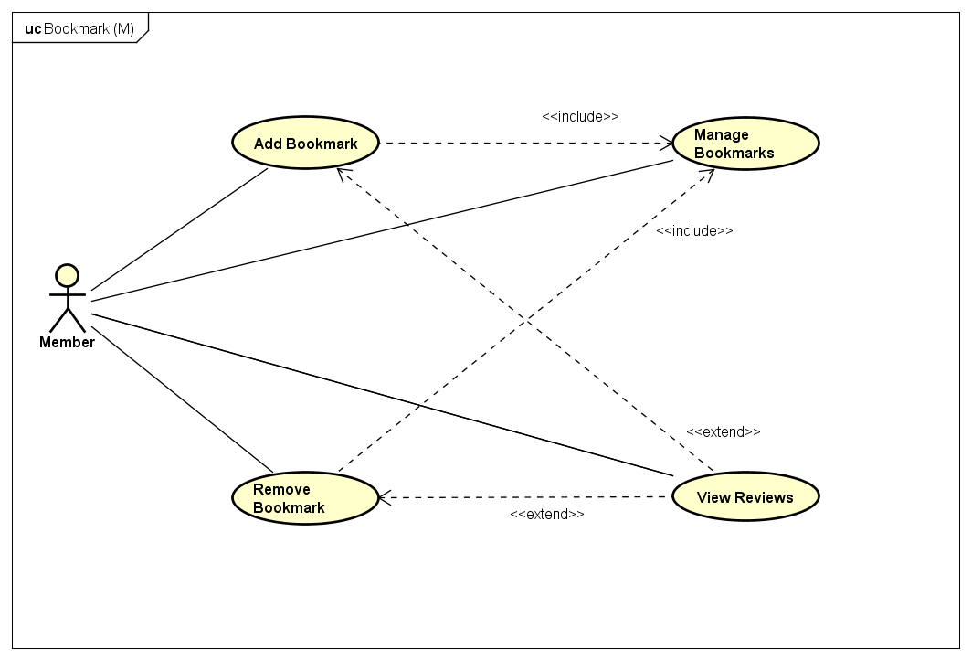

1. Bookmark Group Use Cases for Member

**UC029 – Manage Bookmarks**

1. Detailed Use Case description and Member - System interactions

|  |  |  |  |  |
| --- | --- | --- | --- | --- |
| Use Case ID | | UC029 | Version | 1.0 |
| Use Case Name | | Manage Bookmarks | | |
| Author | | Trần Đăng | **Last Updated** | 27/05/2016 |
| Primary Actor | | Member | **Secondary Actor** |  |
| Description | | Member có nhu cầu xem các review mình đã đánh dấu trang | | |
| Preconditions | | Logged in  Currently at Member’s own Detailed Account Info screen | | |
| Postconditions | | Hiển thị danh sách các review đã được đánh dấu trang của Member | | |
| Normal Flow | | | | |
| Step | **Actor** | **Action** | | |
| 1 | Member | Click on “Bài đánh giá đã đánh dấu” | | |
| 2 | System | Display list of member’s bookmarked reviews | | |
|  | | | | |
| Alternative Flows | | | | |
| A1 | After step 2, Member wants to limit the amount of shown reviews on a single page | | | |
| Step | **Actor** | **Action** | | |
| 3 | Member | Click on the dropdown list next to “Hiển thị” and choose 5, 10 or 20 | | |
| 4 | System | Limit the amount of companies accordingly | | |
|  | | | | |
| Exceptions | | | | |
| EX1 | At step 2, Member has yet to bookmark any review | | | |
| Step | **Actor** | **Action** | | |
| 2 | System | Show message “Chưa có bài đánh giá nào được lưu dấu trang” | | |
|  | | | | |
| Priority | | Normal | | |
| Frequency of Use | | Normal | | |
| Business Rules | | None | | |

**UC030 – Add Bookmark**

1. Detailed Use Case description and Member - System interactions

|  |  |  |  |  |
| --- | --- | --- | --- | --- |
| Use Case ID | | UC030 | Version | 1.0 |
| Use Case Name | | Add Bookmark | | |
| Author | | Trần Đăng | **Last Updated** | 27/05/2016 |
| Primary Actor | | Member | **Secondary Actor** |  |
| Description | | Create a bookmark to keep the reviews for later usages | | |
| Preconditions | | Logged in  Currently at Detailed Review screen | | |
| Postconditions | | New bookmark is successfully saved in the system | | |
| Normal Flow | | | | |
| Step | **Actor** | **Action** | | |
| 1 | Member | Click on “Dấu trang” | | |
| 2 | System | Change the button to “Bỏ lưu dấu trang” and save the bookmark to the member’s list | | |
|  | | | | |
| Alternative Flows: None | | | | |
|  | | | | |
| Exceptions: None | | | | |
| Priority | | Normal | | |
| Frequency of Use | | Normal | | |
| Business Rules | | None | | |

**UC031 – Remove Bookmark**

1. Detailed Use Case description and Member - System interactions

|  |  |  |  |  |
| --- | --- | --- | --- | --- |
| Use Case ID | | UC031 | Version | 1.0 |
| Use Case Name | | Remove Bookmark | | |
| Author | | Trần Đăng | **Last Updated** | 27/05/2016 |
| Primary Actor | | Member | **Secondary Actor** |  |
| Description | | Remove a bookmark from a review | | |
| Preconditions | | Logged in  Currently at Detailed Review|Manage Bookmark screen | | |
| Postconditions | | Bookmark is successffully removed from the member’s list | | |
| Normal Flow | | | | |
| Step | **Actor** | **Action** | | |
| 1 | Member | Click on “Bỏ lưu dấu trang” | | |
| 2 | System | Change the button to “Dấu trang” and remove the review from member’s bookmark list | | |
|  | | | | |
| Alternative Flows: None | | | | |
|  | | | | |
| Exceptions: None | | | | |
| Priority | | Normal | | |
| Frequency of Use | | Normal | | |
| Business Rules | | None | | |

### Administrator

Company

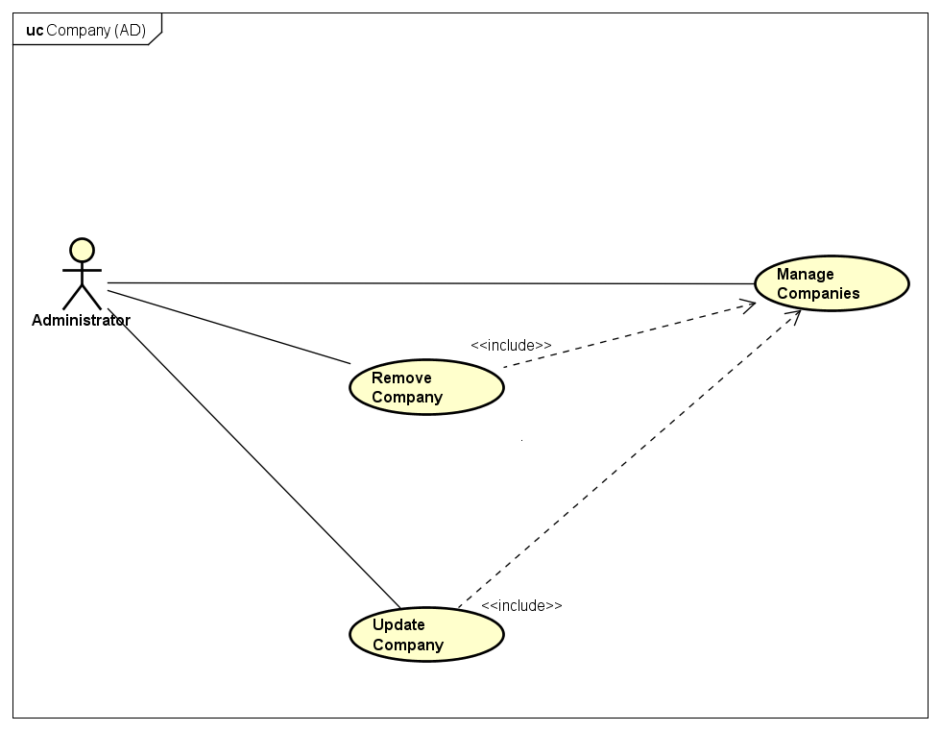

1. Company Group Use Cases for Administrator

**UC032 – Manage Companies**

1. Detailed Use Case description and Administrator - System interactions

|  |  |  |  |  |
| --- | --- | --- | --- | --- |
| Use Case ID | | UC032 | Version | 1.0 |
| Use Case Name | | Manage Companies | | |
| Author | | Trần Đăng | **Last Updated** | 27/05/2016 |
| Primary Actor | | AD | **Secondary Actor** |  |
| Description | | List all companies available in the system | | |
| Preconditions | | Logged in as an AD  Currently at AD Control Panel screen | | |
| Postconditions | | List of all available companies is successfully displayed | | |
| Normal Flow | | | | |
| Step | **Actor** | **Action** | | |
| 1 | AD | Click on “Quản lý thống kê” | | |
| 2 | System | Display dropdown menu | | |
| 3 | AD | Click on “Các công ty” | | |
| 4 | System | Display Manage Companies screen with all companies’ info | | |
|  | | | | |
| Alternative Flows | | | | |
| A1 | After step 2, AD wants to limit the amount of shown companies on a single page | | | |
| Step | **Actor** | **Action** | | |
| 3 | AD | Click on the dropdown list next to “Hiển thị” and choose 10, 20 or 30 | | |
| 4 | System | Limit the amount of companies accordingly | | |
|  | | | | |
| Exceptions | | | | |
| EX1 | At step 2, if there is no company in the system | | | |
| Step | **Actor** | **Action** | | |
| 2 | System | Show message “Hệ thống chưa có công ty nào” | | |
|  | | | | |
| Priority | | High | | |
| Frequency of Use | | Normal | | |
| Business Rules | | None | | |

**UC033 – Update Company**

1. Detailed Use Case description and Administrator - System interactions

|  |  |  |  |  |
| --- | --- | --- | --- | --- |
| Use Case ID | | UC033 | Version | 1.0 |
| Use Case Name | | Update Company | | |
| Author | | Trần Đăng | **Last Updated** | 27/05/2016 |
| Primary Actor | | AD | **Secondary Actor** |  |
| Description | | Update the info of an existing company within the system | | |
| Preconditions | | Logged in as an AD  Currently at Manage Companies screen | | |
| Postconditions | | Company’s info is successfully updated in the system | | |
| Normal Flow | | | | |
| Step | **Actor** | **Action** | | |
| 1 | AD | Click on “Sửa thông tin” | | |
| 2 | System | Display popup modal box for updating purpose | | |
| 3 | AD | Make changes as needed and click on “Lưu chỉnh sửa” | | |
| 4 | System | Save changes into the system | | |
|  | | | | |
| Alternative Flows: None | | | | |
|  | | | | |
| Exceptions | | | | |
| EX1 | At step 3, AD did not input all required info | | | |
| Step | **Actor** | **Action** | | |
| 4 | System | Display error messages accordingly and halt member progress until cleared | | |
| Priority | | High | | |
| Frequency of Use | | Normal | | |
| Business Rules | | None | | |

**UC034 – Remove Company**

1. Detailed Use Case description and Administrator - System interactions

|  |  |  |  |  |
| --- | --- | --- | --- | --- |
| Use Case ID | | UC034 | Version | 1.0 |
| Use Case Name | | Remove Company | | |
| Author | | Trần Đăng | **Last Updated** | 27/05/2016 |
| Primary Actor | | AD | **Secondary Actor** |  |
| Description | | Remove a company from the system | | |
| Preconditions | | Logged in as an AD  Currently at Update Company modal box | | |
| Postconditions | | Company’s state is successfully changed | | |
| Normal Flow | | | | |
| Step | **Actor** | **Action** | | |
| 1 | AD | Click on “Khóa” option in radiobox | | |
| 4 | System | Change company’s state to locked and save into the system | | |
|  | | | | |
| Alternative Flows: None | | | | |
|  | | | | |
| Exceptions | | | | |
| EX1 | After step 2, AD no longer want to remove the company | | | |
| Step | **Actor** | **Action** | | |
| 3 | AD | Click on “Từ chối” | | |
| 4 | System | Close the popup modal box | | |
| Priority | | High | | |
| Frequency of Use | | Normal | | |
| Business Rules | | None | | |

Reviews

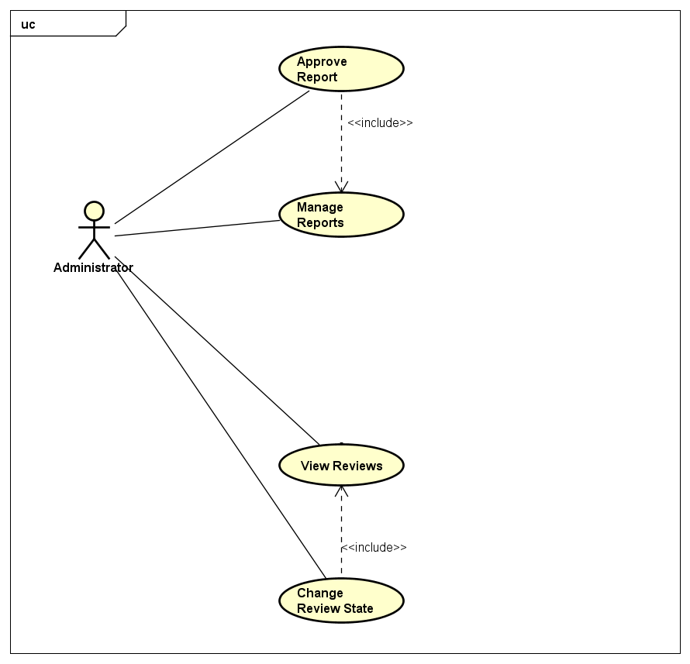

1. Review Group Use Cases for AD

**UC035 – Manage Reports**

1. Detailed Use Case description and Administrator - System interactions

|  |  |  |  |  |
| --- | --- | --- | --- | --- |
| Use Case ID | | UC035 | Version | 1.0 |
| Use Case Name | | Manage Reports | | |
| Author | | Trần Đăng | **Last Updated** | 27/05/2016 |
| Primary Actor | | AD | **Secondary Actor** |  |
| Description | | List all reports available in the system | | |
| Preconditions | | Logged in as an AD  Currently at AD Control Panel screen | | |
| Postconditions | | List of all available reports is successfully displayed | | |
| Normal Flow | | | | |
| Step | **Actor** | **Action** | | |
| 1 | AD | Click on “Xử lý bài đăng” | | |
| 2 | System | Display Manage Reviews screen | | |
| 3 | AD | Click on “Báo cáo chờ xử lý” tab | | |
| 4 | System | Display Manage Reports screen | | |
|  | | | | |
| Alternative Flows: None | | | | |
|  | | | | |
| Exceptions | | | | |
| EX1 | At step 2, if there is no existing report within the system | | | |
| Step | **Actor** | **Action** | | |
| 2 | System | Show message “Hiện thời chưa có báo cáo vi phạm nào” | | |
|  | | | | |
| Priority | | High | | |
| Frequency of Use | | High | | |
| Business Rules | | None | | |

**UC036 – Approve Report**

1. Detailed Use Case description and Administrator - System interactions

|  |  |  |  |  |
| --- | --- | --- | --- | --- |
| Use Case ID | | UC036 | Version | 1.0 |
| Use Case Name | | Approve Report | | |
| Author | | Trần Đăng | **Last Updated** | 27/05/2016 |
| Primary Actor | | AD | **Secondary Actor** |  |
| Description | | Available actions to take with a report | | |
| Preconditions | | Logged in as an AD  Currently at Manage Reports screen | | |
| Postconditions | | Report is successfully revised and has action taken against it | | |
| Normal Flow | | | | |
| Step | **Actor** | **Action** | | |
| 1 | AD | Click on the reports’ review title | | |
| 2 | System | Display Reported Review Details screen | | |
| 3 | AD | Click on “Xử lý” | | |
| 4 | System | Display popup modal box for reasoning and confirmation | | |
| 5 | AD | Input reasoning and click on “Xác nhận” | | |
| 6 | System | Review’s state is successfully changed to rejected and a notification is sent to the review’s owner | | |
|  | | | | |
| Alternative Flows: None | | | | |
|  | | | | |
| Exceptions | | | | |
| EX1 | At step 3, AD see that no action is needed | | | |
| Step | **Actor** | **Action** | | |
| 3 | AD | Click on “Bỏ qua” | | |
| 4 | System | Remove the report from the system | | |
|  | | | | |
| EX1 | At step 5, AD see that no action is needed yet | | | |
| Step | **Actor** | **Action** | | |
| 5 | AD | Click on “Hủy” | | |
| 6 | System | Close the popup modal box | | |
| Priority | | High | | |
| Frequency of Use | | High | | |
| Business Rules | | None | | |

Account

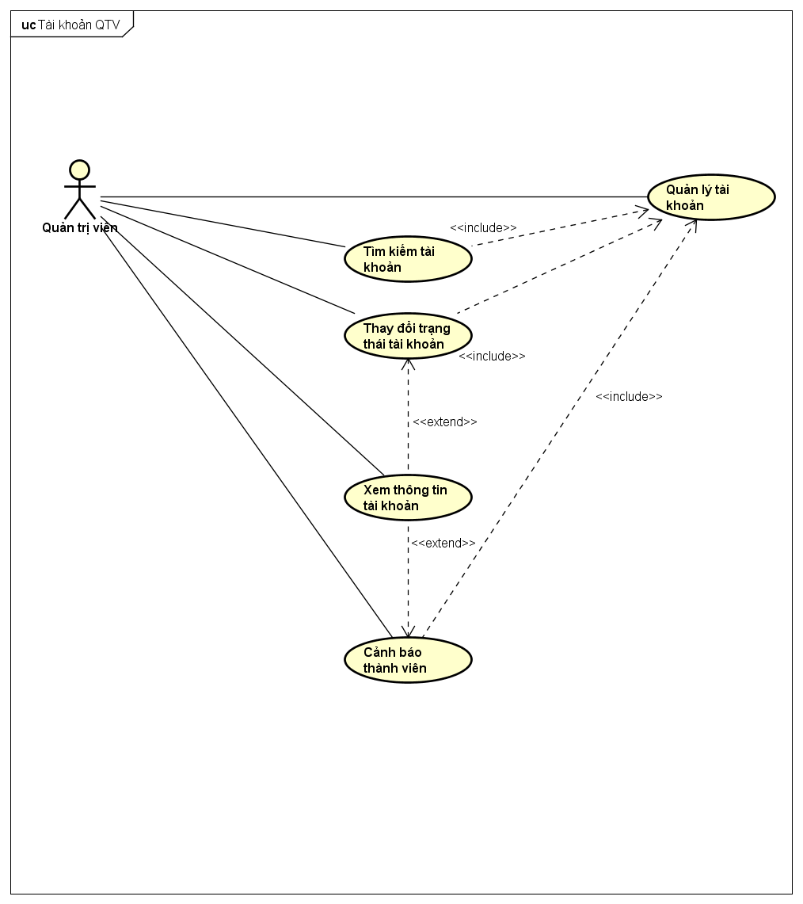

1. Group Use Cases for tài khoản của AD

**UC037 – Manage Accounts**

1. Detailed Use Case description and Administrator - System interactions

|  |  |  |  |  |
| --- | --- | --- | --- | --- |
| Use Case ID | | UC037 | Version | 1.0 |
| Use Case Name | | Manage Accounts | | |
| Author | | Trần Đăng | **Last Updated** | 27/05/2016 |
| Primary Actor | | AD | **Secondary Actor** |  |
| Description | | List all accounts in the system | | |
| Preconditions | | Logged in as an AD  Currently at AD Control Panel screen | | |
| Postconditions | | List of accounts is successfully displayed | | |
| Normal Flow | | | | |
| Step | **Actor** | **Action** | | |
| 1 | AD | Click on “Quản lý thống kê” | | |
| 2 | System | Display dropdown menu | | |
| 3 | AD | Click on “Người dùng” | | |
| 4 | System | Display Manage Accounts screen with all accounts’ info | | |
|  | | | | |
| Alternative Flows | | | | |
| AT1 | After step 2, AD wants to limit the amount of shown accounts on a single page | | | |
| Step | **Actor** | **Action** | | |
| 3 | AD | Click on the dropdown list next to “Hiển thị” and choose 10, 20 or 30 | | |
| 4 | System | Limit the amount of companies accordingly | | |
|  | | | | |
| Exceptions: None | | | | |
| Priority | | High | | |
| Frequency of Use | | High | | |
| Business Rules | | None | | |

**UC038 – Search Account**

1. Detailed Use Case description and Administrator - System interactions

|  |  |  |  |  |
| --- | --- | --- | --- | --- |
| Use Case ID | | UC038 | Version | 1.0 |
| Use Case Name | | Search Account | | |
| Author | | Trần Đăng | **Last Updated** | 27/05/2016 |
| Primary Actor | | AD | **Secondary Actor** |  |
| Description | | Search for accounts in the system, possibily with filter | | |
| Preconditions | | Logged in as an AD  Current at Manage Accounts screen | | |
| Postconditions | | Matching accounts are displayed | | |
| Normal Flow | | | | |
| Step | **Actor** | **Action** | | |
| 1 | AD | Input search query | | |
| 2 | System | Display Manage Accounts screen with matching result | | |
|  | | | | |
| Alternative Flows | | | | |
| AT1 | After step 2, AD wants to limit the amount of search result on a single page | | | |
| Step | **Actor** | **Action** | | |
| 3 | AD | Click on the dropdown list next to “Hiển thị” and choose 10, 20 or 30 | | |
| 4 | System | Limit the search result accordingly | | |
|  | | | | |
| Exceptions: None | | | | |
| Priority | | High | | |
| Frequency of Use | | High | | |
| Business Rules | | None | | |

**UC039 – Change Account State**

1. Detailed Use Case description and Administrator - System interactions

|  |  |  |  |  |
| --- | --- | --- | --- | --- |
| Use Case ID | | UC039 | Version | 1.0 |
| Use Case Name | | Change Account State | | |
| Author | | Trần Đăng | **Last Updated** | 27/05/2016 |
| Primary Actor | | AD | **Secondary Actor** |  |
| Description | | Change an account state accordingly to the rules | | |
| Preconditions | | Logged in as an AD  Currently at Detailed Account Info screen | | |
| Postconditions | | Account’s state is successfully changed | | |
| Normal Flow | | | | |
| Step | **Actor** | **Action** | | |
| 1 | AD | Click on “Khóa” | | |
| 2 | System | Change the button to “Mở khóa” and save the account state into the system | | |
|  | | | | |
| Alternative Flows | | | | |
| AT1 | At step 1, if account is already banned | | | |
| Step | **Actor** | **Action** | | |
| 5 | AD | Click on “Mở khóa” | | |
| 6 | System | Change the button to “Khóa” and save the account state into the system | | |
|  | | | | |
| Exceptions: None | | | | |
| Priority | | Low | | |
| Frequency of Use | | Low | | |
| Business Rules | | None | | |

# Non-Functional Specification

## Reliability

* Mean time between each failure is expected to be around 480 hours of actual usage.
* Maximum bugs per function are 2 bugs/function within 2 months of actual usage.
* Average number of bugs in the software during system testing is expected to be around 1 bug/KLOC.
* Database must be backed up on a daily basis and can be recovered whenever necessary.

## Performance Requirements

### Availability

Website must be available 95% of the time. Users can access to it from their Web browser with an Internet connection wherever they want.

### Response time

In term of response time, waiting time of processing will be 2 to 5 seconds; time to process any function will not exceed 7 seconds.

### Maintainability

* **Coding standards and naming conventions:**
* Output of the project must include coding standards and naming conventions documentations. Implementation code must be easy to maintain.
* If some components are reused, the documentations of those components must also be included.
* **Design:**
* The design of the system must be loosely coupled so that changes on one module will not affect another.
* **Logging:**
* All the errors should be logged to support bug fixing and maintenance.
* All strange or sensitive situations should also be logged.
* **Repair mean time:**
* Immediately when Administrator found a problem or website is attacked/hacked. Average 1 day.

## Hardware/Software Requirements

* **Hardware:** capable of using the required softwares
* **Software:**
* Server: Windows 7 or later, MongoDB, Express.JS, Angular.JS, Node.JS
* Client: Google Chrome, Firefox with Internet connection

## Information Requirements

* **Review States:** Pending, Approved, Rejected, Hightlighted
* **Account States:** Active, Banned
* **Registered Users:** Member, Moderator, Administrator

1. ARCHITECTURE DESIGN

# Architecture Design Choice

## MVC Model

### MVC Model Overview

The **model-view-controller or MVC** is software architecture commonly used for creating web applications or software. The Model-View-Controller (MVC) design pattern assigns objects in an application one of three roles: model, view, or controller. The pattern defines not only the roles objects play in the application, it defines the way objects communicate with each other.

Each of the three types of objects is separated from the others by abstract boundaries and communicates with objects of the other types across those boundaries. The collection of objects of a certain MVC type in an application is sometimes referred to as a layer—for example, model layer.

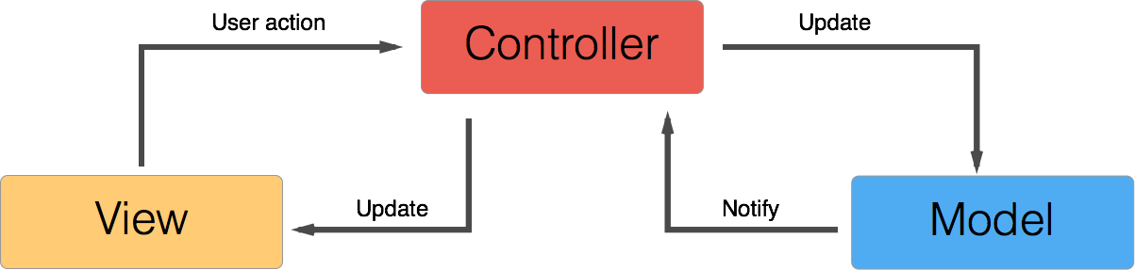

1. MVC Model and their relations

**Model**

The Model is responsible for holding the functions and variables that are involved with whatever it's representing. Model will be accessed by Controller instead of directly by view.

**View**

The View contain all of the markup, CSS, and etc... that you traditionally use with creating a static web page. Controller handles the data before turning it over to View, identifying where and when to show said data.

**Controller**

The controller is the core component which handles all data manipulation. A controller could connect multiple Views and Models together. Controller monitor the user’s interaction on View and alter them on Model, and vice versa, changes on Model are shown on View.

### Pros and Cons

**Pros**

* Can have multiple Views for a single Model.
* Avoid code duplication due to seperation of business logics.
* Modular, meaning changes don’t directly affect one another. Ease of recycle.
* Easy to manage and update components.

**Cons**

* Time consuming regarding structural design.
* Cumbersome for small projects.
* Require attention to details due to higher complexity.
* The division between the View and the Controller is not clear in some cases.
* Multiple pairs of controllers and views based on the same data model make data model change expensive

### Reasoning

By seperating the data from its presentation, programming becomes a lot easier. Components can be handled by different groups and each change will not affect the work of another. The seperation also means code recycling will be easier.

Another advantage is with debugging and testing. We can easily isolate the defective parts thanks to MVC and make changes necessary as soon as bugs are found.

# MEAN Stack And MEAN.JS Framework

## MEAN and MEAN.JS overview

**MEAN** is a collection of JavaScript-based technologies — **MongoDB**, **Express.js**, **AngularJS**, and **Node.js** — used to develop web applications. From the client and server sides to databases, MEAN is a full-stack development toolkit. Because all components of the MEAN stack support programs are written in JavaScript, MEAN applications can be written in one language for both server-side and client-side execution environments.

**MongoDB** is a free and open-source cross-platform document-oriented database. Classified as a NoSQL database, MongoDB avoids the traditional table-based relational database structure in favor of JSON-like documents with dynamic schemas (MongoDB calls the format BSON), making the integration of data in certain types of applications easier and faster.

**Express.js**, or simply Express, is a web application framework for Node.js. It is the de facto standard server framework for Node.js. Express is the backend part of the MEAN stack, together with MongoDB database and AngularJS frontend framework.

**AngularJS** is a complete JavaScript-based open-source front-end web application framework mainly maintained by Google and by a community of individuals and corporations to address many of the challenges encountered in developing single-page applications. The JavaScript components complement PhoneGap, the framework used for developing cross-platform mobile apps. It aims to simplify both the development and the testing of such applications.

**Node.js** is an open-source, cross-platform runtime environment for developing server-side Web applications. Although Node.js is not a JavaScript framework, many of its basic modules are written in JavaScript, and developers can write new modules in JavaScript. The runtime environment interprets JavaScript using Google's V8 JavaScript engine. Node.js has an event-driven architecture capable of asynchronous I/O. These design choices aim to optimize throughput and scalability in Web applications with many input/output operations, as well as for real-time Web applications.

**MEAN.JS** is a full-stack JavaScript solution that helps you build fast, robust, and maintainable production web applications using MongoDB, Express, AngularJS, and Node.js.

## Pros and Cons

**Pros**

* Use the same langage for both client and server.
* Exchange data by only JSON which improves the processing speed and RESTful service. JSON can be understood easily, which help with debugging and testing.
* Open source which bring huge community support, especially recyclable modules.
* Support mass connections.

**Cons**

* Lacking in documents due to being relatively new.
* Require browser to use and handle Javascript.

## Reasoning

By having a framework which only use one language, the team as a whole can learn and develop the system within the shortest possible time. Dividing the functions and features into modules enable the team to consult and learn stack’s structural components and customize their own module.

MEAN.JS is completely open sourced and is supported by multiple named organizations, the toolkit comes with its own template and test system which makes the environment setup a breeze. Having an official template and test system also means that most users would also use these tools, making it easier to exchange knowledge.

# Architectural Representation



1. System Overview

Built on the MVC architecture and MEAN.JS platform, the system includes these main components:

* Model – View – Controller: The 3 main components of the MVC mentioned in section 2. More noteworthy is that Controller is seperated into 2 parts for client and server to handle more efficiently. The seperation supports developing server and client independently, as the changes on one will not affect the other and vice versa.
* Facebook / Google API: support registering and logging in with Facebook/Google account.
* Service: connect via REST API (REpresentational State Transfer Application Programming Interface) to each of the server’s function and return data.
* Route: Bind each connection of REST API to a function from controller to process and transfer data.
* Policy: Limits possible connection depending on user’s type (guest, member, administrator).
* Repository: Connect and manipulate database.
* Database: The website’s data collection: MongoDB.

# Goals And Constraints

Refer to Software Requirements Specifications, section “Non-functional Specification”.

Other constraints:

* Unify server’s functions from the beginning and map them to REST API.
* Must support account creation and sign in via Facebook and Google.
* Other than Angular, Client may use additional external libraries such as jQuery or Bootstrap but should not be used extensively

# Logical View

## Package diagram



1. Package Diagram and their relations

### Model

1. List of Models in the system

|  |  |  |
| --- | --- | --- |
| No | Model | Description |
|  | User | Those who have an account on CRW, be it members or administrators |
|  | Company | Basic information on the company for the reviewers to write a review upon |
|  | Review | A review with grading on a company |
|  | OverallReview | A review with grading on a company’s general basis |
|  | SalaryAndBenefitReview | A review with grading on a company’s salary and benefit basis |
|  | Job | Reviewed professions within the CRW |
|  | Comment | User’s commentary on a review |
|  | Notification | A to-be-sent-note triggered by a pre-determined pool upon a required action |
|  | Report | A report upon a review due to its rule breaking nature or more |

### Controller (Server-side)

1. List of server-side controllers in the system

|  |  |  |
| --- | --- | --- |
| No | Name | Role |
|  | admin | Manage members |
|  | users | Handle CRUD regarding members |
|  | users.profile | Update user profile such as avatar, bio,… |
|  | users.password | Change and recover password |
|  | users.authorization | Fetch user data from database via ID |
|  | users.authentication | Handle user authentication |
|  | core | Handle homepage template and common errors |
|  | errors | Handle errors from server |
|  | companies | Handle CRUD regarding companies, reviews and comments |
|  | jobs | Handle CRUD regarding jobs |
|  | chat-config | Gửi thông báo từ server về client khi có sự kiện mới |

### Controller (Client-side)

1. List of client-side controllers in the system

|  |  |  |
| --- | --- | --- |
| No | Name | Role |
|  | AuthenticationController | Receive authentication and send to the server |
|  | PasswordController | Send and confirm token regarding password |
|  | UserProfileController | Handle information between server and view-user, edit-user |
|  | UserListController | Handle information between server and list-users |
|  | ChangePasswordController | Handle information between server and change-password |
|  | ChangeProfilePictureController | Handle information between server and change-profile-picture |
|  | EditProfileController | Handle information between server and edit-profile |
|  | SocialAccountsController | Handle information between server and manage-social-accounts |
|  | SettingsController | Handle information between server and settings |
|  | HomeController | Handle information between server and home |
|  | HeaderController | Handle information between server and header |
|  | CompaniesController | Handle information between server and view-company, form-company, edit-company |
|  | SearchCompaniesController | Handle information between server and list-companies |
|  | ReviewController | Handle information between server and view-review, form-review, edit-review |
|  | CompaniesListController | Handle information between server and list-companies |
|  | HandleReviewsController | Handle information between server and handle-review |
|  | CompaniesListController | Handle information between server and list-company (Control Panel) |
|  | AccountInfoController | Handle information between server and account-info |
|  | AnnouncementController | Handle information between server and announcement |
|  | BookmarkedReviewsController | Handle information between server and bookmarked-reviews |
|  | FollowedCompaniesController | Handle information between server and followed-companies |
|  | PostedReviewsController | Handle information between server and posted-reviews |

### View

1. List of View in the System

|  |  |  |
| --- | --- | --- |
| No | Name | Role |
|  | layout | Template containing the basic component of the website |
|  | index | Template connecting the layout to Angular on client side |
|  | 500 | Display error screen for server |
|  | 400 | Display error screen for HTTP request |
|  | 403 | Display error screen for lacking access rights |
|  | 404 | Display error screen for page not found |
|  | authentication | Login to the system with a social networking service account |
|  | signin | Login to the system with an email and a password |
|  | signup | Register an account in the system |
|  | view-user | Display user info |
|  | list-users | Display user list |
|  | edit-user | Change user info |
|  | forgot-password | Display password recover screen |
|  | reset-password | Display reset password screen |
|  | reset-password-invalid | Display invalid password reset token message |
|  | reset-password-success | Display valid password reset token message |
|  | change-password | Change user password |
|  | change-profile-picture | Change user avatar |
|  | edit-profile | Change user profile |
|  | manage-social-accounts | Manage social networking service accounts |
|  | settings | Change account settings |
|  | home | System’s homepage |
|  | header | System’s navigation bar |
|  | form-company | Add a company’s info |
|  | edit-company | Change company’s info |
|  | view-company | Add or remove a company |
|  | list-companies | Display company list |
|  | form-review | Add reviews |
|  | edit-review | Change review |
|  | view-review | View or remove a review |
|  | handle-review | Accept or reject reports of a review |
|  | account-info | Display current user’s info |
|  | announcement | Display current user’s notification |
|  | bookmarked-reviews | Display current user’s bookmarked reviews |
|  | followed-companies | Display current user’s followed companies |
|  | posted-reviews | Display current user’s posted reviews |

## Class diagram

Javascript does not have traditional Class, below are prototype diagrams within the project. More at <http://raganwald.com/2014/01/19/prototypes-are-not-classes.html>



1. Class Diagram – 1



1. Class Diagram – 2

## Sequence diagram

Refer to Software Requirements Specifications, section “Use Case Diagram”.

**Use case:** Search Review 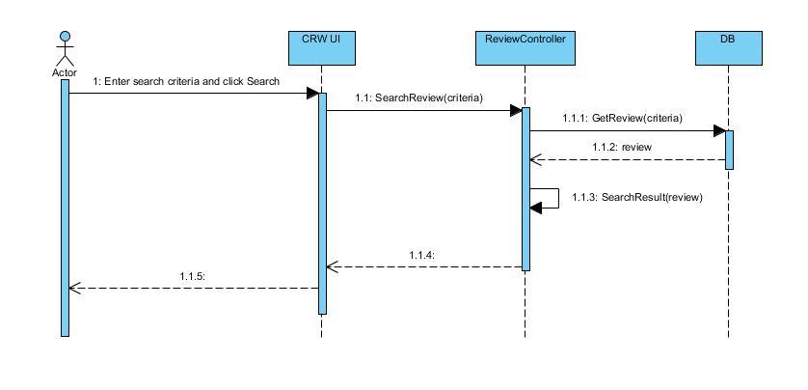

1. Sequence Diagram

**Use case:** Search Company 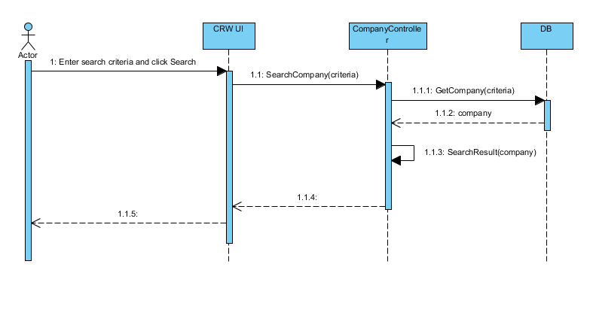

1. Sequence Diagram

**Use case:** Search Job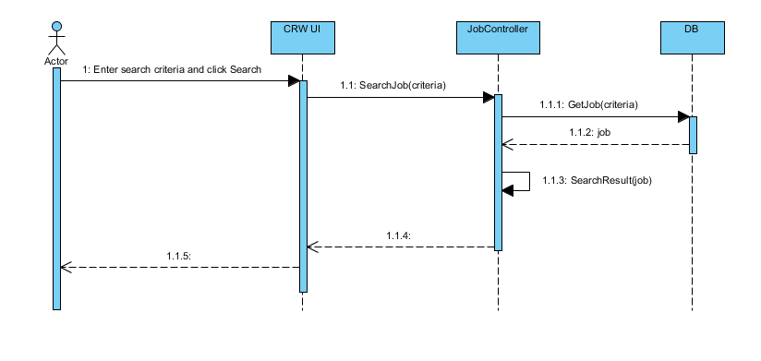

1. Sequence Diagram

**Use case:** Register 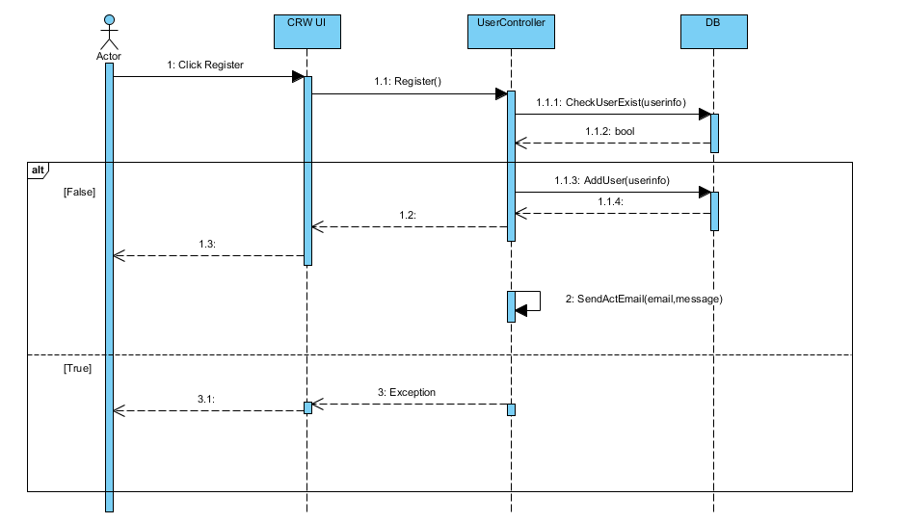

1. Sequence Diagram

**Use case:** Login 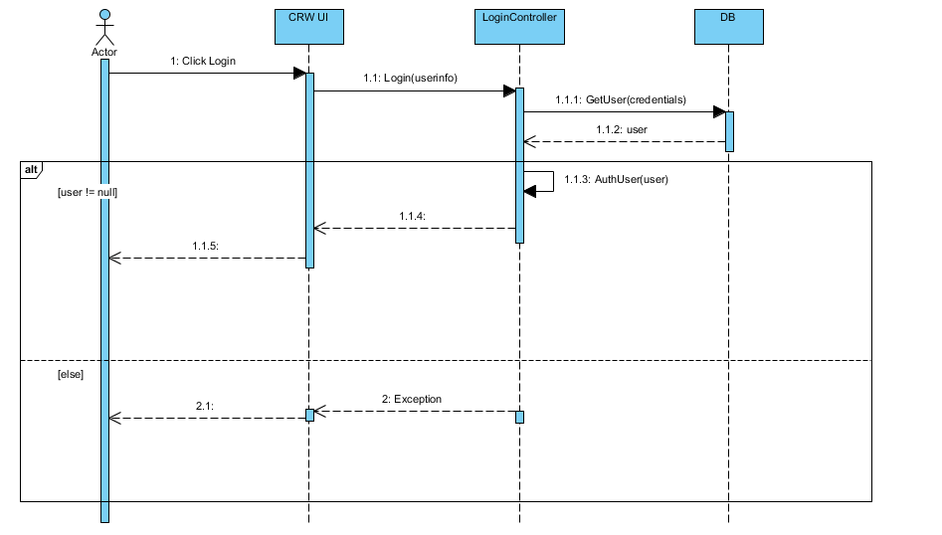

1. Sequence Diagram

**Use case:** Logout 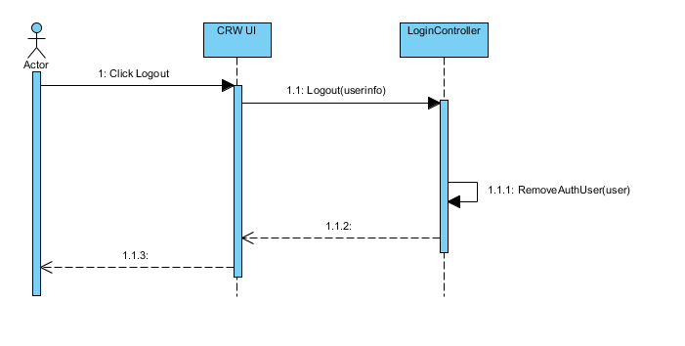

1. Sequence Diagram

**Use case:** Update Account Info 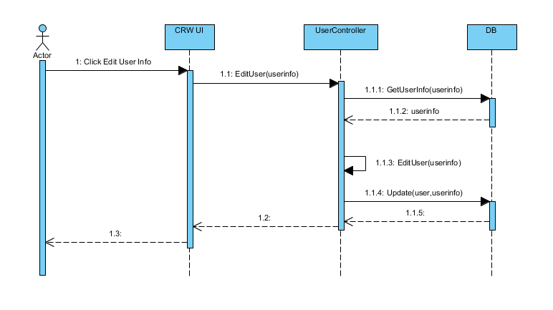

1. Sequence Diagram

**Use case:** Change Password 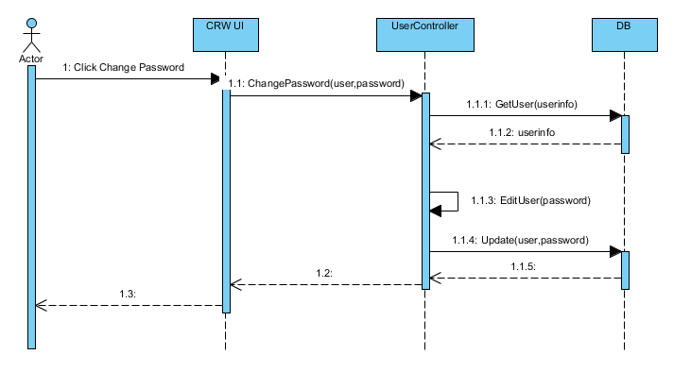

1. Sequence Diagram

**Use case:** Forgot Password 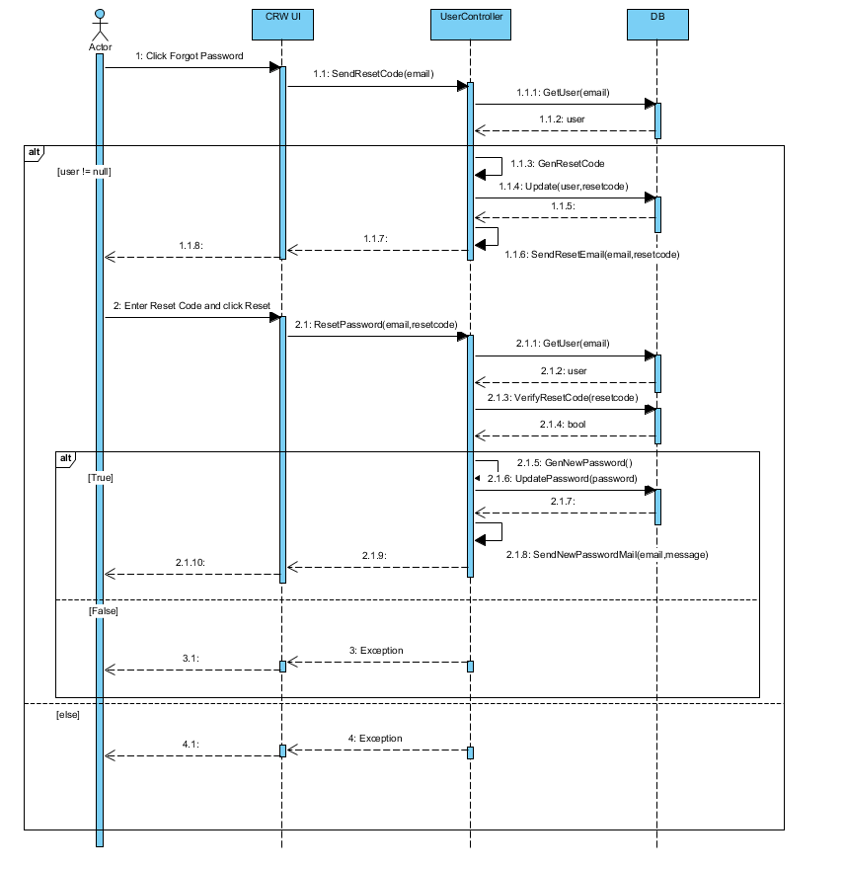

1. Sequence Diagram

**Use case:** Add Comment 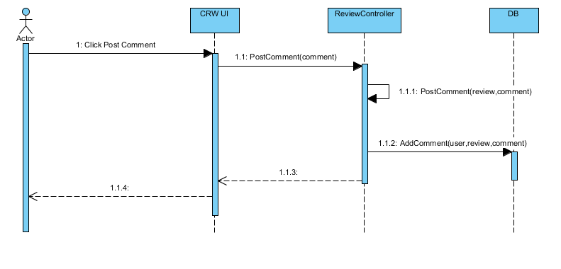

1. Sequence Diagram

**Use case:** Remove Comment 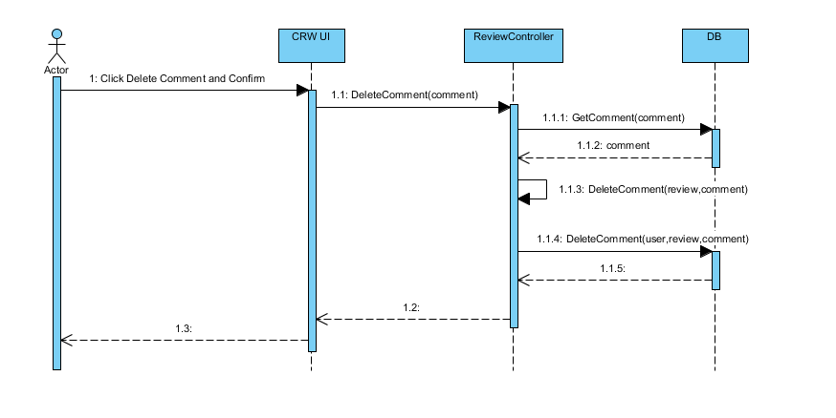

1. Sequence Diagram

**Use case:** Add Job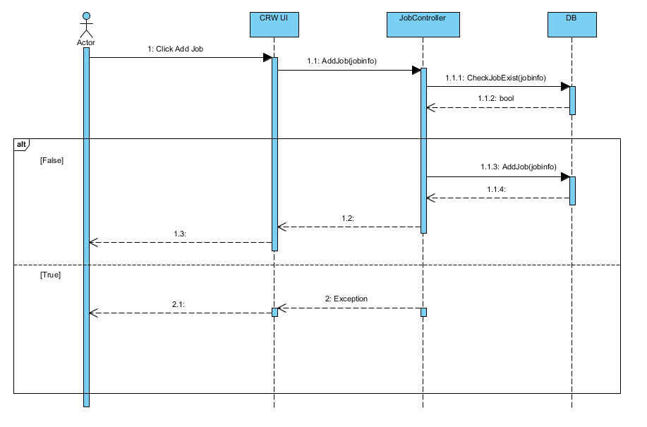

1. Sequence Diagram

**Use case:** Follow Company 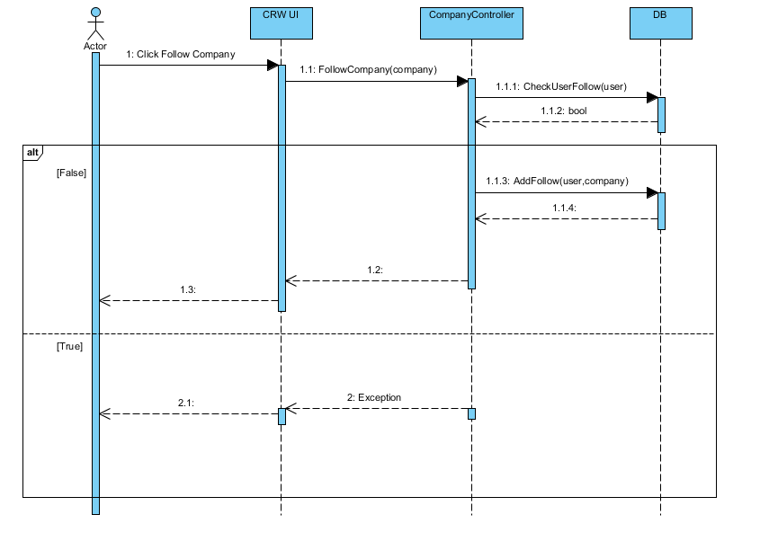

1. Sequence Diagram

**Use case:** Unfollow Company 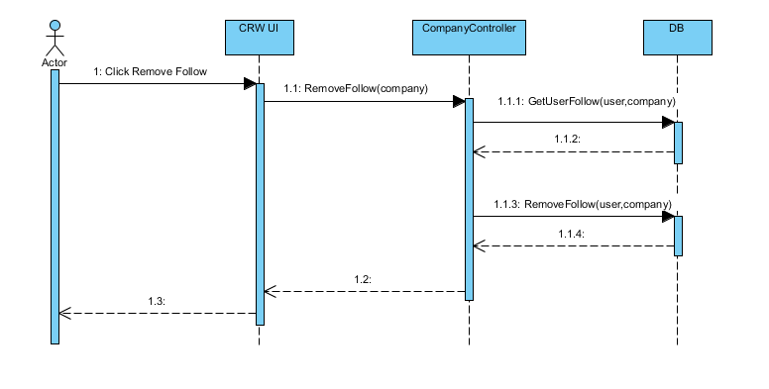

1. Sequence Diagram

**Use case:** Create Review 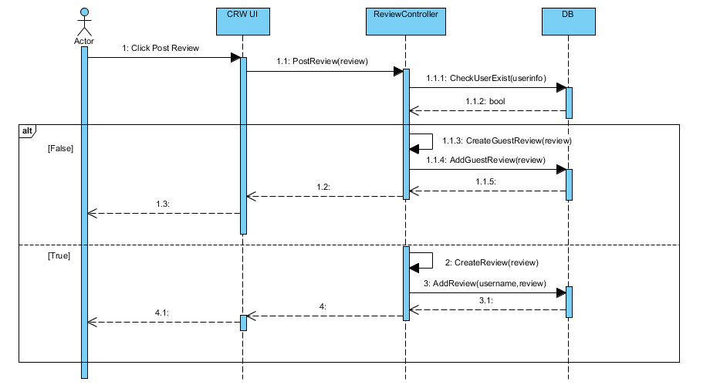

1. Sequence Diagram

**Use case:** Update Review 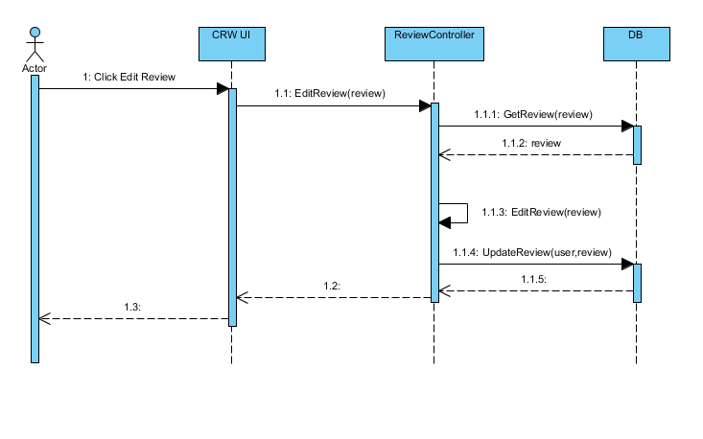

1. Sequence Diagram

**Use case:** Remove Review 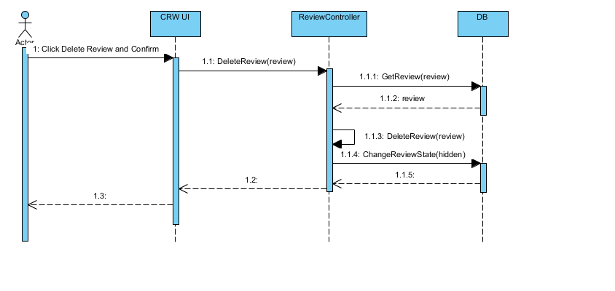

1. Sequence Diagram

**Use case:** Report Review 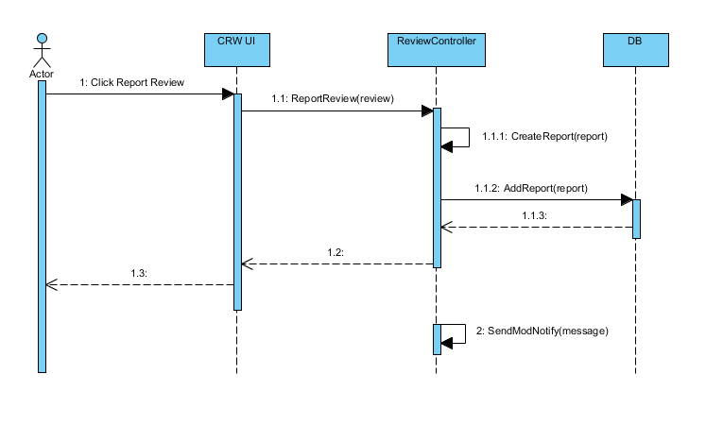

1. Sequence Diagram

**Use case:** Upvote Review 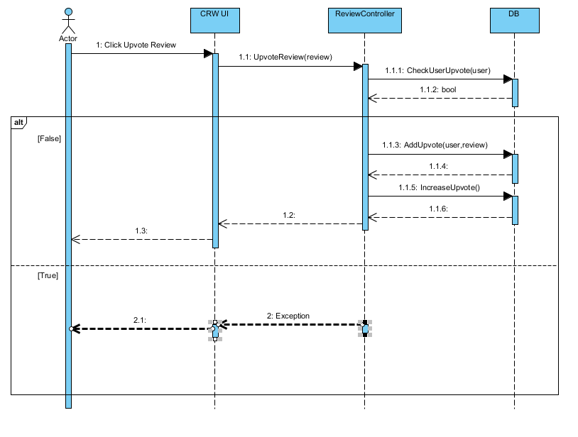

1. Sequence Diagram

**Use case:** Remove Review Upvote 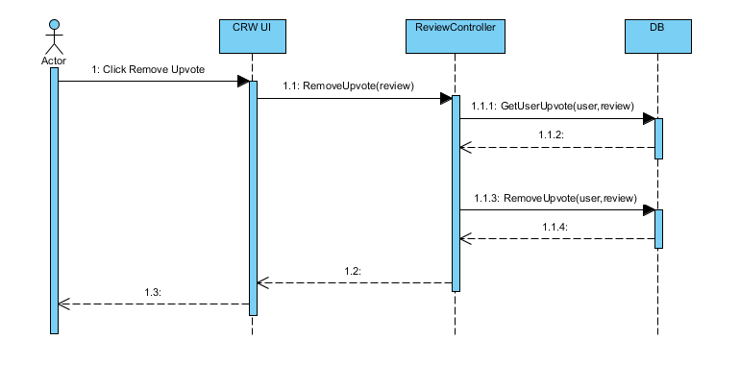

1. Sequence Diagram

**Use case:** Manage Followed Companies 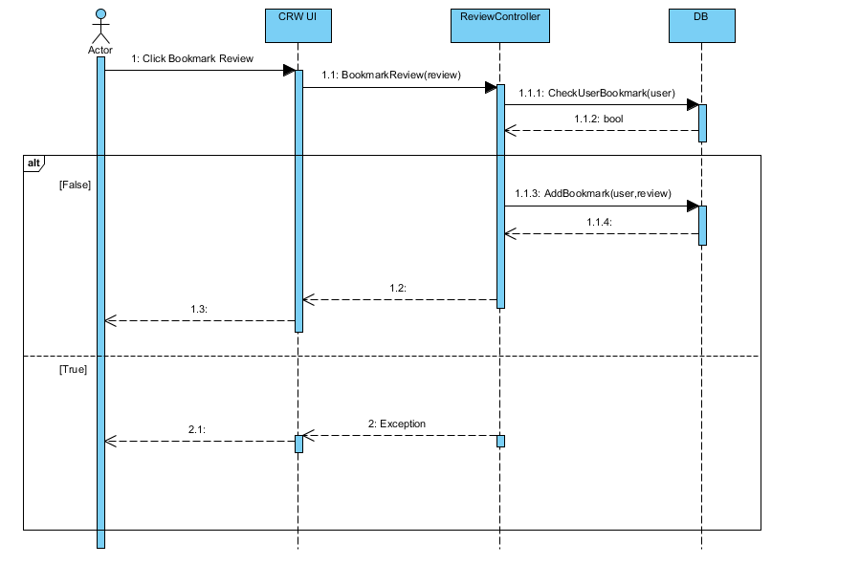

1. Sequence Diagram

**Use case:** Unfollow Company 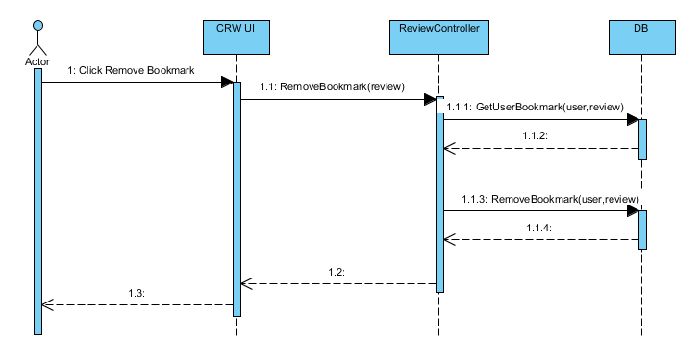

1. Sequence Diagram

**Use case:** Add Company 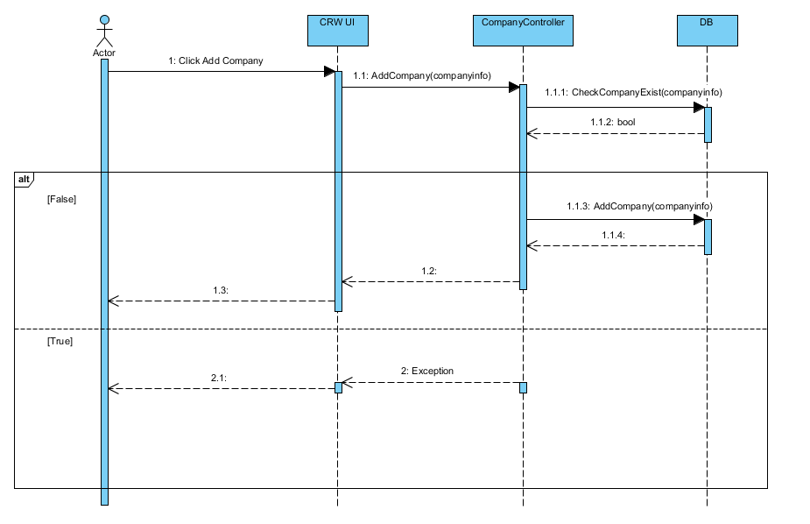

1. Sequence Diagram

**Use case:** Update Company 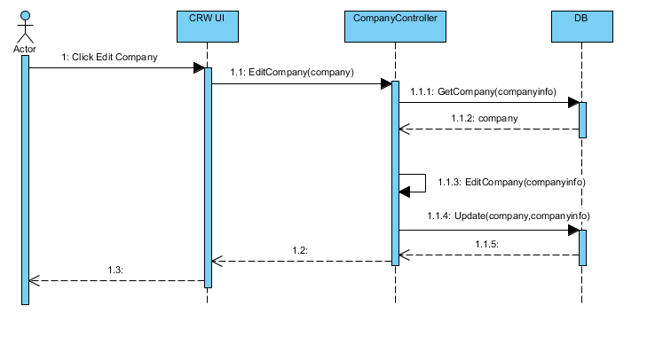

1. Sequence Diagram

**Use case:** Remove Company 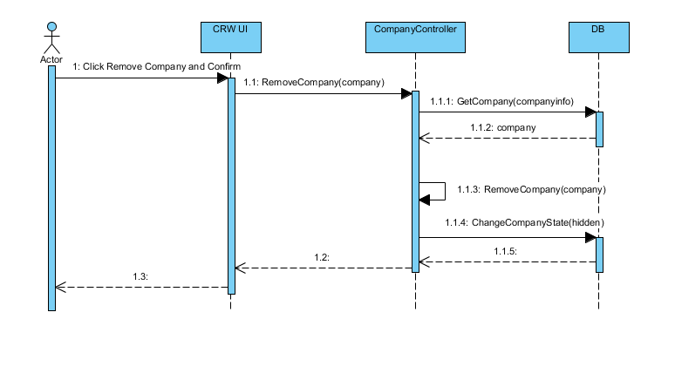

1. Sequence Diagram

**Use case:** Approve Report 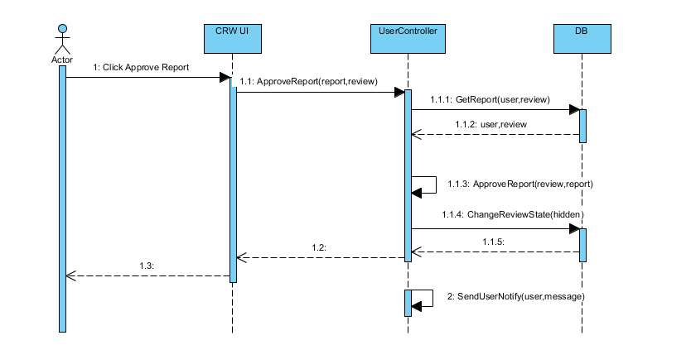

1. Sequence Diagram

**Use case:** Search Account 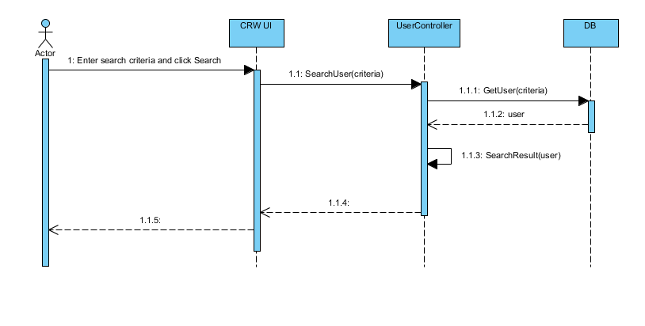

1. Sequence Diagram

# Deployment View



1. System Deployment View
2. System Components according to System Deployment View

|  |  |  |
| --- | --- | --- |
| No | Name | Description |
|  | Web Server | Server containing the core components of the webite |
|  | Client | Client’s browser which access and use the website’s services |
|  | Facebook | Facebook API Server |
|  | Google | Google API Server |
|  | Database | Contain system’s data. Use MongoDB. |

1. DATABASE DESIGN

# Database



## Entity-Relationship Diagram



1. Entity-Relationship Diagram

### Entity description

1. List of entities and their description

|  |  |  |
| --- | --- | --- |
| No | Entity | Description |
|  | User | Those who have an account on CRW, be it members or administrators |
|  | Company | Basic information on the company for the reviewers to write a review upon |
|  | Review | A review with grading on a company |
|  | OverallReview | A review with grading on a company’s general basis |
|  | SalaryAndBenefitReview | A review with grading on a company’s salary and benefit basis |
|  | Job | Reviewed professions within the CRW |
|  | Comment | User’s commentary on a review |
|  | Notification | A to-be-sent-note triggered by a pre-determined pool upon a required action |
|  | Report | A report upon a review due to its rule breaking nature or more |

### Relationship

1. List of entities and their relationship within the system

|  |  |  |  |  |  |
| --- | --- | --- | --- | --- | --- |
| No | Relation | Properties | From | To | Description |
|  | TRANSFER | Send Date | RU | Notification | RU receive Notification from a triggering event |
|  | HAS | Create Date  Modify Date | RU | Review | RU interact with owned Review  AD interact with all Reviews |
|  | VOTE |  | RU | Review | RU give or remove an upvote from a Review |
|  | TRANSFER | Send Date | RU | Report | RU send a report  AD revise a report |
|  | ALTER |  | Report | Review | Report may or may not change a Review’s state depending on the AD |
|  | CONTRIBUTE |  | RU | Company | RU contribute to a Company’s info |
|  | HAS |  | Review | Company | Company receive Reviews from RU |
|  | CONTRIBUTE |  | RU | Job | RU contribute to Job’s name |
|  | HAS |  | RU | Credential | Account credentials for privacy |
|  | Has |  | RU | FBCredential | FB registered Account credentials for privacy |
|  | HAS |  | RU | Comment | RU interact with owned Comment |

# Collection Diagram

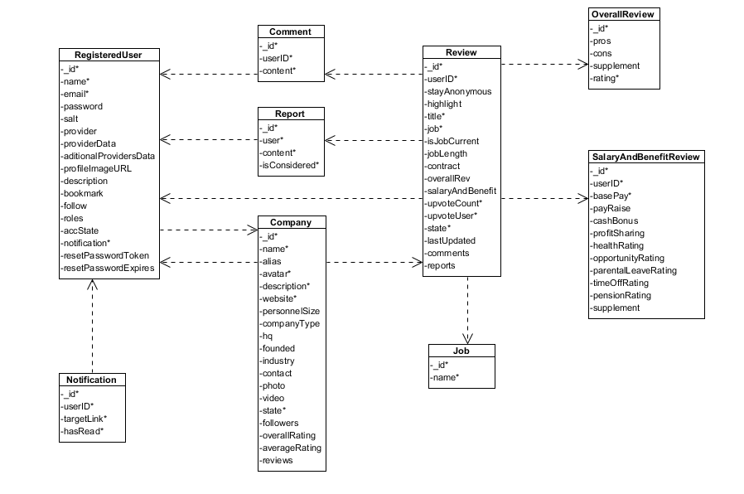

1. Collection Diagram
2. *User*
3. List of User properties

|  |  |  |  |  |
| --- | --- | --- | --- | --- |
| No | Name | Type | Required | Description |
|  | _id | ObjectID | Y | An identifier for accounts |
|  | name | String | Y | Displayed name |
|  | email | String | Y | Account’s email |
|  | password | String | N | Password if account is registered with an email |
|  | salt | String | N | Support password encryptions |
|  | provider | String | N | 3rd party ID for login |
|  | providerData | String | N | Required data from 3rd party |
|  | additionalProvidersData | String | N | Gathered data from 3rd party |
|  | profileImageURL | String | N | Account’s avatar |
|  | description | String | N | Account’s personal info |
|  | bookmark | Array | N | Bookmarked reviews’ identifier |
|  | follow | Array | N | Followed companies’ identifier |
|  | roles | String | Y | Account type (Member, Administrator) |
|  | accState | String | Y | Account state (Active, Banned) |
|  | notification | Array | Y | Notification. Has subcollection *Notification* |
|  | resetPasswordToken | String | N | Token used in password reset |
|  | resetPasswordExpires | Date | N | Token’s expire date |

1. *Company*
2. List of Company properties

|  |  |  |  |  |
| --- | --- | --- | --- | --- |
| No | Name | Type | Required | Description |
|  | _id | ObjectID | Y | An identifier for companies |
|  | name | String | Y | Company’s name |
|  | alias | Array | N | Company’s aliases |
|  | avatar | String | Y | Company’s avatar |
|  | description | String | Y | Company’s detailed info |
|  | website | String | Y | Company’s website |
|  | personnelSize | String | N | Company’s personnel size |
|  | companyType | String | N | Company’s type |
|  | hq | String | N | Company’s headquarter |
|  | founded | Date | N | Company’s founded date |
|  | industry | String | N | Company’s industrial focus |
|  | contact | String | N | Company’s contact |
|  | photo | Array | N | Company’s photoes |
|  | video | Array | N | Company’s video |
|  | state | String | Y | Company’s current state (Active, Locked) |
|  | followers | Array | N | Company’s follower pool |
|  | overallRating | Number | N | Company’s overall rating |
|  | averageRating | Number | N | Company’s average rating |
|  | reviews | Array | N | Company’s reviews pool |

1. *Review*
2. List of General Review properties

|  |  |  |  |  |
| --- | --- | --- | --- | --- |
| No | Name | Type | Required | Description |
|  | _id | ObjectID | Y | An identifier for reviews |
|  | userID | ObjectID | Y | An identifier for reviewers |
|  | stayAnonymous | Boolean | N | Anonimity of the reviewer |
|  | highlight | Boolean | N | State of reviews’ highlight |
|  | title | String | Y | Review’s title |
|  | job | Array | Y | Reviewer’s profession |
|  | isJobCurrent | String | N | Reviewer’s current state of profession |
|  | jobLength | String | N | Reviewer’s time soent as stated profession |
|  | contract | String | N | Reviewer’s type of contract |
|  | overallRev |  | N | Has subcollection *OverallReview* |
|  | salaryAndBenefit |  | N | Has subcollection *SalaryAndBenefitReview* |
|  | upvoteCount | Number | Y | Review’s amount of upvote |
|  | upvoteUser | Array | Y | Review’s upvoter pool |
|  | state | String | Y | Review’s state (Approved, Rejected, Pending) |
|  | lastUpdated | Date | N | Review’s last updated date |
|  | comments | Array | N | Has subcollection *Comment* |
|  | reports | Array | N | Has subcollection *Report* |

1. *OverallReview*
2. List of Overall Review properties

|  |  |  |  |  |
| --- | --- | --- | --- | --- |
| No | Name | Type | Required | Description |
|  | _id | ObjectID | Y | An identifier for reviews |
|  | pros | String | N | Review’s pros regarding the company |
|  | cons | String | N | Review’s cons regarding the company |
|  | supplement | String | N | Additional information regarding the company |
|  | rating | Number | Y | Review’s grading of the company |

1. *SalaryAndBenefitReview*
2. List of Salary and Benefit Review properties

|  |  |  |  |  |
| --- | --- | --- | --- | --- |
| No | Name | Type | Required | Description |
|  | _id | ObjectID | Y | An identifier for reviews |
|  | userID | ObjectID | Y | An identifier for reviewers |
|  | basePay | Number | Y | Reviewer’s base payment |
|  | payRaise | Number | N | Reviewer’s adjusted payment raise |
|  | cashBonus | Number | N | Reviewer’s bonus in cash |
|  | profitSharing | Number | N | Reviewer’s share in profit |
|  | healthRating | Number | N | Reviewer’s grading on healthcare policies |
|  | opportunity Rating | Number | N | Reviewer’s grading on promotion opportunity |
|  | parentalLeaveRating | Number | N | Reviewer’s grading on parental leave policies |
|  | timeOffRating | Number | N | Reviewer’s grading on paid leave policies |
|  | pensionRating | Number | N | Reviewer’s grading on pension policies |
|  | supplement | String | N | Additional information regarding the company |

1. *Job*
2. List of Job properties

|  |  |  |  |  |
| --- | --- | --- | --- | --- |
| No | Name | Type | Required | Description |
| 1. 1 | _id | ObjectID | Y | An identifier for professions |
|  | name | String | Y | Profession’s name |

1. *Comment*
2. List of Comment properties

|  |  |  |  |  |
| --- | --- | --- | --- | --- |
| No | Name | Type | Required | Description |
|  | _id | ObjectID | Y | An identifier for comments |
|  | userID | ObjectID | Y | Comment’s writer |
|  | content | String | Y | Comment’s content |

1. *Notification*
2. List of Notification properties

|  |  |  |  |  |
| --- | --- | --- | --- | --- |
| No | Name | Type | Required | Description |
|  | _id | ObjectID | Y | An identifier for notifications |
|  | message | String | Y | Notification’s content |
|  | targetLink | String | Y | Notification’s hyperlink |
|  | hasRead | Boolean | Y | Notification’s state (Read, Not Read) |

1. *Report*
2. List of Report properties

|  |  |  |  |  |
| --- | --- | --- | --- | --- |
| No | Name | Type | Required | Description |
|  | _id | ObjectID | Y | An identifier for reports |
|  | user | ObjectID | Y | An identifier for reporters |
|  | content | String | Y | Report’s content |
|  | isConsidered | String | Y | Report’s state (Approved, Ignored) |

1. SCREEN DESIGN

# Screen Flow



1. Client Screen Flow

# Screen Design

## Header



1. Header
2. Header

|  |  |  |  |  |  |  |  |
| --- | --- | --- | --- | --- | --- | --- | --- |
| No | Field name | Field name in Vietnamese | Type | Require | Mandatory | Max-Length | Description |
|  | CRW Logo | Lô gô CRW | Image |  |  |  | CRW’s logo |
|  | CRW Logo | Lô gô CRW | Hyperlink | Click |  |  | Go to CRW Hompage screen |
|  | Searchbar | Thanh tìm kiếm | Textbox | Input |  |  | Input keywords for searching companies |
|  | Search | Tìm kiếm | Button | Click |  |  | Search for matching companies with inputted keywords |
|  | Company | Công ty | Hyperlink | Click |  |  | Go to the Company List screen |
|  | Homepage | Trang chủ | Hyperlink | Click |  |  | Go to the CRW Homepage screen |
|  | Login | Đăng nhập | Hyperlink | Click |  |  | Go to the Login screen |
|  | Register | Đăng ký | Hyperlink | Click |  |  | Go to the Register screen |

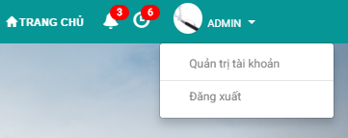

1. Header (Logged in)
2. Header (Logged in)

|  |  |  |  |  |  |  |  |
| --- | --- | --- | --- | --- | --- | --- | --- |
| No | Field name | Field name in Vietnamese | Type | Require | Mandatory | Max-Length | Description |
|  | Notification | Thông báo | Hyperlink | Click |  |  | Go to the Notification List screen |
|  | Pending Reviews/Reports | Đánh giá/báo cáo đang chờ | Hyperlink | Click |  |  | Go to the Pending Review/Reports screen (Administrator) |
|  | Avatar | Ảnh đại diện | Image |  |  |  | Account’s avatar |
|  | Account Name | Tên tài khoản | Label |  |  |  | Account’s name |
|  | Account Name | Tên tài khoản | Dropdown Menu | Click |  |  | Opens the dropdown menu for other functions |
|  | Account Management | Quản lý tài khoản | Hyperlink | Click |  |  | Go to the Account Management screen |
|  | Logout | Đăng xuất | Hyperlink | Click |  |  | Logs the current account out |

## Footer



1. Footer
2. Footer

|  |  |  |  |  |  |  |  |
| --- | --- | --- | --- | --- | --- | --- | --- |
| No | Field name | Field name in Vietnamese | Type | Require | Mandatory | Max-Length | Description |
|  | CRW Name | Tên trang web | Text |  |  |  | CRW’s name |
|  | Homepage | Trang chủ | Hyperlink | Click |  |  | Go to the CRW Homepage screen |
|  | About Us | Về chúng tôi | Hyperlink | Click |  |  | Open the About Us popup modal box |
|  | Contact | Liên hệ | Hyperlink | Click |  |  | Open the Contact popup modal box |

## Homepage

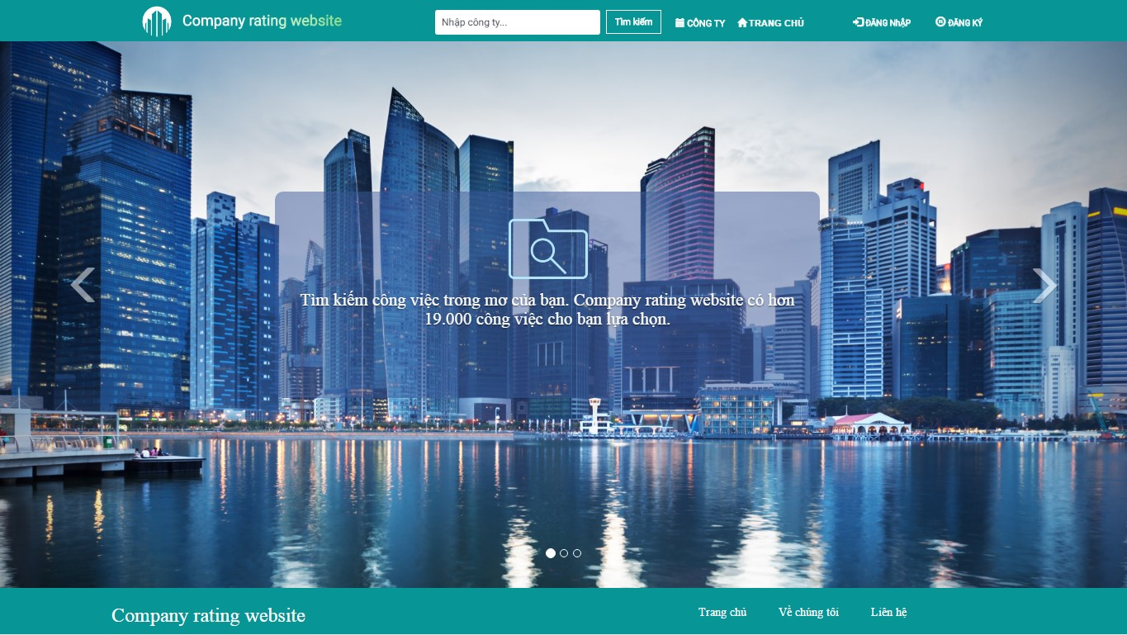

1. Homepage
2. Homepage

|  |  |  |  |  |  |  |  |
| --- | --- | --- | --- | --- | --- | --- | --- |
| No | Field name | Field name in Vietnamese | Type | Require | Mandatory | Max-Length | Description |
|  | Homepage | Trang chủ | Carousel | Click |  |  | A carosel of background images and CRW’s statements |

## Register

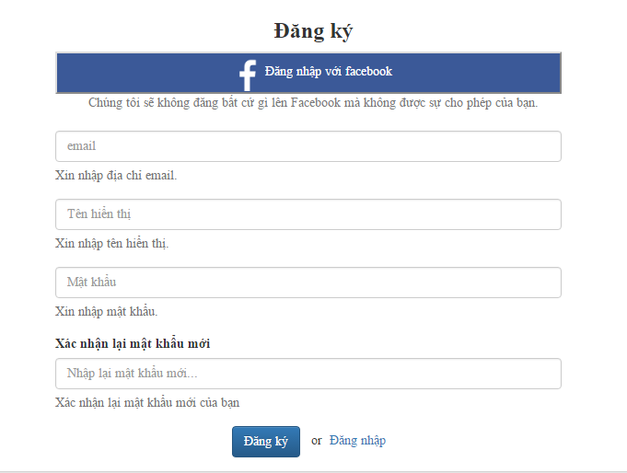

1. Register form
2. Register form

|  |  |  |  |  |  |  |  |
| --- | --- | --- | --- | --- | --- | --- | --- |
| No | Field name | Field name in Vietnamese | Type | Require | Mandatory | Max-Length | Description |
|  | Register | Đăng ký | Label |  |  |  | Label for Register form |
|  | Login với Facebook | Đăng nhập với Facebook | Button | Click |  |  | Login with Facebook |
|  | Facebook Note | Lưu ý Facebook | Label |  |  |  | Label for note when registering with Facebook |
|  | Email | Email | Textbox | Type | Y |  | Input user’s email |
|  | Email | Email | Label |  |  |  | Label for Email when field is empty or does not meet requirement |
|  | Account Name | Tên tài khoản | Textbox | Type | Y |  | Input Account display name |
|  | Account Name | Tên tài khoản | Label |  |  |  | Label for Account Name when field is empty or does not meet requirement |
|  | Password | Mật khẩu | Textbox | Type | Y | 8-50 | Input Password |
|  | Password | Mật khẩu | Label |  |  |  | Label for Password when field is empty or does not meet requirement |
|  | Input Confirm Password | Nhập lại mật khẩu | Textbox | Type | Y | 8-50 | Input Confirm Password |
|  | Input Confirm Password | Nhập lại mật khẩu | Label |  |  |  | Label for Confirm Password when field is empty or does not meet requirement |
|  | Password Strength | Độ mạnh của mật khẩu | Progress Bar |  |  |  | Show the relative strength of the password |
|  | Register | Đăng ký | Button | Click |  |  | Confirm Account Registration |
|  | Login | Đăng nhập | Hyperlink | Click |  |  | Go to the Login screen |

## Login

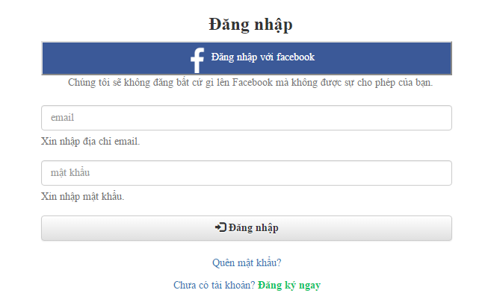

1. Login form
2. Login form

|  |  |  |  |  |  |  |  |
| --- | --- | --- | --- | --- | --- | --- | --- |
| No | Field name | Field name in Vietnamese | Type | Require | Mandatory | Max-Length | Description |
|  | Login | Đăng nhập | Label |  |  |  | Label for Login form |
|  | Login with Facebook | Đăng nhập qua Facebook | Button | Click |  |  | Login with Facebook |
|  | Facebook Note | Lưu ý Facebook | Label |  |  |  | Label for note when registering with Facebook |
|  | Email | Email | Textbox | Type | Y |  | Input registered Email |
|  | Email | Email | Label |  |  |  | Label for Email when field is empty or does not meet requirement |
|  | Password | Mật khẩu | Textbox | Type | Y |  | Input registered Password |
|  | Password | Mật khẩu | Label |  |  |  | Label for Password when field is empty or does not meet requirement |
|  | Login | Đăng nhập | Button | Click |  |  | Confirm Login |
|  | Forgot Password | Quên mật khẩu | Hyperlink | Click |  |  | Go to the Forgot Password screen |
|  | Register Now | Đăng ký ngay | Hyperlink | Click |  |  | Go to the Register screen |

## Forgot Password

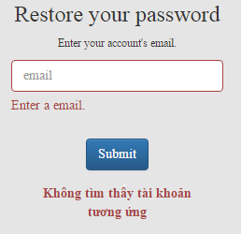

1. Forgot Password form
2. Forgot Password form

|  |  |  |  |  |  |  |  |
| --- | --- | --- | --- | --- | --- | --- | --- |
| No | Field name | Field name in Vietnamese | Type | Require | Mandatory | Max-Length | Description |
|  | Forgot Password | Quên mật khẩu | Label |  |  |  | Label for Forgot Password form |
|  | Email | Email | Textbox | Input | Y |  | Input account’s email for password restoration |
|  | Email | Email | Label |  |  |  | Label for Email when field is empty |
|  | Restore Password | Khôi phục mật khẩu | Button | Click |  |  | Request the system to restore the password via inputted email |
|  | Restore Password | Khôi phục mật khẩu | Label |  |  |  | Label for Restore Password when the email is either successfully sent or not |

## Account Management

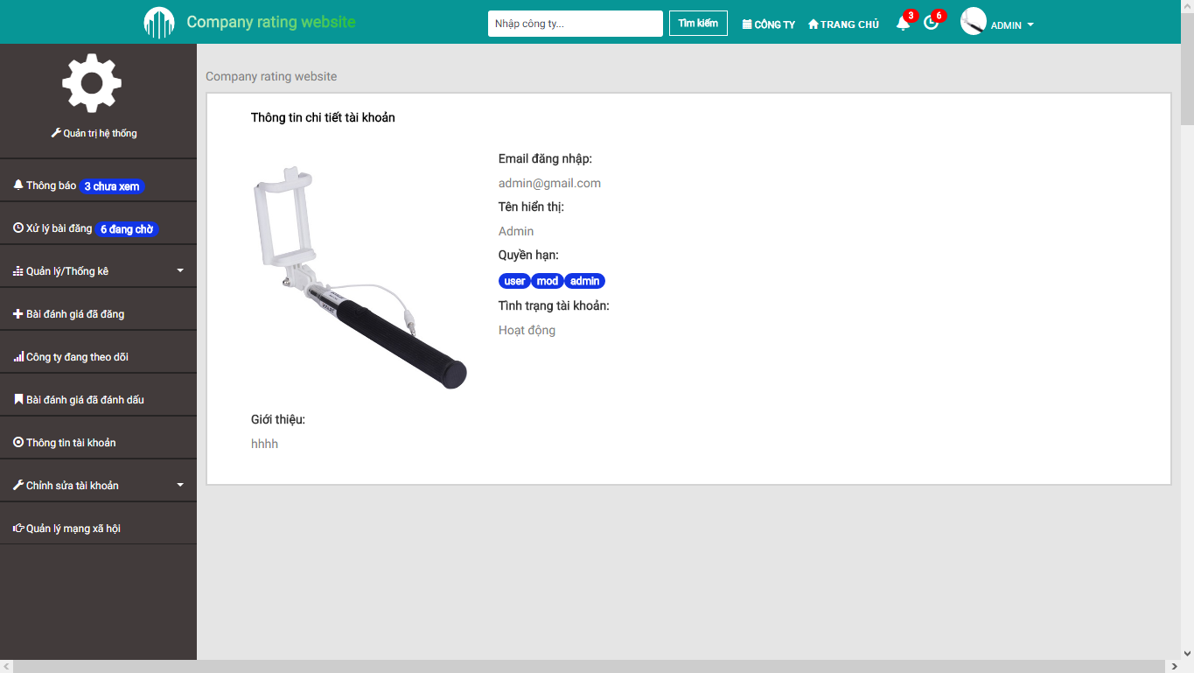

1. Account Management

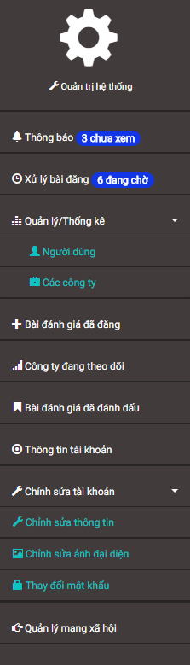

1. Account Management Menu
2. Account Management Menu

|  |  |  |  |  |  |  |  |
| --- | --- | --- | --- | --- | --- | --- | --- |
| No | Field name | Field name in Vietnamese | Type | Require | Mandatory | Max-Length | Description |
|  | Account Management Menu | Menu quản lý tài khoản | Sidebar |  |  |  | List of all available functions regarding management |
|  | Account Management | Quản lý tài khoản | Label |  |  |  | Label for Account Management menu |
|  | Notification | Thông báo | Hyperlink | Click |  |  | Go to the Notification List screen |
|  | Pending Reviews/Reports | Đánh giá/báo cáo đang chờ | Hyperlink | Click |  |  | Go to the Pending Review/Reports screen (Administrator) |
|  | Management And Statistics | Quản lý và thống kê | Dropdown Menu | Click |  |  | Opens the dropdown menu for other functions (Administrator) |
|  | User Management And Statistics | Quản lý và thống kê người dùng | Hyperlink | Click |  |  | Go to the User Management screen (Administrator) |
|  | Company Management And Statistics | Quản lý và thống kê công ty | Hyperlink | Click |  |  | Go to the Company Management screen (Administrator) |
|  | Submitted Reviews | Bài đánh giá đã đăng | Hyperlink | Click |  |  | Go to the Review List screen |
|  | Following Companies | Công ty đang theo dõi | Hyperlink | Click |  |  | Go to the Follow Company List screen |
|  | Bookmarked Reviews | Bài đánh giá đã đánh dấu | Hyperlink | Click |  |  | Go to the Bookmark List screen |
|  | Account Info | Thông tin tài khoản | Hyperlink | Click |  |  | Go to the Account Info screen |
|  | Edit Account | Chỉnh sửa tài khoản | Dropdown Menu | Click |  |  | Opens the dropdown menu for other functions |
|  | Edit Account Profile | Chỉnh sửa thông tin | Hyperlink | Click |  |  | Go to the Edit Profile screen |
|  | Change Account Avatar | Thay đổi ảnh đại diện | Hyperlink | Click |  |  | Go to the Change Avatar screen |
|  | Change Account Password | Thay đổi mật khẩu | Hyperlink | Click |  |  | Go to the Change Password screen |
|  | Social Network Management | Quản lý mạng xã hội | Hyperlink | Click |  |  | Go to the Social Account screen |

## Notification

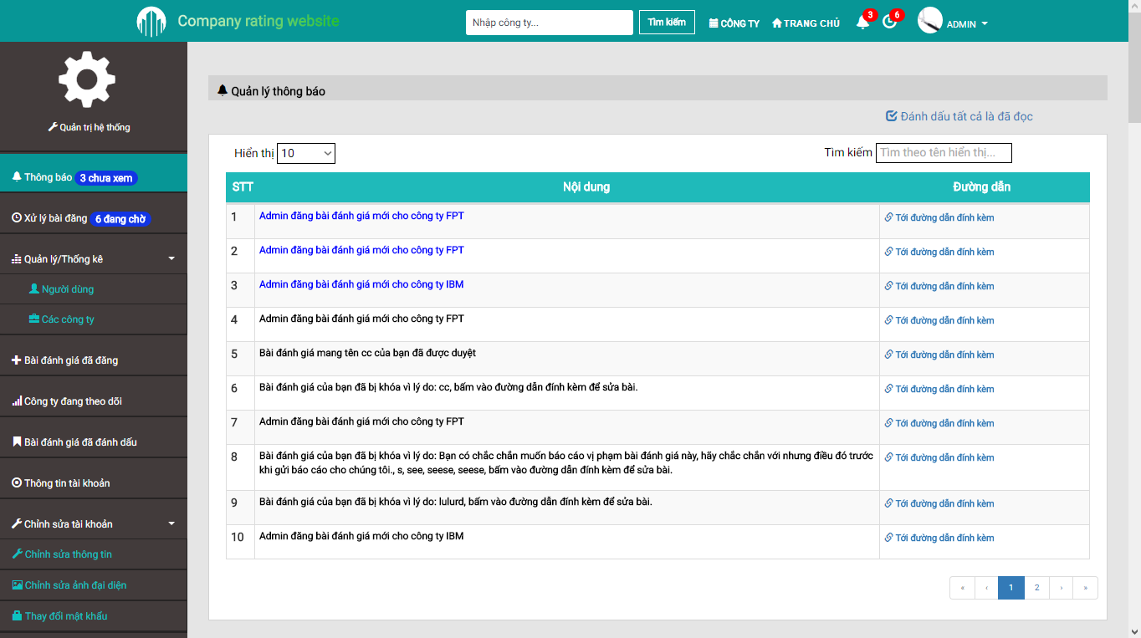

1. Notification Screen

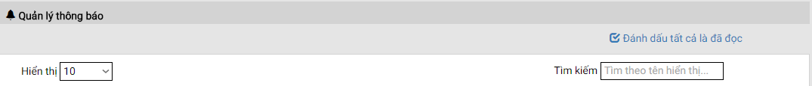

1. Search and Filter (Notification)
2. Search and Filter (Notification)

|  |  |  |  |  |  |  |  |
| --- | --- | --- | --- | --- | --- | --- | --- |
| No | Field name | Field name in Vietnamese | Type | Require | Mandatory | Max-Length | Description |
|  | Notification | Thông báo | Label |  |  |  | Label for Notification section |
|  | Mark All As Read | Đánh dấu tất cả đã đọc | Hyperlink | Click |  |  | Mark all notification as read |
|  | Display Limit | Giới hạn hiển thị | Select | Click |  |  | Limit the amount of notifications per single page |
|  | Filter | Bộ lọc | Textbox | Input |  |  | Filter the notifications accordingly to inputted keyword(s) |

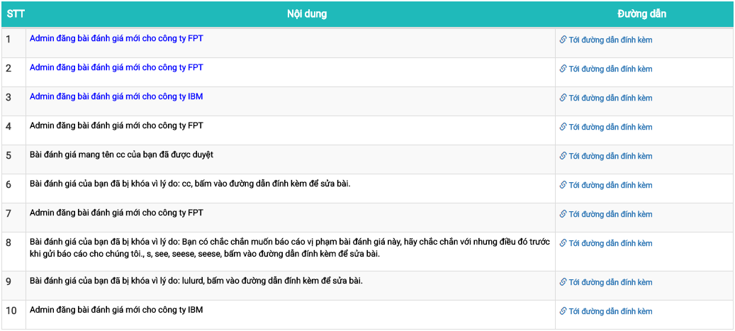

1. Notification Table
2. Notification Table

|  |  |  |  |  |  |  |  |
| --- | --- | --- | --- | --- | --- | --- | --- |
| No | Field name | Field name in Vietnamese | Type | Require | Mandatory | Max-Length | Description |
|  | Numbering | Số thứ tự | Label |  |  |  | Label for the numbering of a notification |
|  | Content | Nội dung | Text |  |  |  | The content of a notification  (Blue = Not Read, Black = Read) |
|  | Notification Link | Đường dẫn thông báo | Hyperlink | Click |  |  | Go to the notification’s triggering event |

## Pending Reviews/Reports

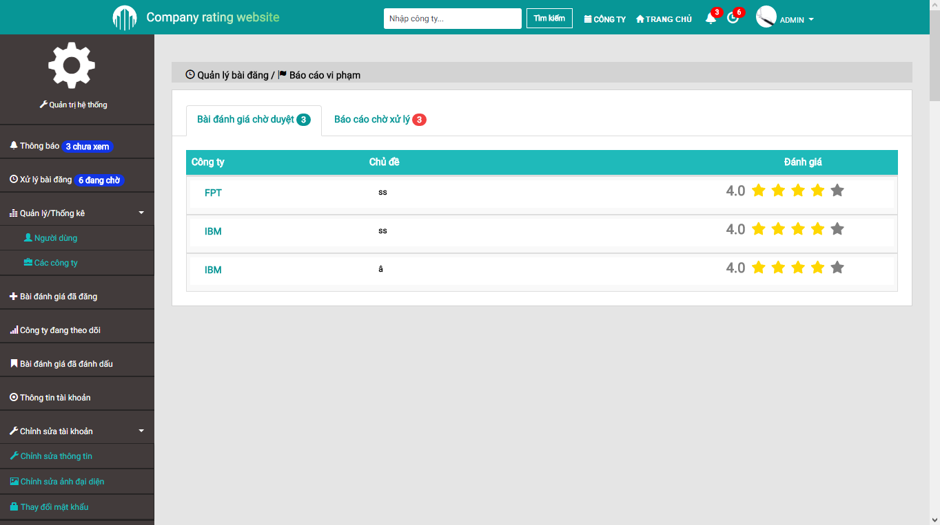

1. Pending Reviews/Reports Screen

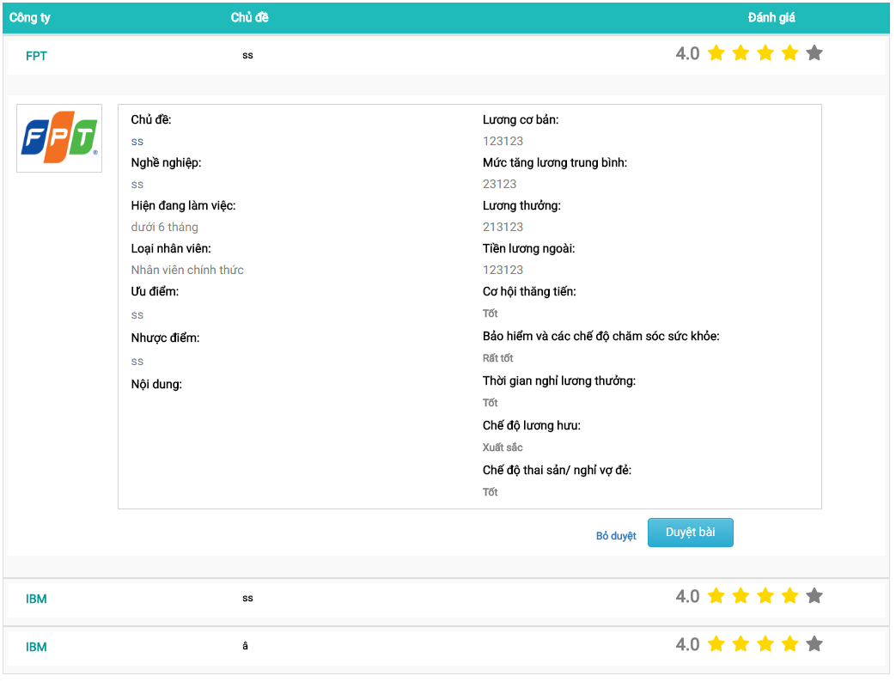

1. Pending Reviews
2. Pending Reviews

|  |  |  |  |  |  |  |  |
| --- | --- | --- | --- | --- | --- | --- | --- |
| No | Field name | Field name in Vietnamese | Type | Require | Mandatory | Max-Length | Description |
|  | Pending Reviews/Reports | Đánh giá/báo cáo đang chờ | Label |  |  |  | Label for Pending Reviews/Reports section |
|  | Pending Reviews | Đánh giá đang chờ | Tab | Click |  |  | Go to the Pending Reviews tab |
|  | Pending Reports | Báo cáo đang chờ | Tab | Click |  |  | Go to the Pending Reports tab |
|  | Company Name | Tên công ty | Label |  |  |  | Company’s name |
|  | Review Title | Tên bài đánh giá | Label |  |  |  | Review’s title |
|  | Review Rating | Điểm đánh giá | Label |  |  |  | Show the rating given by this review as number |
|  | Review Rating Star | Điểm đánh giá sao | Star Rating Bar |  |  |  | Show the rating given by this review as stars |
|  | Review | Bài đánh giá | Hyperlink | Click |  |  | Expand the chosen review to show its details |

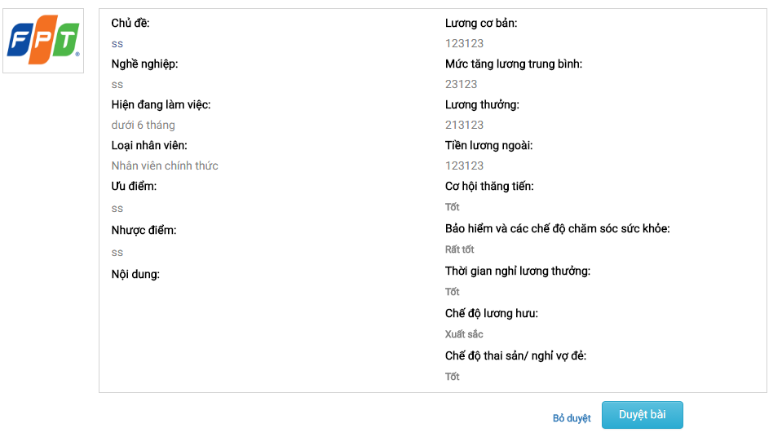

1. Pending Review Details
2. Pending Review Details

|  |  |  |  |  |  |  |  |
| --- | --- | --- | --- | --- | --- | --- | --- |
| No | Field name | Field name in Vietnamese | Type | Require | Mandatory | Max-Length | Description |
|  | Company Avatar | Ảnh đại diện công ty | Image |  |  |  | Company’s logo |
|  | Pending Review Details | Nội dung bài đánh giá đang chờ | Panel |  |  |  | Show the details of this pending review |
|  | Approve | Chấp nhận | Button | Click |  |  | Change the state of this pending review to Approved |
|  | Reject | Từ chối | Button | Click |  |  | Change the state of this pending review to Rejected |

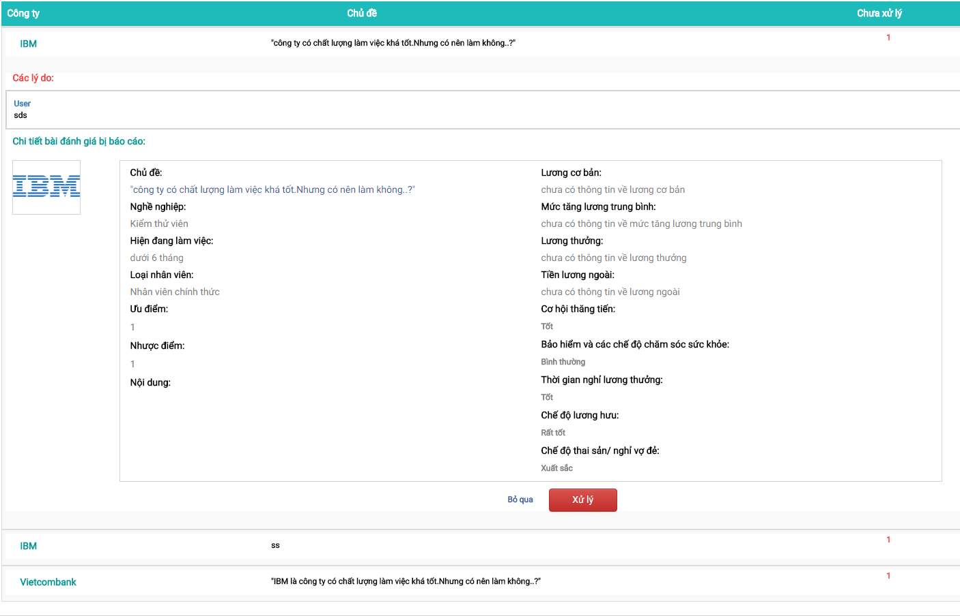

1. Pending Reports
2. Pending Reports

|  |  |  |  |  |  |  |  |
| --- | --- | --- | --- | --- | --- | --- | --- |
| No | Field name | Field name in Vietnamese | Type | Require | Mandatory | Max-Length | Description |
|  | Pending Reviews/Reports | Đánh giá/báo cáo đang chờ | Label |  |  |  | Label for Pending Reviews/Reports section |
|  | Pending Reviews | Đánh giá đang chờ | Tab | Click |  |  | Go to the Pending Reviews tab |
|  | Pending Reports | Báo cáo đang chờ | Tab | Click |  |  | Go to the Pending Reports tab |
|  | Company Name | Tên công ty | Label |  |  |  | Company’s name |
|  | Review Title | Tên bài đánh giá | Label |  |  |  | Review’s title |
|  | Pending Reports | Báo cáo đang chờ | Label |  |  |  | Amount of pending reports for this review |
|  | Review | Bài đánh giá | Hyperlink | Click |  |  | Expand the chosen review to show its details |

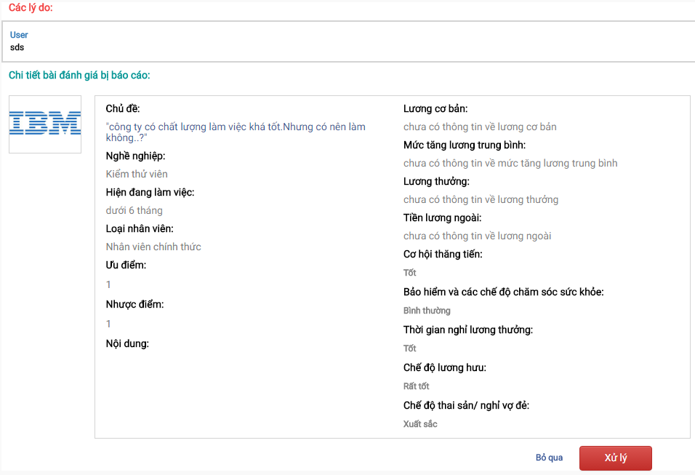

1. Reported Review Details
2. Reported Review Details

|  |  |  |  |  |  |  |  |
| --- | --- | --- | --- | --- | --- | --- | --- |
| No | Field name | Field name in Vietnamese | Type | Require | Mandatory | Max-Length | Description |
|  | Reasoning | Lý do | Label |  |  |  | Label for Reasoning section |
|  | Reporter Name | Tên người báo cáo | Label |  |  |  | Reporter’s name |
|  | Reporter Name | Tên người báo cáo | Hyperlink | Click |  |  | Go to the chosen user’s Account Info screen |
|  | Report Content | Nội dung báo cáo | Text |  |  |  | The content of a report regarding this review |
|  | Reported Review Details | Chi tiết bài bị báo cáo | Label |  |  |  | Label for Reported Review Details section |
|  | Company Avatar | Ảnh đại diện công ty | Image |  |  |  | Company’s logo |
|  | Reported Review Details | Nội dung bài đánh giá bị báo cáo | Panel |  |  |  | Show the details of this reported review |
|  | Approve | Chấp nhận | Button | Click |  |  | Approve the reports against this review and open the popup Reject Review modal box |
|  | Dismiss | Bỏ qua | Button | Click |  |  | Dismiss the reports against this review |

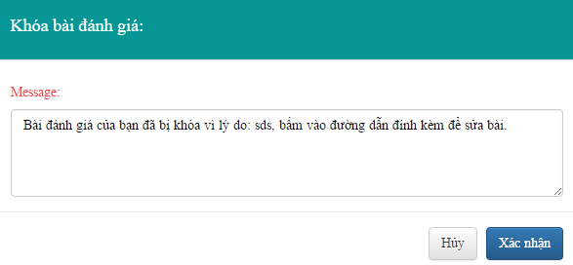

1. Reject Review Modal Box
2. Reject Review Modal Box

|  |  |  |  |  |  |  |  |
| --- | --- | --- | --- | --- | --- | --- | --- |
| No | Field name | Field name in Vietnamese | Type | Require | Mandatory | Max-Length | Description |
|  | Reject Review | Khóa bài đánh giá | Label |  |  |  | Label for Reject Review modal box |
|  | Reject Reason | Lý do khóa bài | Textarea | Input |  |  | Input the reasoning for rejecting this review |
|  | Confirm | Xác nhận | Button | Click |  |  | Change the review state to Rejected and send a notification to the reviewer |
|  | Cancel | Hủy | Button | Click |  |  | Close the modal box |

## User Management

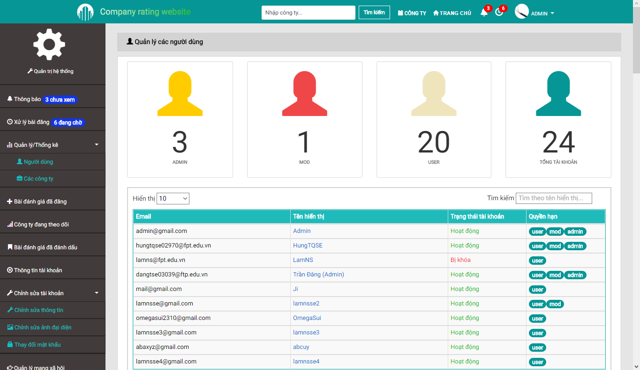

1. User Management Screen

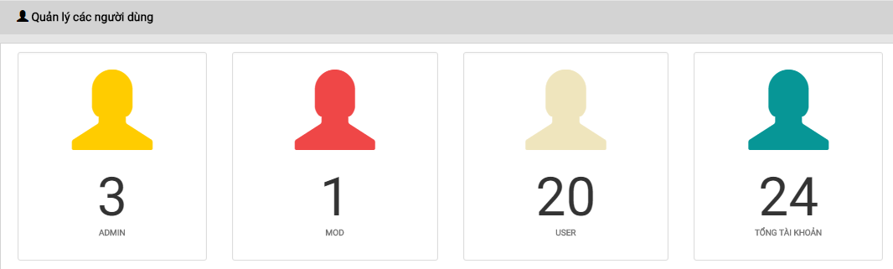

1. User Statistics
2. User Statistics

|  |  |  |  |  |  |  |  |
| --- | --- | --- | --- | --- | --- | --- | --- |
| No | Field name | Field name in Vietnamese | Type | Require | Mandatory | Max-Length | Description |
|  | User Management | Quản lý người dùng | Label |  |  |  | Label for User Management section |
|  | Administrator Statistics | Thống kê quản trị viên | Label |  |  |  | Show the amount of Administrators in the system |
|  | Moderator Statistics | Thống kê điều hành viên | Label |  |  |  | Show the amount of Moderators in the system |
|  | User Statistics | Thống kê thành viên | Label |  |  |  | Show the amount of Users in the system |
|  | Total Account | Tổng số tài khoản | Label |  |  |  | Show the amount of accounts in the system |



1. Search And Filter (User Management)
2. Search And Filter (User Management)

|  |  |  |  |  |  |  |  |
| --- | --- | --- | --- | --- | --- | --- | --- |
| No | Field name | Field name in Vietnamese | Type | Require | Mandatory | Max-Length | Description |
|  | Display Limit | Giới hạn hiển thị | Select | Click |  |  | Limit the amount of notifications per single page |
|  | Filter | Bộ lọc | Textbox | Input |  |  | Filter the notifications accordingly to inputted keyword(s) |

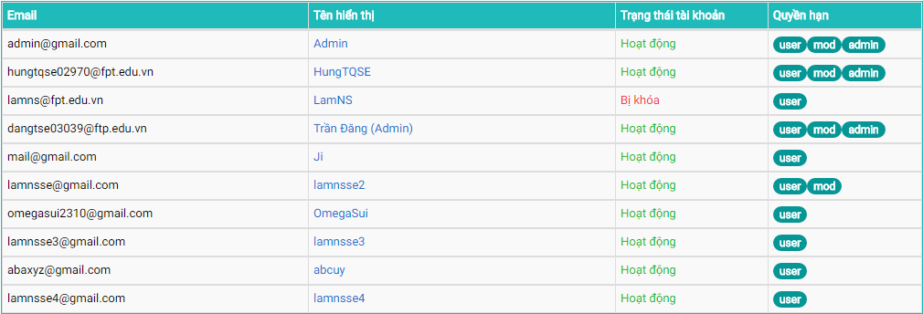

1. User Table
2. User Table

|  |  |  |  |  |  |  |  |
| --- | --- | --- | --- | --- | --- | --- | --- |
| No | Field name | Field name in Vietnamese | Type | Require | Mandatory | Max-Length | Description |
|  | Email | Email | Label |  |  |  | Account’s email |
|  | Display Name | Tên hiển thị | Hyperlink | Click |  |  | Go to chosen user’s Account Info screen |
|  | Display Name | Tên hiển thị | Label |  |  |  | Account’s display name |
|  | Account State | Trạng thái tài khoản | Label |  |  |  | Account’s state |
|  | Authority | Quyền hạn | Tag |  |  |  | Show account’s privilege |

## Company Management

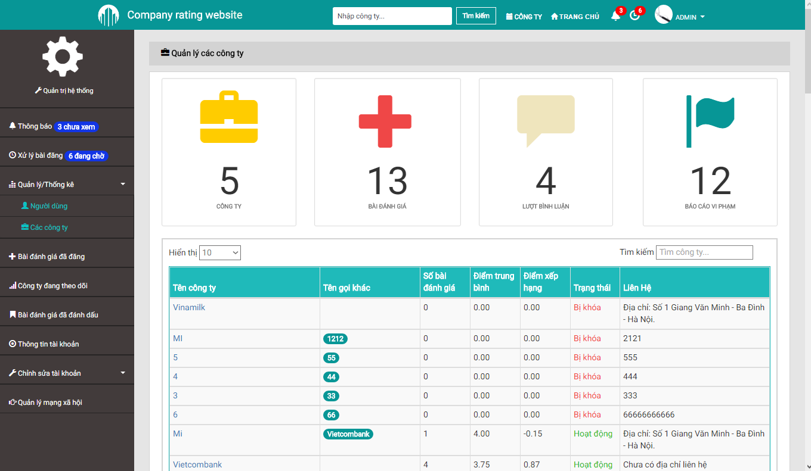

1. Company Management Screen

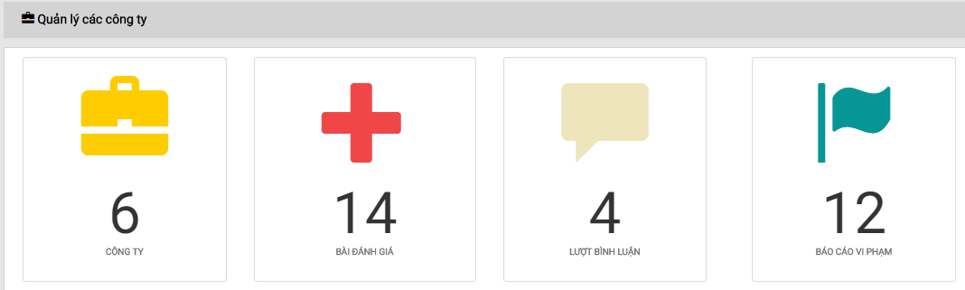

1. Company Statistics
2. Company Statistics

|  |  |  |  |  |  |  |  |
| --- | --- | --- | --- | --- | --- | --- | --- |
| No | Field name | Field name in Vietnamese | Type | Require | Mandatory | Max-Length | Description |
|  | Company Management | Quản lý công ty | Label |  |  |  | Label for Company Management section |
|  | Company Statistics | Thống kê công ty | Label |  |  |  | Show the amount of companies in the system |
|  | Review Statistics | Thống kê đánh giá | Label |  |  |  | Show the amount of reviews in the system |
|  | Comment Statistics | Thống kê bình luận | Label |  |  |  | Show the amount of comments in the system |
|  | Report Statistics | Thống kê báo cáo | Label |  |  |  | Show the amount of reports in the system |



1. Search and Filter (Company Management)
2. Search and Filter (Company Management)

|  |  |  |  |  |  |  |  |
| --- | --- | --- | --- | --- | --- | --- | --- |
| No | Field name | Field name in Vietnamese | Type | Require | Mandatory | Max-Length | Description |
|  | Display Limit | Giới hạn hiển thị | Select | Click |  |  | Limit the amount of notifications per single page |
|  | Filter | Bộ lọc | Textbox | Input |  |  | Filter the notifications accordingly to inputted keyword(s) |

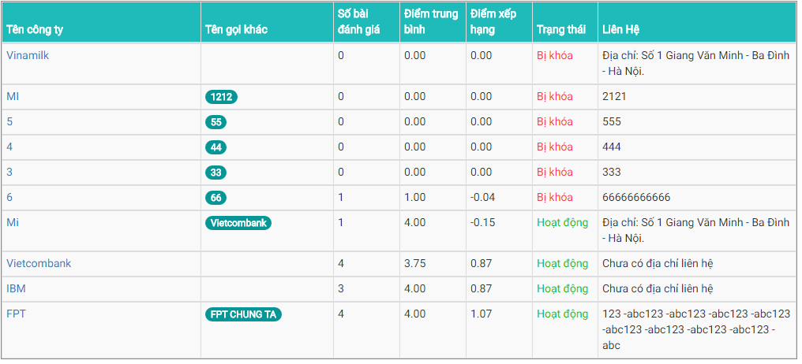

1. Company Table
2. Company Table

|  |  |  |  |  |  |  |  |
| --- | --- | --- | --- | --- | --- | --- | --- |
| No | Field name | Field name in Vietnamese | Type | Require | Mandatory | Max-Length | Description |
|  | Company Name | Tên công ty | Hyperlink | Click |  |  | Go to the Detailed Company screen of chosen company |
|  | Company Name | Tên công ty | Label |  |  |  | Company’s name |
|  | Alias | Tên gọi khác | Tag |  |  |  | Company’s other name |
|  | Number of Reviews | Số bài đánh giá | Label |  |  |  | Show the amount of reviews this company has |
|  | Average Rating | Điểm trung bình | Label |  |  |  | Show the average rating for this company |
|  | Ranking Point | Điểm xếp hạng | Label |  |  |  | Show the ranking point for this company |
|  | Company State | Trạng thái | Label |  |  |  | Show the current state of this company |
|  | Company Contact | Liên hệ | Label |  |  |  | Company’s contact |

## Account Info

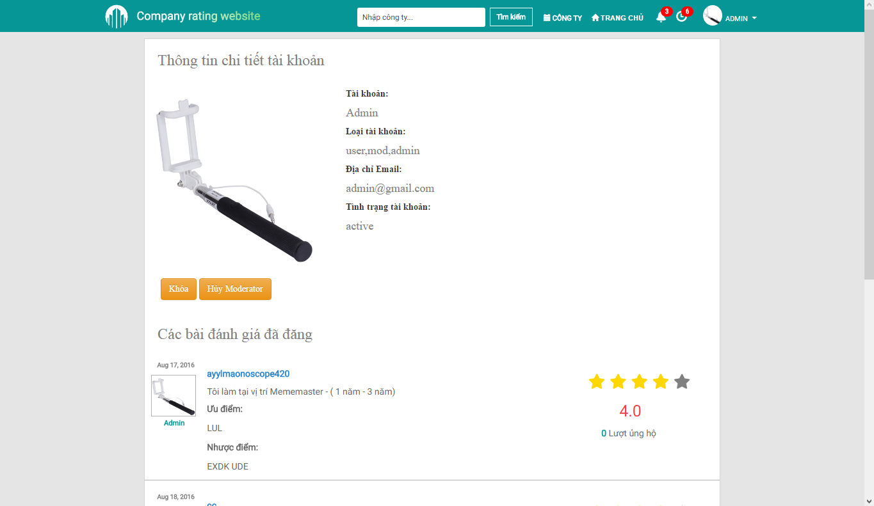

1. Account Info Screen

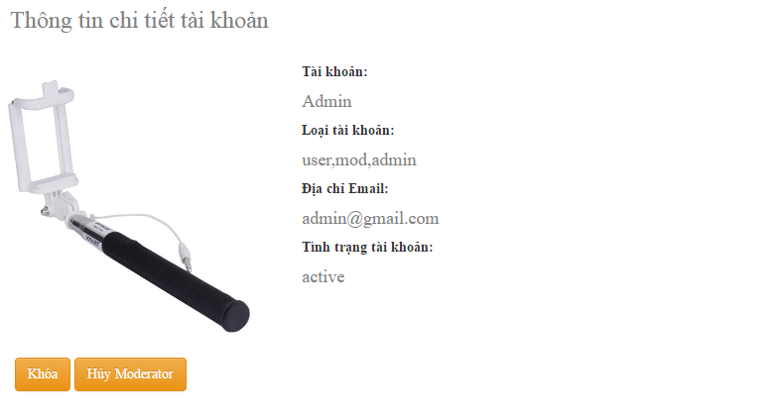

1. Detailed Account Info
2. Detailed Account Info

|  |  |  |  |  |  |  |  |
| --- | --- | --- | --- | --- | --- | --- | --- |
| No | Field name | Field name in Vietnamese | Type | Require | Mandatory | Max-Length | Description |
|  | Detailed Account Info | Thông tin chi tiết tài khoản | Label |  |  |  | Label for Detailed Account Info section |
|  | Account Details | Thông tin chi tiết | Panel |  |  |  | Show all info regarding this account |
|  | Lock | Khóa | Button | Click |  |  | Change the state of this account to Deactive (Administrator) |
|  | Unlock | Mở khóa | Button | Click |  |  | Change the state of this account to Active (Administrator) |
|  | Appoint Moderator | Bổ nhiệm điều hành viên | Button | Click |  |  | Assign the role of Moderator to this account (Administrator) |
|  | Demote Moderator | Cách chức điều hành viên | Button | Click |  |  | Remove the role of Moderator from this account (Administrator) |

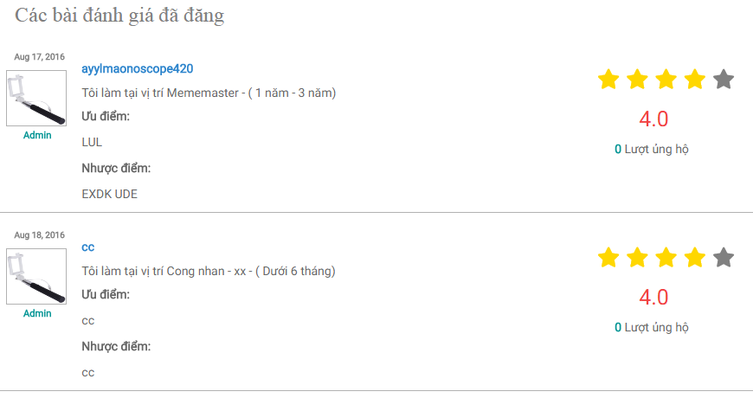

1. Posted Reviews
2. Posted Reviews

|  |  |  |  |  |  |  |  |
| --- | --- | --- | --- | --- | --- | --- | --- |
| No | Field name | Field name in Vietnamese | Type | Require | Mandatory | Max-Length | Description |
|  | Posted Review | Bài đánh giá đã đăng | Label |  |  |  | Label for Posted Review section |
|  | Reviewer Name | Tên người đánh giá | Label |  |  |  | Label for the reviewer’s name |
|  | Reviewer Avatar | Ảnh đại diện người đánh giá | Image |  |  |  | Reviewer’s avatar |
|  | Review Latest Date | Ngày cập nhật đánh giá lần cuối | Label |  |  |  | Label for the review’s latest updated date |
|  | Review Basic Content | Nội dung đánh giá căn bản | Panel Body |  |  |  | The basic content of the review |
|  | Review Star Rating | Điểm đánh giá sao | Star Rating Bar |  |  |  | Show the rating given by this review as stars |
|  | Review Rating | Điểm đánh giá | Label |  |  |  | Show the rating given by this review as number |
|  | Review Upvote | Số ủng hộ | Label |  |  |  | Label for the review’s upvote count |
|  | Review | Đánh giá | Hyperlink | Click |  |  | Go to the Detailed Review screen |

## Update Profile

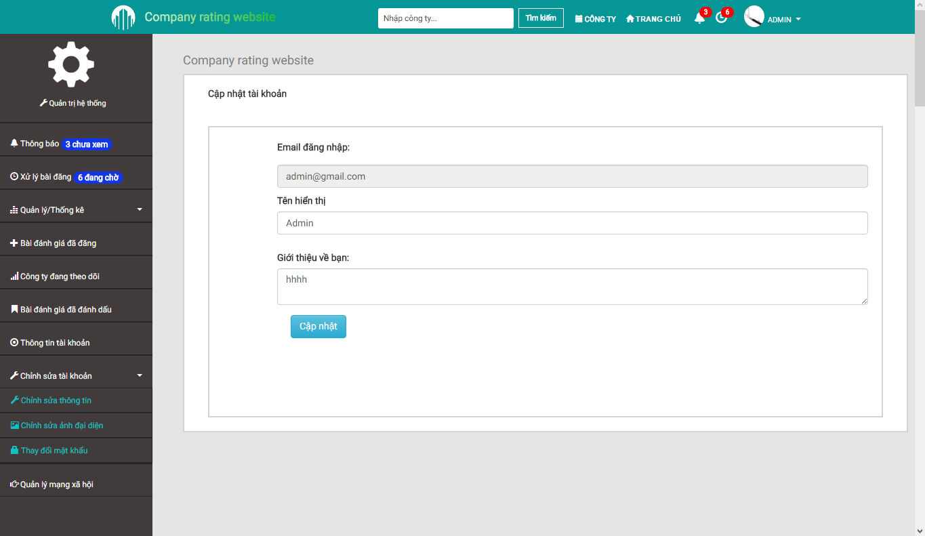

1. Update Profile Screen
2. Update Profile

|  |  |  |  |  |  |  |  |
| --- | --- | --- | --- | --- | --- | --- | --- |
| No | Field name | Field name in Vietnamese | Type | Require | Mandatory | Max-Length | Description |
|  | Update Profile | Cập nhật thông tin | Label |  |  |  | Label for Update Profile section |
|  | Registered Email | Email đăng ký | Textbox |  |  |  | Show this account’s registered email |
|  | Display Name | Tên hiển thị | Textbox | Input | Y |  | Input desired display name |
|  | Display Name | Tên hiển thị | Label |  |  |  | Label for Display Name field is empty or does not meet requirement |
|  | Profile | Thông tin bản thân | Textarea | Input |  |  | Input profile |
|  | Update | Cập nhật | Button | Click |  |  | Save the inputted changes |
|  | Update | Cập nhật | Label |  |  |  | Label for when Profile update is successful or not |

## Change Avatar

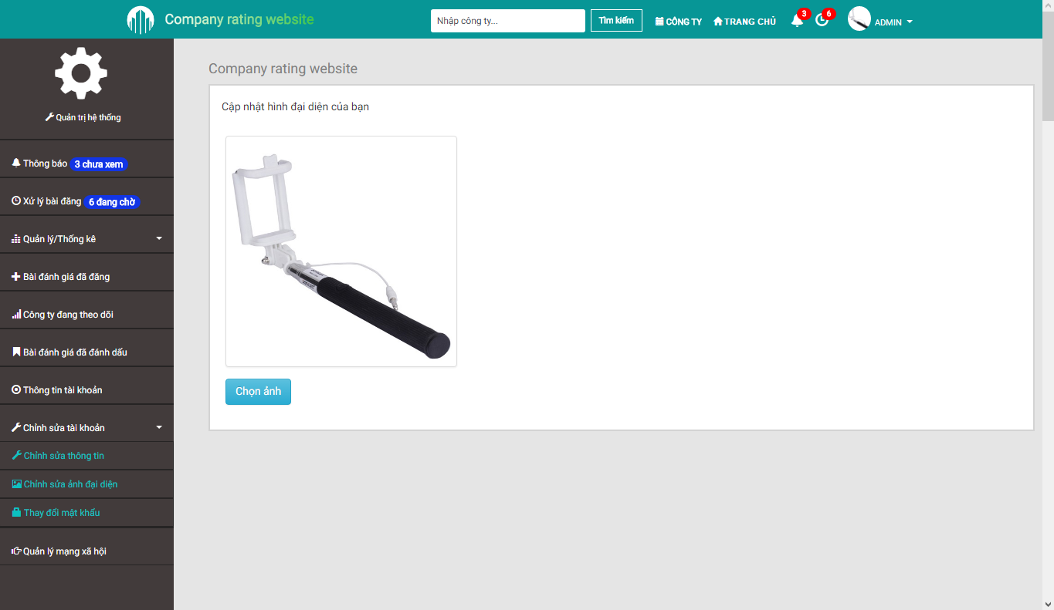

1. Change Avatar Screen

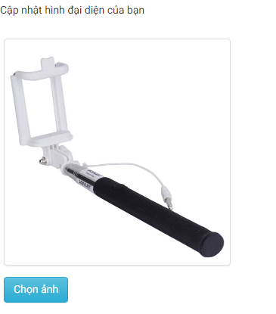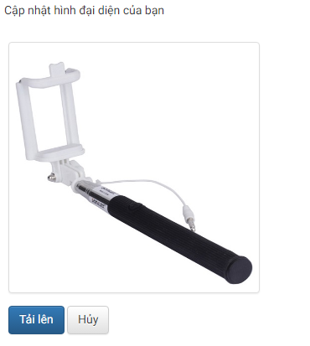

1. Change Avatar
2. Change Avatar

|  |  |  |  |  |  |  |  |
| --- | --- | --- | --- | --- | --- | --- | --- |
| No | Field name | Field name in Vietnamese | Type | Require | Mandatory | Max-Length | Description |
|  | Change Avatar | Thay ảnh đại diện | Label |  |  |  | Label for Change Avatar section |
|  | Avatar | Ảnh đại diện | Image |  |  |  | Image previewer for current image or the newly uploaded one |
|  | Upload | Tải ảnh lên | Button | Click |  |  | Open the Explorer to choose an image as avatar |
|  | Confirm | Chấp nhận | Button | Click |  |  | Confirm the use of the currently shown image as avatar |
|  | Cancel | Hủy | Button | Click |  |  | Cancel avatar changes |

## Change Password

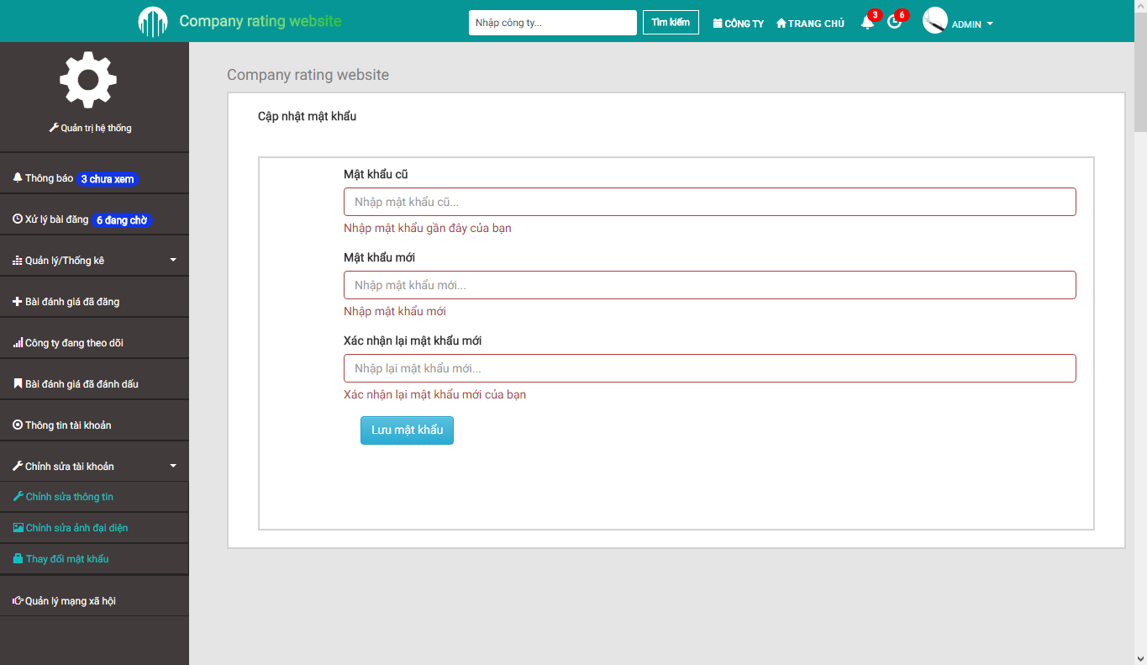

1. Change Password Screen
2. Change Password

|  |  |  |  |  |  |  |  |
| --- | --- | --- | --- | --- | --- | --- | --- |
| No | Field name | Field name in Vietnamese | Type | Require | Mandatory | Max-Length | Description |
|  | Change Password | Thay đổi mật khẩu | Label |  |  |  | Label for Change Password section |
|  | Old Password | Mật khẩu cũ | Textbox | Input | Y |  | Input old password |
|  | Old Password | Mật khẩu cũ | Label |  |  |  | Label for Old Password field is empty or does not meet requirement |
|  | New Password | Mật khẩu mới | Textbox | Input | Y |  | Input new password |
|  | New Password | Mật khẩu mới | Label |  |  |  | Label for New Password field is empty or does not meet requirement |
|  | New Password Confirm | Xác nhận mật khẩu mới | Textbox | Input | Y |  | Input new password again |
|  | New Password Confirm | Xác nhận mật khẩu mới | Label |  |  |  | Label for New Password Confirm field is empty or does not meet requirement |
|  | Save New Password | Lưu mật khẩu | Button | Click |  |  | Save the inputted changes |

## Review Management

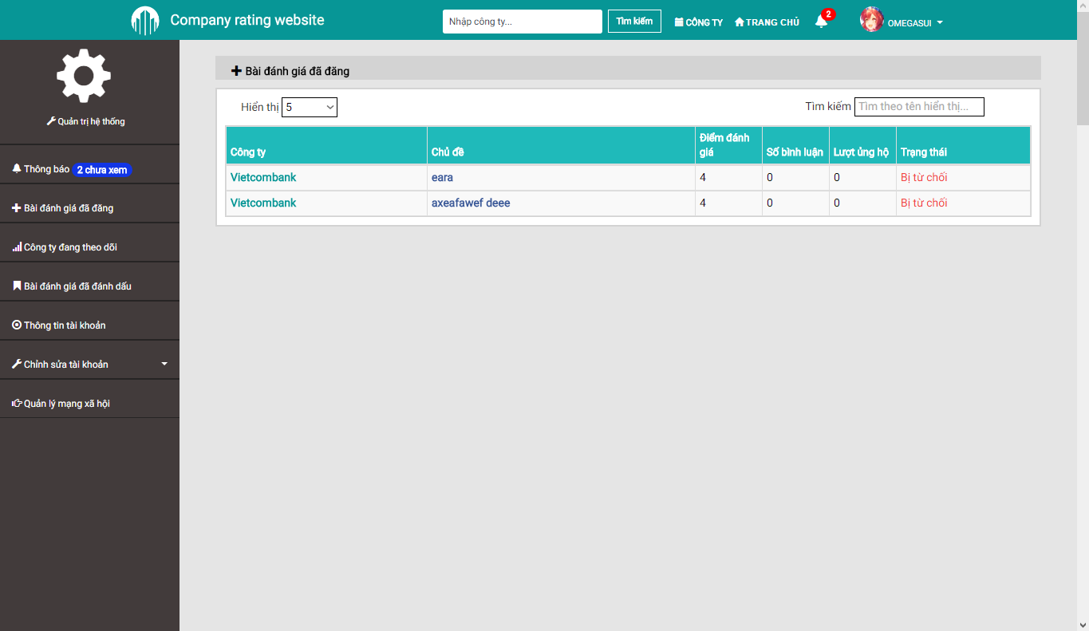

1. Review Management Screen



1. Search and Filter (Review Management)
2. Search and Filter (Review Management)

|  |  |  |  |  |  |  |  |
| --- | --- | --- | --- | --- | --- | --- | --- |
| No | Field name | Field name in Vietnamese | Type | Require | Mandatory | Max-Length | Description |
|  | Review Management | Quản lý đánh giá | Label |  |  |  | Label for Review Management section |
|  | Display Limit | Giới hạn hiển thị | Select | Click |  |  | Limit the amount of notifications per single page |
|  | Filter | Bộ lọc | Textbox | Input |  |  | Filter the notifications accordingly to inputted keyword(s) |

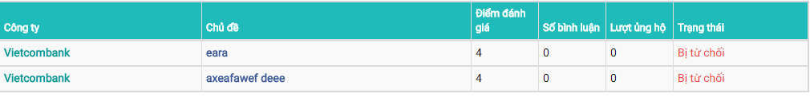

1. Review Table
2. Review Table

|  |  |  |  |  |  |  |  |
| --- | --- | --- | --- | --- | --- | --- | --- |
| No | Field name | Field name in Vietnamese | Type | Require | Mandatory | Max-Length | Description |
|  | Company Name | Tên công ty | Label |  |  |  | Company’s name |
|  | Company Name | Tên công ty | Hyperlink | Click |  |  | Go to the chosen company’s Detailed Company screen |
|  | Review Title | Tiêu đề | Label |  |  |  | Review’s title |
|  | Review Title | Tiêu đề | Hyperlink | Click |  |  | Go to the chosen review’s Detailed Review screen |
|  | Rating | Điểm đánh giá | Label |  |  |  | Show the rating given by this review |
|  | Number of Comments | Số bình luận | Label |  |  |  | Show the amount of comments for this review |
|  | Number of Upvotes | Lượt ủng hộ | Label |  |  |  | Show the amount of upvotes for this review |
|  | Review State | Trạng thái | Label |  |  |  | Show the current state of this review |

## Follow List

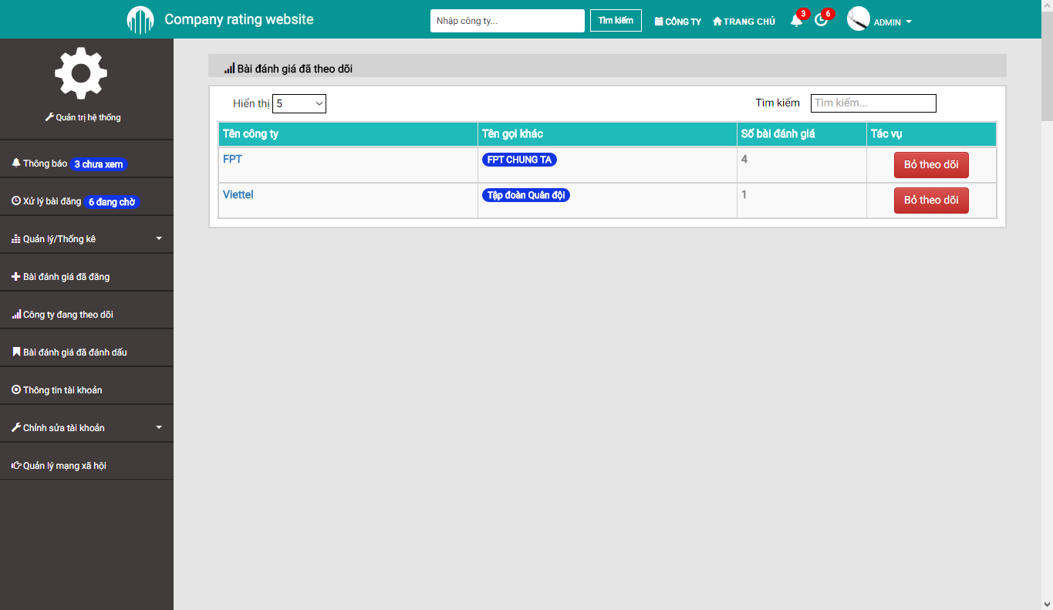

1. Follow List Screen



1. Search and Filter (Follow List)
2. Search and Filter (Follow List)

|  |  |  |  |  |  |  |  |
| --- | --- | --- | --- | --- | --- | --- | --- |
| No | Field name | Field name in Vietnamese | Type | Require | Mandatory | Max-Length | Description |
|  | Follow | Theo dõi | Label |  |  |  | Label for Follow List section |
|  | Display Limit | Giới hạn hiển thị | Select | Click |  |  | Limit the amount of notifications per single page |
|  | Filter | Bộ lọc | Textbox | Input |  |  | Filter the notifications accordingly to inputted keyword(s) |

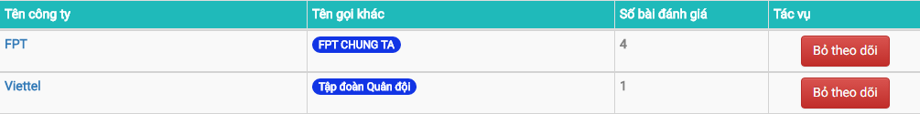

1. Followed Company Table
2. Followed Company Table

|  |  |  |  |  |  |  |  |
| --- | --- | --- | --- | --- | --- | --- | --- |
| No | Field name | Field name in Vietnamese | Type | Require | Mandatory | Max-Length | Description |
|  | Company Name | Tên công ty | Label |  |  |  | Company’s name |
|  | Company Name | Tên công ty | Hyperlink | Click |  |  | Go to the chosen company’s Detailed Company screen |
|  | Company Alias | Tên khác của công ty | Tag |  |  |  | Company’s other name |
|  | Number of Reviews | Số bài đánh giá | Label |  |  |  | Show the amount of reviews this company has |
|  | Unfollow | Bỏ theo dõi | Button | Click |  |  | Remove the chosen company from the follow list |

## Bookmark List

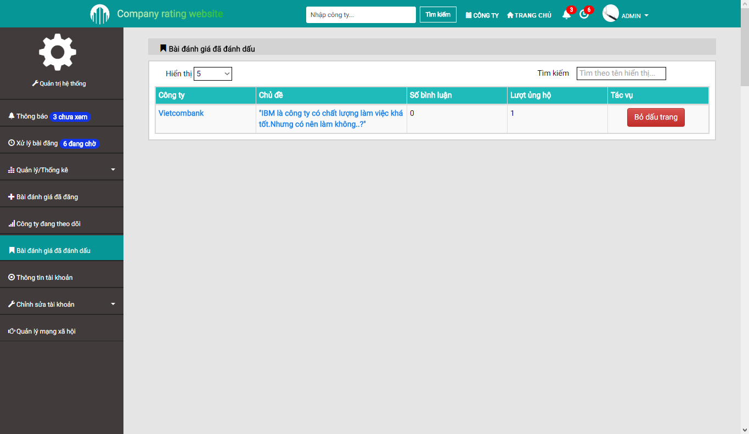

1. Bookmark List Screen



1. Search and Filter (Bookmark List)
2. Search and Filter (Bookmark List)

|  |  |  |  |  |  |  |  |
| --- | --- | --- | --- | --- | --- | --- | --- |
| No | Field name | Field name in Vietnamese | Type | Require | Mandatory | Max-Length | Description |
|  | Bookmark | Dấu trang | Label |  |  |  | Label for Bookmark List section |
|  | Display Limit | Giới hạn hiển thị | Select | Click |  |  | Limit the amount of notifications per single page |
|  | Filter | Bộ lọc | Textbox | Input |  |  | Filter the notifications accordingly to inputted keyword(s) |



1. Bookmark Table
2. Bookmark Table

|  |  |  |  |  |  |  |  |
| --- | --- | --- | --- | --- | --- | --- | --- |
| No | Field name | Field name in Vietnamese | Type | Require | Mandatory | Max-Length | Description |
|  | Company Name | Tên công ty | Label |  |  |  | Company’s name |
|  | Company Name | Tên công ty | Hyperlink | Click |  |  | Go to the chosen company’s Detailed Company screen |
|  | Review Title | Tiêu đề | Label |  |  |  | Review’s title |
|  | Review Title | Tiêu đề | Hyperlink | Click |  |  | Go to the chosen review’s Detailed Review screen |
|  | Number of Comments | Số bình luận | Label |  |  |  | Show the amount of comments for this review |
|  | Number of Upvotes | Lượt ủng hộ | Label |  |  |  | Show the amount of upvotes for this review |
|  | Remove Bookmark | Bỏ dấu trang | Button | Click |  |  | Remove the chosen review from the Bookmark list |

## Company List

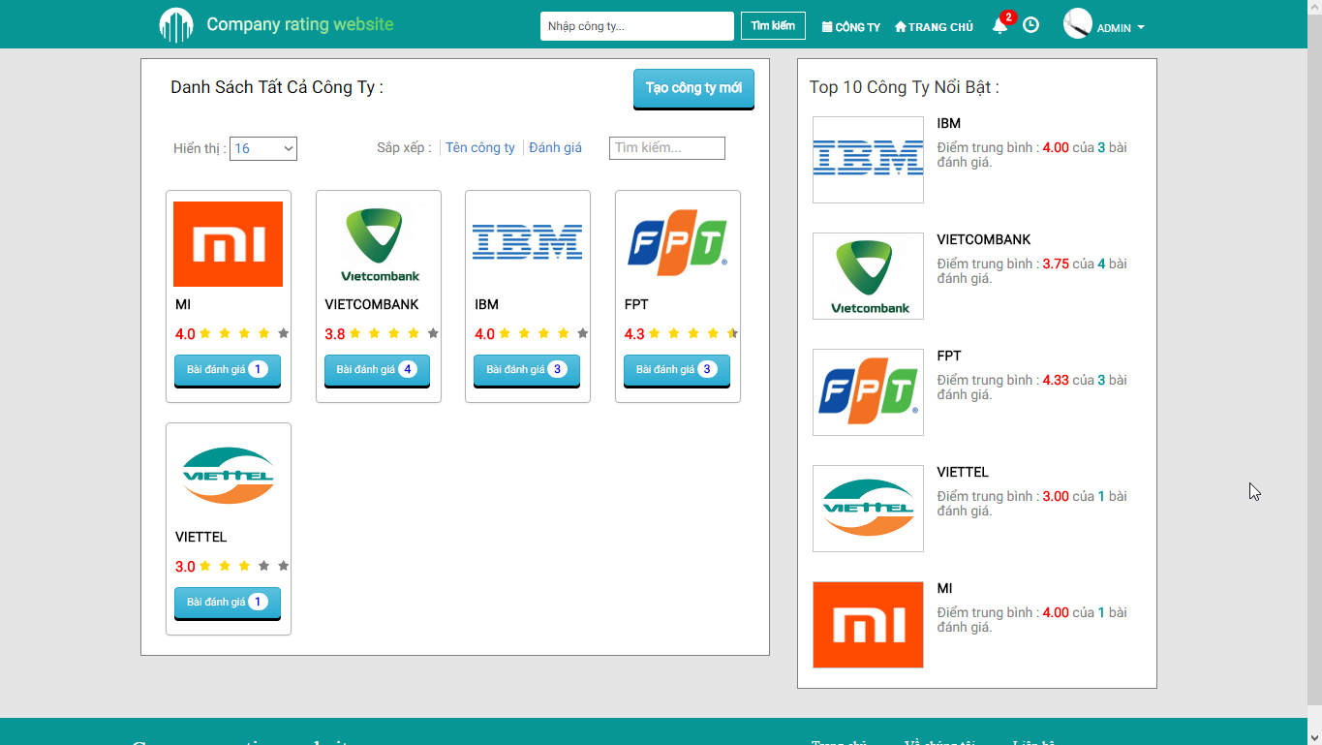

1. Company List Screen

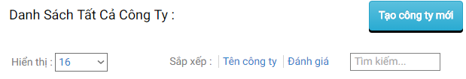

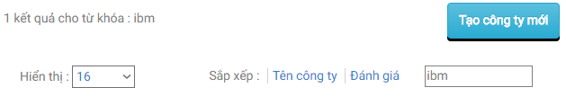

1. Search and Filter (Company List)
2. Search and Filter (Company List)

|  |  |  |  |  |  |  |  |
| --- | --- | --- | --- | --- | --- | --- | --- |
| No | Field name | Field name in Vietnamese | Type | Require | Mandatory | Max-Length | Description |
|  | Company List | Danh sách công ty | Label |  |  |  | Label for Company List section |
|  | Searchbar | Nhập công ty | Textbox |  |  |  | Input keywords for querying purposes |
|  | Search | Tìm kiếm | Button | Click |  |  | Input Search |
|  | Search Result | Kết quả tìm kiếm | Label |  |  |  | Label for amount of matching results with the given keywords |
|  | Create New Company | Tạo mới công ty | Button | Click |  |  | Go to the Create Company screen |
|  | Sort by Name | Xếp theo tên công ty | Hyperlink | Click |  |  | Sort by Company’s name alphabetically |
|  | Sort by Reviews | Xếp theo số đánh giá | Hyperlink | Click |  |  | Sort by Company’s amount of reviews numberically |

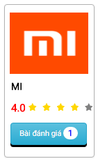

1. Company Thumbnail
2. Company Thumbnail

|  |  |  |  |  |  |  |  |
| --- | --- | --- | --- | --- | --- | --- | --- |
| No | Field name | Field name in Vietnamese | Type | Require | Mandatory | Max-Length | Description |
|  | Company Avatar | Ảnh đại diện công ty | Image |  |  |  | Company’s logo |
|  | Company Name | Tên công ty | Label |  |  |  | Company’s name |
|  | Average Rating | Điểm đánh giá trung bình | Label |  |  |  | Show average ratings of this company as number |
|  | Average Star Rating | Điểm đánh giá trung bình | Star Rating Bar |  |  |  | Show average ratings of this company as stars |
|  | Number of Reviews | Số bài đánh giá | Label |  |  |  | Show the amount of reviews for this company |
|  | Company Thumbnail | Công ty | Hyperlink | Click |  |  | Go to the Detailed Company screen of this company |

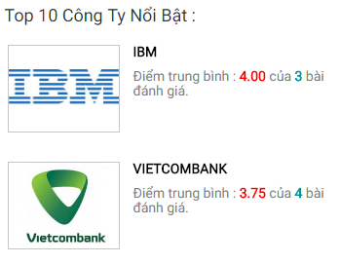

1. Top 10 Companies
2. Top 10 Companies

|  |  |  |  |  |  |  |  |
| --- | --- | --- | --- | --- | --- | --- | --- |
| No | Field name | Field name in Vietnamese | Type | Require | Mandatory | Max-Length | Description |
|  | Top 10 | Tốp 10 | Label |  |  |  | Label for Top 10 Companies section |
|  | Company Avatar | Ảnh đại diện công ty | Image |  |  |  | Company’s logo |
|  | Company Name | Tên công ty | Label |  |  |  | Company’s name |
|  | Average Rating | Điểm đánh giá trung bình | Label |  |  |  | Label for Average Rating and amount of reviews |
|  | Average Star Rating | Điểm đánh giá trung bình | Star Rating Bar |  |  |  | Show average ratings of this company as stars |
|  | Company Thumbnail | Công ty | Hyperlink | Click |  |  | Go to the Detailed Company screen of this company |

## Create Company

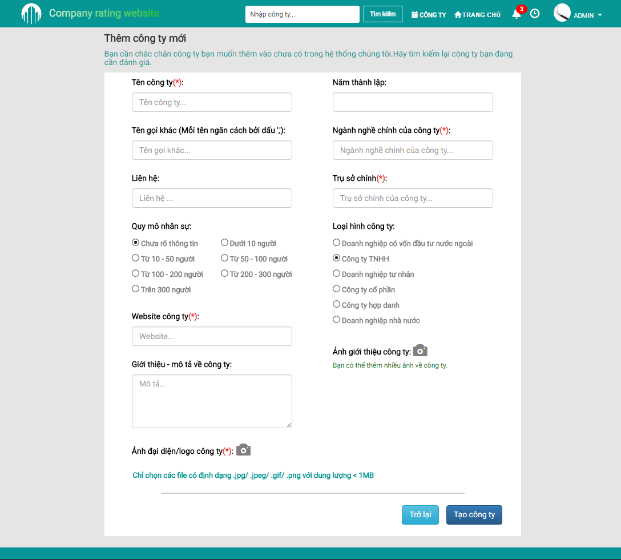

1. Create Company Screen

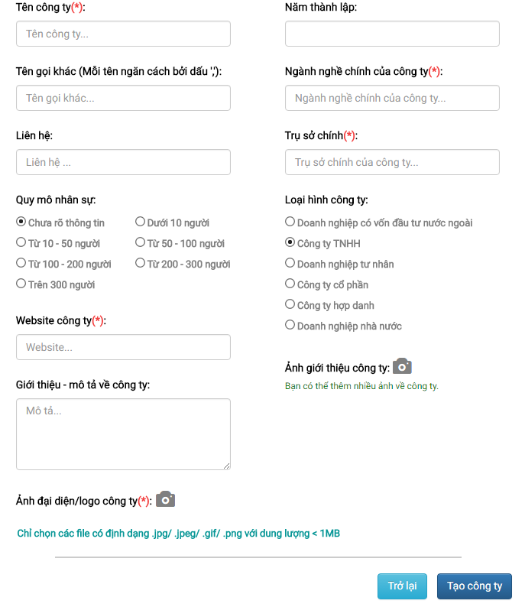

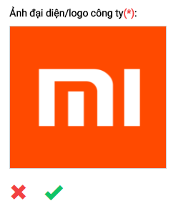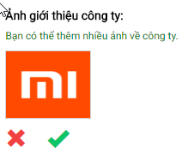

1. Create Company Form
2. Create Company

|  |  |  |  |  |  |  |  |
| --- | --- | --- | --- | --- | --- | --- | --- |
| No | Field name | Field name in Vietnamese | Type | Require | Mandatory | Max-Length | Description |
|  | Create Company | Thêm công ty | Label |  |  |  | Label for Create Company form |
|  | Company Status | Trạng thái công ty | Radio Button | Click | Y |  | Current and avaiable states of this company |
|  | Company Name | Tên công ty | Textbox | Input | Y |  | Input company’s name |
|  | Company Name | Tên công ty | Label |  |  |  | Label for Company Name when field is empty or does not meet requirement |
|  | Company Alias | Tên gọi khác | Textbox | Input |  |  | Input company’s alias name |
|  | Company Contact | Liên hệ | Textbox | Input |  |  | Input company’s contact |
|  | Company Personnel Size | Quy mô nhân sự | Radio Button | Click |  |  | Choose the range of this company’s personnel size |
|  | Company Website | Trang web của công ty | Textbox |  |  |  | Input company’s website |
|  | Company Avatar Upload | Đăng ảnh đại diện | Button | Click |  |  | Open the Explorer to choose an image as this company’s logo |
|  | Company Avatar | Ảnh đại diện | Image |  | Y |  | Image previewer for company’s uploaded logo |
|  | Company Avatar Accept | Chấp nhận ảnh đại diện | Button | Click |  |  | Accept the currently uploaded image as this company’s logo |
|  | Company Avatar Reject | Bỏ ảnh đại diện | Button | Click |  |  | Reject the currently uploaded image as this company’s logo |
|  | Company Avatar | Ảnh đại diện | Label |  |  |  | Label for Company Avatar when field is empty or does not meet requirement |
|  | Company Introduction | Giới thiệu về công ty | Textarea | Input |  |  | Input summary of this company |
|  | Company Founded Date | Năm thành lập | Date Picker | Click |  |  | Choose the founded year of this company |
|  | Company Industrial Focus | Ngành nghề chính công ty | Textbox |  |  |  | Input the company’s industrial focus |
|  | Company Industrial Focus | Ngành nghề chính công ty | Label |  |  |  | Label for Company Industrial Focus when field is empty or does not meet requirement |
|  | Company HQ | Trụ sở chính | Textbox | Input | Y |  | Input the company’s headquarter |
|  | Company HQ | Trụ sở chính | Label |  |  |  | Label for Company HQ when field is empty or does not meet requirement |
|  | Company Type | Loại hình công ty | Radio Button | Click |  |  | Choose a type for this company’s type |
|  | Company Photo Upload | Đăng ảnh công ty | Button | Click |  |  | Open the Explorer to choose an image as this company’s photo |
|  | Company Photo | Ảnh công ty | Image |  | Y |  | Image previewer for company’s uploaded photo |
|  | Company Photo | Ảnh công ty | Label |  |  |  | Label for Company Photo when field is empty or does not meet requirement |
|  | Company Photo Accept | Chấp nhận ảnh công ty | Button | Click |  |  | Accept the currently uploaded image as this company’s photo |
|  | Company Photo Reject | Bỏ ảnh công ty | Button | Click |  |  | Reject the currently uploaded image as this company’s photo |
|  | Company Photo Remove | Xóa ảnh công ty | Button | Click |  |  | Remove a company photo |

## Company Details

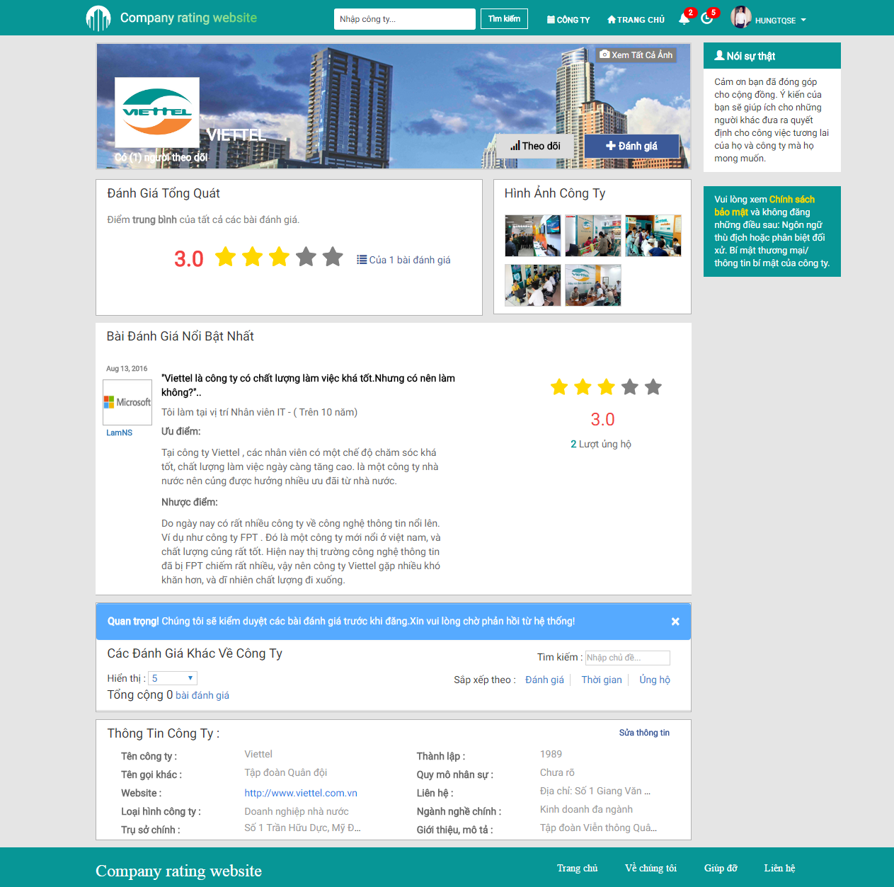

1. Detailed Company Screen

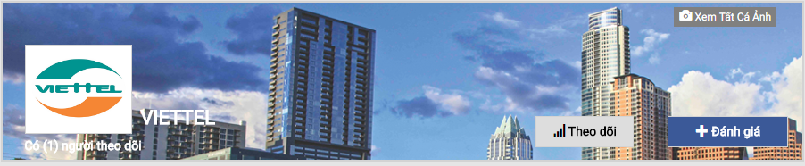

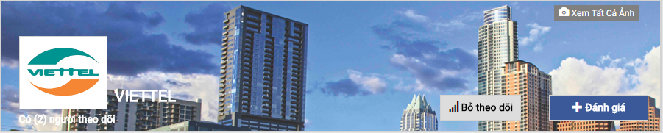

1. Company Banner
2. Company Banner

|  |  |  |  |  |  |  |  |
| --- | --- | --- | --- | --- | --- | --- | --- |
| No | Field name | Field name in Vietnamese | Type | Require | Mandatory | Max-Length | Description |
|  | Banner | Ảnh banner | Image |  |  |  | Common banner for all companies |
|  | Follow | Theo dõi | Button | Click |  |  | Add the current company to the Follow list |
|  | Unfollow | Bỏ theo dõi | Button | Click |  |  | Remove the current company from the Follow list |
|  | Create Review | Đăng bài | Button | Click |  |  | Go to Create Review screen |
|  | View All Banners | Xem ảnh banner | Button | Click |  |  | Open all banner images in a carousel |
|  | Avatar | Ảnh đại diện | Image |  |  |  | Company’s logo |
|  | Company Name | Tên công ty | Label |  |  |  | Label for company’s name |
|  | Number of followers | Số người theo dõi | Label |  |  |  | Label for showing the amount of followers |

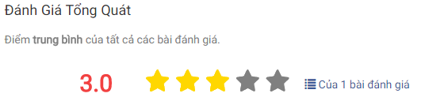

1. Overall Rating
2. Overall Rating

|  |  |  |  |  |  |  |  |
| --- | --- | --- | --- | --- | --- | --- | --- |
| No | Field name | Field name in Vietnamese | Type | Require | Mandatory | Max-Length | Description |
|  | Overall Rating | Điểm đánh giá tổng quát | Label |  |  |  | Label for Overall Rating section |
|  | Average Star Rating | Điểm đánh giá trung bình sao | Star Rating Bar |  |  |  | Show average rating of this company as stars |
|  | Average Rating | Điểm đánh giá trung bình | Label |  |  |  | Show average rating of this company as number |
|  | Detailed Rating | Điểm đánh giá chi tiết | Fade Model | Click |  |  | Show Detailed rating for this Company |

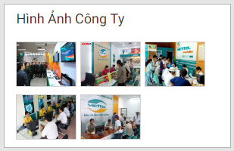

1. Company Photo
2. Company Photo

|  |  |  |  |  |  |  |  |
| --- | --- | --- | --- | --- | --- | --- | --- |
| No | Field name | Field name in Vietnamese | Type | Require | Mandatory | Max-Length | Description |
|  | Company Photo | Ảnh công ty | Label |  |  |  | Label for Company Photo section |
|  | Company Photo | Ảnh công ty | Image | Hover |  |  | Company’s photo |

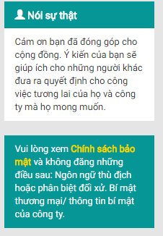

1. Note and Policy
2. Note and Policy

|  |  |  |  |  |  |  |  |
| --- | --- | --- | --- | --- | --- | --- | --- |
| No | Field name | Field name in Vietnamese | Type | Require | Mandatory | Max-Length | Description |
|  | Note | Ghi chú | Panel |  |  |  | Show the note regarding review contribution |
|  | Privacy Policy | Chính sách bảo mật | Hyperlink | Click |  |  | Open the Privacy Policy popup modal box |

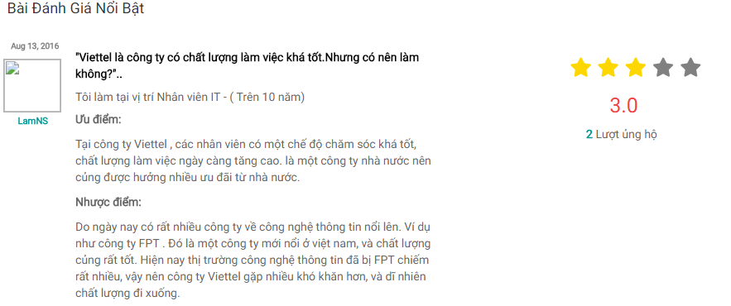

1. Highlighted Review
2. Highlighted Review

|  |  |  |  |  |  |  |  |
| --- | --- | --- | --- | --- | --- | --- | --- |
| No | Field name | Field name in Vietnamese | Type | Require | Mandatory | Max-Length | Description |
|  | Highlighted Review | Đánh giá nổi bật | Label |  |  |  | Label for Highlighted Review section |
|  | Highlighted Reviewer Name | Tên người đánh giá nổi bật | Label |  |  |  | Label for the highlighted reviewer’s name |
|  | Highlighted Reviewer Avatar | Ảnh đại diện người đánh giá nổi bật | Image |  |  |  | Highlighted reviewer’s avatar |
|  | Highlighted Review Latest Date | Ngày cập nhật đánh giá nổi bật lần cuối | Label |  |  |  | Label for the highlighted review’s latest updated date |
|  | Highlighted Review Basic Content | Nội dung đánh giá nổi bật căn bản | Panel Body |  |  |  | The basic content of the highlighted review |
|  | Highlighted Review Star Rating | Điểm đánh giá sao | Star Rating Bar |  |  |  | Show the rating given by this highlighted review as stars |
|  | Highlighted Review Rating | Điểm đánh giá nổi bật | Label |  |  |  | Label for the highlighted review’s rating as number |
|  | Highlighted Review Upvote | Số ủng hộ | Label |  |  |  | Label for the highlighted review’s upvote count |
|  | Highlighted Review | Đánh giá nổi bật | Hyperlink | Click |  |  | Go to the Detailed Review screen |



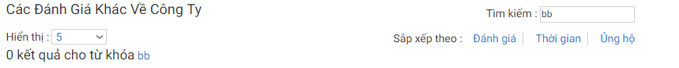

1. Search and Filter (Company Details)
2. Search and Filter (Company Details)

|  |  |  |  |  |  |  |  |
| --- | --- | --- | --- | --- | --- | --- | --- |
| No | Field name | Field name in Vietnamese | Type | Require | Mandatory | Max-Length | Description |
|  | Review | Đánh giá | Label |  |  |  | Label for the Remaining Review section |
|  | Display Limit | Giới hạn hiển thị | Select | Click |  |  | Limit the amount of reviews per single page |
|  | Filter | Bộ lọc | Textbox | Input |  |  | Filter the reviews accordingly to inputted keyword(s) |
|  | Filter Result | Kết quả lọc | Label |  |  |  | Label for amount of matching results with the given keywords |
|  | Sort by Review Rating | Sắp xếp theo điểm đánh giá | Hyperlink | Click |  |  | Sort reviews by ratings numberically |
|  | Sort by Review Date | Sắp xếp thời gian | Hyperlink | Click |  |  | Sort reviews by lastest date |
|  | Sort by Review Upvote | Sắp xếp ủng hộ | Hyperlink | Click |  |  | Sort reviews by upvote count numberically |

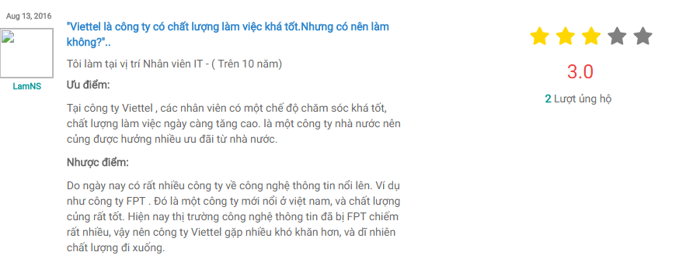

1. Review Screen
2. Review

|  |  |  |  |  |  |  |  |
| --- | --- | --- | --- | --- | --- | --- | --- |
| No | Field name | Field name in Vietnamese | Type | Require | Mandatory | Max-Length | Description |
|  | Reviewer Name | Tên người đánh giá | Label |  |  |  | Label for the reviewer’s name |
|  | Reviewer Avatar | Ảnh đại diện người đánh giá | Image |  |  |  | Reviewer’s avatar |
|  | Review Latest Date | Ngày cập nhật đánh giá lần cuối | Label |  |  |  | Label for the review’s latest updated date |
|  | Review Basic Content | Nội dung đánh giá căn bản | Panel Body |  |  |  | The basic content of the review |
|  | Review Star Rating | Điểm đánh giá sao | Star Rating Bar |  |  |  | Show the rating given by this review as stars |
|  | Review Rating | Điểm đánh giá | Label |  |  |  | Show the rating given by this review as number |
|  | Review Upvote | Số ủng hộ | Label |  |  |  | Label for the review’s upvote count |
|  | Review | Đánh giá | Hyperlink | Click |  |  | Go to the Detailed Review screen |

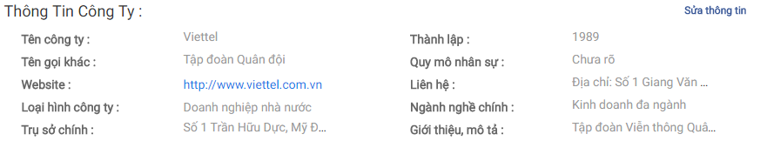

1. Company Info (Company Details)
2. Company Info (Company Details)

|  |  |  |  |  |  |  |  |
| --- | --- | --- | --- | --- | --- | --- | --- |
| No | Field name | Field name in Vietnamese | Type | Require | Mandatory | Max-Length | Description |
|  | Company Info | Thông tin công ty | Label |  |  |  | Label for Company Info section |
|  | Company Info | Thông tin công ty | Panel |  |  |  | Show this company’s info |
|  | Company Website | Website công ty | Hyperlink | Click |  |  | Go to this company’s website |
|  | Update Company | Cập nhật công ty | Hyperlink | Click |  |  | Open the Update Company popup modal box (Administrator) |

## Update Company

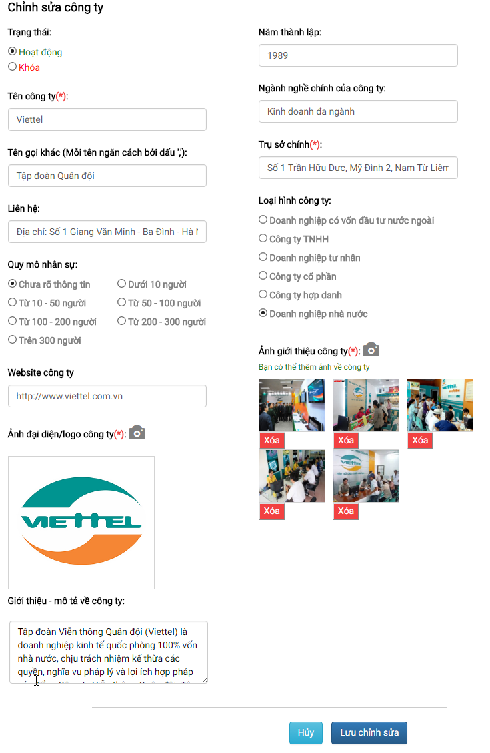

1. Update Company Modal Box
2. Update Company Modal Box

|  |  |  |  |  |  |  |  |
| --- | --- | --- | --- | --- | --- | --- | --- |
| No | Field name | Field name in Vietnamese | Type | Require | Mandatory | Max-Length | Description |
|  | Update Company | Chỉnh sửa công ty | Label |  |  |  | Label for Update Company modal box |
|  | Company Status | Trạng thái công ty | Radio Button | Click | Y |  | Current and avaiable states of this company |
|  | Company Name | Tên công ty | Textbox | Input | Y |  | Input company’s name |
|  | Company Name | Tên công ty | Label |  |  |  | Label for Company Name when field is empty or does not meet requirement |
|  | Company Alias | Tên gọi khác | Textbox | Input |  |  | Input company’s alias name |
|  | Company Contact | Liên hệ | Textbox | Input |  |  | Input company’s contact |
|  | Company Personnel Size | Quy mô nhân sự | Radio Button | Click |  |  | Choose the range of this company’s personnel size |
|  | Company Website | Trang web của công ty | Textbox |  |  |  | Input company’s website |
|  | Company Avatar Upload | Đăng ảnh đại diện | Button | Click |  |  | Open the Explorer to choose an image as this company’s logo |
|  | Company Avatar | Ảnh đại diện | Image |  | Y |  | Image previewer for company’s uploaded logo |
|  | Company Avatar | Ảnh đại diện | Label |  |  |  | Label for Company Avatar when field is empty or does not meet requirement |
|  | Company Avatar Accept | Chấp nhận ảnh đại diện | Button | Click |  |  | Accept the currently uploaded image as this company’s logo |
|  | Company Avatar Reject | Bỏ ảnh đại diện | Button | Click |  |  | Reject the currently uploaded image as this company’s logo |
|  | Company Introduction | Giới thiệu về công ty | Textarea | Input |  |  | Input summary of this company |
|  | Company Founded Date | Năm thành lập | Date Picker | Click |  |  | Choose the founded year of this company |
|  | Company Industrial Focus | Ngành nghề chính công ty | Textbox |  |  |  | Input the company’s industrial focus |
|  | Company HQ | Trụ sở chính | Textbox | Input | Y |  | Input the company’s headquarter |
|  | Company HQ | Trụ sở chính | Label |  |  |  | Label for Company HQ when field is empty or does not meet requirement |
|  | Company Type | Loại hình công ty | Radio Button | Click |  |  | Choose a type for this company’s type |
|  | Company Photo Upload | Đăng ảnh công ty | Button | Click |  |  | Open the Explorer to choose an image as this company’s photo |
|  | Company Photo | Ảnh công ty | Image |  | Y |  | Image previewer for company’s uploaded photo |
|  | Company Photo | Ảnh công ty | Label |  |  |  | Label for Company Photo when field is empty or does not meet requirement |
|  | Company Photo Accept | Chấp nhận ảnh công ty | Button | Click |  |  | Accept the currently uploaded image as this company’s photo |
|  | Company Photo Reject | Bỏ ảnh công ty | Button | Click |  |  | Reject the currently uploaded image as this company’s photo |
|  | Company Photo Remove | Xóa ảnh công ty | Button | Click |  |  | Remove a company photo |

## Create Review

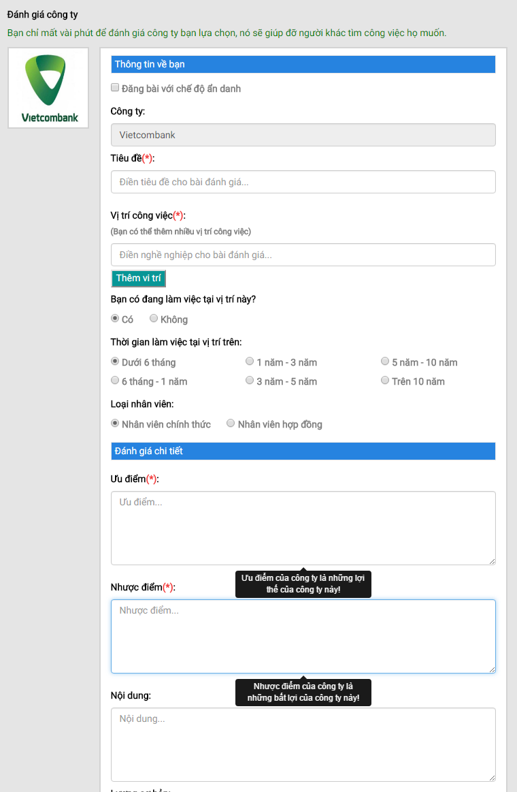

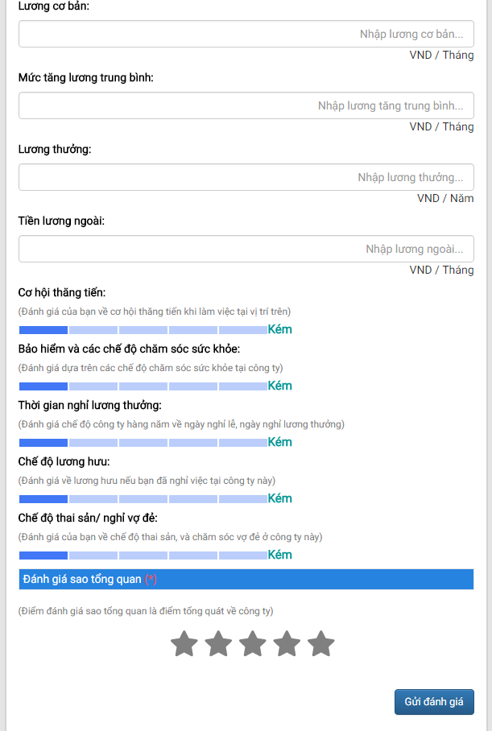

1. Create Review Screen

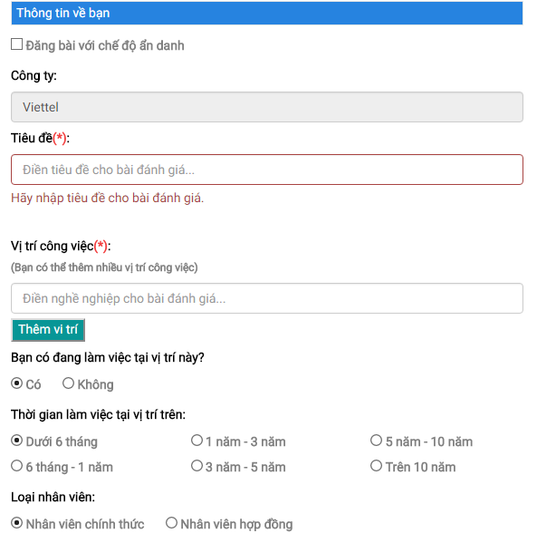

1. Reviewer Info

1. Reviewer Info

|  |  |  |  |  |  |  |  |
| --- | --- | --- | --- | --- | --- | --- | --- |
| No | Field name | Field name in Vietnamese | Type | Require | Mandatory | Max-Length | Description |
|  | Reviewer Info | Thông tin về người đánh giá | Label |  |  |  | Label for Reviewer Info section |
|  | Anonymity | Ẩn danh | Checkbox | Click |  |  | Enable anonymity mode for posting review |
|  | Company Name | Tên công ty | Textbox |  | Y |  | Automatically inputted company’s name |
|  | Review Title | Tiêu đề đánh giá | Textbox | Input | Y |  | Input review’s title |
|  | Review Title | Tiêu đề đánh giá | Label |  |  |  | Label for Review Title when field is empty or does not meet requirement |
|  | Profession | Nghề nghiệp | Auto Complete Textbox | Input | Y |  | Input or choose from a pre-existing profession in the system |
|  | Profession | Nghề nghiệp | Button | Click |  |  | Add the inputted profession as the reviewer’s |
|  | Current Profession | Nghề nghiệp hiện tại | Radio button | Click |  |  | Define whether the reviewer is currently working as the chosen profession |
|  | Profession Length | Thời gian làm việc | Radio button | Click |  |  | Define the amount of time spent as the chosen profession |
|  | Profession Contract | Hợp đồng | Radio button | Click |  |  | Define the type of contract for the chosen profession |

## Create Review Details

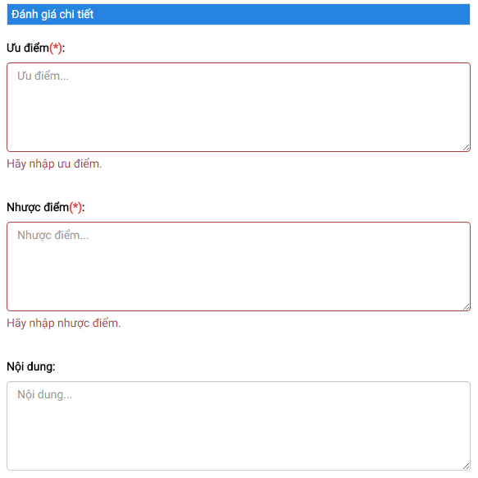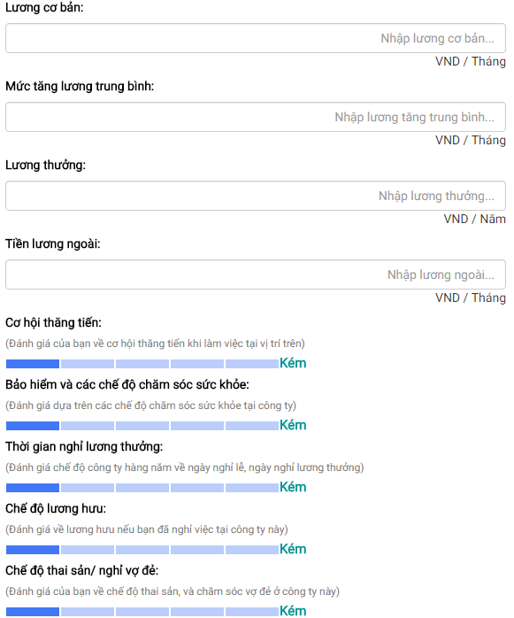

1. Review Details
2. Review Details

|  |  |  |  |  |  |  |  |
| --- | --- | --- | --- | --- | --- | --- | --- |
| No | Field name | Field name in Vietnamese | Type | Require | Mandatory | Max-Length | Description |
|  | Review Details | Đánh giá chi tiết | Label |  |  |  | Label for Review Details section |
|  | Pros | Ưu điểm | Textarea | Input | Y |  | Input the pros of working as the chosen profession in this company |
|  | Pros | Ưu điểm | Label |  |  |  | Label for Pros when field is empty or does not meet requirement |
|  | Cons | Nhược điểm | Textarea | Input | Y |  | Input the cons of working as the chosen profession in this company |
|  | Cons | Nhược điểm | Label |  |  |  | Label for Cons when field is empty or does not meet requirement |
|  | Content | Nội dung | Textarea | Input |  |  | Input additional information as needed regarding the company |
|  | Base Pay | Lương cơ bản | Textbox | Input |  |  | Input basic payment when reviewer first started as the chosen profession |
|  | Pay Raise | Lương tăng trưởng trung bình | Textbox | Input |  |  | Input payment raise as reviewer continously work as the chosen profession |
|  | Bonus Pay | Lương thưởng | Textbox | Input |  |  | Input bonus payment as reviewer excels at his chosen profession |
|  | Other Pay | Tiền lương ngoài | Textbox | Input |  |  | Input outside payment as reviewer continously work as the chosen profession |
|  | Currency | Đơn vị tiền tệ | Label |  |  |  | Label for depicting the currency of payments |
|  | Promotion Opportunity | Cơ hội thăng tiến | Select | Click |  |  | Grade the chances of getting a promotion |
|  | Healthcare | Chăm sóc sức khỏe | Select | Click |  |  | Grade the healthcare provided by this company |
|  | Paid Leave | Nghỉ hưởng lương | Select | Click |  |  | Grade the paid leave provided by this company |
|  | Pension | Lương hưu | Select | Click |  |  | Grade the pension provided by this company |
|  | Parental Leave | Thai sản | Select | Click |  |  | Grade the parental leave by this company |
|  | Explanation | Giải thích | Label |  |  |  | Label for explaining which field does what |

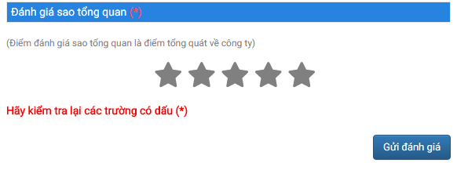

1. Review Rating
2. Review Rating

|  |  |  |  |  |  |  |  |
| --- | --- | --- | --- | --- | --- | --- | --- |
| No | Field name | Field name in Vietnamese | Type | Require | Mandatory | Max-Length | Description |
|  | Review Rating | Điểm đánh giá | Label |  |  |  | Label for Review Rating section |
|  | Total Rating | Điểm đánh giá tổng | Select | Click | Y |  | Grade the company |
|  | Mandatory | Yêu cầu | Label |  |  |  | Label for all mandatory fields when they are empty or do not meet requirement |
|  | Submit Review | Gửi đánh giá | Button | Click |  |  | Submit the review for approval |

## Review Details

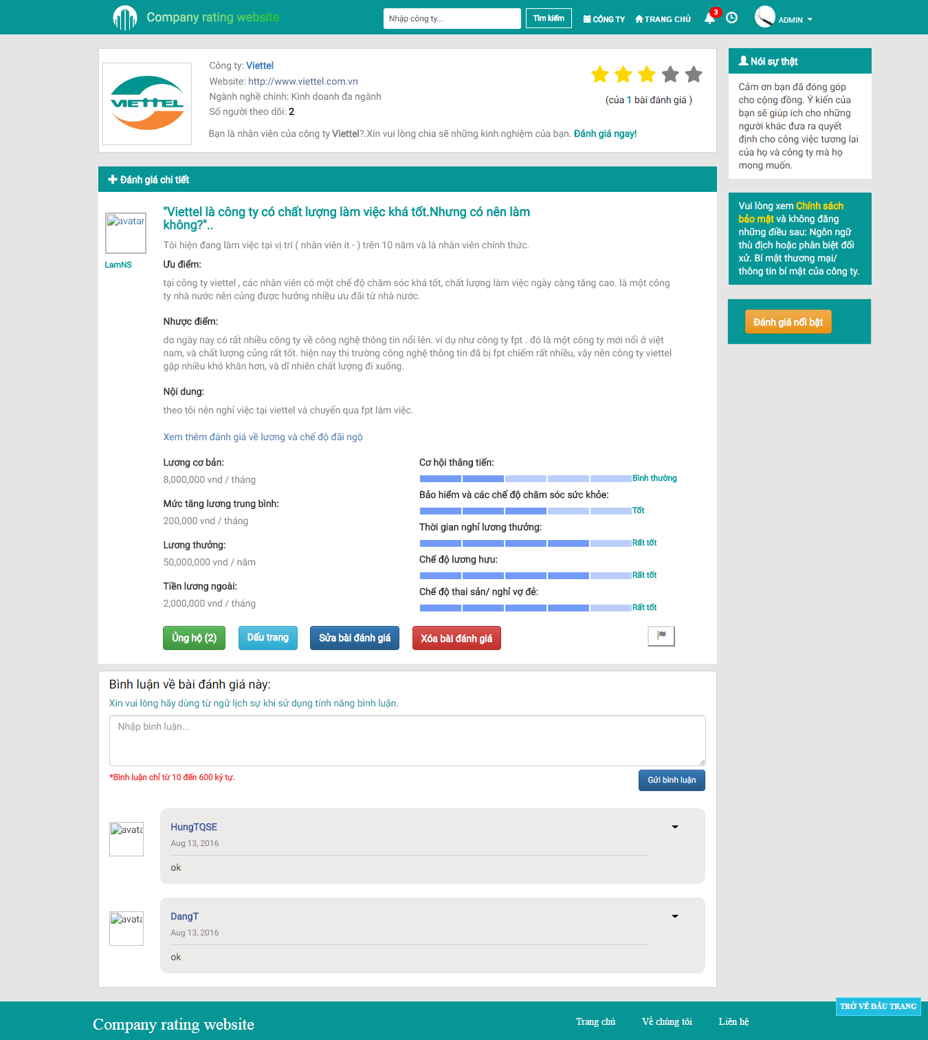

1. Detailed Review Screen

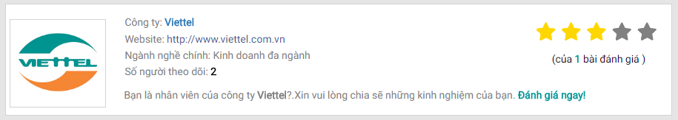

1. Company Info (Review Details)
2. Company Info (Review Details)

|  |  |  |  |  |  |  |  |
| --- | --- | --- | --- | --- | --- | --- | --- |
| No | Field name | Field name in Vietnamese | Type | Require | Mandatory | Max-Length | Description |
|  | Avatar | Ảnh đại diện | Image |  |  |  | Company’s logo |
|  | Company Name | Tên công ty | Hyperlink |  |  |  | Go to this company’s Detailed Company screen |
|  | Company Website | Website công ty | Hyperlink | Click |  |  | Go to this company’s website |
|  | Number of Followers | Số người theo dõi | Label |  |  |  | Label for showing the amount of followers |
|  | Average Star Rating | Điểm đánh giá trung bình | Star Rating Bar |  |  |  | Show average ratings of this company as stars |
|  | Number of Reviewers | Số người đánh giá | Label |  |  |  | Label for showing the amount of reviewers |
|  | Create Review | Đăng bài | Hyperlink | Click |  |  | Go to Create Review screen |

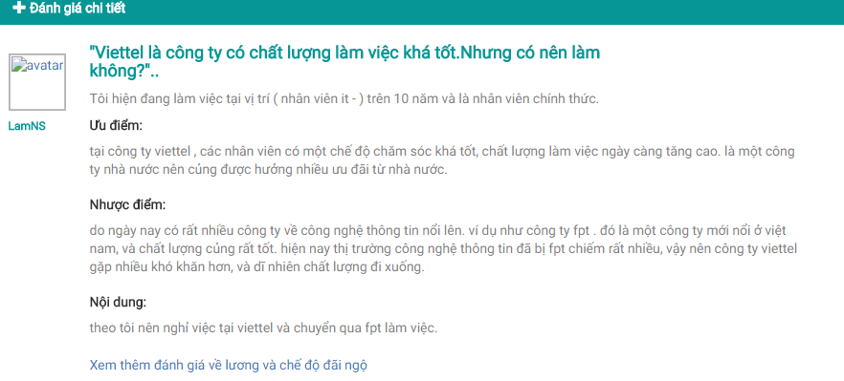

1. Review Basic Content
2. Review Basic Content

|  |  |  |  |  |  |  |  |
| --- | --- | --- | --- | --- | --- | --- | --- |
| No | Field name | Field name in Vietnamese | Type | Require | Mandatory | Max-Length | Description |
|  | Review Details | Chi tiết đánh giá | Label |  |  |  | Label for the review section |
|  | Reviewer | Người đánh giá | Hyperlink | Click |  |  | Go to the reviewer’s Account Info Screen |
|  | Reviewer Name | Tên người đánh giá | Label |  |  |  | Label for the reviewer’s name |
|  | Reviewer Avatar | Ảnh đại diện người đánh giá | Image |  |  |  | Reviewer’s avatar |
|  | Review Basic Content | Nội dung đánh giá căn bản | Panel Body |  |  |  | The basic content of the review |
|  | Review Salary And Benefit | Đánh giá lương và đãi ngộ | Hyperlink | Click |  |  | Display the Salary and Benefit section of the review |

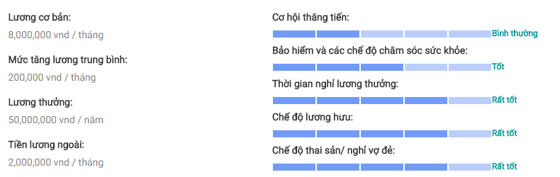

1. Review Salary and Benefit
2. Review Salary and Benefit

|  |  |  |  |  |  |  |  |
| --- | --- | --- | --- | --- | --- | --- | --- |
| No | Field name | Field name in Vietnamese | Type | Require | Mandatory | Max-Length | Description |
|  | Review Salary | Đánh giá lương | Panel Body |  |  |  | The Salary section of the review |
|  | Review Benefit | Đánh giá đãi ngộ | Disabled Select |  |  |  | The Benefit section of the review |

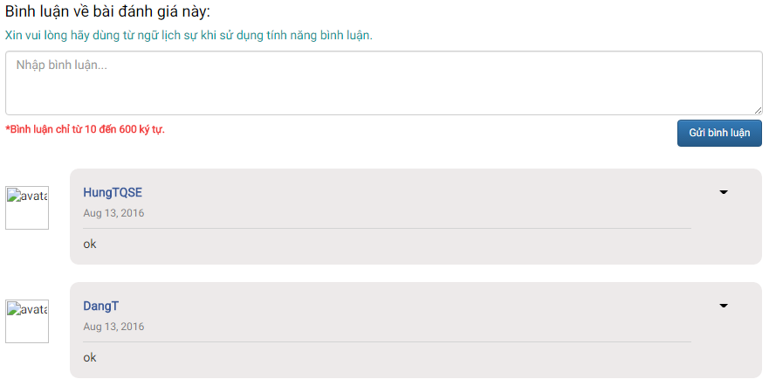

1. Comment
2. Comment

|  |  |  |  |  |  |  |  |
| --- | --- | --- | --- | --- | --- | --- | --- |
| No | Field name | Field name in Vietnamese | Type | Require | Mandatory | Max-Length | Description |
|  | Comment | Bình luận | Label |  |  |  | Label for Comment section |
|  | Comment Note | Chú ý bình luận | Label |  |  |  | Label for noting the rules regarding comment |
|  | Comment Content | Nội dung bình luận | Textarea | Input |  | 10 -600 | Input comment regarding this review |
|  | Comment Limit | Giới hạn bình luận | Label |  |  |  | Label for noting the limit regarding comment length |
|  | Submit Comment | Gửi bình luận | Button | Click |  |  | Submit the inputted comment |
|  | Commenter Avatar | Ảnh đại diện người bình luận | Image |  |  |  | Commenter’s avatar |
|  | Commenter Name | Tên người bình luận | Label |  |  |  | Name of the commenter |
|  | Comment Date | Ngày gửi bình luận | Label |  |  |  | Show when the comment was submitted |
|  | Commentary | Bình luận về đánh giá | Text |  |  |  | The content of a comment regarding this review |
|  | Comment Delete | Xóa comment | Button | Click |  |  | Delete the chosen comment (Comment Owner, Administrator) |





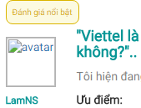

1. Other Functions (Review Details)
2. Other Functions (Review Details)

|  |  |  |  |  |  |  |  |
| --- | --- | --- | --- | --- | --- | --- | --- |
| No | Field name | Field name in Vietnamese | Type | Require | Mandatory | Max-Length | Description |
|  | Upvote | Ủng hộ | Button | Click |  |  | Give an upvote to the current review |
|  | Remove Upvote | Bỏ ủng hộ | Button | Click |  |  | Remove the given upvote from the current review |
|  | Bookmark | Dấu trang | Button | Click |  |  | Add the current review to the Bookmark list |
|  | Remove Bookmark | Bỏ dấu trang | Button | Click |  |  | Remove the current review from the Bookmark list |
|  | Edit Review | Sửa bài đánh giá | Button | Click |  |  | Go to the Update Review screen (Review Owner, Administrator) |
|  | Remove Review | Xóa bài đánh giá | Button | Click |  |  | Open the Remove Confirmation popup modal box (Review Owner, Administrator) |
|  | Report Review | Báo cáo bài đánh giá | Button | Click |  |  | Open the Report Reasoning popup modal box |
|  | Highlight Status | Trạng thái nổi bật | Label |  |  |  | Show the highlight status of the current review |
|  | Highlight | Nổi bật | Button | Click |  |  | Give the current review a highlight status (Administrator) |
|  | Remove Highlight | Bỏ nổi bật | Button | Click |  |  | Remove the current review’s highlight status (Administrator) |

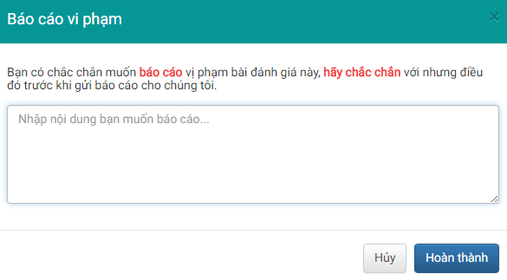

1. Report Reason Modal Box
2. Report Reason Modal Box

|  |  |  |  |  |  |  |  |
| --- | --- | --- | --- | --- | --- | --- | --- |
| No | Field name | Field name in Vietnamese | Type | Require | Mandatory | Max-Length | Description |
|  | Report | Báo cáo | Label |  |  |  | Label for Report Reasoning modal box |
|  | Report Note | Chú ý báo cáo | Label |  |  |  | Label for noting the reporter on the rules |
|  | Report Content | Nội dung báo cáo | Textarea | Input |  |  | Input report’s reasoning |
|  | Submit Report | Gửi báo cáo | Button | Click |  |  | Submit the report |
|  | Cancel Report | Hủy | Button | Click |  |  | Cancel the report |

1. TEST PLAN

# Introduction

## Background information

The target of testing is to ensure all functions will be run correctly as SRS description. In addition, restrict maximum of defect during the user access in the application. To do this target, website will have to:

* Passed the stages of testing: Unit Testing, Component Testing, Integration Testing, System Testing, Acceptance Testing.
* Passed the types of testing: Function Testing, User Interface Testing , Data and Data Integrity Testing.
* Run normally in required devices/browsers.

## Scope of testing

CRW will be tested in 5 phases:

**Phase 1: Unit testing**

* Unit testing will be done by developers.
* Developers use White Box Testing technique to do.
* When executing unit testing, if any bug is found, developers will have to log bug on “Defect Log Management” file and fix it until it is correct.

1. Test result guide

|  |  |
| --- | --- |
| Rule for filling test result | |
| Test result pass | Passed |
| Test result fail | Failed |
| Do not test | Untested |
| Cannot Test | N/A (Not available) |

**Phase 2: Integration testing**

* After finishing with component testing, integration testing will be performed by testers.
* Material will be integration test cases, high-level design and test tools.
* Integration test focuses on specific areas of use cases whereas all requirements are completed.
* Integration test should be performed to ensure all components incorporate well.
* When executing integration testing, if any bug is found, testers will have to log on “Defect Log Management” file and assign to developer to fix it and loop this process until it is correct.

1. Test result guide

|  |  |
| --- | --- |
| Rule for filling test result | |
| Test result pass | Passed |
| Test result fail | Failed |
| Do not test | Untested |
| Cannot Test | N/A (Not available) |

**Phase 3: System testing**

* After finishing integration testing and developers collected all functions and items, testers will perform system testing, which means testing the system as a whole.
* Material will be system test cases and SRS.
* When executing system testing, if any bug is found, developers will have to fix it and testers will verify as needed.
* System test will end only when all test cases are passed and no bug is found.

1. Test result guide

|  |  |
| --- | --- |
| Rule for filling test result | |
| Test result pass | Passed |
| Test result fail | Failed |
| Do not test | Untested |
| Cannot Test | N/A (Not available) |

**Phase 4: Acceptance testing**

* Based on customer/user requirement specification, system will be tested again to ensure that there is no longer any missing feature or mistake regarding requirement.
* When executing acceptance testing, if there is any problem, developers will have to fix/update it accordingly and tester will verify as needed.
* Acceptance testing will end only when the system met requirement specification.

## Constraints

* Deadline for testing can only be met when the development progress is on time.
* Test execution can only be performed when system passes Unit Test Inspection.
* At least one round of testing must be performed for requirements.
* Have multiple environments to be tested: Windows XP, Windows 8… and multiple browsers: Firefox 40 and Google Chrome 50…

## Risk list

* Dependant on the UI design and develop progress.
* Not enough time to write the required amount of test cases for test phases execution or re-test of fixed bug.
* Tester(s) could be ill during the testing phase.

## Guarantee the quality model

CRW follows the V-Model process:

1. V-Model

Testing progress is divided into 5 phases: Unit test, Component test, Integration test, System test and Acceptance test

* Unit test:
  + *Unit testing is used to verify a single minimal unit of source code. The purpose of unit testing is to isolate the smallest testable parts of DDL and verify that they function properly in isolation.*
  + Unit testing is the first level of testing and is performed prior to component testing
  + Unit testing will be done by developer.
* Component test:
  + *Component testing is used to validate a combined many minimal units of source code.*
  + *Component testing is performed after unit testing and before integration testing*
  + *Component testing will be done by tester*
* Integration test:
  + *Integration testing is a level of the software testing process where individual units or component are combined and tested as a group.*
  + *The purpose is to expose faults in the interaction between integrated units.*
  + *Integration testing is performed after component testing*
  + *Integration testing will be done by tester*
  + *There are two methods of doing integration testing: Bottom-up Integration testing and Top Down Integration testing:*

1. Integration test

|  |  |
| --- | --- |
| No | Integration Testing Method |
| 1 | Bottom-up integration  This testing begins with unit testing, followed by tests of progressively higher-level combinations of units called modules. |
| 2 | Top- Down integration  This testing, the highest-level modules are tested first and progressively lower-level modules are tested after that |

* System test:
  + *System Testing is a level of the software testing process where a complete, integrated system is tested*
  + *The purpose is to evaluate the system’s compliance with the specified requirements*
  + *System testing is performed after integration testing*
  + *System testing will be done by tester*
* Acceptance test:
  + *Acceptance testing is performed after system testing*
  + *Acceptance testing will be performed by the test leader and team leader.*
  + *The acceptance test will be done for a period of 1 weeks after completion of the system test process*

# Requirements For Test

## Test item

1. Function list and corresponding function test cases

|  |  |  |  |
| --- | --- | --- | --- |
| TC No. | Group of Fuctions | Function | Glossary |
| User | | | |
| TC001 | Review | View Review |  |
| TC002 | Search Review |  |
| TC003 | Company | View Company Information |  |
| TC004 | Search Company |  |
| TC005 | Comment | View Comment |  |
| Guest | | | |
| TC006 | Common | Register Account |  |
| TC007 | Review | Post Review (Anonymous) |  |
| Member & Administrator | | | |
| TC008 | Common | Login |  |
| TC009 | Logout |  |
| TC010 | View Notification |  |
| TC011 | Get Notification |  |
| TC012 | Account | View Account Information |  |
| TC013 | Update Account Information |  |
| TC014 | Change Password |  |
| TC015 | Forgot Password |  |
| TC016 | Comment | Add Comment |  |
| TC017 | Update Comment |  |
| TC018 | Delete Comment |  |
| TC019 | Profession | Suggest Profession |  |
| TC020 | Add Profession |  |
| TC021 | Company | Suggest Company |  |
| TC022 | Add Company |  |
| Member | | | |
| TC023 | Company | Manage Followed Company |  |
| TC024 | Follow Company |  |
| TC025 | Unfollow Company |  |
| TC026 | Review | Manage Review |  |
| TC027 | Post Review |  |
| TC028 | Update Review |  |
| TC029 | Delete Review |  |
| TC030 | Report Review |  |
| TC031 | Upvote Review |  |
| TC032 | Remove Review Upvote |  |
| TC033 | Bookmark | Manage Bookmark |  |
| TC034 | Add Bookmark |  |
| TC035 | Remove Bookmark |  |
| Administrator | | | |
| TC036 | Company | Manage Company |  |
| TC037 | Add Company |  |
| TC038 | Update Company |  |
| TC039 | Delete Company |  |
| TC040 | Review | Manage Report |  |
| TC041 | Revise Report |  |
| TC042 | Change Review Status |  |
| TC043 | Account | ManageAccount |  |
| TC044 | Search Account |  |
| TC045 | Change Account Status |  |
| TC046 | Warn User |  |

## Acceptance test criteria

* Criteria for Development team’s Unit test, for Test team accepts to start testing:
  + *Number of TC/KLOC: 40TC/KLOC*
  + *Number defects/KLOC: 3-4 defects/KLOC*
  + *Statement coverage: 100%*
  + *Branch coverage: 100%*
  + *Path coverage: 100%*
* Criteria for Integration test:
  + *Number of TC/KLOC: 30 TC/KLOC*
  + *Number defects/KLOC: 2-3 defects/KLOC*
* Criteria for System test:
  + *Number of TC/KLOC: 20 TC/KLOC*
  + *Number defects/KLOC: 4-6 defects/KLOC*
* Criteria for Acceptance test:
  + *Number defects/KLOC: 1-2 defects/KLOC*

## Feature not to be tested

* The stablility of website when internet connection is lost.
* Over than 5000 concurrent user at any given point.

# Test Strategy

## Test type



### Function testing

* Functional testing is a type of software testing whereby the system is tested against the functional requirements/specifications.
* Functions are tested by feeding them input and examining the output. Functional testing ensure that the requirements are properly satisfied by the website. This type of testing is not concerned with how processing occurs, but rather, with the results of processing.
* During functional testing, [Black Box Testing](http://softwaretestingfundamentals.com/black-box-testing/) technique is used in which the internal logic of the system being tested is not known to the tester.

1. Function Test Guide

|  |  |
| --- | --- |
| Test Objective | This type of test is to ensure proper target-of-test functionality, including user interaction and all function defined in specification document is to be implemented correctly. |
| Technique | Execute each use case, use-case flow or function, using valid and invalid data, to verify the following:   * The expected results occur when valid data is used. * The appropriate error or warning messages are displayed when invalid data is used. * Each business rule is properly applied. |
| Completion Criteria | * All planned tests have been executed. * All identified defects have been addressed and closed. |
| Special Considerations | Testing may be stopped when:   * Time runs out * A certain number of defects found * Test coverage > 97% * Stop when testing becomes unproductive |

### User Interface testing

* GUI testing is the process of ensuring proper functionality of the GUI for a given web and making sure it conforms to its written specifications.
* GUI testing evaluates design elements such as layout, colors, [fonts](http://whatis.techtarget.com/definition/font), font sizes, labels, text boxes, text formatting, captions, buttons, lists, icons, links, content and more.

1. UI testing guide

|  |  |
| --- | --- |
| Test Objective | Verify the following:   * Navigation through the target-of-test properly reflects business functions and requirements, including window-to-window, field-to-field and ease of access methods (tab keys, mouse movements, accelerator keys) * Window objects and characteristics, such as menus, size, position, state and focus conform to standards. |
| Technique | Create or modify tests for each window to verify proper navigation and object states of each application window and objects. |
| Completion Criteria | Each window successfully verified to remain consistent with benchmark version or within acceptable standard. |
| Special Considerations | Not all properties for custom and third party objects can be accessed. |

### Data and Database Integrity testing

The databases and the database processes should be tested as a subsystem within the Project. These subsystems should be tested without the target-of-test’s User Interface as the interface to the data.  Additional research into the Database Management System (DBMS) needs to be performed to identify the tools and techniques that may exist to support the testing identified below.

1. Data and Data Integrity testing guide

|  |  |
| --- | --- |
| Test Objective | Ensure database access methods and processes function properly and without data corruption. |
| Technique | * Invoke each database access method and process, seeding each with valid and invalid data or requests for data. * Inspect the database to ensure the data has been populated as intended, all database events occurred properly, or review the returned data to ensure that the correct data was retrieved for the correct reasons. |
| Completion Criteria | All database access methods and processes function as designed and without any data corruption. |
| Special Considerations | * Testing may require a DBMS development environment or drivers to enter or modify data directly in the databases. * Processes should be invoked manually. * Small or minimally sized databases (limited number of records) should be used to increase the visibility of any non-acceptable events. |

## Test stages

Clarified state of the stage in which the test will be executed. Identified below are the stages in which common tests are executed.

1. Types and stages of test

|  |  |  |  |  |
| --- | --- | --- | --- | --- |
| Types of Test | Stages of Test | | | |
| **Unit** | **Integration** | **System** | **Acceptance** |
| Function Testing | X | X | X | X |
| User Interface Testing | X |  | X | X |

# Resources

## Human Resource

1. Human Resource

|  |  |  |
| --- | --- | --- |
| Worker/Doer | Role | Specific Responsibilities/Comments |
| LamNS | Test Leader | Manage Test Resource and assign test tasks.  Create and review Test Plan.  Create and review Test Case.  Execute test.  Create and review Test Report |
| QuangNN | Tester | Create and review Test Case.  Execute test.  Create Test view points  Create and review Test Report |

# Test Environment

## Hardware

1. Hardware test environment

|  |  |  |
| --- | --- | --- |
| Name | Purpose | Detail |
| Laptop HP | Device for create and execute test | Windows 10 Core i5 |
| Laptop Asus | Device for create and execute test | Windows 8 Core i7 |

## Software

1. Software test environment

|  |  |  |
| --- | --- | --- |
| Name | Purpose | Detail |
| Test Plan | Managing test | Microsoft Word 2013 |
| Test Case | Executing test | Microsoft Word 2013 |
| Test Report, Test Checklist | Tracking test | Microsoft Word 2013, Redmine |
| Chrome | Executing test | Version 50 |
| Firefox | Executing test | Version 40 |

## Infrastructure

1. Test infrastructure

|  |  |  |  |  |
| --- | --- | --- | --- | --- |
| Name | Purpose | Detail | Vendor/In-house | Version |
| CRW_Defect Log Management_v1.0_EN | Tracking Bug during testing time | Microsoft Excel 2013, Redmine | FPT University | V1.0 |
| Test Effort | Effort for test execution | Microsoft Excel 2013 | FPT University | V1.0 |

# Test Milestones

1. Milestone task and their requirements

|  |  |  |  |
| --- | --- | --- | --- |
| Milestone Task | Effort (pd) | Start Date | End Date |
| Create Test Plan | 6 |  |  |
| Review & Update Test Plan | 2 |  |  |
| Create Component Test case | 12 |  |  |
| Review & Update Component Test Case | 2 |  |  |
| Create Integration Test case | 2 |  |  |
| Review & Update Integration Test Case | 2 |  |  |
| Create System Test case | 6 |  |  |
| Review & Update System Test Case | 2 |  |  |
| Execute Component test phase 1 | 1 |  |  |
| Execute Component test phase 2 | 1 |  |  |
| Execute Integration test phase 1 | 2 |  |  |
| Execute Integration test phase 2 | 2 |  |  |
| Execute System test phase 1 | 4 |  |  |
| Execute System test phase 2 | 4 |  |  |

# Deliverables

1. Deliverables and their requirements

|  |  |  |
| --- | --- | --- |
| No | Deliverables | Responsibilities |
| **1** | Test Plan | Tester |
| **2** | Component Test case | Tester |
| **3** | Integration Test case | Tester |
| **4** | System Test case | Tester |
| **5** | Defect Log Management | All members |
| **6** | Test report | PM |

# Test Case

## Unit Test Case

Refer to these files belows for Unit Test Case and Detailed Result:

Client Unit Test:

* UnitTestCase_companies.client.controller.xlsx
* UnitTestCase_handle-reviews.client.controller.xlsx
* UnitTestCase_reviews.client.controller.xlsx
* UnitTestCase_searchcompanies.client.controller.xlsx
* UnitTestCase_users.client.controller.xlsx

Server Unit Test:

* UnitTestCase_admin.server.controller.xlsx
* UnitTestCase_chat.server.socket.config.xlsx
* UnitTestCase_companies.server.controller.xlsx
* UnitTestCase_companies.server.model.xlsx
* UnitTestCase_jobs.server.controller.xlsx
* UnitTestCase_users.authentication.server.controller.xlsx
* UnitTestCase_users.authorization.server.controller.xlsx
* UnitTestCase_users.password.server.controller.xlsx
* UnitTestCase_users.profile.server.controller.xlsx

## Integration Test Case

Refer to CRW_Integration Test Case_v1.0_EN.xlsx

## System Test Case

Refer to CRW_System-Test-Case_v1.0_EN.xlsx

# Test Report

## Test Result

1. Test cases and defects statistics

|  |  |  |  |  |  |  |  |
| --- | --- | --- | --- | --- | --- | --- | --- |
| Phase | #Test cases Planned | #Defects Planned | #Test cases Actual | #Defects Actual | % Tests Executed | % Tests Passed | % Tests Fail |
| Unit Test | 30TC/KLOC | 3 -4 defects/KLOC | 337 | 4 defects/KLOC | 100% | 100% | 0% |
| Integration Test | 20TC/KLOC | 2 -3 defects/KLOC | 200 | 1 defects/KLOC | 100% | 96% | 4% |
| System Test | 40TC/KLOC | 4 -6 defects/KLOC | 502 | 5 defects/KLOC | 100% | 96% | 4% |
| Acceptance Test | N/A | N/A | N/A | N/A | N/A | N/A | N/A |
| Total | 90TC/KLOC | 9-13 defects/KLOC | 1039 | 10 defects/KLOC | 100% | 97% | 3% |

1. Test result round 1

|  |  |  |  |  |
| --- | --- | --- | --- | --- |
| Phase | Round 1 | | | |
| Pass | Fail | Untested | N/A |
| Unit Test | 337 | 0 | 0 | 0 |
| Integration Test | 142 | 42 | 0 | 30 |
| System Test | 300 | 90 | 0 | 130 |
| Total | 779 | 132 | 0 | 160 |

1. Test result round 2

|  |  |  |  |  |
| --- | --- | --- | --- | --- |
| Phase | Round 1 | | | |
| Pass | Fail | Untested | N/A |
| Unit Test | 337 | 0 | 0 | 0 |
| Integration Test | 180 | 20 | 0 | 0 |
| System Test | 450 | 54 | 0 | 2 |
| Total | 967 | 74 | 0 | 2 |

1. Test result round 3

|  |  |  |  |  |
| --- | --- | --- | --- | --- |
| Phase | Round 1 | | | |
| Pass | Fail | Untested | N/A |
| Unit Test | 337 | 0 | 0 | 0 |
| Integration Test | 192 | 8 | 0 | 0 |
| System Test | 484 | 20 | 0 | 2 |
| Total | 1013 | 28 | 0 | 2 |

## Defect Report

1. Defect statistics

|  |  |  |  |  |
| --- | --- | --- | --- | --- |
| Defect | Logged | %Closed | %Invalid | %Open |
| Critical | 0 | 0% | 0% | 0% |
| High | 12 | 100% | 0% | 0% |
| Medium | 29 | 90% | 0% | 10% |
| Low | 28 | 100% | 0% | 0% |
| Total | 50 | 96% | 0% | 4% |

1. Defect statistics by category

|  |  |  |  |
| --- | --- | --- | --- |
| Defect category | Open | Closed | Total |
| Critical | 0 | 17 | 17 |
| High | 0 | 8 | 8 |
| Medium | 3 | 41 | 44 |

1. Defect statistics by person

|  |  |  |  |
| --- | --- | --- | --- |
| Defect category | Open | Closed | Total |
| LamNS | 0 | 0 | 0 |
| HungTQ | 3 | 35 | 38 |
| QuangNN | 0 | 0 | 0 |
| HungNV | 0 | 25 | 25 |
| DangT | 0 | 6 | 6 |

1. USER MANUAL

# Installation Guide

## Prepare Environment

Following are the softwares required to start the CRW system:

* Operating System: Windows 8, Window 10
* Browsers: Firefox 40, Chrome 50 or higher.
* Database: MongoDB 3.2
* Tool: RoboMongo 0.9, PuTTY, PuTTYgen

## Deploy website to AWS

### Setup hosting at AWS

#### Setup new account to use EC2 instance at AWS

* **Step 1:** Create an account with AWS with link: <https://aws.amazon.com/>

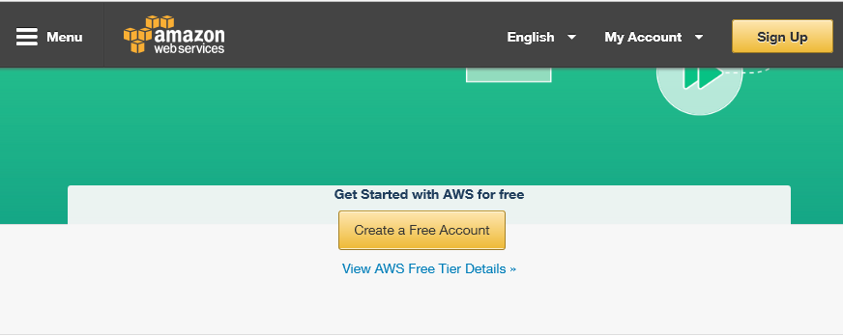

1. AWS Screen

* **Step 2:** Once registered, click “Sign In to the Console”. Click EC2 at Dashboard

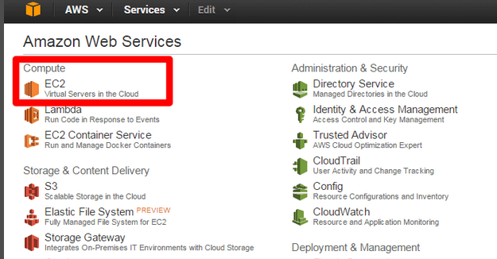

1. AWS Dashboard

* **Step 3:** Before launching EC2 instance, we need to create an EC2 key pair. Navigate to the menu option titled “Key Pairs” and click “Create Key Pair”.

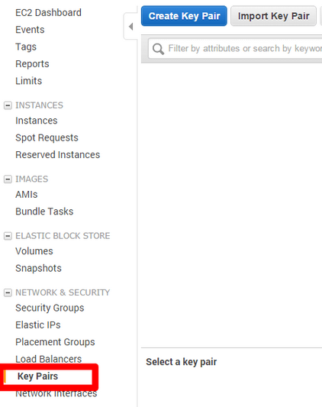

1. **Key Pairs Dashboard**

* **Step 4:** Name key pair to “CRW” in the pop-up that appears. Immediately after, a .pem file with the same name will download to system. Don’t lose this file, it’s very important! It’s only generated once and we’ll need it to access EC2 instance.

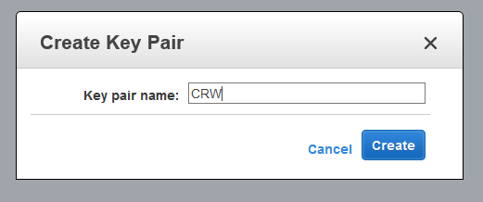

1. Name Key Pair

#### Launching EC2 Instance

If we lauch EC2 instance using the traditional way, we have to install and config every core components of MEAN, which is very complicated. The better choice is AWS Marketplace. The Marketplace includes a variety of pre-configured images, include MEAN-supported image, which help us simplifying progress of deploying CRW onto AWS.

* **Step 1:** Go to AWS Marketplace: <https://aws.amazon.com/marketplace>

Search for this in the marketplace and open up the one titled: “MEAN Powered by Bitnami (HVM)”.

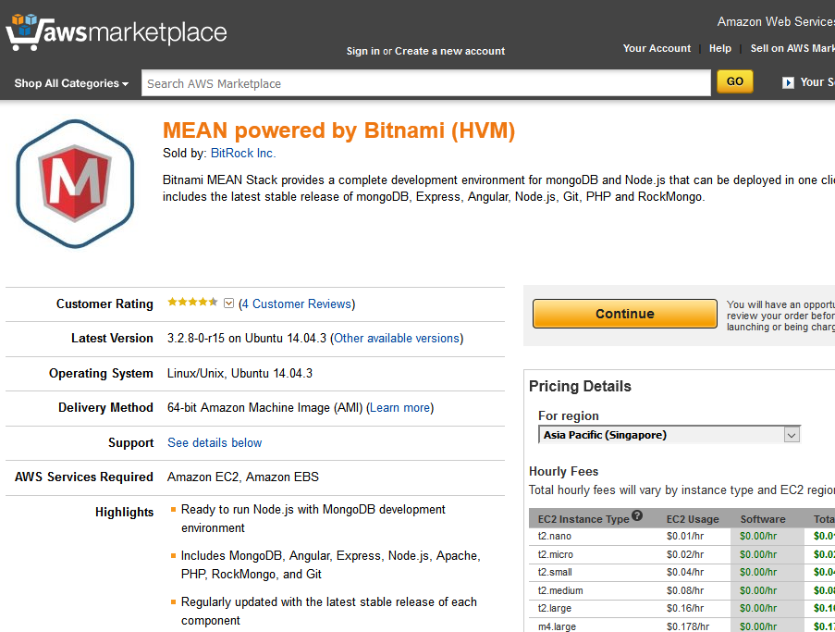

1. AWS Marketplace

* **Step 2:** From the Bitnami MEAN screen, set region to “Asia Pacific (Singapore)”, click “Continue”
* **Step 3:** Choose suitable instance type based on project budget (t2.micro for free).

At Key Pair section, select “CRW” (the Key Pair we created earlier).

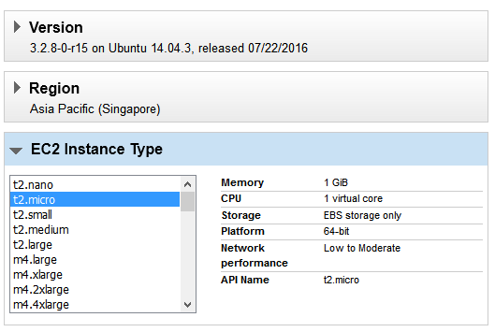

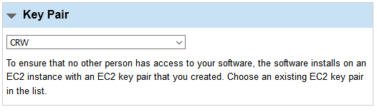

1. Choose hosting place

* Step 4: Click “Accept Terms & Launch with 1-Click”. We will then receive a notification telling you that your EC2 instance is being deployed.

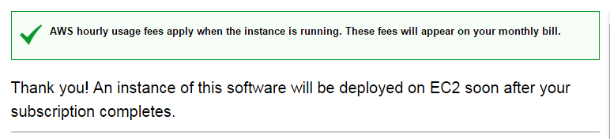

1. Success notification

#### Setting Security Access

Different from testing local website, whenever we build MEAN applications we designate a specific port to which the server refers. (localhost:3000, localhost:8080, etc). This doesn’t require configuring when we’re running locally, but now that we’re in the real-world, our ports aren’t just open by default. This means since our application is looking to use port 8080, 27017 (for MongoDB) we need to make sure that port 8080 and 27017 accessible for use.

* **Step 1:** Navigate to the AWS EC2 Dashboard. Using the menu on the left, open up the Security Groups panel. Click on the row associated with our MEAN application. (It will have a Group name like: “MEAN powered by Bitnami”). Beneath our row is a set of Inbound and Outbound rules specifying which ports are accessible for the application and by the outside world.

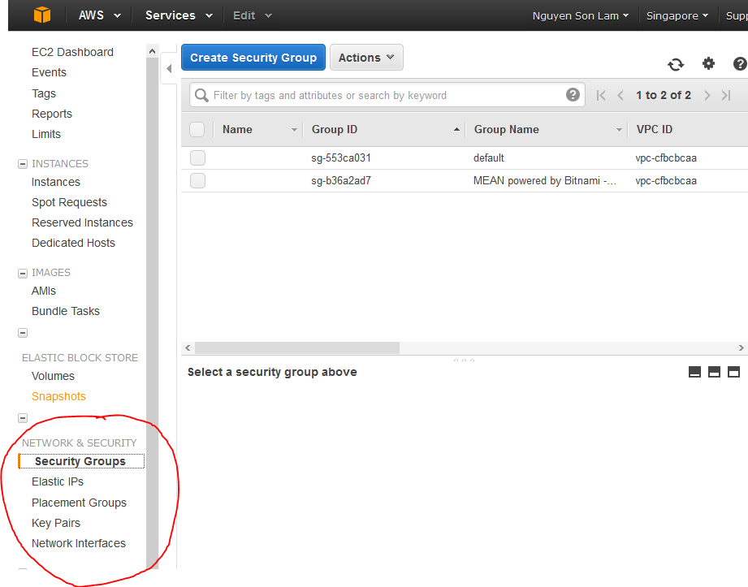

1. AWS Dashboard

* **Step 2:** Create a custom inbound TCP rule that makes port 8080 accessible. Set the Protocol to TCP, the Port Range to 8080, and the source 0.0.0.0/0 (anywhere). Additionally, we’ll do the same for port 27017, which will be used by MongoDB. Once we’ve added this new rule, refresh the security group using the menu button at the top right.

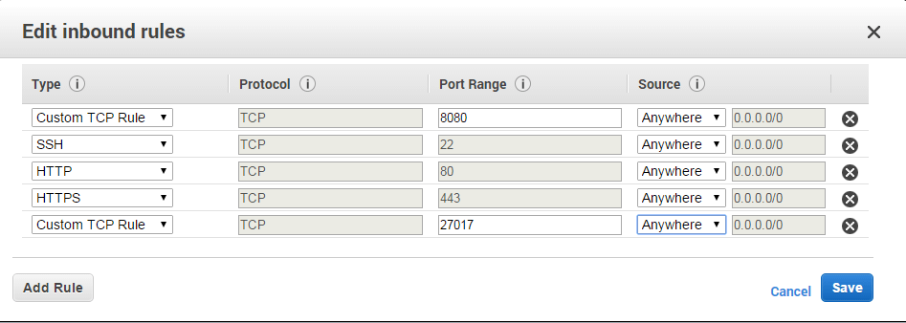

1. Add inbound rules screen

### Deploying website code onto AWS

#### Connecting to EC2 Instance

* **Step 1:** *This step is very important*. As part of the Bitnami MEAN installation, EC2 instance comes pre-configured with an initial MongoDB admin username and password. The initial username is always root, but a unique password is created upon first launch of an instance. To obtain password, right-click on the row of EC2 instance and navigate to Instance Settings -> Get System Log.

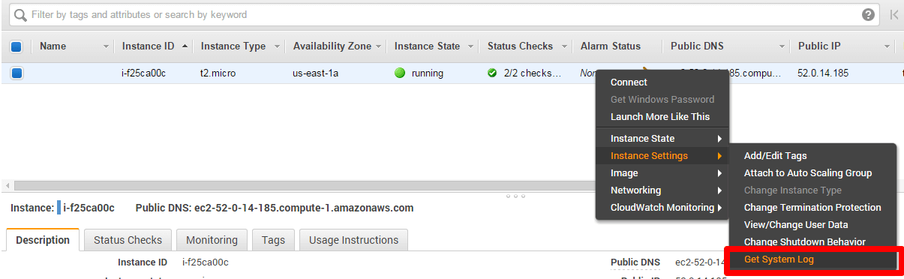

1. AWS Dashboard

Scroll through the System Log to the very end, we will see a bright box with the words: Setting Bitnami application password to followed by a password. This is the initial MongoDB admin password. Copy it and paste it somewhere safe. *Don’t lose this password*. We will only be shown it once, and we will need this in order to access EC2 instance of MongoDB.

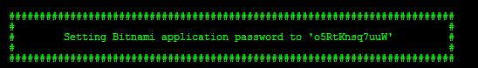

1. System Log

**From step 2 to 4, we will use PuTTY to connect to EC2 instance via SSH.**

* **Step 2:** Download PuTTY at <http://www.chiark.greenend.org.uk/~sgtatham/putty/download.html>

Once installed, navigate back to AWS Console and then the running EC2 instance. From this screen look at the description section associated with EC2 instance. Note the Public DNS. This represents the URL where CRW will sit and the hostname we will be connecting to. we’ll be using this Host Name along with the .pem security key we downloaded earlier to connect to EC2 instance.

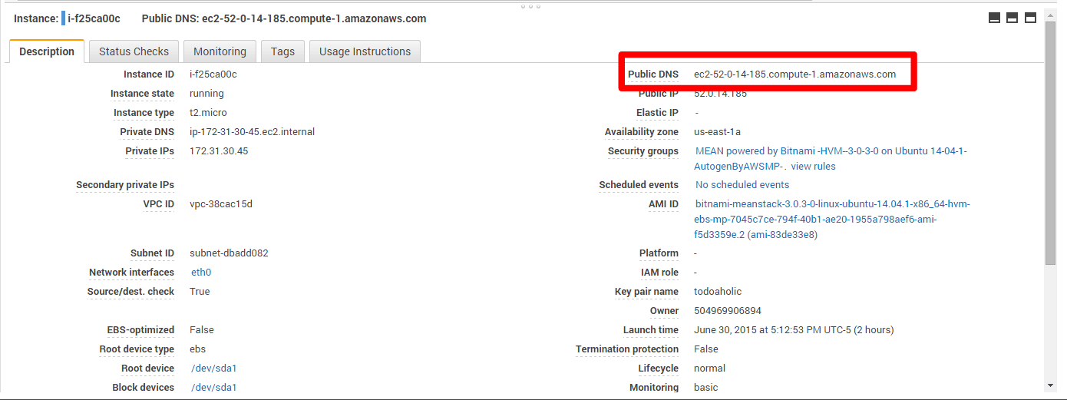

1. EC2 Instance Information

* **Step 3:** Before we can proceed with our connection, we will need to convert .pem file into a .ppk file that PuTTY can recognize. For this we will need the program PuTTYgen (download at <http://www.chiark.greenend.org.uk/~sgtatham/putty/download.html> )

Load .pem security file into PuTTYgen (switch the file types to all “All Files .” when browsing for key). Once its loaded, click “Save Private Key” and re-save file as a PuTTY Private Key file (.ppk).

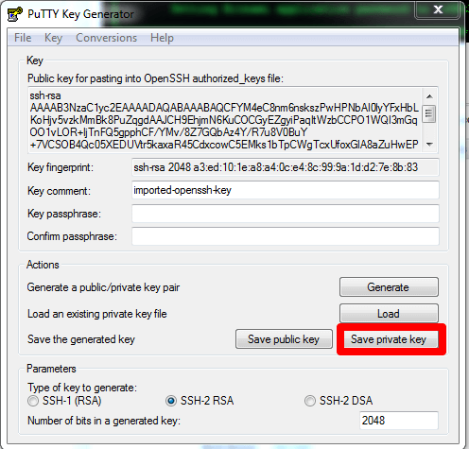

1. PuTTY Key Generator

* **Step 4:** Open up PuTTY and enter the Public DNS we noted earlier as the Host Name. Set the Port for 22. Finally, look at the category menu for the SSH -> Auth page. Where it says: “Private Key for Authentication” upload the .ppk file we generated earlier.

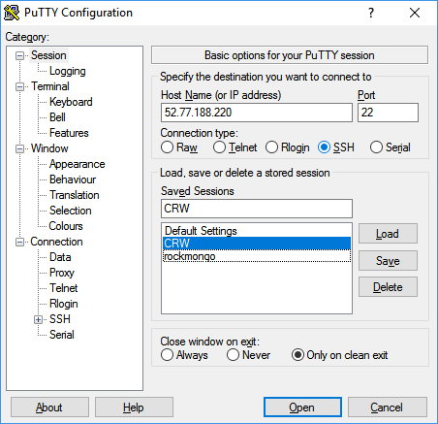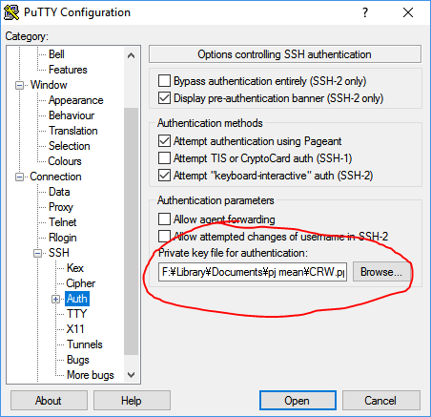

1. Upload private key to PuTTY

Step 5: Click “Open” and a terminal will pop-up. If this is the first time we’ve accessed this specific host, a warning will appear informing us that the server's host key is not cached in the registry. Just hit “Yes” to instruct it to continue. We’ll then be greeted by a screen saying: “login as”. Enter “bitnami”.

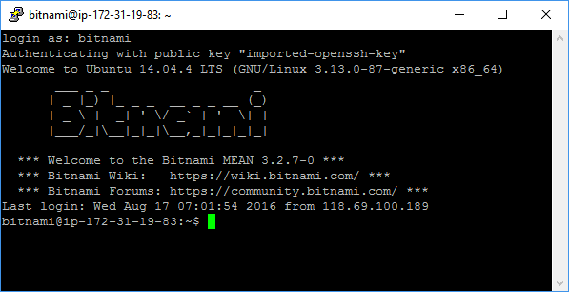

1. Logging in to Bitnami

#### Deploying CRW code onto EC2 Instance

* **Step 1:** Connect to EC2 Instance via SSH. Type these commands one after another to download CRW code by cloning CRW Git repository onto the server:

cd

cd apps

sudo git clone <https://github.com/ShiroNek0/CRW.git>

cd CRW

To confirm things worked out, type command *ls* to check that the CRW folder was created. *cd* into that folder and again check the contents with *ls*.

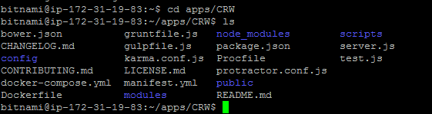

1. Cloning source code to server

* **Step 2:** Type these commands to install all MEAN.JS dependencies:

sudo npm install -g bower

sudo npm install gulp -g

sudo npm install -g grunt-cli

sudo npm install

#### Configuring MongoDB

* **Step 1:** Connect to EC2 Instance via PuTTY. When prompted, enter: bitnami to login.
* **Step 2:** We’ll be making use of the green password we obtained earlier:



1. System Log

While in the EC2 terminal, use “mongo admin” to enter MongoDB

sudo mongo admin --username root --password {YOUR GREEN PASSWORD}

Once you’ve logged in, the first action we’ll take is to create a new user with administrative privileges. This will be our admin user.

> show dbs

> use admin

> db.createUser

> db.createUser(

{

user: "AdminCRW",

pwd: "maiwaifu",

roles: [ "root" ]

}

)

If all goes well, we should be notified that the user was successfully added.

Now, log out of mongodb by entering ctrl+c and try logging back in using your new admin username and password.

sudo mongo admin --username AdminCRW --password maiwaifu

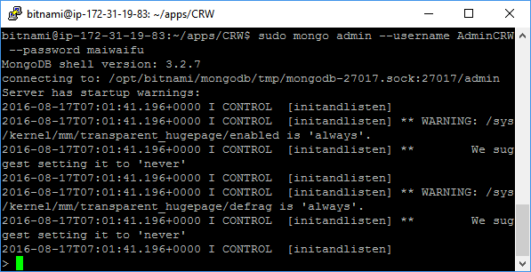

1. Log in to MongoDB

* **Step 3:** Confirm that your account has been granted complete privileges by querying the databases and adding in a dummy record. Here we’ll add a record: “This is a test” into the “test” collection of “dummyDB”.

> show dbs

> use dummyDB

> db.test.insert({ item: "This is a test"})

If we query for the record we should see it appear.

> db.test.find().pretty()



1. Expected result

**At next step we’ll configure MongoDB so it knows which IP addresses to allow database access.**

* **Step 4:** Head to Stack -> MongoDB by type those commands:

cd

cd stack

ls

cd mongodb

ls

Open mongodb.conf file and making a few edits using nano editor:

sudo nano mongodb.conf

Change the bind_ip value to equal 0.0.0.0. This will allow all IP addresses access to our MongoDB instance.

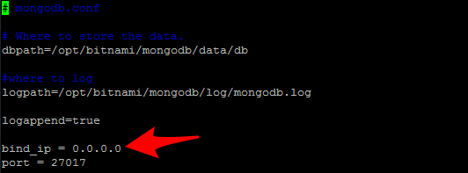

1. Update bind_ip

Next, we need to configure the authentication of MongoDB 3.2. With version 3.0, came a new authentication mechanism for MongoDB. In Mongo 2.0, a database could be accessed via a remote shell or terminal so long as an admin username and password was supplied. This was convenient for upstart developers trying to quickly set things up. With the latest change, the authentication mechanism requires a bit more work as many third-party tools (including Bitnami’s default image) have yet to switch to the new drivers.

Look for where it says: auth = true. Temporarily, comment this value out, and uncomment the parameter that says noauth = true. Then press Ctrl+O then Enter to save file, Ctrl+X to exit nano.

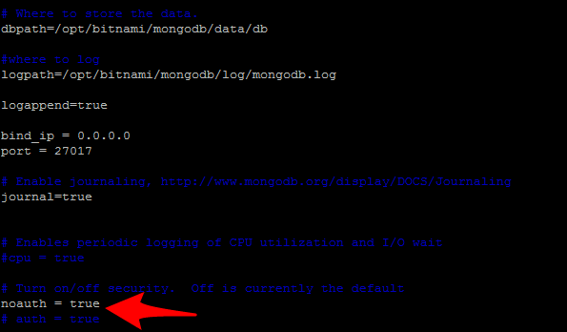

1. Changing authentication for MongoDB

Once complete, navigate up one level back to the stack folder. Then run the bash script in ctlscript.sh to restart mongodb.

cd ..

ls

sudo bash ctlscript.sh restart mongodb

After that, login to MongoDB and run the following:

> use admin

> var schema = db.system.version.findOne({"_id": "authSchema"})

> schema.currentVersion = 3

> db.system.version.save(schema)

Now we create a new admin profile. This administrator will work with the reverted authentication mechanism and work for remote connections.

> show dbs

> use dummyDB

> db.createUser({

user: "AdminCRW_remote",

pwd: "maiwaifu",

roles:[

{

"role" : "readWrite",

"db": "CRW"

}

]

})

Once created, go back again to the mongodb.conf file, comment out noauth=true, and uncomment auth=true. (Essentially re-activate the authentication requirement). Your config file should now look like this:

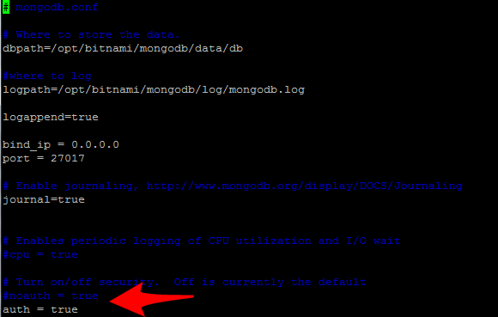

1. Example config file

Run the bash script in ctlscript.sh to restart mongodb again to ensure changes take effects. We can confirm the changes by connecting to Mongo Instance via local terminal:

mongo {EC2 DOMAIN}/CRW -u {New Username} -p {password}

**At next step, we will incorporate the EC2 DB into our website.**

* **Step 5:** Navigate to the database.js file found in the config folder. Replace the existing URL and replace it with the URL associated with our EC2 instance of MongoDB. It should follow the format below:

mongodb://AdminCRW_remote:maiwaifu@{EC2 URL}:27017/CRW'

### Running website

* **Step 1:** Connect to EC2 Instance via PuTTY. Navigate to CRW folder

cd

cd apps/CRW

* **Step 2:** As of now, the moment we close out PuTTY, our application dies with it. Conceivably, we could keep our PuTTY window open forever, but that sort of defeats the purpose of having our application on a server.

So instead, we’re going to utilize the node package forever.js. Forever is a simple tool that ensures a given script runs continuously (i.e. forever). To install it, let’s first stop our existing application with ctrl+c.

We’ll use this command:

sudo npm install forever -g

We will get a short message saying Forever processing file: server.js and this should be good to go. The best way to test that things after that is to simply close out PuTTY instance of PuTTY and reload website in browser.

## Setup RoboMongo at local computer

Since Mongo CLI is kind of inconvenient to manage database efficiently, we should use RoboMongo, a native MongoDB management tool, which has a very easy-to-use UI.

* **Step 1:** Download and install RoboMongo at <https://robomongo.org/download>

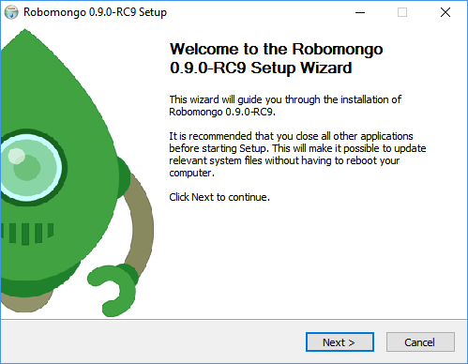

1. Robomongo Installer Greeting screen

* **Step 2:** Open RoboMongo, press Ctrl+N

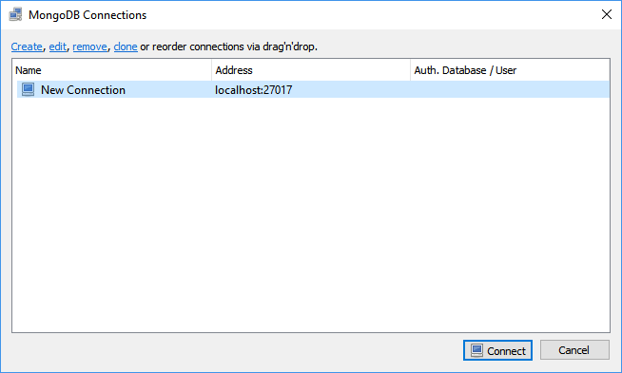

1. Create a New Connection

Click “Create” hyperlink to open new Connection Setting.

At tab Connection, set Name to CRW and fill in public domain DNS of EC2 instance to Address textbox.

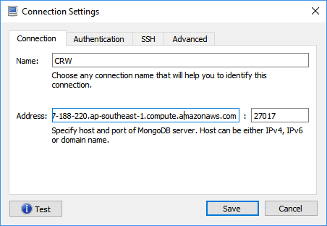

1. Connection Settings

At tab Authentication tab, check “Perform authentication” checkbox, fill in all nescessary info:

* Database: CRW
* Username: AdminCRW_remote
* Password: maiwaifu
* Auth Mechanism: SCRAM-SHA-1

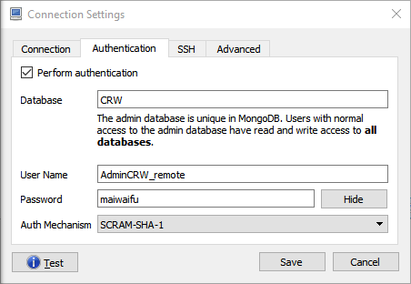

1. Authentication Settings

At Advanced tab, type CRW. Then click Test to confirm connection to database on EC2 Instance.

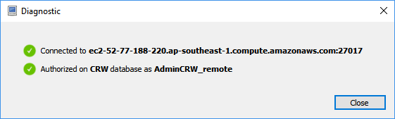

1. Connection Test Result

* **Step 3:** After confirmation, click Save. Press Ctrl+N, now CRW is displayed on connection list.

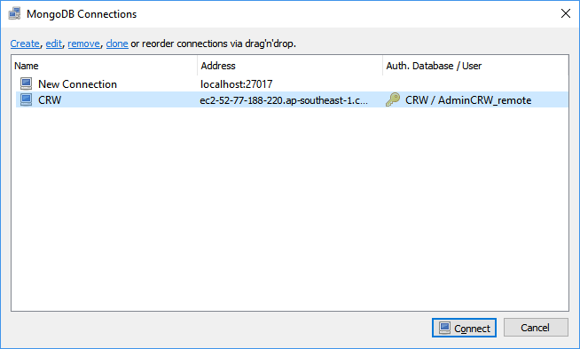

1. MongoDB Connection List

Click Connect to access to database.

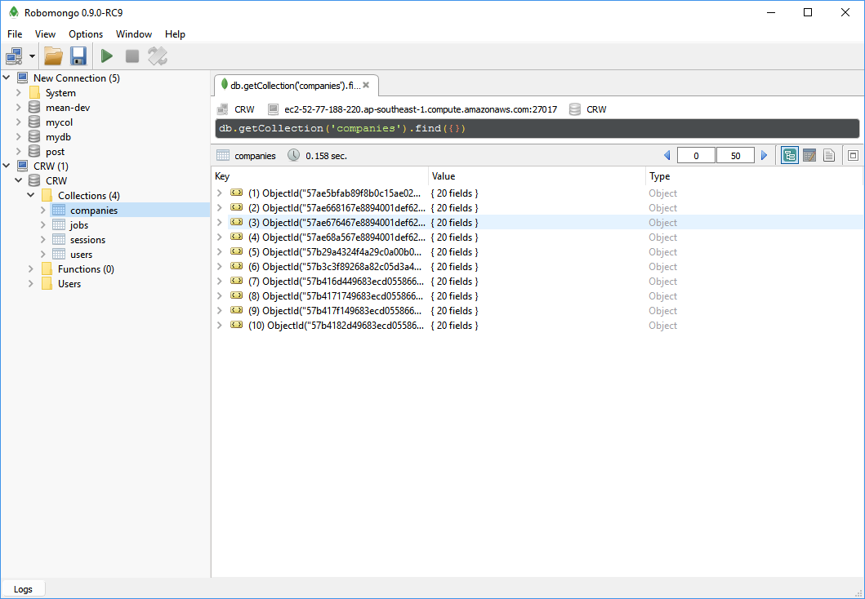

1. RoboMongo Working Screen

# User Guide

## Register

To register account on website, you should follow these steps:

Step 1: Open browser and enter to the address bar: <http://companyrating.xyz/>. Homepage is displayed.

Step 2: Click on “Đăng nhập” button in header. Then click “Chưa có tài khoản? Đăng ký ngay!” hyperlink, you will be redirected to Register page.

Step 3: Enter information and click on “Đăng ký” button or you can register by choose “Đăng nhập với Facebook”.

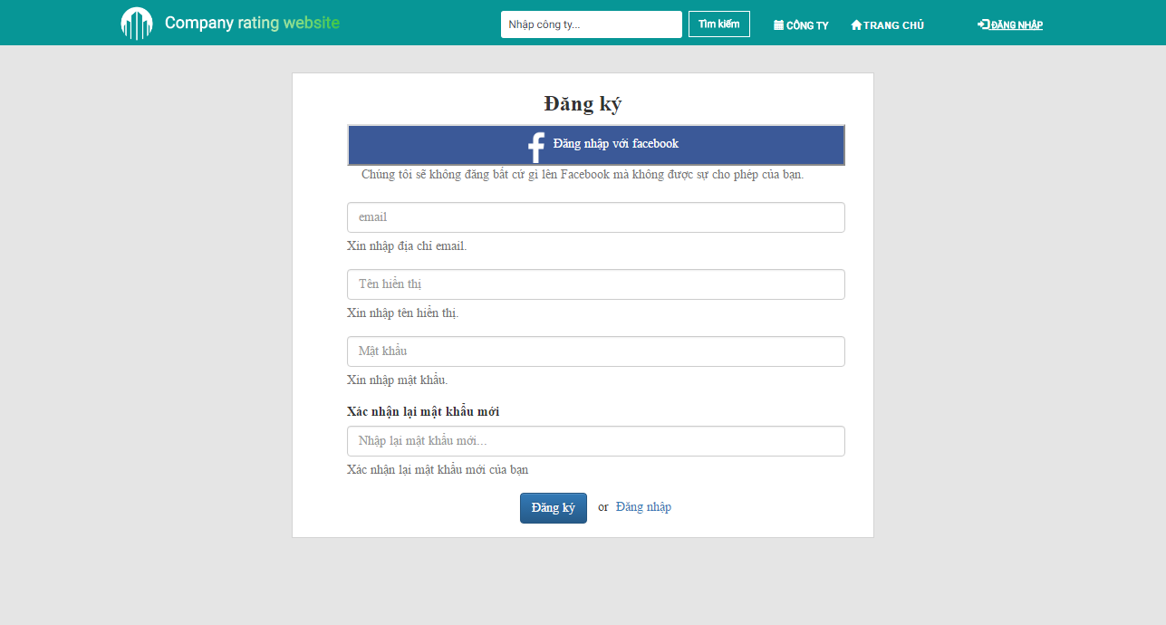

1. Register scren

## Login

To login account on website, you should follow these steps:

Step 1: Open browser and enter to the address bar: <http://companyrating.xyz/>. Homepage is displayed.

Step 2: Click on “Đăng nhập” button in header. You will be redirected to Login page.

Step 3: You can choose login with account or login with Facebook.

Step 3.1: If you choose login with account, you can enter username and password and click “Đăng nhập” button.

Step 3.2: If you choose login with Facebool, you can click “Đăng nhập với Facebook” button.

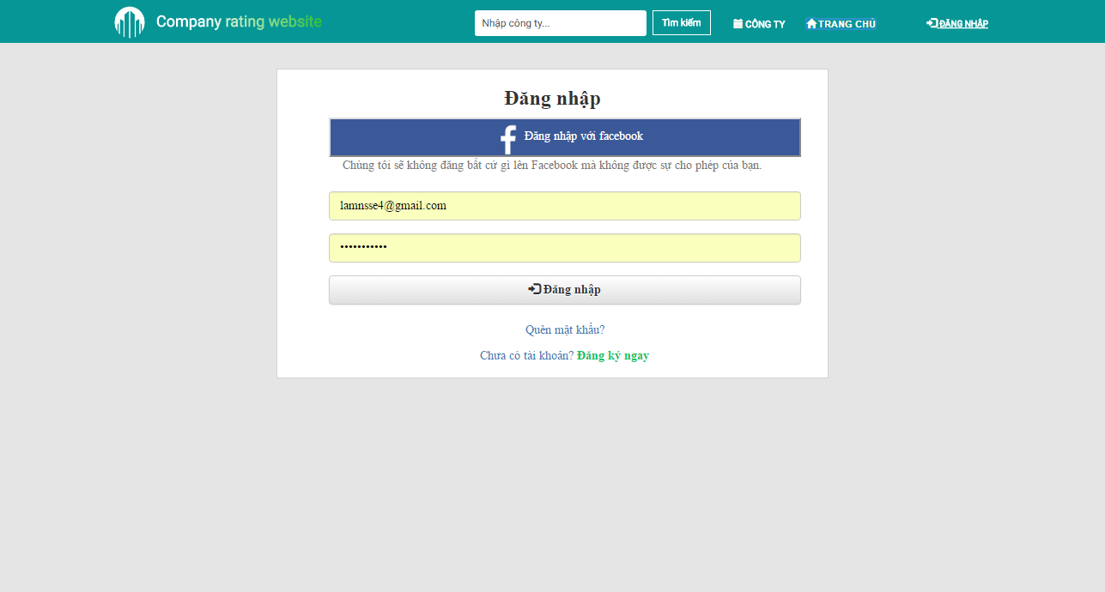

1. Login page

## Logout

To logout, you should follow these steps:

Step 1: Click on user avatar at upper-left of screen.

Step 2: Click on “Đăng xuất” button at dropdown menu.

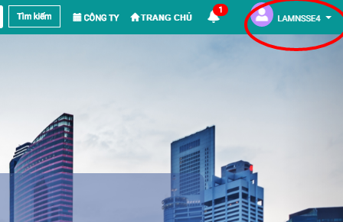

1. Log out

## Recover password:

If user forgot account password and can’t login, user can follow these steps to recover password:

Step 1: Go to Homepage, click “Đăng nhập button”.

Step 2: Click “Quên mật khẩu” hyperlink.

Step 3: Type account email into textbox and click “Xác nhận”.

Step 4: Check account email to get new password.

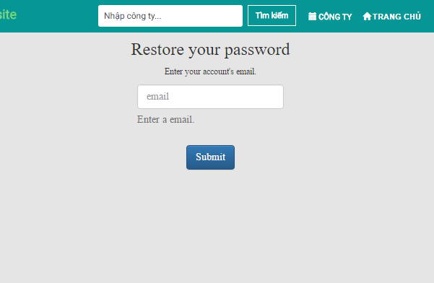

1. Recover password

## Discover company

### Go to Company list page

Company list page is the page that user can view all companies, number of reviews of each company, average score of each company, highlighted companies… To go to Company list page, the user do the steps below:

Step 1: Go to Homepage.

Step 2: Click on “Công ty” button in header. Company list page will be displayed.

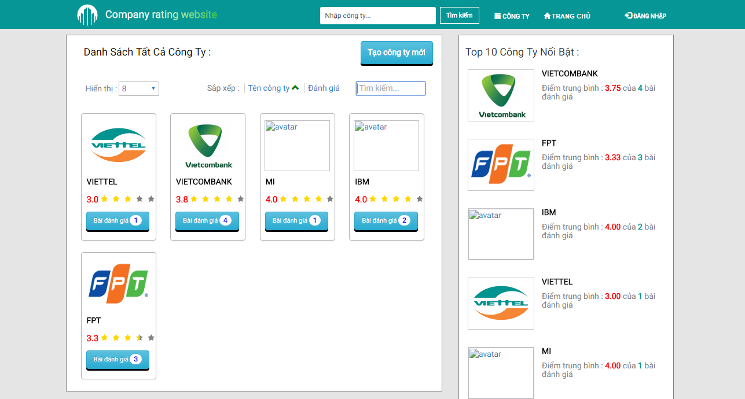

1. Company list page

### Filter at Company list page

You can filter at Company list page by many criteria: average score, company name, number of reviews.

To filter at Company list page, you should follow these steps:

Step 1: Go to Company list page.

Step 2: Click on “Tên công ty” or “Đánh giá” filter.

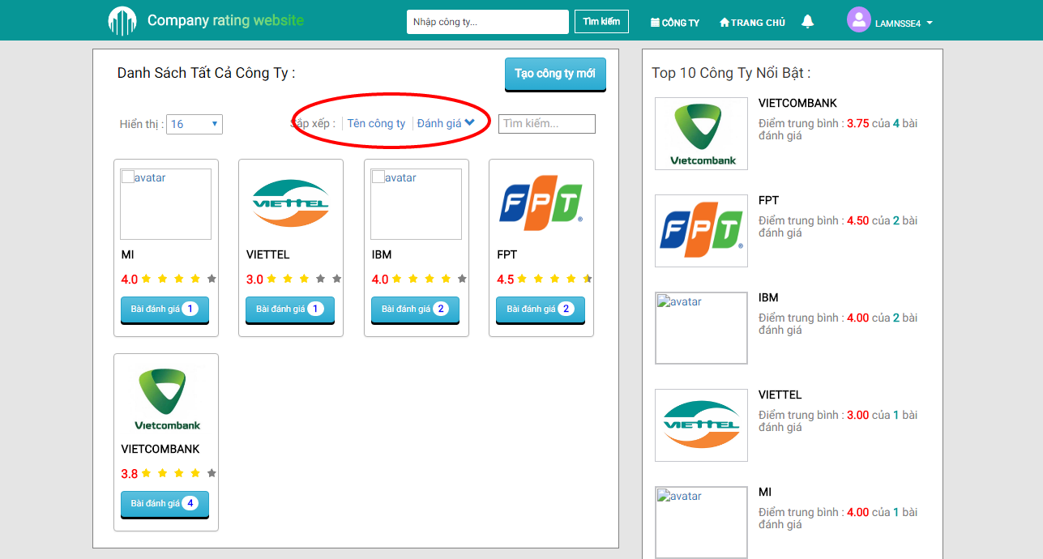

1. Filter at Company list page

## Search company

CRW provides 2 options to search company: Use search bar at header or Use search textbox at Company list page.

### Search via search bar at header

Step 1: Go to Homepage.

Step 2: Type company name into search bar at header, then press Enter or click “Tìm kiếm” button.

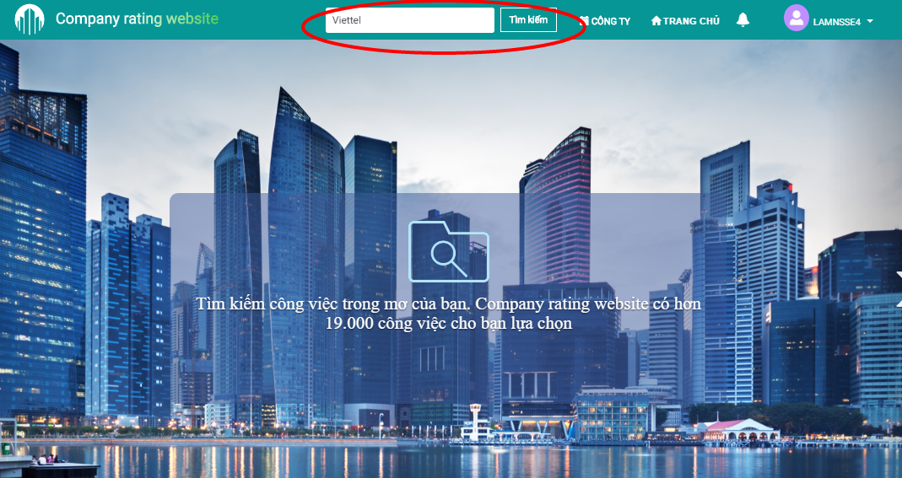

1. Seach at header

### Search via Company list page

Step 1: Go to Company list page.

Step 2: Type company name into search textbox at Company list page. Result will be displayed in real-time.

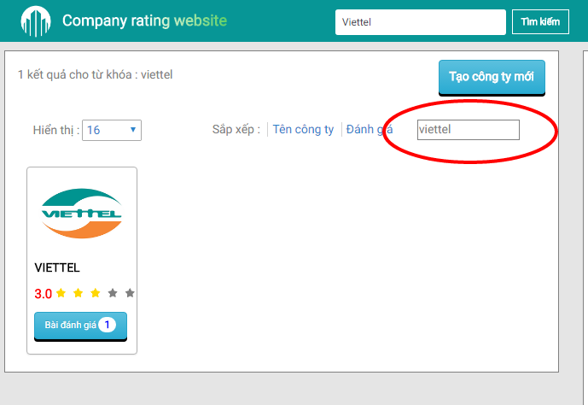

1. Search via Company list page

## Company details

In this page, user can view company details and its review list, follow company, write review for that company. You can view a company details page by following these steps:

Step 1: Go to Company list page.

Step 2: Click to a company that you want to view details page.

### Follow a company

If user follows a company, system will send notification to user when that company has a new review.

Step 1: Go to Company list page, click to company you want to follow (i.e FPT).

Step 2: Click “Theo dõi” button at banner of company, click OK at comfirmation popup.

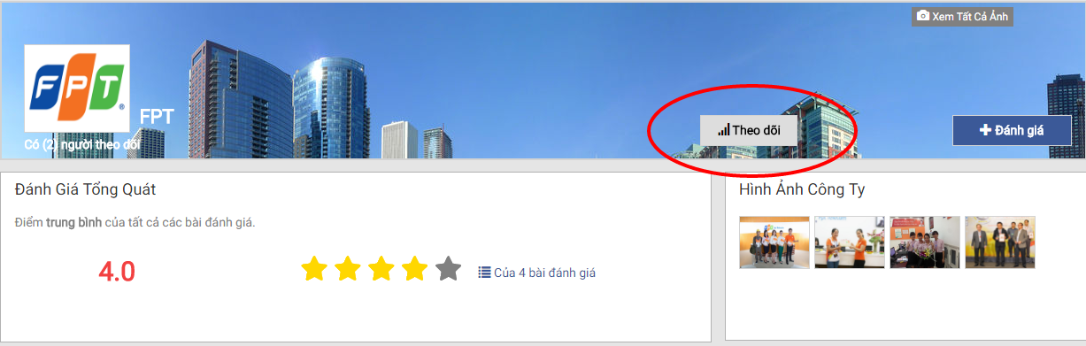

1. Follow a company

### Unfollow a company

If you are following a company but want to stop receiving notification, you can unfollow that company by doing these steps:

Step 1: Go to Company list page, click to company you want to unfollow (i.e FPT).

Step 2: Click “Bỏ theo dõi” button at banner of company, click OK at comfirmation popup.

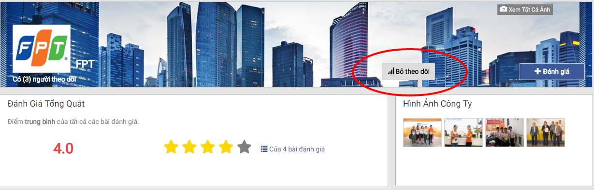

1. Unfollow a company

## Review Details

In a review details page, you can view, upvote, bookmark, comment on or report that review. To go to review details page, you should follow these steps:

Step 1: Go to Company list page, click to company that you want to read its reviews (i.e IBM).

Step 2: Click review you want to read. Review details page will be displayed.

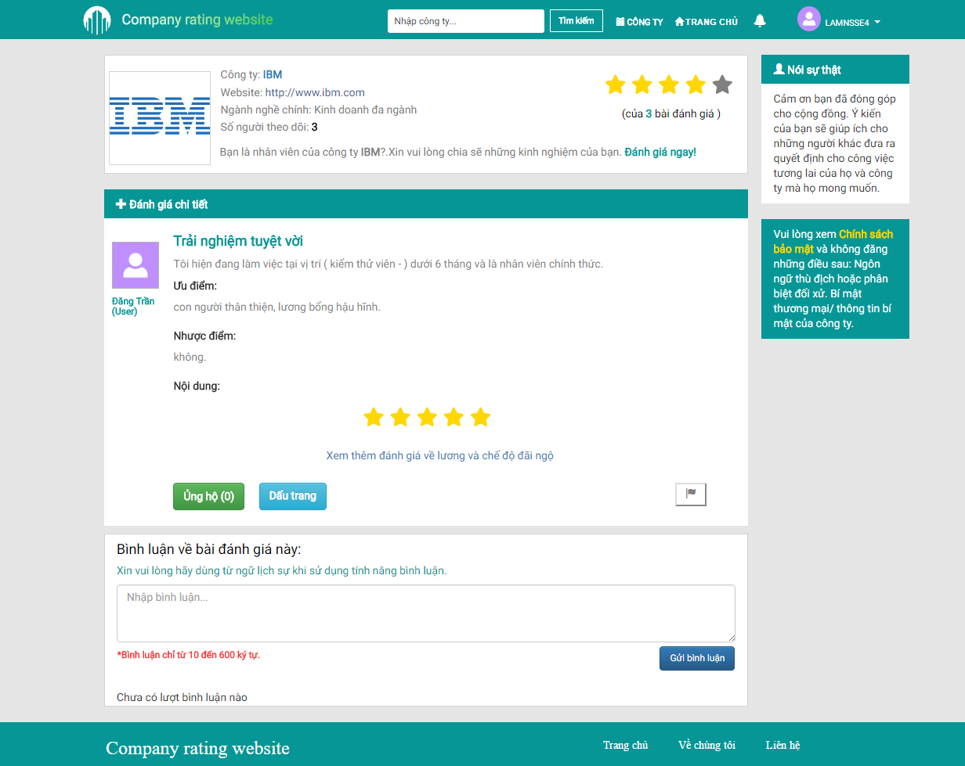

1. Review details page

### Comment

You can comment on a review by following these steps:

Step 1: Go to Review details page.

Step 2: Type comment into comment textbox and click “Gửi bình luận” button.

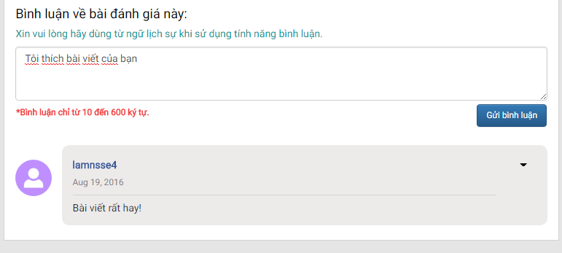

1. Comment

### Delete comment

If you want to delete your comment, you can follow these steps:

Step 1: Go to Review details page that has your comment.

Step 2: Click to triangle button at upper-right corner of your comment, then click “Xóa” button.

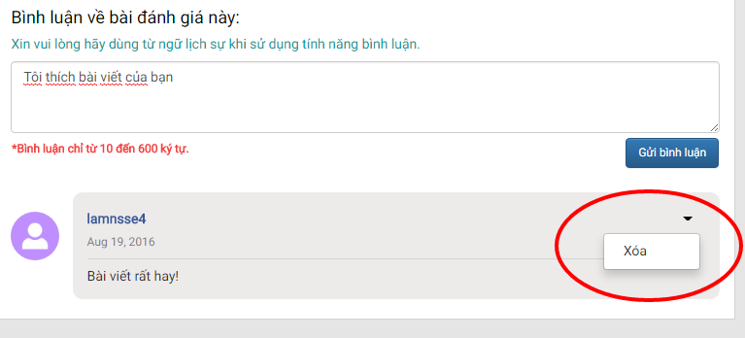

1. Delete comment

### Upvote review

If you want to show your support to a review, you can upvote that review. To upvote a review, you should follow these steps:

Step 1: Go to Review details page.

Step 2: Click “Ủng hộ” button under the review, then click “Xác nhận” button.

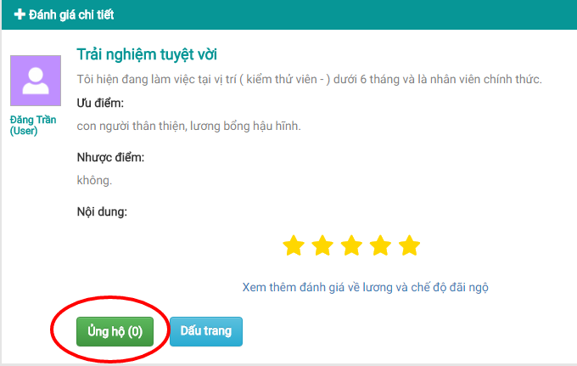

1. Upvote

### Remove upvote

To remove upvote from a review, you should follow these steps:

Step 1: Go to Review details page that has your upvote.

Step 2: Click “Bỏ ủng hộ” button under the review, then click “Xác nhận” button.

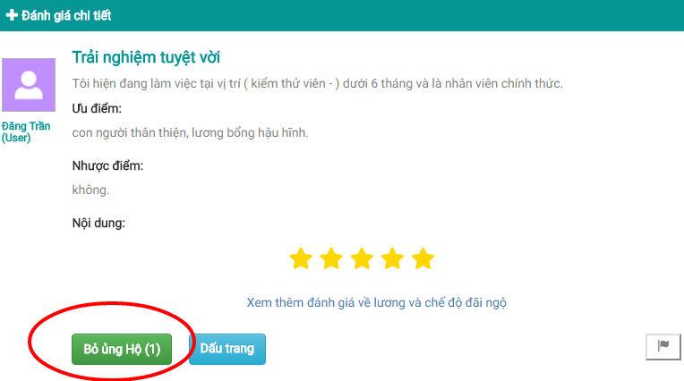

1. Remove upvote

### Bookmark review

You can bookmark a review to read it later. To bookmark a review, you should follow these steps:

Step 1: Go to Review details page.

Step 2: Click “Dấu trang” button under the review.

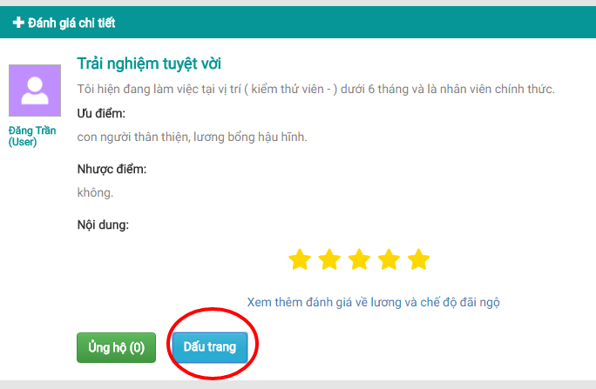

1. Bookmark review

### Remove bookmark

To remove a bookmark, you should follow these steps:

Step 1: Go to Review details page that you’ve bookmarked.

Step 2: Click “Bỏ lưu dấu trang” button under the review.

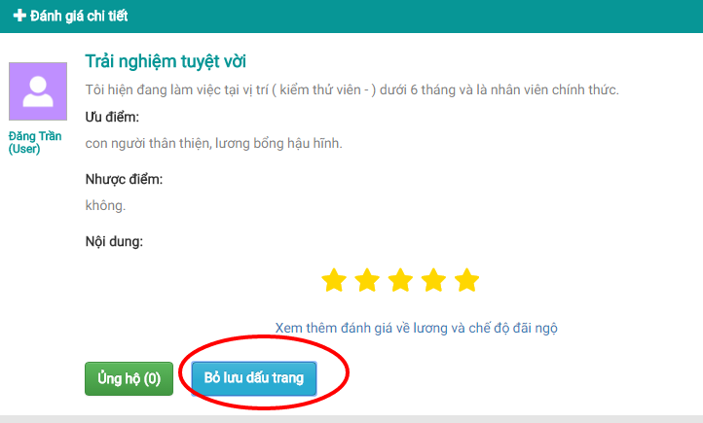

1. Remove bookmark

### Report

If you want to report a review (hate speech, malicious content…) to mod, admin, you should follow these steps:

Step 1: Go to Review details page that you want to report.

Step 2: Click “Báo cáo” button under the review.

Step 3: Type your report into textbox, then click “Hoàn thành” button.

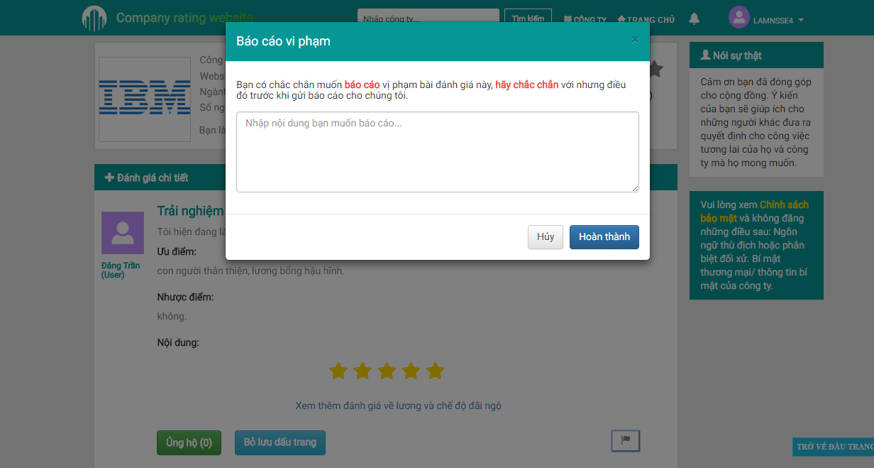

1. Report Modal Dialog

## Write review

You can share your experience with your company by writing a review. You have 2 options: Write review for an existed company or Write review for a new company.

**Note:** All reviews will be checked by mod/admin. Your review will be displayed on website if mod/admin approves that review. On the contrary, if mod/admin reject your review, you must edit then resend it for approving again.

### Write review for an existed company

Step 1: Go to Company list page, click to company you want to write review for (i.e FPT).

Step 2: Click “Đánh giá” button at banner of company.

Step 3: Fill in all nescessary fields in Create review page.

Step 4: Click “Gửi đánh giá” button.

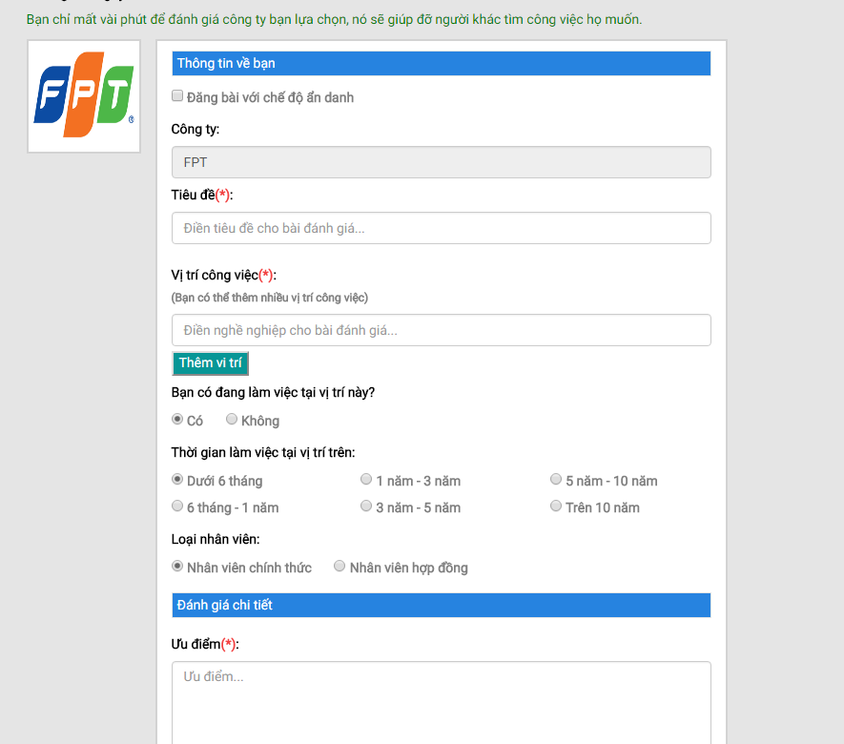

1. Write review for an existed company

### Write review for a new company

Step 1: Go to Company list page, click “Thêm công ty” button.

Step 2: Fill in all nescessary fields in Create company page. Click “Tạo công ty” button.

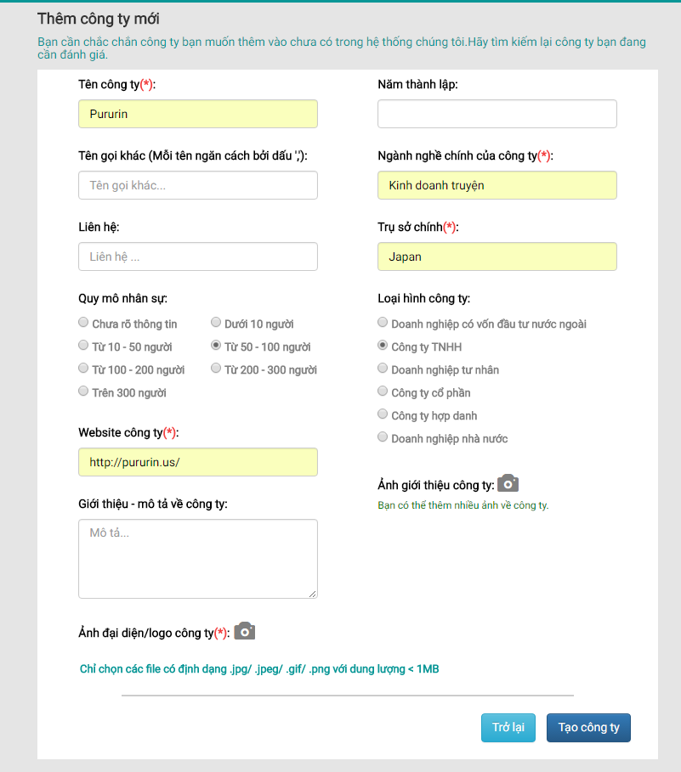

1. Create company page

Step 3: You will be redirected to the Create review page of the new company. Fill in all nescessary fields and click “Gửi đánh giá” button.

## Account management

### Account info

User can view his public profile by following these steps:

Step 1: Login with user’s account.

Step 2: Click on user avatar, then click “Quản trị tài khoản” hyperlink.

Step 3: Click on “Thông tin tài khoản” tab at side menu

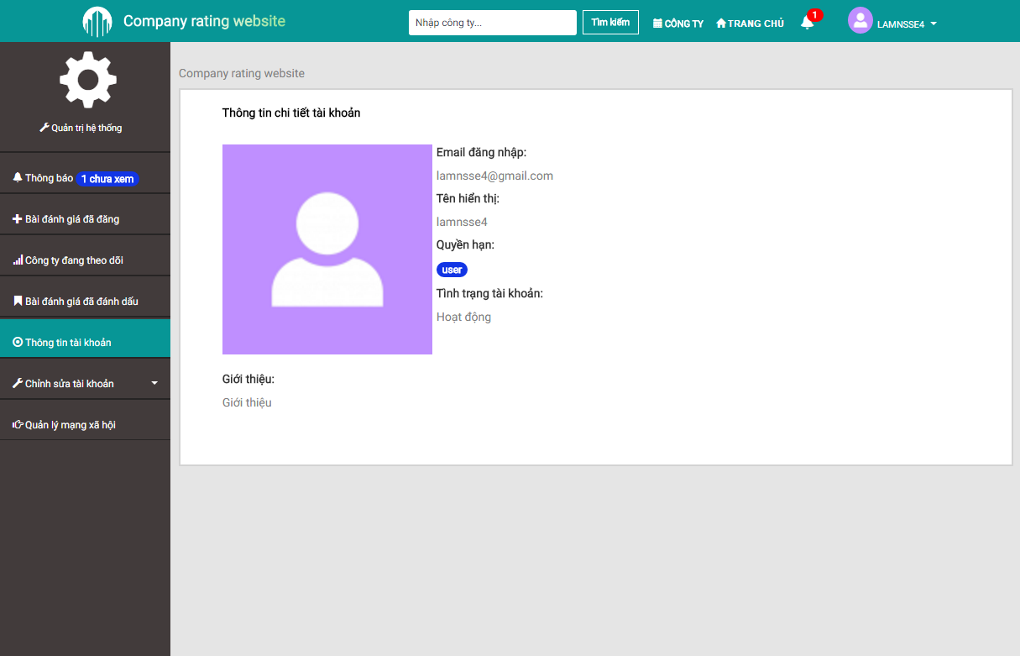

1. Account Info

### Notification

User will receive notification from CRW when user’s review is approved, user’s followed company has new review… To manage notification, user should follow these steps:

Step 1: Login with user’s account.

Step 2: Click to bell icon at the header.

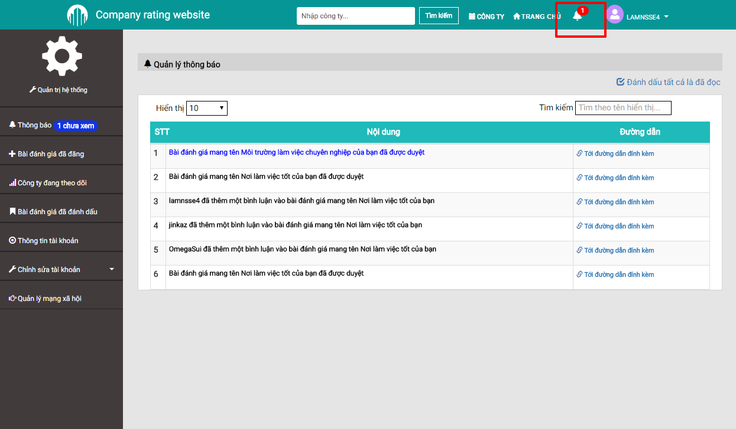

1. Notification

### Posted review managemnt:

You can manage your posted review(s) by following these steps:

Step 1: Login with your account.

Step 2: Click at user avatar, then click “Quản trị tài khoản” hyperlink.

Step 3: Click at “Bài đánh giá đã đăng” tab.

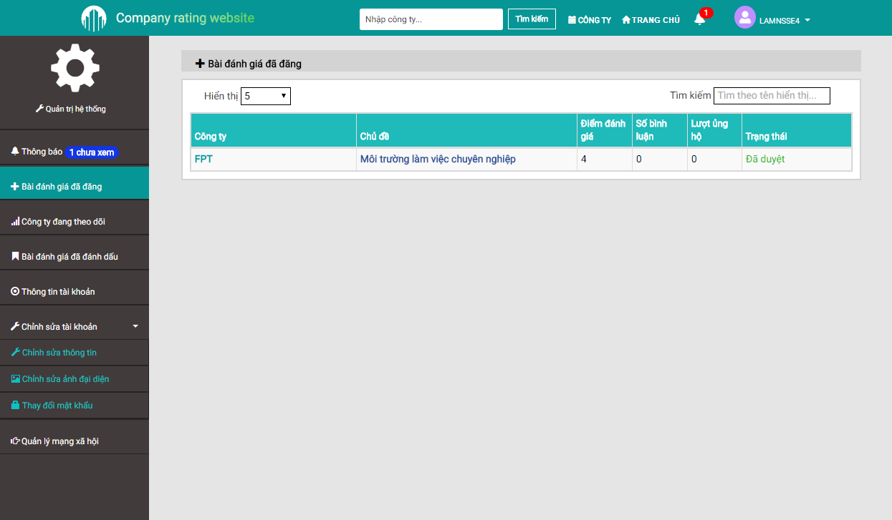

1. Posted review management

### Bookmarked review managemnt:

You can manage your bookmarked review(s) by following these steps:

Step 1: Go to “Quản trị tài khoản” page

Step 2: Click at “Bài đánh giá đã đánh dấu” tab.

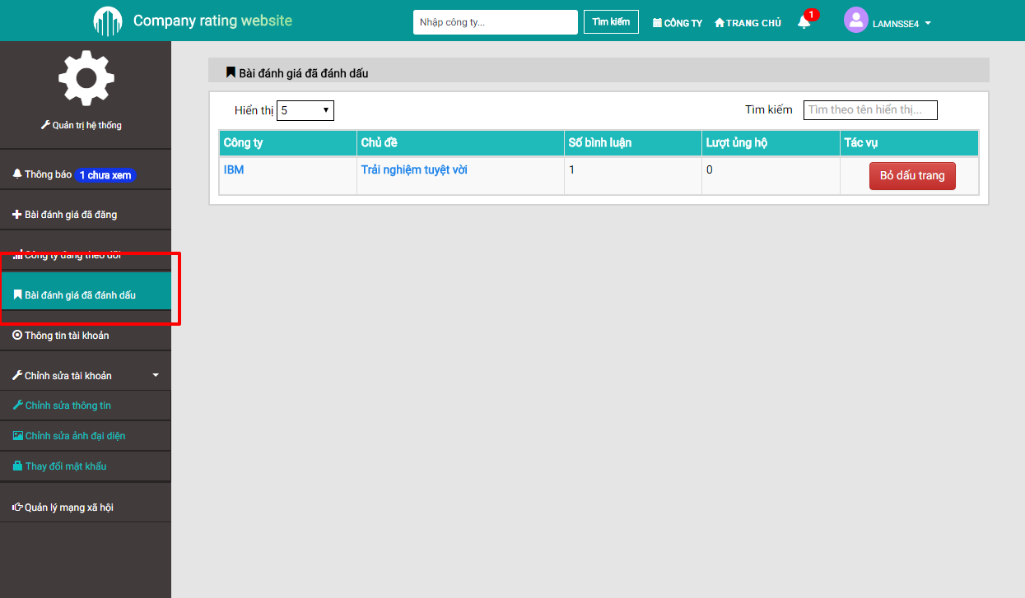

1. Bookmarked review management

### Followed company list:

You can manage your followed company list following these steps:

Step 1: Go to “Quản trị tài khoản” page

Step 2: Click at “Công ty đang theo dõi” tab.

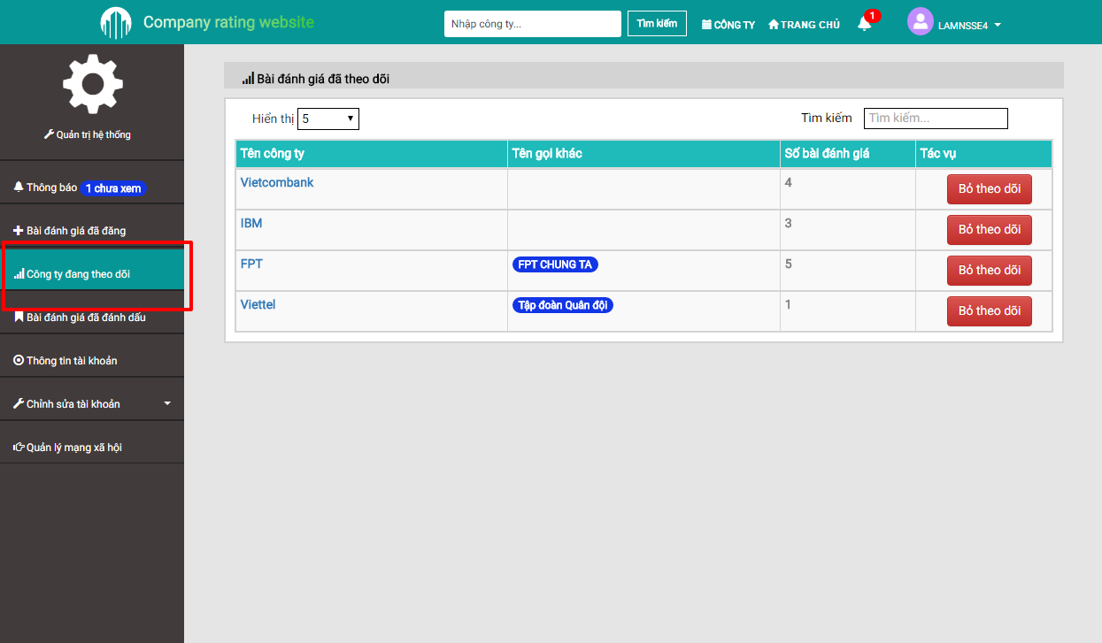

1. Followed company list

### Edit account info

User can edit account info by following these steps:

Step 1: Go to “Quản trị tài khoản” page

Step 2: Click at “Chỉnh sửa thông tin tài khoản” tab at side menu.

#### Update profile

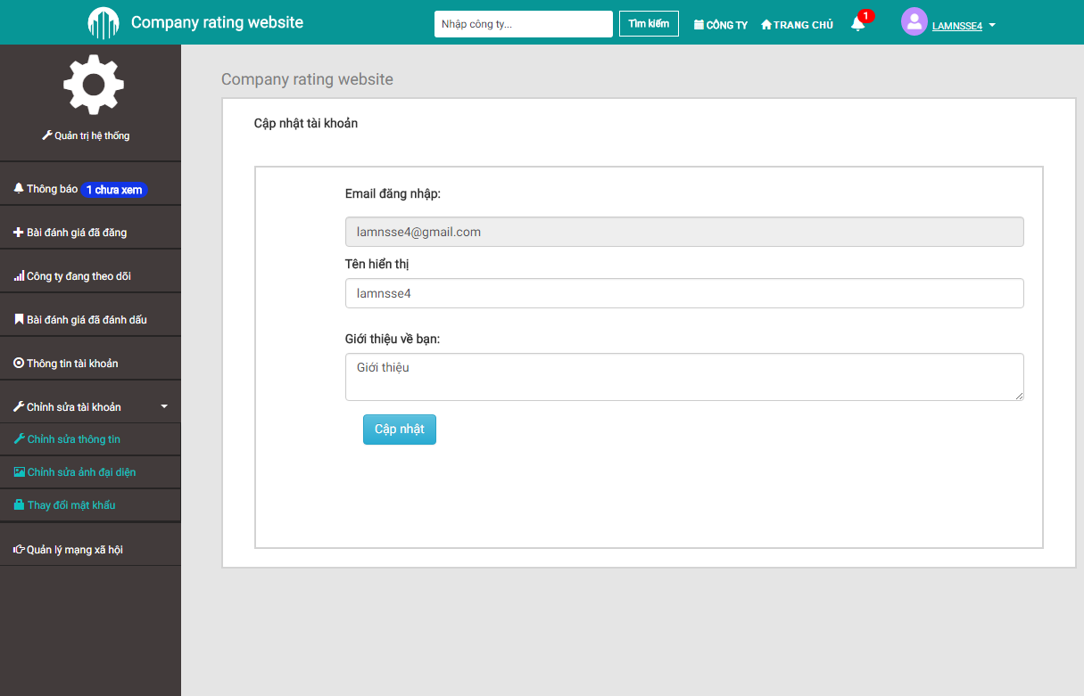

1. Update profile

#### Update avatar

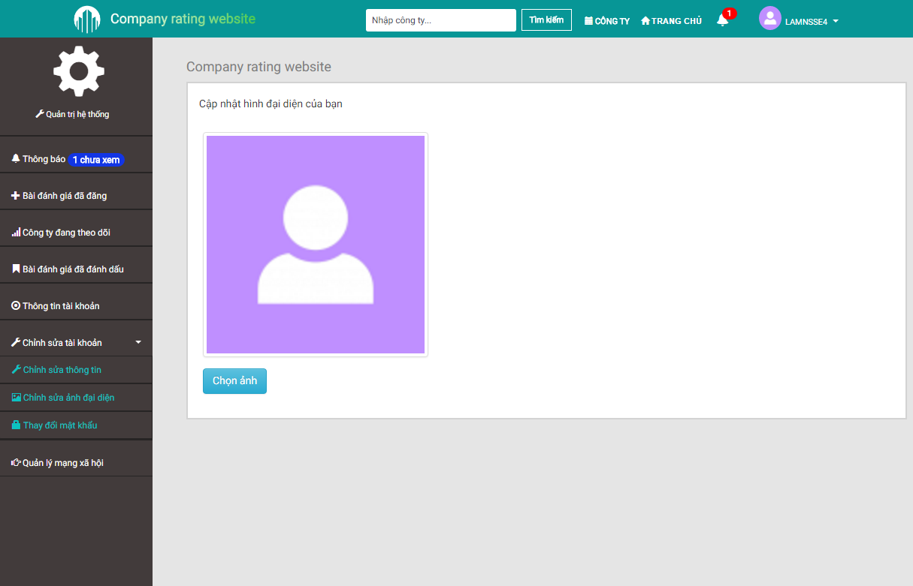

1. Update avatar

#### Update password

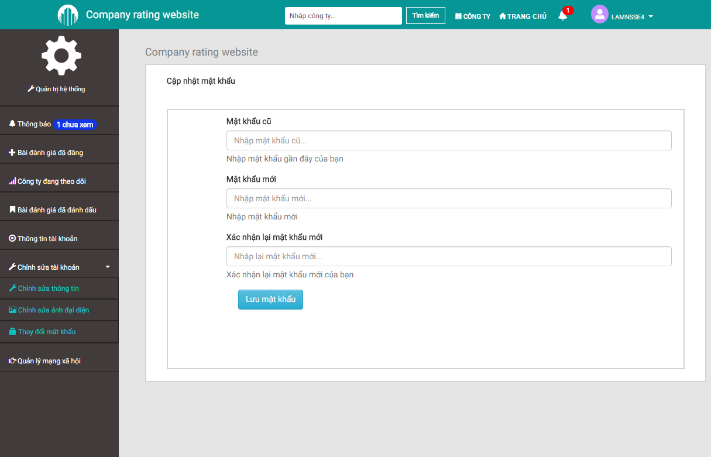

1. Update password

### Manage SNS account

User can manage SNS accounts that are used to login to CRW. To manage SNS account, user should follow these steps:

Step 1: Go to “Quản trị tài khoản” page

Step 2: Click at “Quản lý tài khoản mạng xã hội” tab at side menu.

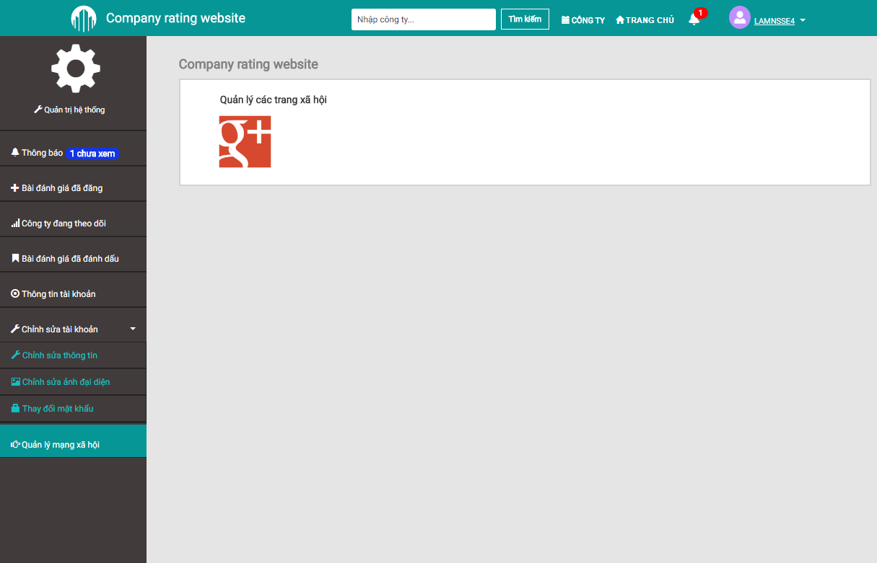

1. Manage SNS account

## Admin management

This group of function is only available to mod/admin.

### Pending review management

Admin can approve reviews that are sent from users to display them on web site, or reject bad reviews.

#### Approve a review

To approve a review, admin should follow these steps:

Step 1: Login with admin account

Step 2: Go to “Quản trị tài khoản” page

Step 3: Click at “Xử lý bài đăng” tab at side menu.

Step 4: Click to the review admin want to approve at “Bài đánh giá chờ duyệt” tab.

Step 5: Click “Duyệt bài” button, then click “Xác nhận” button.

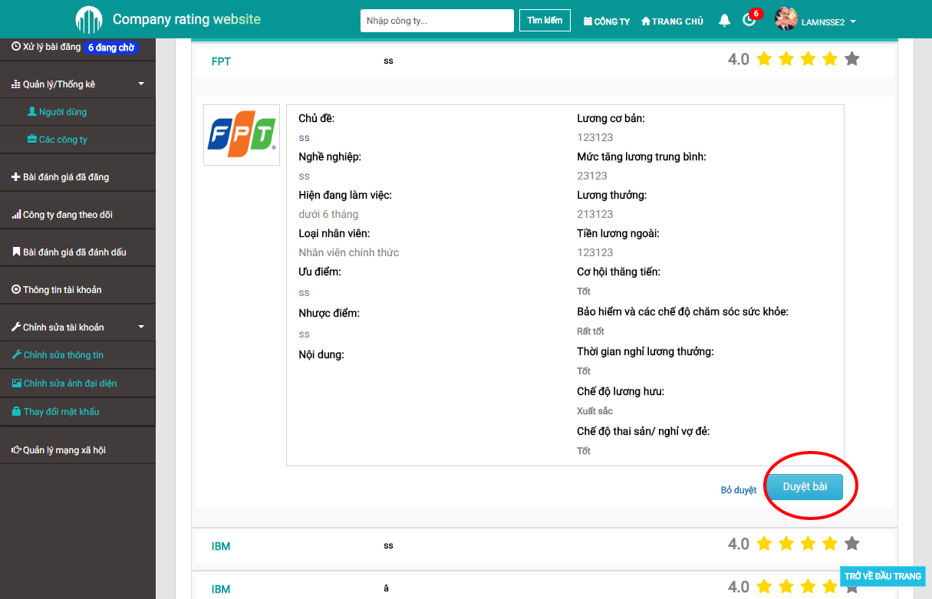

1. Approve a review

#### Reject a review

To reject a review, admin should follow these steps:

Step 1: Login with admin account

Step 2: Go to “Quản trị tài khoản” page

Step 3: Click at “Xử lý bài đăng” tab at side menu.

Step 4: Click to the review admin want to reject at “Bài đánh giá chờ duyệt” tab.

Step 5: Click “Bỏ duyệt” button, then type into textbox the rejection reason and click “Xác nhận” button.

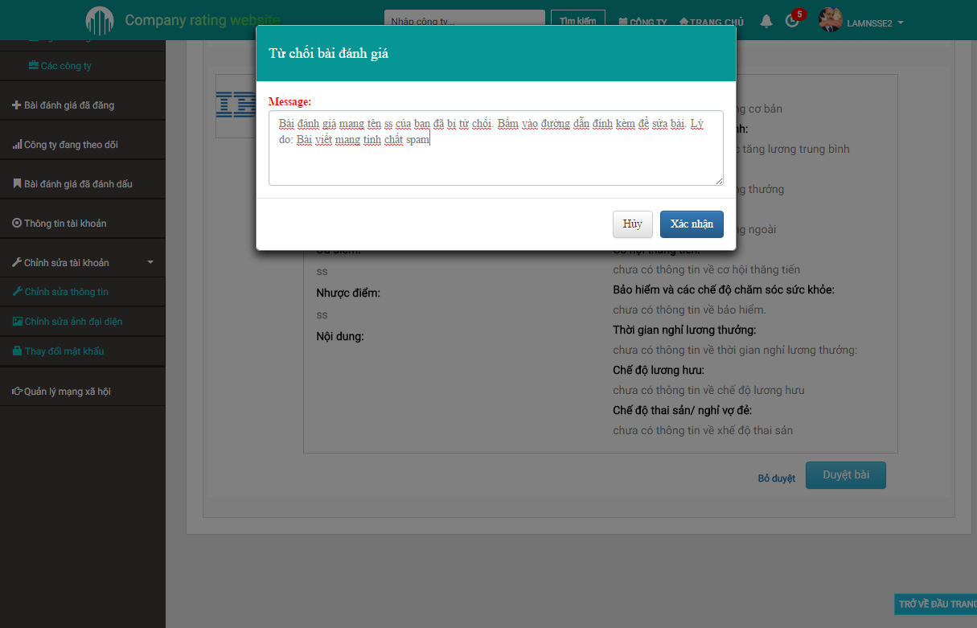

1. Reject a review

### Report management

#### Accept report(s)

To accept a report, admin should follow these steps:

Step 1: Login with admin account

Step 2: Go to “Quản trị tài khoản” page

Step 3: Click at “Xử lý bài đăng” tab at side menu.

Step 4: Click to the review admin want to accept reports at “Bài cáo chờ xử lý” tab.

Step 5: Click “Xử lý” button, then type into textbox the reason and click “Xác nhận” button.

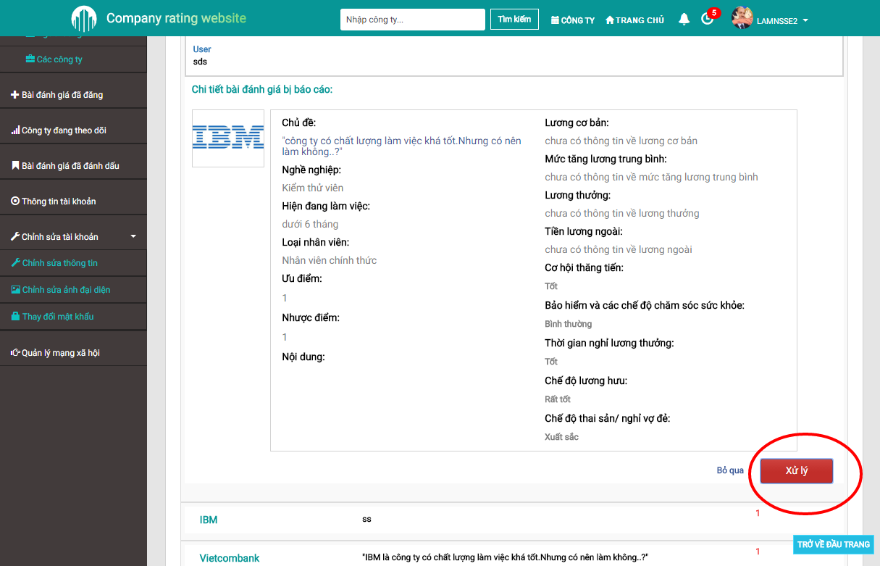

1. Approve report(s)

#### Reject report(s)

To reject a report, admin should follow these steps:

Step 1: Login with admin account

Step 2: Go to “Quản trị tài khoản” page

Step 3: Click at “Xử lý bài đăng” tab at side menu.

Step 4: Click to the review admin want to rejct reports at “Bài cáo chờ xử lý” tab.

Step 5: Click “Bỏ qua” button, then click “Xác nhận” button.

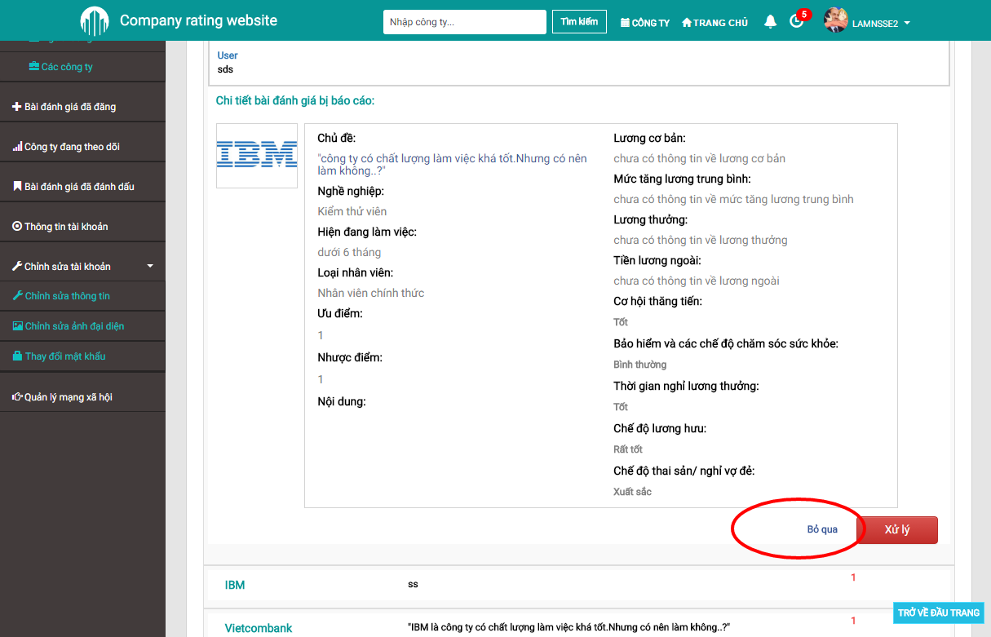

1. Reject report(s)

### User management

Admin can view all users and their status at User management page. To access this page, admin should follow these steps:

Step 1: Login with admin account

Step 2: Go to “Quản trị tài khoản” page

Step 3: Click at “Quản lý/Thống kê” then “Người dùng” tab at side menu.

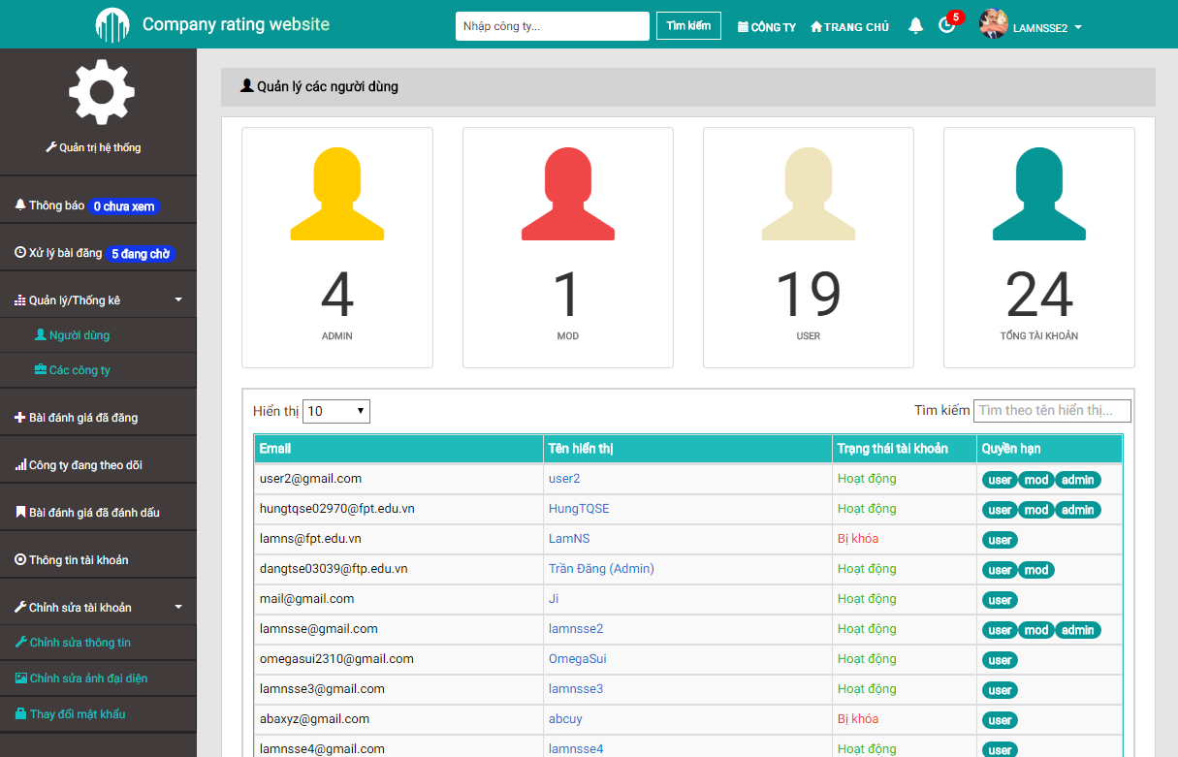

1. User management

#### Block/Unblock an user

Step 1: Go to User management page.

Step 2: Click to the user needed to block/unblock.

Step 3: Click to “Khóa”/“Mở khóa” button.

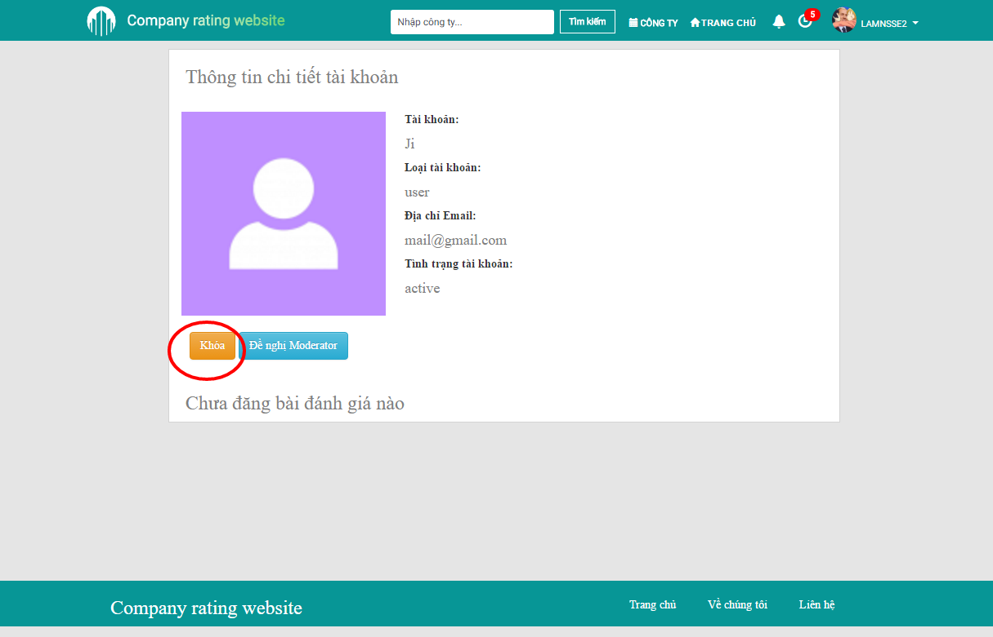

1. Block an user

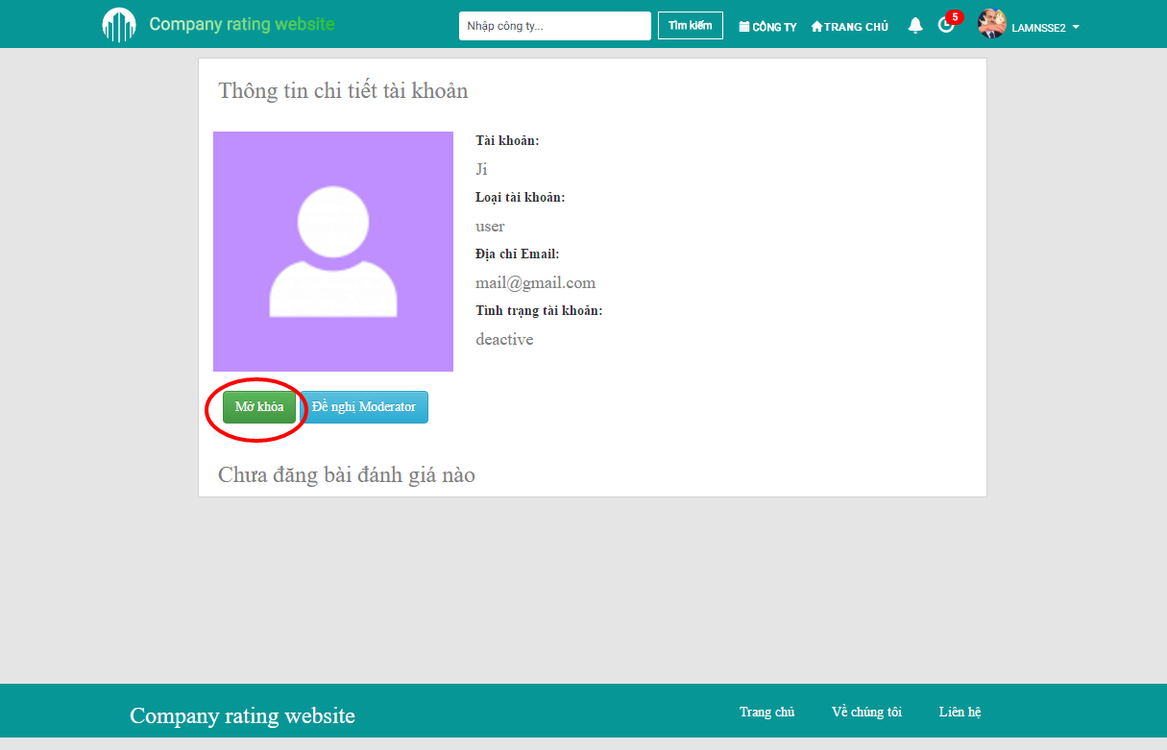

1. Unblock an user

#### Promote/demote an user/mod

Step 1: Go to User management page.

Step 2: Click to the user/mod needed to promote/demote.

Step 3: Click to “Đề nghị Moderator”/“Hủy Moderator” button.

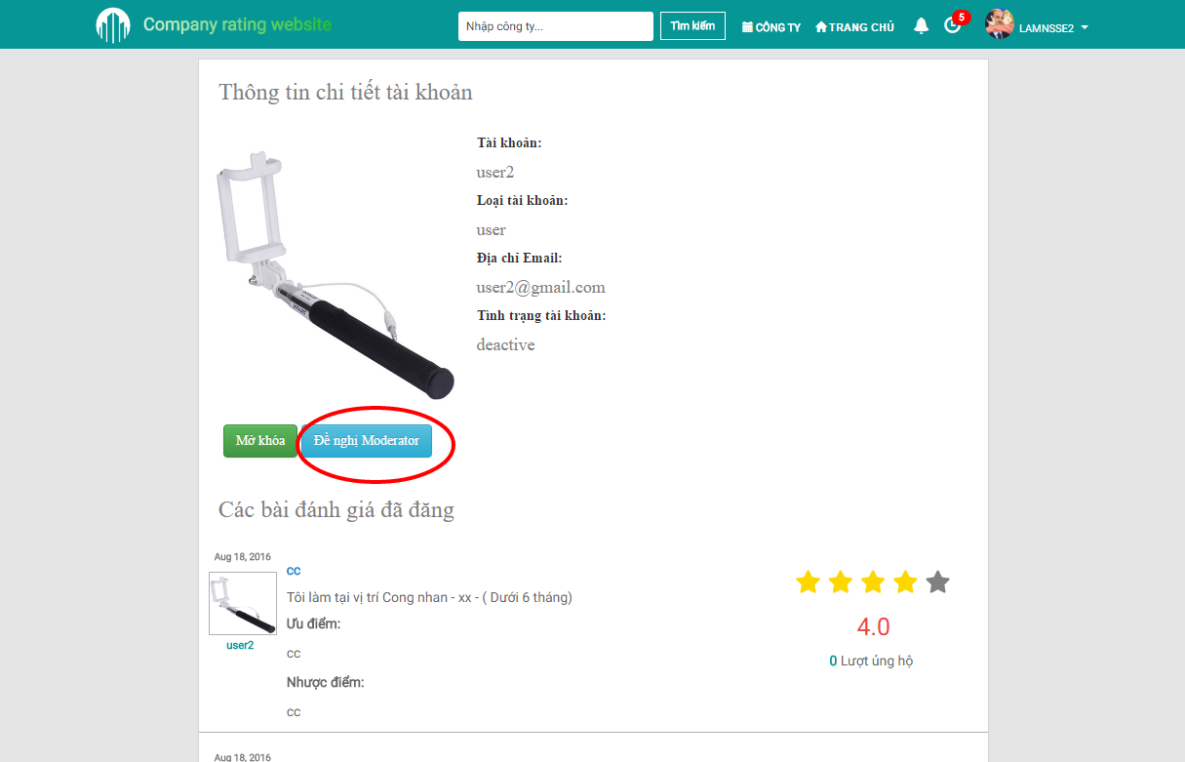

1. Promote an user

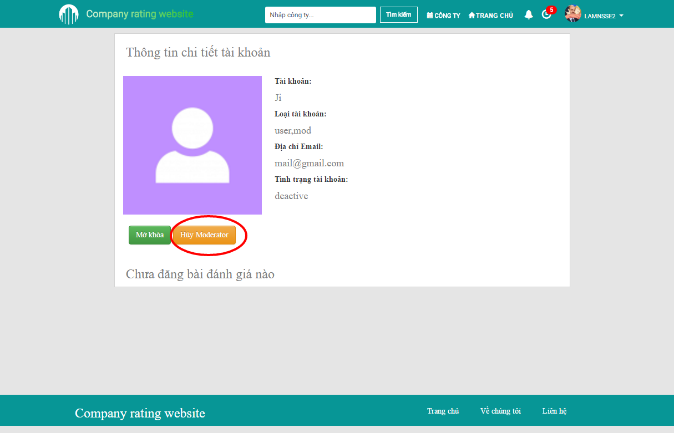

1. Demote an moderator

### Company management

Admin can view all companies and their status at Company management page. To access this page, admin should follow these steps:

Step 1: Login with admin account

Step 2: Go to “Quản trị tài khoản” page

Step 3: Click at “Quản lý/Thống kê” then “Công ty” tab at side menu.

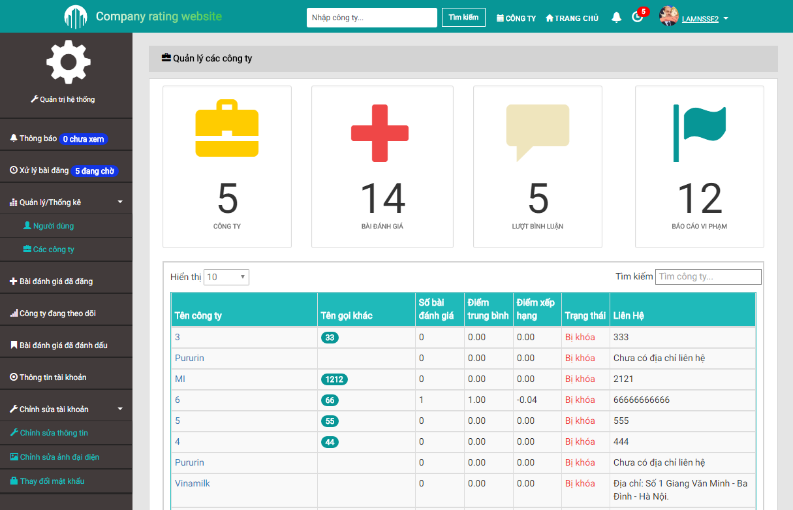

1. Company management
2. REFERENCE
3. Scotch.io, Setting Up a MEAN Stack Single Page Application

<https://scotch.io/tutorials/setting-up-a-mean-stack-single-page-application>

1. Scotch.io, Deploying a MEAN App to Amazon EC2:

<https://scotch.io/tutorials/deploying-a-mean-app-to-amazon-ec2-part-1>

<https://scotch.io/tutorials/deploying-a-mean-app-to-amazon-ec2-part-2>

1. Evan Miller, Ranking Items With Star Ratings

<http://www.evanmiller.org/ranking-items-with-star-ratings.html>

1. Bradley Braithwaite, Mean Stack Tutorial – Beginners Tutorial

<http://www.bradoncode.com/tutorials/learn-mean-stack-tutorial/>

1. Shristi, The 30 Day MEAN Stack Honolulu Challenge

<http://www.bossable.com/555/mean-app-challenge/>

1. Wikipedia, Prototype-based programming

<https://en.wikipedia.org/wiki/Prototype-based_programming>